These clips accompanied the first year lecture course Probability & Statistics 1B
Lec 1: Flash Mob: Peer Gynt
http://www.youtube.com/watch?v=gww9_S4PNV0&feature=youtube_gdata_player
Lec 2: Chris Bliss, juggler
https://www.youtube.com/watch?v=AAILqBg_cJo
PC 1: Tom and Jerry live at the Hollywood Bowl (or use Google if this link fails)
https://www.facebook.com/watch/?v=148734486880511
Lec 3: 2Cello & Lang Lang, Live and Let Die
https://www.youtube.com/watch?v=6UMla4zYpoc
Lec 4: Yosemite National Park
https://www.youtube.com/watch?v=N6-2fVsFV8E
PC 2: A Normal Day
http://www.youtube.com/watch?v=86p62pKVtO4
Lec 5: Dog
http://eafa.org.uk/work/?id=1025609
Lec 5: Dog and fridge
http://www.youtube.com/watch?v=nGeKSiCQkPw
Lec 6: Knick Knack – snowman in snow-dome
https://www.youtube.com/watch?v=9uhM_SUhdaw
PC 3: Road runner, Chariots of Fur (or use Google if this link fails)
https://www.dailymotion.com/video/x2660mr
Lec 7: The Piano Guys, Cello Wars: The Phantom Cellist
http://www.youtube.com/watch?v=BgAlQuqzl8o
Lec 7: Birdbox: Car park
https://www.youtube.com/watch?v=iTWuZav-elY
Lec 8: Ukelele orchestra of Great Britain: Ride of the Valkyries and Silver Machine
http://www.youtube.com/watch?v=xBweqmLk6dU
Lec 8: Henri 2 paw de deux
http://www.youtube.com/watch?v=Q34z5dCmC4M
PC 4: Flash mob “Ode to Joy”
https://www.youtube.com/watch?v=cxLbmnvMWM0
Lec 9: OK Go - Upside Down & Inside Out
https://www.youtube.com/watch?v=LWGJA9i18Co
Lec 10: Sacla’ Stage a Surprise Opera in a School Lunch Hall
https://www.youtube.com/watch?v=JNgCM7zp30M&feature=youtu.be
PC 5: Road runner, Going Going Gosh
https://www.dailymotion.com/video/x2d5j5f
The Road Runner & Wile E Coyote cartoons have 9 rules.
They are not quite Kolmogorov’s axioms for probability, but they explain a lot.
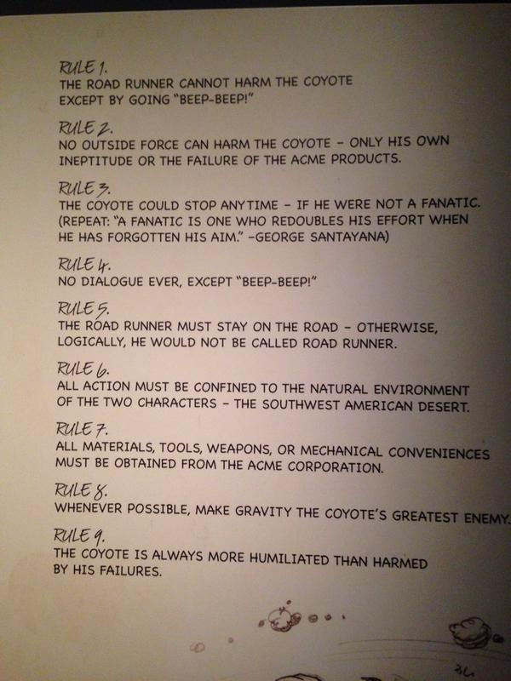
Lec 11: Wintergatan - Marble Machine
https://www.youtube.com/watch?v=IvUU8joBb1Q
Olive & Mabel Lockdown Life
https://www.youtube.com/watch?v=uBttTAhRTY0
Lec 12: Song from pi!
https://www.youtube.com/watch?v=wM-x3pUcdeo
PC 6: Flash mob “Grease” in Central Station, Antwerp
https://www.youtube.com/watch?v=s_hlvRNgGOQ
Lec 13: Pachelbel, Canon in D major
http://www.youtube.com/watch?v=NlprozGcs80
For a rendition of this piece on unusual “instruments”, see
https://www.youtube.com/watch?v=cD3QlR98--A
Lec 14: Flanders and Swan, The Gnu Song
http://www.youtube.com/watch?v=Qu6q5kRY2M8
Lec 14: Birdbox: Wildebeest (or gnu)
https://www.youtube.com/watch?v=JMJXvsCLu6s
PC 7: Tom and Jerry Mice Follies (or use Google if this link fails)
http://www.dailymotion.com/video/xgrqk6
https://www.facebook.com/watch/?v=703851280201062 (remastered)
Lec 15: David Bowie, Let’s Dance
https://www.youtube.com/watch?v=VbD_kBJc_gI
Lec 15: Olive and Mabel, Home Help
https://www.youtube.com/watch?v=Xmm_BLyzXbk
Lec 16: The Piano Guys: Vivaldi’s Winter
http://www.youtube.com/watch?v=6Dakd7EIgBE

PC 8: What’s Opera Doc
https://vimeo.com/444002896
See https://www.facebook.com/watch/?v=894936933579235 for more about how this animation was produced.
Lec 17: Ukelele orchestra of Great Britain: Devil’s gallop
http://www.youtube.com/watch?v=6N6t6NEJBQ0
Lec 17: Is this the most ridiculous penalty ever?
https://www.bbc.co.uk/sport/av/football/41728826
Lec 18: Up and Over it, We No Speak Americano
http://www.youtube.com/watch?v=iANRO3I30nM&feature=youtu.be
Lec 18: Olive and Mabel: Card school
https://www.youtube.com/watch?v=Ts1iG5cgl8E
PC 9: Tom and Jerry: The Invisible Mouse (or use Google if this link fails)
https://www.facebook.com/watch/?v=2706012249652172
Lec 19: Yuja Wang, Variations on the Turkish March
https://www.youtube.com/watch?v=RGAPTRrAilY
Lec 19: Birdbox: Carwash
https://www.youtube.com/watch?v=-sAjrL0fJzw
Lec 20: “Zorba” by Emmetron
https://www.youtube.com/watch?v=kG12C1oX5Eo
Lec 20: Olive and Mabel, online dating
https://www.youtube.com/watch?v=j75Ti2oiCAA
PC 10: “Amazing Flash Mob Leaves Londoners Speechless”
https://www.youtube.com/watch?v=xQ_GwWTdYtk
Lec 21: Flash mob, St Pancras Station, New Year’s Eve 2010
https://www.youtube.com/watch?v=-bnYpCiwV2Q
Lec 21: Sketchy duel
https://www.youtube.com/watch?v=Qi2kaDzGh9A
Lec 22: Elton John: Crocodile Rock
https://www.youtube.com/watch?v=JrpI7WbJcO8
Lec 22: Olive & Mabel: Alternative Olympics
https://www.youtube.com/watch?v=gEw1KUCa7KE
RC1: Riverdance, Eurovision 1994
https://www.youtube.com/watch?v=zy79KKpQ988
Olive and Mabel: Company meeting
https://www.youtube.com/watch?v=nFVHaus_pjI
RC2: Tom and Jerry “The Cat Concerto” (or use Google if this link fails)
https://www.facebook.com/watch/?v=244257363776347
Henri 7, The Cat is Sat
https://www.youtube.com/watch?v=Q8jJuTYfa_E
RC3: Leonard Cohen: Closing time
http://www.youtube.com/watch?v=7-0lV5qs1Qw&feature=kp
Henri 10, Reigning Cat and Dog
https://www.youtube.com/watch?v=OMOga8x6aLk

Video researcher: Debbie Slater

