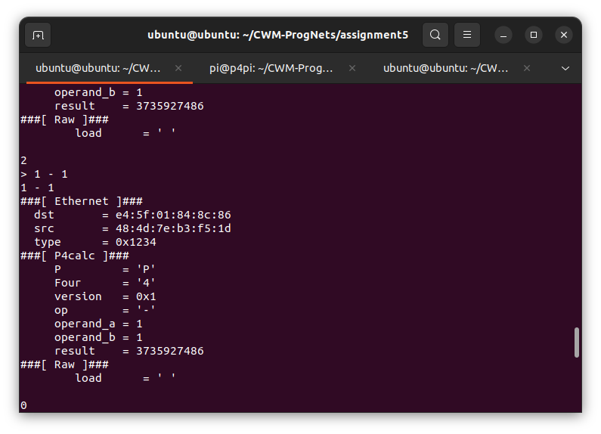
https://github.com/CJimbob/CWM-ProgNets/tree/main/assignment5

