**IT 2045C Computer Programming II  
Prof. Tom Wulf   
Lab 03 Filter Interface  
Spring Semester 2018**

Learning Goals:  
  
Modified from problem from your textbook.

* Get practice using Interfaces
* Create a predicate based interface
* Create a call back interface

1. Create a Netbeans project called Interfaces. All of your code will be in this project.
2. Create an interface Filter as follows:

public interface Filter

{

boolean accept(Object x);

}

1. Write a method:

**public static ArrayList<Object> collectAll(ArrayList<Object> objects, Filter f)** that returns all objects in the objects array that are accepted by the given filter. You will use this for the program that follow. You can copy this method into the main file of each of your programs below or place it in a static class file and use it from there with this: MYCLASSFILENAME.collectAll(…)

**Program 1:**Provide a class ShortWordFilter which implements the Filter interface whose accept method accepts all strings of length < 5.

Then write a program **ShortLister.java** that lets the user pick a text file (JFileChooser) which uses the filter to display the short words from the file.

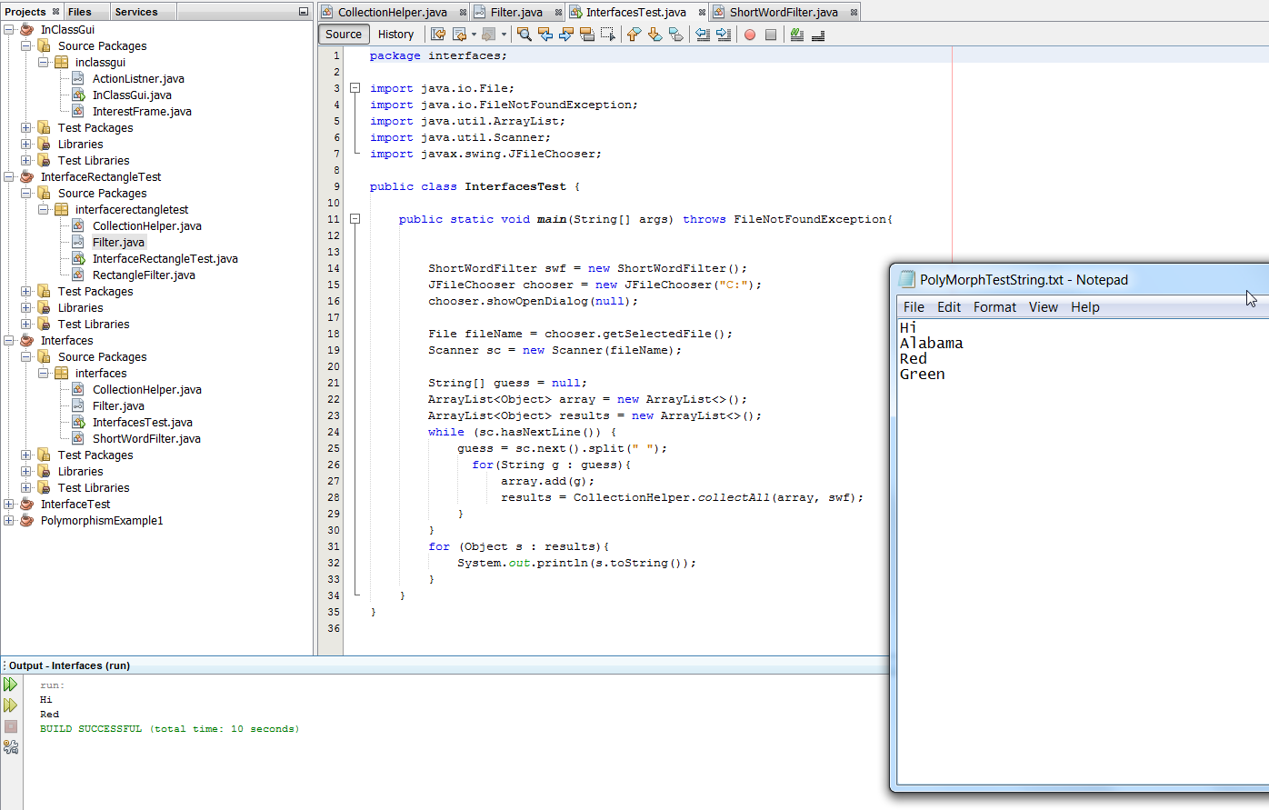

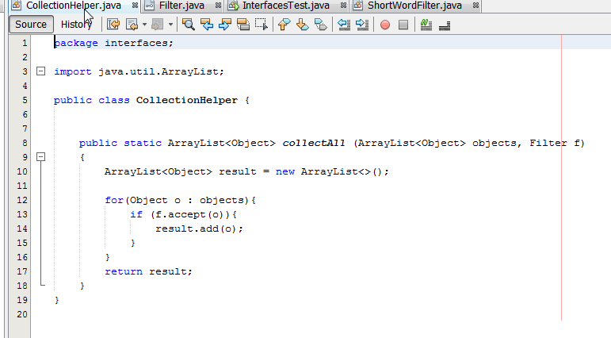

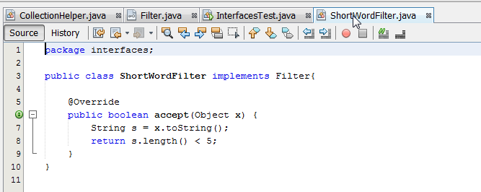

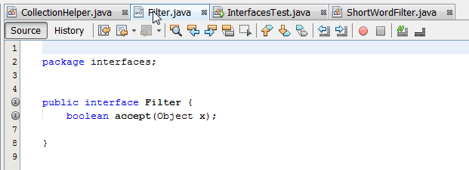

**Program 2:**Provide a class BigRectangleFilter which implements the Filter interface whose accept method accepts all java Rectangle objects that have a perimeter > 10.

Then write a program **BigRectLister.java** that creates an ArrayList of 10 Rectangles making sure that you have several that are under and several that are over a perimeter of 10. Use the collectAll method as before to list the rectangles that have big perimeters.

As always take screen shots of your output to show that your programs run correctly. Paste them at the end of this document.

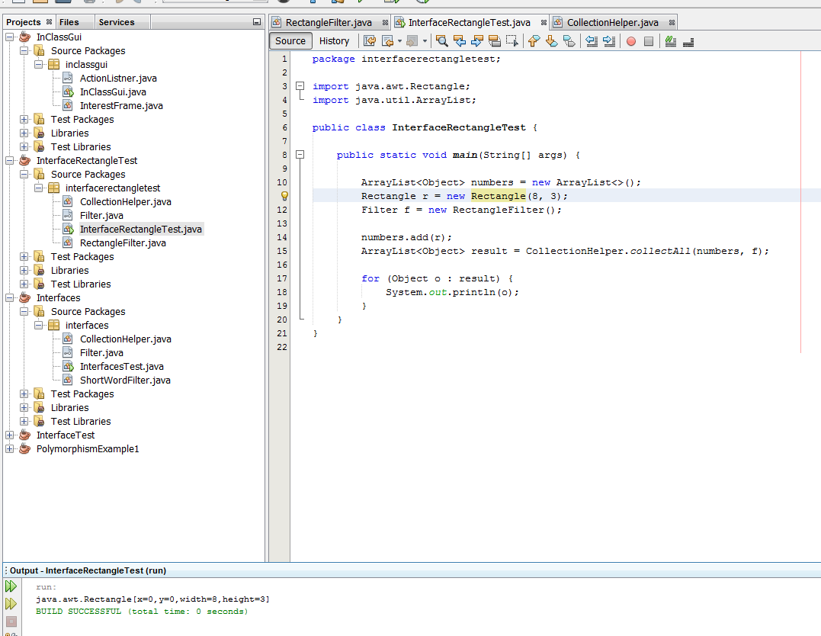

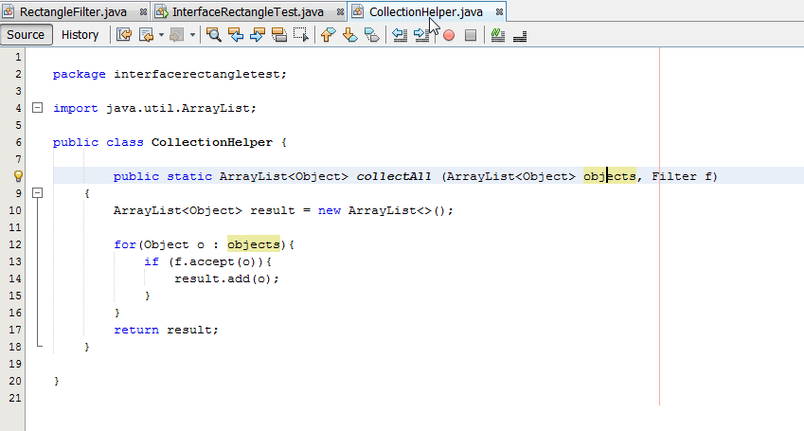

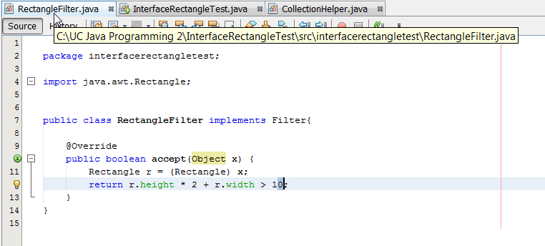

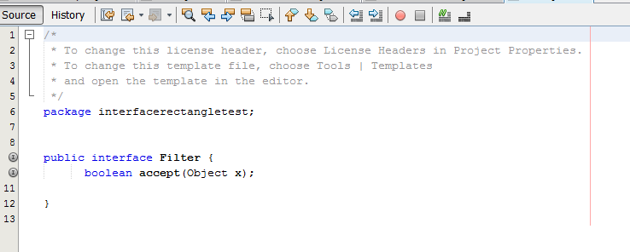

**Submission:**

Create a single zip archive called **Lastname_Firstname_Lab03.zip** that includes your complete Netbeans project folder. Add this word docx file with you screen shots to the archive.

Submit a separate copy of the MS Word docx file with the screen shots in addition to your complete archive so I can read it in Bb