GIS Data Inventory
  - Database Details for Original Process Design - 2017

The GIS Group Database (20170601 M:\IRGIS\GIS Data\4_GIS_Group_Database\GIS_Group_Database.accdb ) is an inventory of the Spatial Database Engine (SDE) environments, their existing administrative accounts, the feature classes within each account, contact persons responsible for data, and the fields within each feature class. It was created and is stored in a Microsoft Access database.
The data is generated by a python script created in the third fiscal year quarter of 2017 by CJuice.

Figure 1 - Database Relationship Diagram
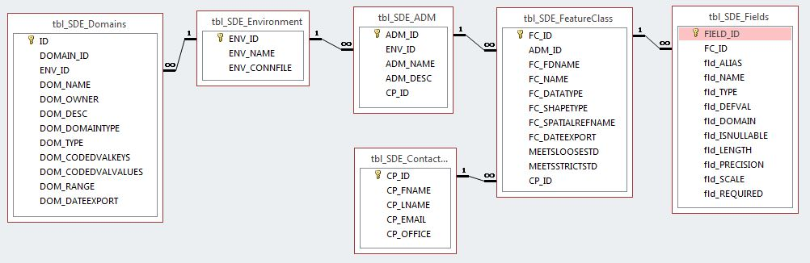

Table 1- Entity Relationship Model
ENTITY | RELATIONSHIP | CONNECTIVITY | ENTITY
ENVIRONMENT | hosts | 1:M | ADMs
ENVIRONMENT | contains | 0:M | DOMAINS
ADM | stores | 0:M | FEATURECLASS
CONTACTPERSON | owns | 0:M | ADMs
CONTACTPERSON | owns | 0:M | FEATURECLASS
FEATURECLASS | consists of | 1:M | FIELD
FIELD | contains | 0:M | VALUE

Figure 2 - Environment Entity
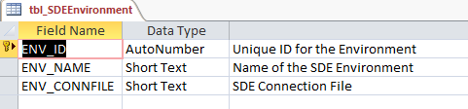

Figure 3 - ADM Entity
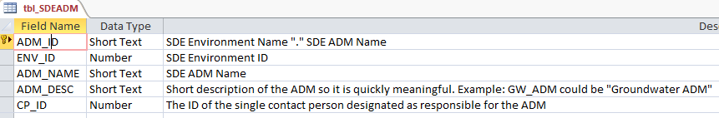

Figure 4 - Contact Person Entity
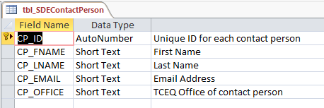

Figure 5 - Feature Class Entity
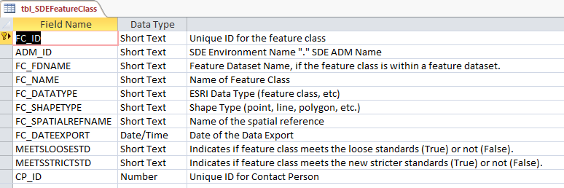

Figure 6 - Fields Entity
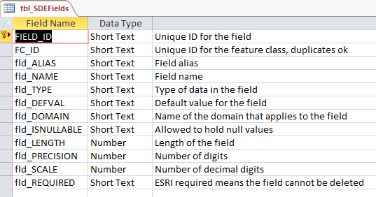

Figure 7 - Domains Entity
