Basic Physics-Light Nature

The Big Idea

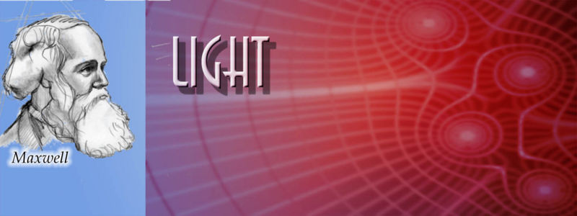

Figure Scottish theoretical physicist and mathematician

Light is a wave of changing electric and magnetic fields. Light waves are caused by disturbances in the ***electromagnetic field*** that permeates the universe, for example, the acceleration of charged particles (such as electrons). Light has a dual nature: at times, it acts like waves; at other times it acts like particles, called photons. x*2* H2O Light travels through space at the maximum speed allowed by the laws of physics, called the speed of light. Light has no mass, but it carries energy and momentum. Of ~~all possible paths~~ light rays will always take the path that takes the least amount of time (not distance). This is known as Fermat‘s Principle. **See:** *Jump to table 1*

Light, more generally known as *Electromagnetic Waves (****EM Waves****)*, can be produced in many different wavelengths that can be very large to extremely small. EM waves can be polarized when produced or after going through a filter (natural or man-made). Polarization of light, means that  the light wave oscillates in only one direction rather than unpolarized light that oscillates in two directions as it moves forward.

Key Concepts

Long blockquote which should span multiple lines - notice that this is different from **literallayout** below. This can have some inline formatting and it is not fixed width.

Literal text - this cannot have any special formatting  
 all spaces are preserved and line breaks are honored.   
 <emphasis role="strong">not bold text</emphasis>  
 formatting elements like the one above are not processed but rendered verbatim  
 more text

* Light is produced when **charged particles** accelerate. As a result changing electric and magnetic fields radiate outward. The traveling electric and magnetic fields of an accelerating (often oscillating) charged particle are known as electromagnetic radiation or light.
* The color of light that we observe is nothing more than the wavelength of the light:
  + the longer the wavelength, the redder the light.
* Light can have any wavelength at all. Our vision is restricted to a very narrow range of colors between red and violet.

1. Light is produced when **charged particles** accelerate. As a result changing electric and magnetic fields radiate outward. The traveling electric and magnetic fields of an accelerating (often oscillating) charged particle are known as electromagnetic radiation or light.
2. The color of light that we observe is nothing more than the wavelength of the light:
   1. the longer the wavelength, the redder the light.
3. Light can have any wavelength at all. Our vision is restricted to a very narrow range of colors between red and violet.

* Light is produced when **charged particles** accelerate. As a result changing electric and magnetic fields radiate outward. The traveling electric and magnetic fields of an accelerating (often oscillating) charged particle are known as electromagnetic radiation or light.
* The color of light that we observe is nothing more than the wavelength of the light:
  + the longer the wavelength, the redder the light.
* Light can have any wavelength at all. Our vision is restricted to a very narrow range of colors between red and violet.

Summary

**When light travels from one type of material (like air) into another (like glass), its speed is reduced due to interactions** between [**photons**](http://www.ck12.org/) and electrons. If the ray enters the material at an angle, [Fermat‘s Principle](http://www.ck12.org) dictates that the light will change the direction of its motion. This is called refraction. The figure to the right demonstrates the refraction a light ray experiences as it passes from air into a rectangular piece of glass and out again. Because light travels at slower than usual speed in transparent materials (due to constantly being absorbed and re-emitted), *this means that light doesn‘t always travel in a straight line.*

New para after emphasis



| header 1 | [header 2](http://www.google.com) |
| **1**,1 | 2,1 |
| 1,2 | 2,  2 |

Table Long caption

Jump to Figure 1 backref

energy level

One of the energies at which, according to quantum laws, atoms or nuclei may be found.

electron

Light elementary particle, negatively charged, found in all atoms.



{height: 315, class: youtube, internalid: 66, fileref: http://www.youtube.com/watch?v=qTXTDqvPnRk, width: 400, flashvars: http://www.youtube.com/watch?v=qTXTDqvPnRk}

Figure LYMPHATIC SYSTEM

Some math stuff below

\[\begin{align}
\sqrt {{a^2} + {b^2}} *3
\end{align}\]

Consider Einstein's famous equation: ${E = m * {c^2}}$. Here E is the amount of energy, m is mass and c is the constant speed of light.

\[\begin{align}
x + x &= 2\\ 2x &= 2\\ x &= 1
\end{align}\]