Variable Expressions

Learning Objectives

The International Day of the World's Indigenous People was first pronounced by the General Assembly of the United Nations in December 1994, to be celebrated every year during the first International Decade of the World's Indigenous People (1995 – 2004).  In 2004, the Assembly proclaimed a Second International Decade, from 2005 – 2015, with the theme of “A Decade for Action and Dignity.”[1] People from different nations are encouraged to participate in observing the day to spread the UN’s message on indigenous peoples. Activities may include educational forums and classroom activities to gain an appreciation and a better understanding of indigenous peoples.[2]

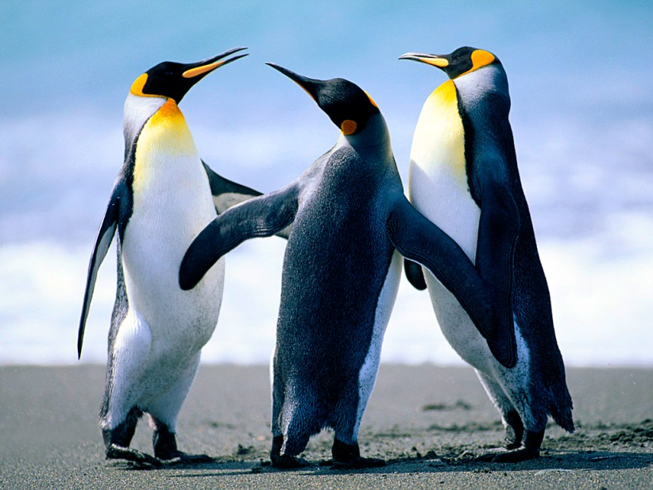

 By resolution 49/214 of 23 December 1994, the United Nations General Assembly decided that the International Day of the World's Indigenous People shall be observed on 9 August every year during the International Decade of the World's Indigenous People. The date marks the day of the first meeting, in 1982, of the UN Working Group on Indigenous Populations of the Subcommission on the Promotion and Protection of Human Rights.[3]

Header

Body

The International Day of the World's Indigenous People was first pronounced by the General Assembly of the United Nations in December 1994, to be celebrated every year during the first International Decade of the World's Indigenous People (1995 – 2004). In 2004, the Assembly proclaimed a Second International Decade, from 2005 – 2015, with the theme of “A Decade for Action and Dignity.”[1] People from different nations are encouraged to participate in observing the day to spread the UN’s message on indigenous peoples. Activities may include educational forums and classroom activities to gain an appreciation and a better understanding of indigenous peoples.[2]

A list and a table below:

1. One
2. Two
   1. Two, One

|  |  |
| --- | --- |
| r1c1 | r1c2 |

The International Day of the World's Indigenous People was first pronounced by the General Assembly of the United Nations in December 1994, to be celebrated every year during the first International Decade of the World's Indigenous People (1995 – 2004). In 2004, the Assembly proclaimed a Second International Decade, from 2005 – 2015, with the theme of “A Decade for Action and Dignity.”[1] People from different nations are encouraged to participate in observing the day to spread the UN’s message on indigenous peoples. Activities may include educational forums and classroom activities to gain an appreciation and a better understanding of indigenous peoples.[2]

By resolution 49/214 of 23 December 1994, the United Nations General Assembly decided that the International Day of the World's Indigenous People shall be observed on 9 August every year during the International Decade of the World's Indigenous People. The date marks the day of the first meeting, in 1982, of the UN Working Group on Indigenous Populations of the Subcommission on the Promotion and Protection of Human Rights.[3]

The International Day of the World's Indigenous People was first pronounced by the General Assembly of the United Nations in December 1994, to be celebrated every year during the first International Decade of the World's Indigenous People (1995 – 2004). In 2004, the Assembly proclaimed a Second International Decade, from 2005 – 2015, with the theme of “A Decade for Action and Dignity.”[1] People from different nations are encouraged to participate in observing the day to spread the UN’s message on indigenous peoples. Activities may include educational forums and classroom activities to gain an appreciation and a better understanding of indigenous peoples.[2]

Header (*link 2*)

Body

A list and a table below:

* One
* Two

|  |  |
| --- | --- |
| r1c1 | r1c2 |

By resolution 49/214 of 23 December 1994, the United Nations General Assembly decided that the International Day of the World's Indigenous People shall be observed on 9 August every year during the International Decade of the World's Indigenous People. The date marks the day of the first meeting, in 1982, of the UN Working Group on Indigenous Populations of the Subcommission on the Promotion and Protection of Human Rights.[3]