第五次上机作业

**18029100040**

**吴程锴**

# 作业 36：利用pyqt编写简单界面：

## 代码

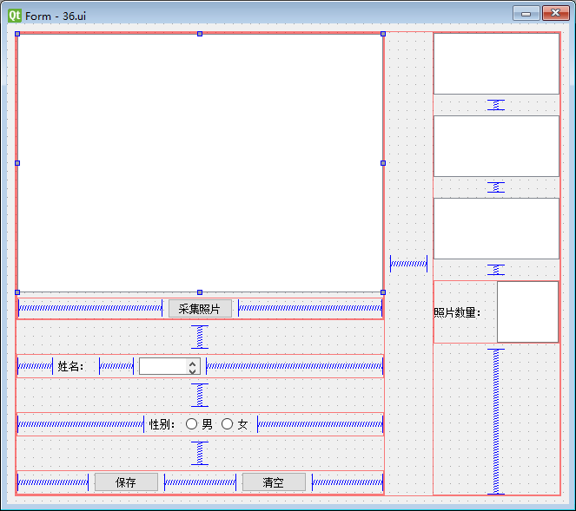

## 结果

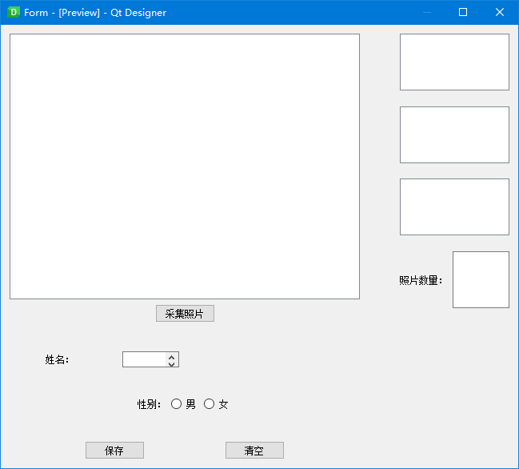

# 作业 37：利用pyqt编写简单界面的计算器：

## 代码

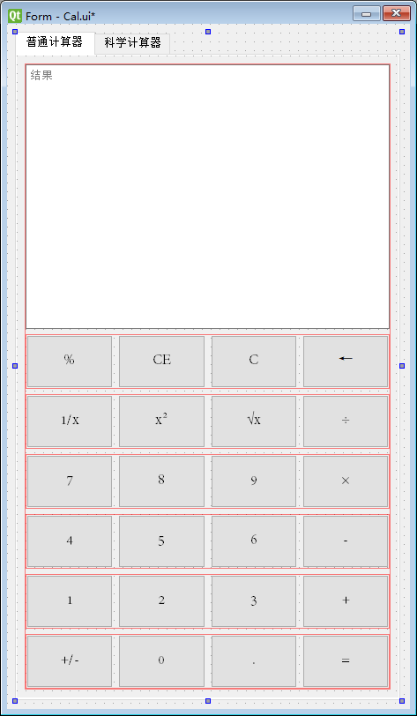

1. **from** PyQt5.QtWidgets **import** QApplication, QMessageBox
2. **from** PyQt5 **import** uic
4. **class** Stats:
6. **def** __init__(self):
7. self.ui = uic.loadUi('Cal.ui')
8. self.info = ''
10. self.ui.pushButton_C.clicked.connect(self.push_C)
11. self.ui.pushButton_CE.clicked.connect(self.push_C)
13. self.ui.pushButton_1.clicked.connect(self.push_1)
14. self.ui.pushButton_2.clicked.connect(self.push_2)
15. self.ui.pushButton_3.clicked.connect(self.push_3)
16. self.ui.pushButton_4.clicked.connect(self.push_4)
17. self.ui.pushButton_5.clicked.connect(self.push_5)
18. self.ui.pushButton_6.clicked.connect(self.push_6)
19. self.ui.pushButton_7.clicked.connect(self.push_7)
20. self.ui.pushButton_8.clicked.connect(self.push_8)
21. self.ui.pushButton_9.clicked.connect(self.push_9)
22. self.ui.pushButton_0.clicked.connect(self.push_0)
24. self.ui.pushButton_Plus.clicked.connect(self.push_Plus)
25. self.ui.pushButton_Reduce.clicked.connect(self.push_Reduce)
26. self.ui.pushButton_Multiply.clicked.connect(self.push_Multiply)
27. self.ui.pushButton_Divide.clicked.connect(self.push_Divide)
28. self.ui.pushButton_Modulus.clicked.connect(self.push_Modulus)
30. self.ui.pushButton_div_x.clicked.connect(self.push_div_x)
31. self.ui.pushButton_Square.clicked.connect(self.push_Square)
32. self.ui.pushButton_Sqrt.clicked.connect(self.push_Sqrt)
34. self.ui.pushButton_Del.clicked.connect(self.push_Del)
35. self.ui.pushButton_Minus.clicked.connect(self.push_Minus)
36. self.ui.pushButton_Point.clicked.connect(self.push_Point)
37. self.ui.pushButton_Equal.clicked.connect(self.push_Equal)
39. ###############################################################
40. self.ui.pushButton_Cal.clicked.connect(self.push_Cal)


44. **def** push_C(self):
45. self.ui.textBrowser_Cal.clear()
46. self.info = ''
47. ###############数字按钮
48. **def** push_1(self):
49. self.ui.textBrowser_Cal.insertPlainText('1')
50. self.info = self.info+'1'
51. **def** push_2(self):
52. self.ui.textBrowser_Cal.insertPlainText('2')
53. self.info = self.info + '2'
54. **def** push_3(self):
55. self.ui.textBrowser_Cal.insertPlainText('3')
56. self.info = self.info + '3'
57. **def** push_4(self):
58. self.ui.textBrowser_Cal.insertPlainText('4')
59. self.info = self.info + '4'
60. **def** push_5(self):
61. self.ui.textBrowser_Cal.insertPlainText('5')
62. self.info = self.info + '5'
63. **def** push_6(self):
64. self.ui.textBrowser_Cal.insertPlainText('6')
65. self.info = self.info + '6'
66. **def** push_7(self):
67. self.ui.textBrowser_Cal.insertPlainText('7')
68. self.info = self.info + '7'
69. **def** push_8(self):
70. self.ui.textBrowser_Cal.insertPlainText('8')
71. self.info = self.info + '8'
72. **def** push_9(self):
73. self.ui.textBrowser_Cal.insertPlainText('9')
74. self.info = self.info + '9'
75. **def** push_0(self):
76. self.ui.textBrowser_Cal.insertPlainText('0')
77. self.info = self.info + '0'
78. ###############加减乘除 取余
79. **def** push_Plus(self):
80. self.ui.textBrowser_Cal.insertPlainText('+')
81. self.info = self.info + '+'
82. **def** push_Reduce(self):
83. self.ui.textBrowser_Cal.insertPlainText('-')
84. self.info = self.info + '-'
85. **def** push_Multiply(self):
86. self.ui.textBrowser_Cal.insertPlainText('×')
87. self.info = self.info + '*'
88. **def** push_Divide(self):
89. self.ui.textBrowser_Cal.insertPlainText('÷')
90. self.info = self.info + '/'
91. **def** push_Modulus(self):
92. self.ui.textBrowser_Cal.insertPlainText('%')
93. self.info = self.info + '%'
95. ###############倒数 平方 开根号
96. **def** push_div_x(self):
97. self.info = eval(self.info)
98. self.info = str(1.0 / self.info)
99. self.ui.textBrowser_Cal.insertPlainText('\n')
100. self.ui.textBrowser_Cal.insertPlainText(self.info)
101. self.ui.textBrowser_Cal.moveCursor(self.ui.textBrowser_Cal.textCursor().End)
102. **def** push_Square(self):
103. self.info = eval(self.info)
104. self.info = str(self.info ** 2)
105. self.ui.textBrowser_Cal.insertPlainText('\n')
106. self.ui.textBrowser_Cal.insertPlainText(self.info)
107. self.ui.textBrowser_Cal.moveCursor(self.ui.textBrowser_Cal.textCursor().End)
108. **def** push_Sqrt(self):
109. self.info = eval(self.info)
110. self.info = str(self.info ** 0.5)
111. self.ui.textBrowser_Cal.insertPlainText('\n')
112. self.ui.textBrowser_Cal.insertPlainText(self.info)
113. self.ui.textBrowser_Cal.moveCursor(self.ui.textBrowser_Cal.textCursor().End)


117. **def** push_Del(self):
118. **if** (len(self.info)>0):
119. self.ui.textBrowser_Cal.insertPlainText('\n')
120. self.info = self.info[:-1]
121. self.ui.textBrowser_Cal.insertPlainText(self.info)
123. **def** push_Minus(self):
124. self.info = str(-eval(self.info))
125. self.ui.textBrowser_Cal.insertPlainText('\n')
126. self.ui.textBrowser_Cal.insertPlainText(self.info)
127. self.ui.textBrowser_Cal.moveCursor(self.ui.textBrowser_Cal.textCursor().End)
128. **def** push_Point(self):
129. self.ui.textBrowser_Cal.insertPlainText('.')
130. self.info = self.info + '.'
131. **def** push_Equal(self):
132. self.info = str(eval(self.info))
133. self.ui.textBrowser_Cal.insertPlainText('\n')
134. self.ui.textBrowser_Cal.insertPlainText(self.info)
135. self.ui.textBrowser_Cal.moveCursor(self.ui.textBrowser_Cal.textCursor().End)
136. self.ui.textBrowser_Cal.ensureCursorVisible()
138. **def** push_Cal(self):
139. info = self.ui.plainTextEdit.toPlainText()
140. info = str(eval(info))
141. self.ui.textBrowser_Sci.insertPlainText(info)
142. self.ui.textBrowser_Sci.insertPlainText('\n')
144. app = QApplication([])
145. stats = Stats()
146. stats.ui.show()
147. app.exec_()

## 结果

### 加

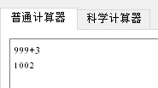

### 减

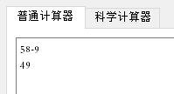

### 乘

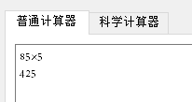

### 除

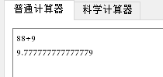

### 平方

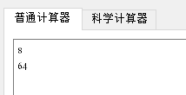

### 开方

