

# Designing Content for the DigitalLearn.org Audience



This is an introduction to designing courses for DigitalLearn.org, a website designed to support digital literacy instruction in public libraries.

If you’re watching this, you probably work in a library or other organization using DigitalLearn.org and are interested in designing your own e-Learning courses. If so, you’ve come to the right place.

For more information visit: www.digitallearn.org/about

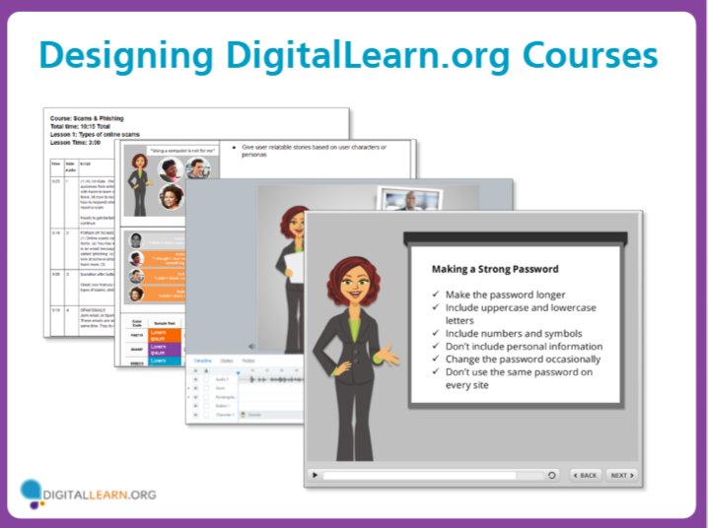

In this course, we’ll share our process for designing courses using our e-Learning storyboard template. We’ll share style guidelines for designing professional looking tutorials in Articulate Storyline, the software we use for DigitalLearn.org courses.

We will also go over recommended practices for designing effective e-Learning content specific to teaching basic digital skills to public library users. Throughout this course, we’ll share links to additional resources which you may find useful.

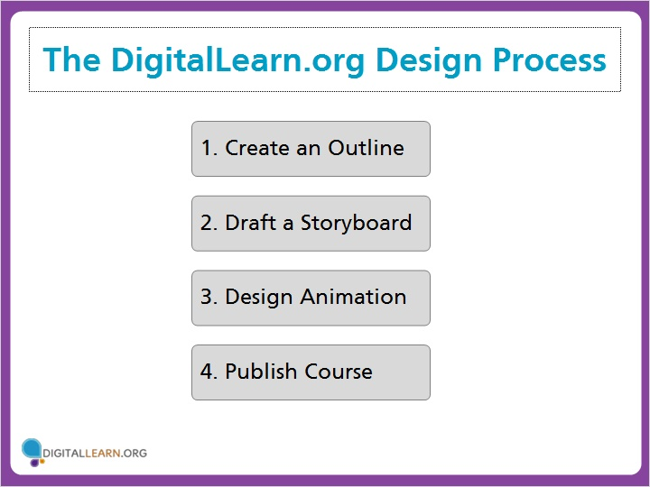

Let’s start by looking at the overall design process for DigitalLearn courses, start-to finish. Click the first step to get started.

The DigitalLearn.org Design Process:

1. Create an Outline
2. Draft a Storyboard
3. Design Animation
4. Publish Course

## Create an Outline

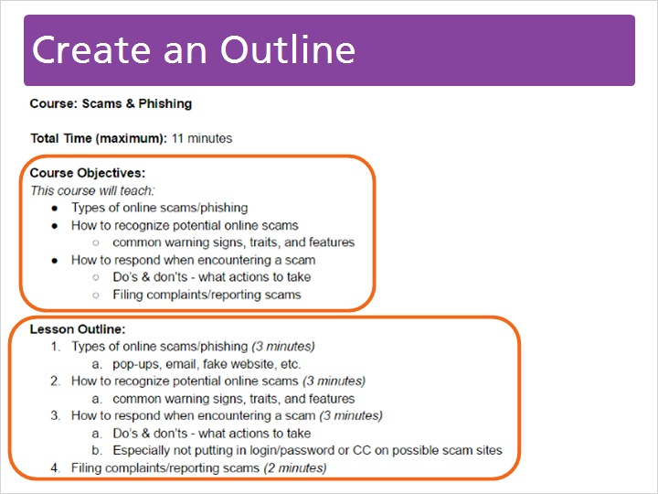

First, you should create an outline of the course. The outline should include course objectives to clarify what the course will teach. Be careful to limit the number of objectives to what is achievable in a short course.

Organize individual points in the course outline to form several short lessons (which are referred to as activities on DigitalLearn.org), and estimate the time that will be spent on each topic.

Most DigitalLearn courses are 10-15 minutes total, broken into several short lessons of 2-4 minutes each.

## Draft a Storyboard

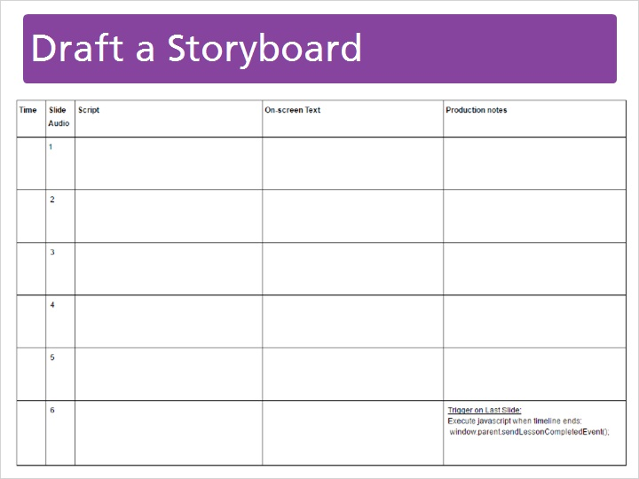

After the outline is complete, you can begin to draft a storyboard. The storyboard breaks up information into individual slides and includes a script and description of all the animation or interactive elements in the course.

We’ve created a standard e-Learning storyboard template, which is available to libraries creating DigitalLearn courses.

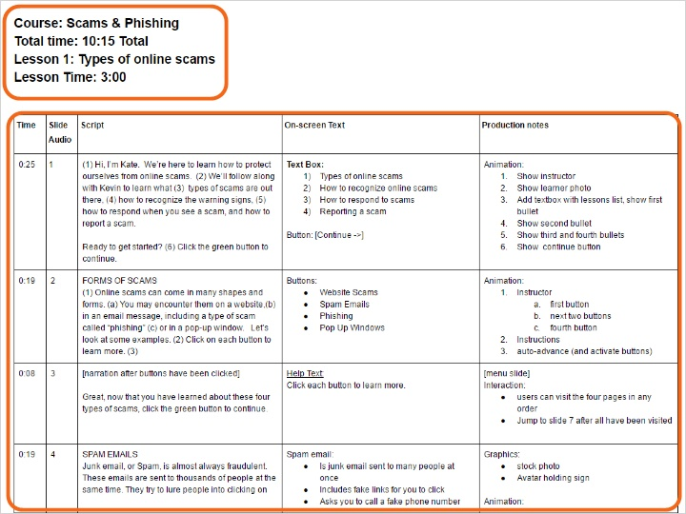

At the top of our storyboard, we keep track of the course and lesson titles and other important details about the course. Below that, our storyboard is divided into rows and columns. Click each column to learn more.

**Time:** This column tracks the time spent on each slide. To estimate this figure, practice reading the text out loud and use a stopwatch to estimate the time.

**Slide:** Use this column to number your slides. These numbers should correspond to the slide numbers in Articulate Storyline. You can use these numbers when labeling your audio tracks.

**Script:** You’ll use this column to draft the narration for the course. Numbers indicate cues for the animation to be added in the e-learning timeline.

**On-screen Text:** “On-screen Text” is used to keep track of any written text that appears, such as text boxes or menus.

**Production Notes:** The last column is used to describe animation and interactivity. You can include numerical cues in the narration to keep track of exactly when you want the animation to occur.

## Design Animation

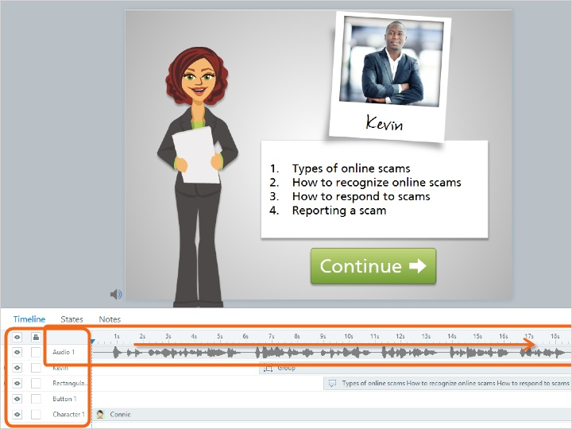

Once you have finished your storyboard, you’ll be ready to begin animating the course in Articulate Storyline. The animation is built out by creating slides and adding in graphic elements.

You’ll also be ready to record the audio narration, insert the audio into the animation, and set the timing of the animation.

## 6dTKBnN4Mor

DigitalLearn.org provides a template and style guide so you can create courses that will look similar to existing courses. This is an example from the Storyline Template we’ve created for you, which is available to libraries creating DigitalLearn courses.

The template is already configured to use the correct slide proportions and the same basic formatting.

A few sample slides are provided. You can copy these slides, or delete the ones you don’t need.

## 6eEJQc7I38r

The last slide in the template includes a trigger, which will load javascript on the DigitalLearn.org site to finish the lesson. It is important to include this on the last slide of your course. Instructions for creating the trigger are also included on the Storyboard Template.

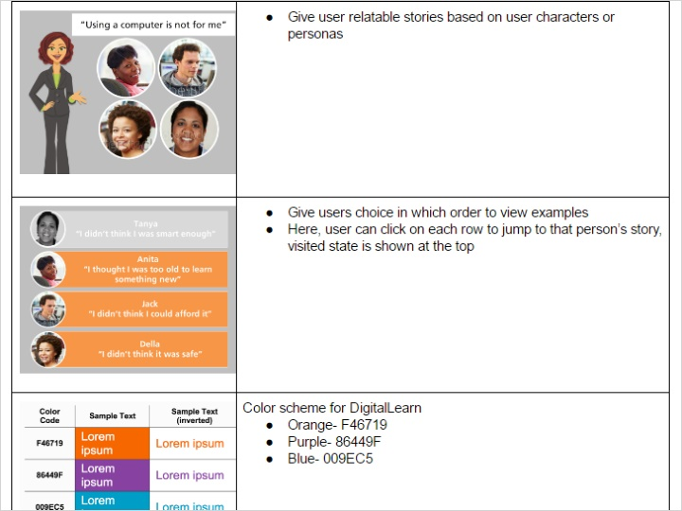

While you design your animation, refer to our Style Sheet for suggested format and design guidelines. Following these guidelines will keep courses visually consistent and make it easier for users to follow. The DigitalLearn style sheet is a document available to libraries creating DigitalLearn courses.

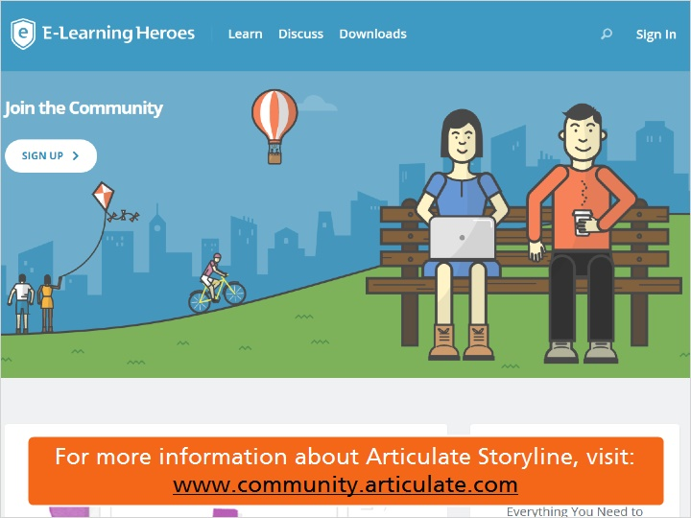

If you are new to using Articulate Storyline, we recommend the Articulate E-Learning Heroes as a great place to get started. Download free e-books and read blog posts containing tips from e-Learning experts.

For more information about Articulate Storyline, visit:

www.community.articulate.com

## Publish Course

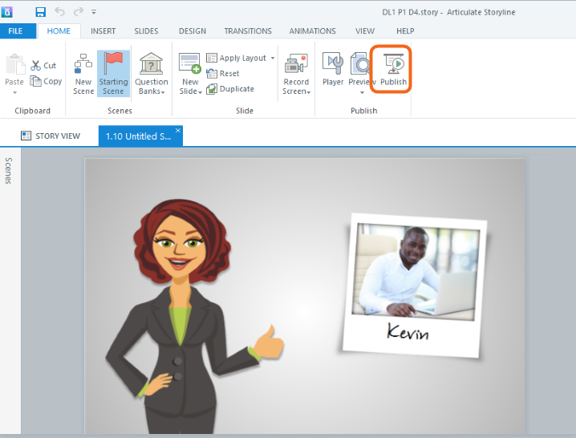

When you are finished creating a lesson, you will need to publish it as a ZIP file so that it can be uploaded to your DigitalLearn.org subsite or other website. Each lesson needs to be published as a separate file. Follow these instructions, which are also included in the Style Sheet.

First, click on “publish.”

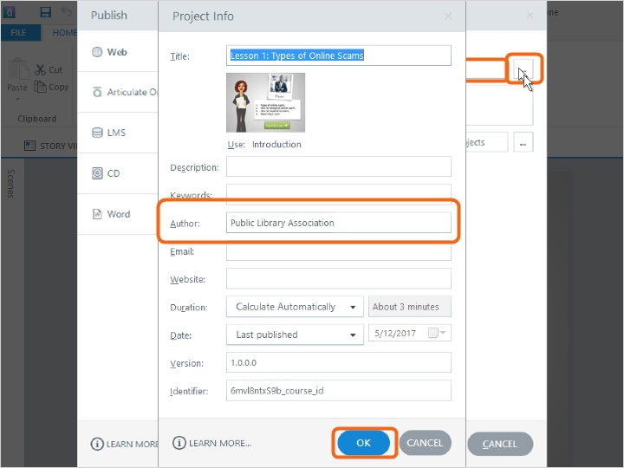

In the pop-up, enter the title of the lesson as you would like it to appear at the top of the player window.

You can expand the details to add additional project information, such as author, which may be your name or your library’s name. Click OK once you’ve edited the course information.

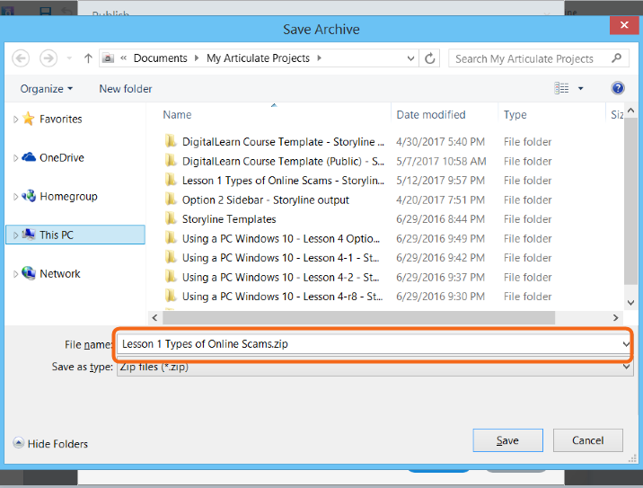

Next you’ll select a destination to save the file, and then click “Publish.” In the next pop-up click ZIP to also save the published files as a compressed folder which you will later upload to DigitalLearn.org.

Confirm or edit the file name for the ZIP file and click save.

If you are using an older version of Storyline, click the link on your screen for additional instructions.

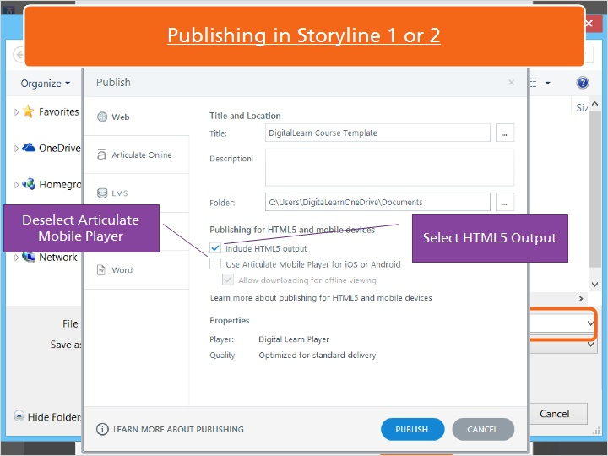

When publishing courses in Storyline 1 or 2, you need to make a few additional selections. Please select the box to “Include HTML5 output” and deselect the box to “Use Articulate Mobile Player” in order to remain consistent with DigitalLearn.org publishing standards.

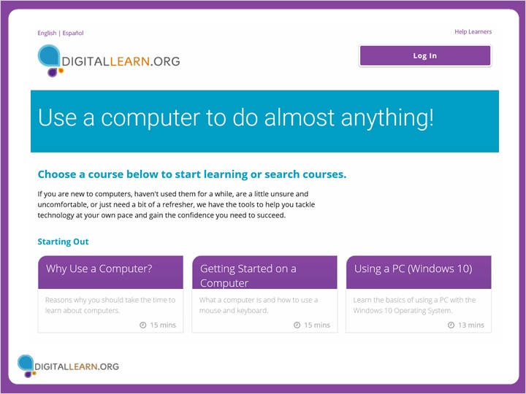

Once you’ve published your lessons, you are ready to upload them to your DigitalLearn.org subsite following the instructions you’ve received on how to add courses.

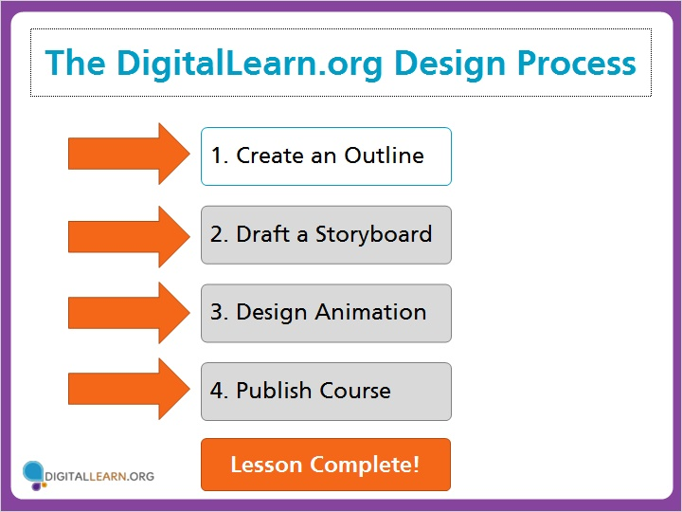

Now you’ve seen an overview of the design process. In the next lesson, we’ll look at design techniques for the DigitalLearn.org audience.

The DigitalLearn.org Design Process:

1. Create an Outline
2. Draft a Storyboard
3. Design Animation
4. Publish Course

Lesson Complete!