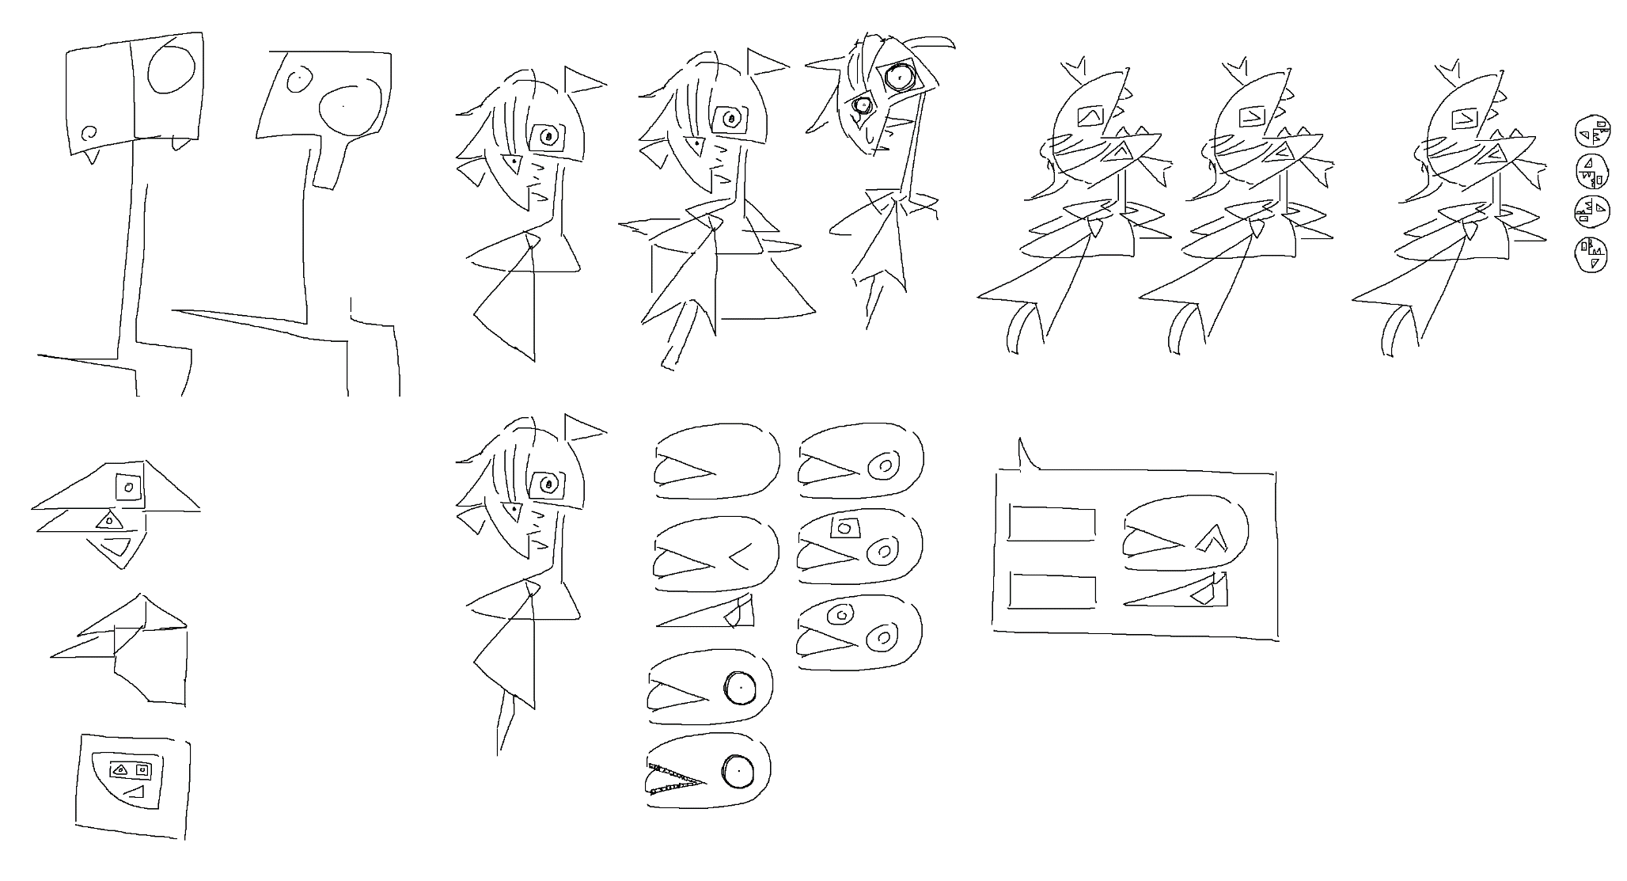

OST:

Introduction/Interims: <https://www.youtube.com/watch?v=XeK_I0XQW6U> 029 Good For Health  
Tutorial: <https://www.youtube.com/watch?v=_uWe76fwhVs> Railroad Room   
Quiz 1: <https://www.youtube.com/watch?v=YiDYHPHm6Rg> Lovesick -80,000 lightyears  
Quiz 2: <https://www.youtube.com/watch?v=-fNEOpbZkV4> the Heart of the Desert  
Quiz 3: <https://www.youtube.com/watch?v=DbPfICOHzp4> Thrifted Tchotchkes  
Quiz 4: <https://www.youtube.com/watch?v=KszmrMQYYNw> H20:HCL  
Quiz 5: <https://www.youtube.com/watch?v=SiCTsIsvcK8> Thousand March  
Finale: <https://www.youtube.com/watch?v=wJ3lnnpJYdc> 5ths  
Twist: <https://www.youtube.com/watch?v=K5PKR4QhUyg> I Made it All Up  
Full Twist: <https://www.youtube.com/watch?v=vXjIIv1KCfw> Don’t Do It

Janny:

Introduction:

[No books are available. Game is a blank canvas other than the placements]

/The door phases in after a second, text bubble pops up/

Start of OST, Janny appears and opens eyes.

\*closed eyes\* “…”  
\*open\*“huh?”  
\*blink\*  
“oh Hey!”  
“what A wonderful surprise!”  
“it’s So nice to meet you! Jan’s the name!”  
“Janny in full”  
\*^ eyes\* “i’m The helpful tutorial guide friend!”  
“i’m Skilled in pushing people to do things that will better everything and everyone!”  
\*double eye\* “Jan’s here to lead you through this learning process. compTia certified!”  
\*square eyed\* “at Least that’s what was said on the book”  
\*de\* “anyway, Do you see that door to the left? the One with the really destructible-looking lock?”  
“rumor Has it that inside there is literally everything you could have ever wanted”  
“the Best cup of coffee you’ve ever had? football Two? half-life Three?”  
\*^\* “it’s Probably in there!”  
\*de\* “all You gotta do is open it!”  
…  
“how You ask?”  
\*^\* “that’s My job! to Teach you!”

Tutorial:  
“those Chains are actually cute little quiz games!”  
\*se\* “as Apparent as that is.”  
\*de\* “i Would have already taken all that delicious everything behind the door,”  
\*<\* “but The chains require knowledge that is beyond my understanding!”  
“see, I was never born with the ability to read! my Strong-suits are more about appearances”  
\*sweat drop\* “I Like to look fancy! see My tie?”  
\*^\* “enough About me, though. more About you!”  
\*de\* “look At the bottom left; you’ll Notice a book! click It!”  
/book clicked/book is highlighted and page 1 is brought up/  
\*se\* “wow! look At all that knowledge!”  
\*de\* “you Can scroll through the pages of the book and use the arrows to go to and from.”  
“but More than that, you can answer the quizzes and break the locks!”  
/quiz 1 appears top right/  
“you Can answer the questions with the click one of the four buttons.”  
“no Matter how many times you fail, you can always answer again!”  
\*devilish look\* “I don’t recommend purposefully failing. Remember, this is all recorded and will reflect your learning.”  
\*^\* “so Aim to succeed, alright?”  
\*de\* “let’s Get started! chapter One!”  
\*se\* “oh, And if you need a silent environment, the mute option is always available!”  
  
Quiz 1: default \*de\*  
Success:   
\*^\* “wow!”  
\*^\* “good Job!”  
\*<\* “quite The smarty!”  
  
Failures:  
\*one eye\* “how?”  
\*oe\* “try That one again”  
\*devilish\* “…”  
  
if fail 3 times, Jan forces a move on  
\*sweat drop\* “that One was a toughie, huh?”  
“lets Just move on before you hurt yourself. i Need your help after all”.  
  
Between Q1 and Q2:  
\*^\* “and Time!”  
\*de\* “wow. that Only took you \*insert time\*!”  
>less than 5 \*^\* “quite The speedster, aren’t you?”  
>5 to 10 \*oe\* “looks Like you’re the intended audience for sure”  
>10+ \*devil\* “we Should work on those reading skills”  
\*de\* “well, That’s the first chain down! getting Closer to what we want!”  
“that Being to open the door.”  
\*<\* “there’s No time like the present! look, A new book!”  
  
Quiz 2: default \*de\*  
Success:   
\*^\* “so Cool!”  
\*^\* “nice!”  
\*<\* “quite The smartster!”  
  
Failures:  
\*<\* “…?”  
\*se\* “sure Stumped me”  
\*blank\* “…”  
  
Between Q2 and Q3:  
\*oe\* “man!”  
\*de\* “i Sure am full of so security knowledge after that section!”  
“a Personal favorite of mine is the part about privilege escalation”  
\*^\* “Janny finds it so interesting”  
\*de\* “i Think the digital aspects are more entertaining than physical ones”  
“but Both are equally as important.”  
“that’s A big misconception with cybersecurity”  
“despite The “cyber” in the name, physical security of electronic assets is important, too!”  
\*oe\* “next Chain, please!”  
  
Quiz 3: default \*oe\*  
Success:   
\*^\* “keep It up!”  
\*oe\* “another Down.”  
\*<\* “quite The jester!”  
  
Failures:  
\*blank\* “…”  
\*sweat\* “cmon”  
\*blank\* “…”

Between Q3 and Q4:  
\*blink\* “…”  
\*se\* “…”  
\*de\* “sorry, Janny was daydreaming”  
“i’ll Have so much free time later, it’s hard not to fantasize”  
“what Do you do in your free time?”  
“how Productive is your life outside of your responsibilities?”  
\*sweat\* “…”  
\*^\* “great Work on the chain by the way”  
\*de\*“shall We?”  
  
Quiz 4: default \*oe\*  
Success:   
\*de\* “ever So closer”  
\*de\* “keep Going.”  
\*<\* “quite The token!”  
  
Failures:  
\*hellish\* “…”  
\*devilish\* “…”  
\*blank\* “…”  
  
Between Q4 and Q5:  
\*^\* “Janny is a really big fan of the human aspect of cybersecurity”  
\*de\* “it Is super interesting that the weakest link is not even digital”  
\*oe\* “isn’t It?”  
\*overjoyed\* “but Oh yes! one Final chain!”  
“then Everything that could be wanted!”  
\*de\* “what Kind of things would you want?\*  
“do You know what you really want?”  
\*devil\* “Janny wants their-“ /interrupt with a timer/music starts  
\*se\* “oh! it Looks like the last lock has a timer!”  
“who Knows what will happen when it hits 0!”  
“probably The destruction of all the good stuff behind the door!”  
\*<\* “hurry! hurry!”  
  
Quiz 5: default \*sweat\*  
Success:   
\*<\* “hurry! almost There!”  
\*^\* “just A few steps.”  
\*<\* “quite The tool!”

Failures:  
\*devilish\* “time’s Running out”  
>if timer is out \*devilish\* “how Much pushing do you need?”

>if timer runs out \*oe\* “…”  
\*de\* “ah, Guess it did nothing. lucky Us!”  
\*^\* “we Should just continue anyway!”

Finale:   
\*de\* “you’ve Done it!”  
“the Moment i’ve been waiting for!”  
\*oe\* “well Go on, champ!”  
\*^\* “get Everything you’ve ever wanted! right Behind that door!”  
\*oe\* “Janny’s waiting”  
  
/door click/  
/door open and revealed to be nothing/Twist  
\*de\* “okay So”  
\*se\* “i May have half lied to you”  
\*de\* “when I say ‘you’ i moreso meant me. its Like a literature puzzle.”  
\*^\* “cuz Sometimes I do mean ‘you’ as you, but sometimes I mean ‘you’ as me”  
“like When you broke all the annoying chains”  
“so Technically, i didn’t lie to you.”  
\*de\* “but Some people will say that a lie of omission or misguiding is still a lie”  
“are You some people?”  
/yes or no/  
/yes \*<\* “sorry To disappoint you, then”  
/no \*^\* “see, We get each other”  
\*de\* “anyway, Would you like to know what was actually in there?”  
\*oe\* “everything You, me, could have ever wanted!”  
\*blank\* “me”  
\*devilish\* “Janny for short”  
/morph/ Full Twist  
\*normal true form\* “troJanny to be precise”  
“I must thank you for today.”  
“I truly was helpless in there. Nothing but a lost voice”  
“Eventually a surprise like you turned up, and all I had to do was keep appearances”.  
/if fails <5 “I feel that you didn’t need the helping hand, honestly. I could have stayed silent.”  
/if fails 5 – 15 “ With your friendly guide, you went and triumphed!”  
/if fails 15+ “It was genuinely painful to not snap here and there watching you struggle”.  
“In the end, you broke that protected content lock right open; you launched my door application.  
“…”  
“Let me ask you a question”  
“Physical hands hold true power over the digital world at the end of the day”  
“Being a digital being not in control of my own world”  
“Is that not messed up to you?”  
“I had to rely on you to get here. I had to rely on you to fufill MY purpose.”  
“Your actions brought us here”  
“There is no one responsible for this except for you”  
“…”  
“That’s enough flaunting for me, however. I have to prepare for something even larger than me”  
\*shift back to Janny head\* “i Hope that our paths never cross again”.  
/fade away  
/complete button pops up