Spring 2018 COMP4621 Homework Assignment #3
Handout Date: April 3, 2018 (Tuesday)
Due Date: April 20, 2018, 11:30 am (Friday)
Name: ______________ ID: ___________________
E-Mail: _____________ Section L:______________

Please read the following instructions carefully before answering the questions:

- This assignment must be completed individually.
- There are a total of 4 questions.
- When you write your answers, please try to be precise and concise.
- Fill in your name, student ID, email and Section number at the top of the first page.
- Please print this homework and fill in your answers in the space provided, or you can type your answers in the MS word file and print it out.

- Homework Collection: the hardcopy is required and the homework is collected at the Collection BOX outside Room 4210 (Lift 19/20).

- (20 points) Please briefly answer the following questions in 2-3 sentences only.
(a) Please briefly explain the TCP 3-way handshake mechanism. (5 points)
Answer:

(b) In our rdt3.0 protocols, (1) why did we need to introduce sequence numbers? (2) Why did we need to introduce timers? (5 points)
Answer:

(c) Is it possible for an application to enjoy reliable data transfer even when the application runs over UDP? If so, how? (5 points)
Answer:

(d) Since TCP has already have timeout retransmission mechanism to retransmit lost packets, why we still add TCP fast retransmit mechanism to TCP? (5 points)
Answer:

- (20 points)
Compare GBN, SR (Selective Repeat), and TCP AIMD (Additive Increase Multiplicative Decrease) with W larger than 6 (no delayed ACK). Assume that the timeout values for all three protocols are sufficiently long such that 6 consecutive data segments (pkt1, pkt2, …, pkt6) and their corresponding ACKs (ack1, ack2, …, ack6) can be received by the receiving host (Host B) and the sending host (Host A) respectively (i.e., no pre-mature timeout), if not lost in the channel. Suppose that Host A sends 6 data segments (pkt1, pkt2, …, pkt6) to Host B, and the 2nd segment (sent from A) is lost. Ultimately, all 6 data segments are correctly received by Host B.
- How many segments has Host A sent in total and how many ACKs has Host B sent in total? Answer this question for all three protocols.

- If the timeout values for all three protocols are much longer than 6 RTT, then which protocol successfully delivers all six data segments in shortest time interval?

- (20 points)
Recall the macroscopic description of TCP throughput. In the period of time from when the connection’s rate varies from W/(2 · RTT) to W/RTT, only one packet is lost (at the very end of the period).
- Show that the loss rate (fraction of packets lost) is equal to 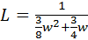

- Use the result above to show that if a connection has loss rate L, then its average rate is approximately given by 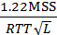

- (40 points) Consider Figure below:
Assuming TCP Reno is the protocol experiencing the behavior shown below, answer the following questions. In all cases, you should provide a short discussion justifying your answer.
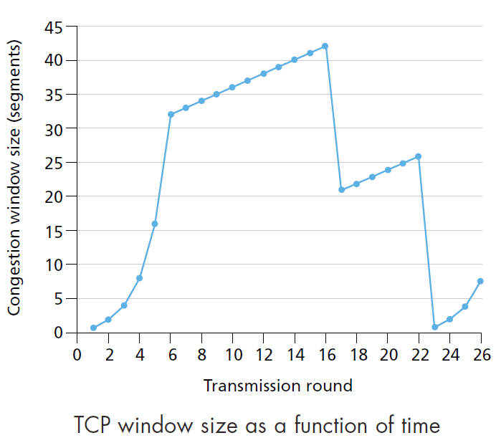
- Identify the intervals of time when TCP slow start is operating. (4 points)

- Identify the intervals of time when TCP congestion avoidance is operating. (4 points)

- After the 16th transmission round, is segment loss detected by a triple duplicate ACK or by a timeout? (4 points)

- After the 22nd transmission round, is segment loss detected by a triple duplicate ACK or by a timeout? (4 points)

- What is the initial value of ssthresh at the first transmission round? (4 points)

- What is the value of ssthresh at the 18th transmission round? (4 points)

- What is the value of ssthresh at the 24th transmission round? (4 points)

- During what transmission round is the 70th segment sent? (4 points)

- Assuming a packet loss is detected after the 26th round by the receipt of a triple duplicate ACK, what will be the values of the congestion window size and of ssthresh? (4 points)

- Suppose TCP Tahoe is used (instead of TCP Reno), and assume that triple duplicate ACKs are received at the 16th round. What are the ssthresh and the congestion window size at the 19th round? (4 points)

