

**HCMC UNIVERSITY OF TECHNOLOGY AND EDUCATION**

**FACULTY OF INFORMATION TECHNOLOGY**



**FINAL TERM PROJECT**

**Course name: Information Technology Project**

**Optimizing Web Hosting**

**Lecturer name:** Assoc. Prof. Hoang Van Dung

**List of members:**

|  |  |  |
| --- | --- | --- |
| **Student ID** | **Student name** | **Contribution (%)** |
| 21110058 | Cao Khai Minh | 100 |
| 21110777 | Dao Trung Kien | 100 |

*Ho Chi Minh City, 5/2024*

# Acknowledgement

First and foremost, our group would like to express our sincere gratitude to Lecturer Hoang Van Dung for the invaluable guidance and support provided throughout the last 15 weeks. Successfully completing this topic and report would not have been possible without such dedicated assistance. The teacher meticulously helped us identify and rectify our mistakes, guiding us towards perfecting our final project. Drawing from extensive teaching experience, the teacher offered precise advice and excellent suggestions, ensuring we met all necessary requirements. The thoughtful answers and practical guidance provided allowed us to make timely improvements and address our weaknesses effectively. This unwavering support was crucial in enabling us to complete the project successfully within the given timeframe and to meet the set standards.

The project was undertaken over a span of eight weeks. However, the introduction of a substantial amount of new knowledge, combined with less-than-optimal time management each week, inevitably led to some errors. We eagerly anticipate receiving comprehensive feedback to help us enhance our understanding and further refine our work. Our group recognizes that continuous improvement is vital, and we are committed to learning from our experiences to achieve better results in future endeavors. We deeply appreciate the teacher's commitment to our educational journey and the role played in helping us achieve our project goals.

# Content

Acknowledgement 2

Content 3

Abbreviations 5

Chapter 1. Project descriptions 6

1.1. Explanations of the project 6

1.2. Purposes and tasks 6

1.3. Scopes and objects 8

Chapter 2: Background knowledges 10

2.1. MySql 10

2.2. HTML and CSS 10

2.3. PHP 10

Chapter 3. Designs 11

3.1. Graphic User Interface 11

Chapter 4. Implementation, test results and discussions 14

4.. Environment and tools 14

Chapter 5: Conclusions 14

5.1. Self evaluation 14

5.2. Development ideas 15

References 17

# Abbreviations

1. Hypertext: text (often with embeds such as images, too) that is organized in order to connect related items

2. Markup: a style guide for typesetting anything to be printed in hardcopy or soft copy format

3. Language: a language that a computer system understands and uses to interpret commands.

4. CSS: Cascading Style Sheets

5. PHP: Hypertext Preprocessor

6. MySQL: Structured Query Language

# Chapter 1. Project descriptions

## 1.1. Explanations of the project

In web development, creating user-friendly and efficient applications is a universal challenge. A typical web application consists of an interface (UI), interactive elements (with actions and states), a data management system, and a set of functionalities that transform user actions into desired outcomes. Many web applications, such as social media platforms, online stores, and productivity tools, involve managing and displaying data in an intuitive way. Out of these applications, our group found that developing a Google Drive clone is an intriguing project due to its complexity and the unique way it manages and organizes files.

Google Drive is a cloud storage service where users can upload, store, and manage files in an organized manner. The objective of our project is to replicate the core features of Google Drive using HTML and CSS. Users should be able to upload files, create folders, and navigate through their files and folders within a visually appealing and responsive interface.

## 1.2. Purposes and tasks

Purposes:

- Educational Advancement:

+ Enhance our knowledge and skills in web development using HTML and CSS.

+ Understand the principles of responsive design and user interface (UI) creation.

- Practical Application:

+ Develop a functional web application that simulates the core features of Google Drive.

+ Apply theoretical knowledge to a real-world project, bridging the gap between learning and practice.

- User Experience Focus:

+ Create an intuitive and visually appealing interface that improves user interaction and satisfaction.

+ Implement user-friendly features to make file management easy and efficient.

- Problem-Solving:

+ Address challenges related to file management, responsive design, and user navigation.

+ Develop solutions to common web development issues, such as layout adjustments and visual feedback mechanisms.

Tasks:

- Designing the User Interface:

+ Task: Create the main layout of the personal drive, including the dashboard, navigation bar, and sidebar.

+ Outcome: A visually structured and cohesive interface that resembles Google Drive.

- Implementing File Upload and Management:

+ Task: Develop functionality for users to upload files through buttons and drag-and-drop.

+ Outcome: Users can seamlessly upload, rename, delete, and organize files into folders.

- Ensuring Responsive Design:

+ Task: Use CSS media queries and flexible grid systems to ensure the application is responsive across different devices.

+ Outcome: The interface works optimally on desktops, tablets, and smartphones.

- Developing Visual Feedback Mechanisms:

+ Task: Implement visual cues for user actions, such as highlighting selected items and displaying upload progress.

+ Outcome: Enhanced user experience through clear and immediate feedback on interactions.

- Creating Navigation Features:

+ Task: Implement easy navigation through breadcrumbs and a sidebar menu.

+ Outcome: Users can efficiently navigate through their files and folders.

- Testing and Debugging:

+ Task: Rigorously test the application to identify and fix any bugs or issues.

+ Outcome: A stable and reliable application with smooth functionality.

By fulfilling these purposes and completing these tasks, our project aims to deliver a robust and user-friendly Google Drive clone that not only demonstrates our web development capabilities but also provides a practical solution for file management.

## 1.3. Scopes and objectives

Scopes:

· **File Upload and Management**: Users will be able to upload files, create folders, rename items, and delete files and folders.

· **User Interface**: Design and implement an intuitive UI that mirrors the layout and style of Google Drive.

· **Responsive Design**: Ensure the application functions well on various devices, including desktops, tablets, and smartphones.

· **Visual Feedback**: Provide users with visual feedback for their actions, such as highlighting selected items and displaying progress indicators for uploads.

· **Navigation**: Develop easy-to-use navigation tools including a sidebar menu, breadcrumbs, and a top navigation bar with search functionality.

Objectives:

· **Develop a User-Friendly Interface**:

+ Create a layout that is easy to navigate, visually appealing, and intuitive for users of all skill levels.

+ Ensure the UI elements, such as buttons and menus, are consistent with the design principles of Google Drive.

· **Implement Core File Management Features**:

+ Allow users to upload files and create folders through an intuitive drag-and-drop interface or upload button.

+ Enable basic file operations such as renaming, deleting, and moving files and folders.

**· Ensure Responsive Design**:

+ Use media queries and responsive design techniques to make sure the application works seamlessly on various screen sizes.

+ Optimize the layout and functionality for both touch and non-touch devices.

**· Provide Visual Feedback**:

+ Integrate visual indicators for user actions to improve the user experience.

+ Highlight selected items, show upload progress, and provide clear notifications for completed actions.

**· Facilitate Easy Navigation**:

+ Implement a sidebar menu and breadcrumbs for easy access to different sections of the application.

+ Include a search functionality in the top navigation bar to help users quickly find files and folders.

**· Test and Refine the Application**:

+ Conduct thorough testing to identify and resolve any bugs or issues.

+ Refine the application based on user feedback to ensure it meets usability standards.

# Chapter 2: Background knowledge

## 2.1. MySql

MySQL is an open-source, Relational Database Management System that stores data in a structured format using rows and columns. It’s software that enables users to create, manage, and manipulate databases. Developed by MySQL AB, which is now owned by Oracle Corporation, MySQL is renowned for its reliability, scalability, and ease of use.

## 2.2. HTML and CSS code

HTML (Hypertext Markup Language): HTML is the standard markup language used to create the structure and content of web pages. It consists of a series of elements or tags that define the different parts of a webpage, such as headings, paragraphs, images, links, and forms. HTML provides the basic structure for a webpage, organizing its content in a hierarchical manner.

CSS (Cascading Style Sheets): CSS is a style sheet language used to describe the presentation of a document written in HTML. It allows developers to control the layout, appearance, and formatting of HTML elements across multiple web pages. With CSS, developers can specify properties such as colors, fonts, margins, padding, and positioning to create visually appealing and consistent designs. CSS works by selecting HTML elements and applying styles to them, either inline, within a <style> tag in the HTML document, or externally in a separate CSS file.

## 2.3. PHP

PHP (Hypertext Preprocessor) is a server-side scripting language commonly used for web development. It is embedded within HTML code and executed on the server, generating dynamic web pages. PHP code is typically processed by a web server with a PHP processor module, which interprets the PHP code and generates HTML content to be sent to the client's web browser.

Here are some key aspects of PHP:

- Dynamic Web Content: PHP allows developers to create dynamic web pages that can generate content on-the-fly, interact with databases, handle form data, and perform other server-side tasks.

- Embedding in HTML: PHP code is embedded directly into HTML documents using special delimiters (<?php and ?>). This allows developers to mix PHP code with HTML markup seamlessly, making it easy to generate dynamic content within static HTML templates.

- Database Interaction: PHP can interact with various databases, including MySQL, PostgreSQL, SQLite, and others. It enables developers to perform database queries, insert, update, and delete records, and retrieve data to be displayed on web pages.

- Server-Side Processing: PHP runs on the server side, meaning that the PHP code is executed on the web server before the resulting HTML is sent to the client's browser. This allows for secure processing of sensitive data and dynamic content generation.

- Extensive Functionality: PHP comes with a vast standard library and numerous built-in functions for handling strings, arrays, files, dates, and more. Additionally, there is a large ecosystem of third-party libraries and frameworks available for PHP development, such as Laravel, Symfony, and CodeIgniter.

Overall, PHP is a powerful and versatile scripting language widely used for developing dynamic websites, web applications, and web services. It is known for its ease of use, flexibility, and broad support across different web hosting platforms and operating systems.

# Chapter 3. Designs

## 3. Graphic User Interface

Personal Drive consists of 3 pages: Main page, Login and Sign up page.

### *3.1.* Login *page*

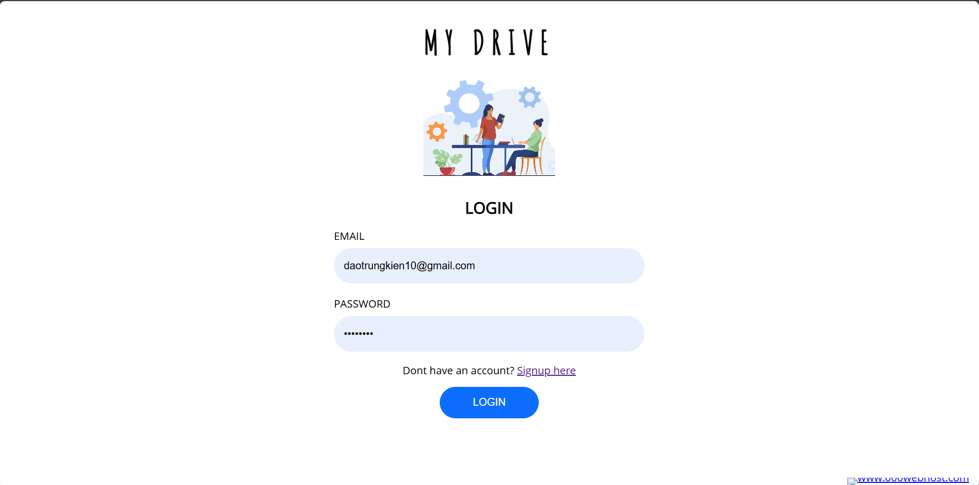

*Figure 1 - The Login page*

The login page presents users with a simple and intuitive interface to access their account. It consists of the following elements:

- Header: The top section of the page contain the website or application logo along with a navigation menu or links to other pages.

- Login Form:

+ Email Field: Users can enter their Gmail address in this field.

+ Password Field: Users can enter their password to authenticate their identity.

+ Sign In Button: Initiates the login process when clicked.

Footer: The bottom section of the page contain links to privacy policy, terms of service, contact information, and other relevant resources.

Functionality:

- Authentication: Upon submission of the login form, the entered Gmail address and password are validated against the stored credentials in the system. If the credentials match, the user is authenticated and granted access to their account.

- Error Handling: If invalid credentials are entered or any other authentication-related errors occur, appropriate error messages are displayed to the user, prompting them to correct their input or take necessary actions to resolve the issue.

- Accessibility and Usability:

+ Responsive Design: The login page is designed to be mobile-friendly and accessible across a variety of devices and screen sizes.

+ User-Friendly Interface: The interface is designed with usability in mind, featuring clear instructions, intuitive form fields, and helpful error messages to guide users through the login process.

### 3.2. The sign up page

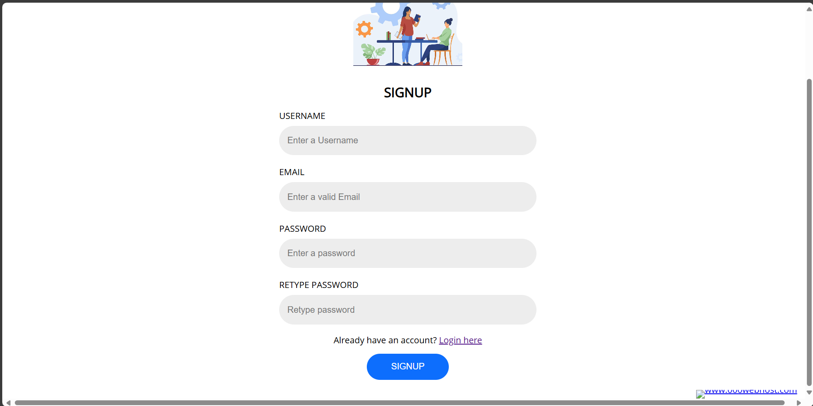

The sign-up page provides new users with a streamlined process to create an account. It consists of the following elements:

- Header: Similar to the login page, the header may contain the website or application logo along with navigation links.

- Registration Form:

+ Username Field: Users can enter their full username.

+ Email Field: Users can enter their Gmail address.

+ Password Field: Users can create a password to secure their account.

+ Confirm Password Field: Users must re-enter their password to ensure accuracy.

+ Sign-Up Button: Initiates the registration process when clicked.

+ Footer: Similar to the login page, the footer may contain links to privacy policy, terms of service, contact information, and other relevant resources.

- Functionality:

+ User Registration: Upon submission of the registration form, the entered information is validated to ensure completeness and accuracy. If the information provided meets the required criteria, a new user account is created.

+ Error Handling: If any errors occur during the registration process, such as incomplete fields or mismatched passwords, appropriate error messages are displayed to prompt users to correct their input.

- Accessibility and Usability:

+ Responsive Design: The sign-up page is designed to be mobile-friendly and accessible across various devices and screen sizes.

+ User-Friendly Interface: The interface is designed with usability in mind, featuring clear instructions, intuitive form fields, and helpful error messages to guide users through the sign-up process.

### 3.3 Main page

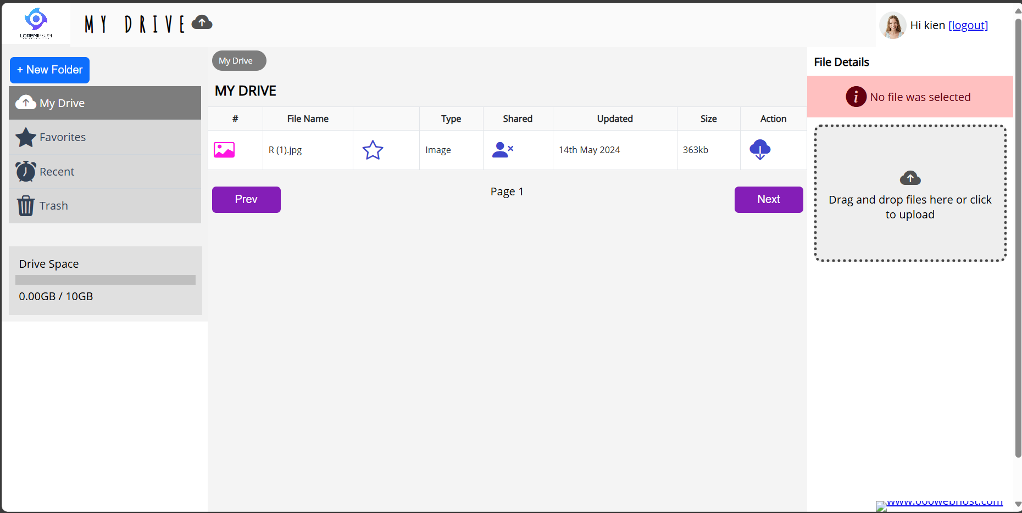

Main Page has 4 controls: 4 buttons.

* New Folder: create a new folder on the drive to store your stuff.
* Prev and Next: Go to the previous/next page of your drive.
* Action: Download the uploaded file.

# Chapter 4. Implementation

## 4.1. Environment and tools

- IDE: Visual Studio Code.

- Language: HTML and CSS.

# Chapter 5: Conclusions

## 5.1. Self evaluation

What Went Well:

- Functionalities Implemented: The core functionalities of Google Drive, such as file upload, folder creation, and basic file management, were successfully implemented.

- Responsive Design: The application was designed to be responsive, ensuring a seamless user experience across different devices and screen sizes.

- User Interface: The user interface closely resembled that of Google Drive, providing users with a familiar and intuitive environment for managing their files.

Areas for Improvement:

- Error Handling: Although basic error handling was implemented, more robust error handling mechanisms could have been incorporated to provide users with clearer feedback in case of errors or invalid inputs.

- Security Considerations: While password hashing and SSL encryption were mentioned in the project description, a more detailed approach to security, such as implementing additional measures like CSRF protection and input validation, could have been explored.

- Testing and Debugging: While testing was conducted to identify and resolve bugs, a more comprehensive testing strategy, including unit tests, integration tests, and user acceptance testing, could have been employed to ensure the reliability and stability of the application.

- User Feedback: Gathering feedback from users during the development process and incorporating it into iterative improvements could have further enhanced the usability and effectiveness of the application.

Lessons Learned:

- Importance of Planning: Proper planning, including defining requirements, establishing clear objectives, and outlining a development roadmap, is crucial for the success of a project.

- Continuous Learning: Web development technologies and best practices are constantly evolving, emphasizing the need for continuous learning and staying updated with the latest trends and developments.

- Collaboration and Communication: Effective collaboration and communication among team members are essential for coordinating efforts, resolving issues, and achieving project goals efficiently.

- Iterative Improvement: Adopting an iterative approach to development allows for flexibility, adaptability, and continuous improvement based on feedback and changing requirements.

## 5.2. Development ideas

- Real-Time Collaboration: Implement real-time collaboration features that allow multiple users to edit and view documents simultaneously, similar to Google Docs.

- Advanced Search Functionality: Enhance the search functionality to include advanced filters, sorting options, and keyword highlighting for improved file discovery.

- File Versioning: Introduce file versioning capabilities, allowing users to track changes made to documents over time and revert to previous versions if needed.

- Offline Access: Enable offline access to files by implementing local caching and synchronization mechanisms, allowing users to access and edit documents even without an internet connection.

- Customizable User Interface: Provide users with the ability to customize the interface by choosing themes, layouts, and display options tailored to their preferences.

- Integration with Third-Party Apps: Integrate with popular productivity tools and services, such as Microsoft Office, Adobe Creative Cloud, or project management platforms, to streamline workflow and enhance productivity.

- File Sharing Enhancements: Enhance file sharing capabilities by adding more granular permissions settings, expiration dates for shared links, and the ability to set access restrictions based on user roles or groups.

- Advanced Security Features: Implement additional security measures such as two-factor authentication, encryption at rest, and data loss prevention policies to safeguard user data and enhance privacy.

- File Previews and Thumbnails: Generate file previews and thumbnails for supported file types, allowing users to preview documents, images, and videos without downloading them.

- Integration with Cloud Storage Providers: Offer seamless integration with other cloud storage providers, allowing users to access files stored on platforms like Dropbox, OneDrive, or Box within the Google Drive clone interface.

- Task Management Integration: Integrate with task management tools like Trello or Asana to enable users to create tasks, assign deadlines, and link relevant files directly from the Google Drive interface.

- File Analytics and Insights: Provide users with insights into their file usage, such as the number of views, downloads, and edits, as well as storage usage statistics and recommendations for optimizing storage space.

- Mobile App Development: Develop companion mobile applications for iOS and Android devices, offering users the flexibility to access and manage their files on the go.

- Accessibility Features: Ensure the application is accessible to users with disabilities by incorporating accessibility features such as screen reader compatibility, keyboard navigation, and high-contrast themes.

- Community Collaboration: Foster community collaboration by allowing users to contribute feedback, suggest new features, and participate in beta testing programs to shape the future direction of the project.

These development ideas can help elevate the Personal Drive project to the next level by adding new features, improving existing functionality, and enhancing the overall user experience. Each idea can be prioritized based on user feedback, market demand, and the project's development roadmap.

# References