**Steps**

1. **Build Docker Image name as welcome-app**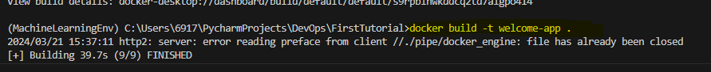
2. **Check the details of the Docker Images**

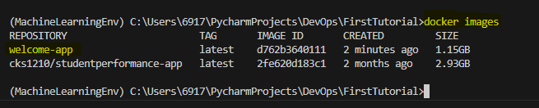

1. **Run the Docker Image**

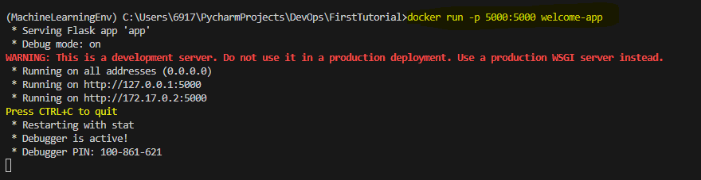

1. **To check how many containers are running**

**0.0.0.0:5000->5000/tcp This means that accessing from Host 5000 to container 5000**

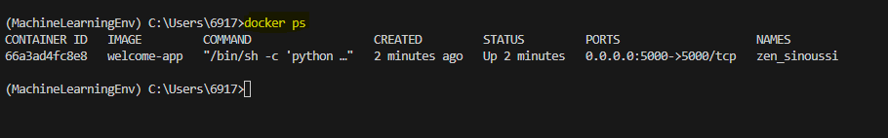

1. **In Docker Desktop, we can see that Docker and containers are running**

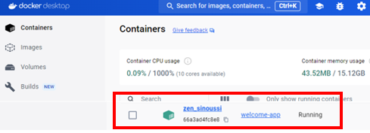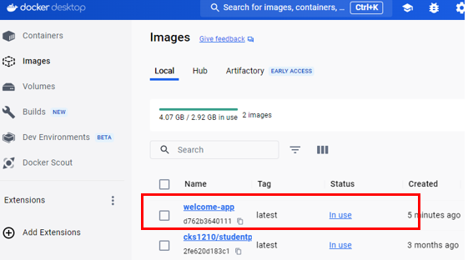

1. **Stop the container by using command docker stop [container id]**

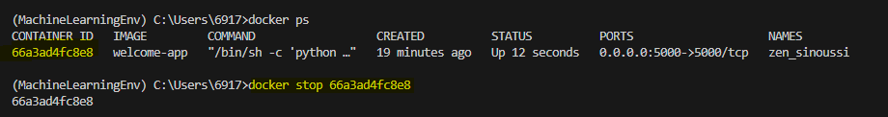

1. **Push the docker container into Docker Hub Repository**

**First of all, login to the Docker Hub**

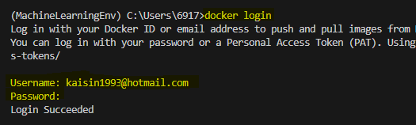

1. **Rename the docker image**

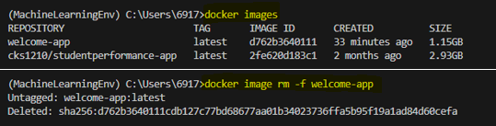

**Check the Docker Images and Welcome-app docker images are removed!**

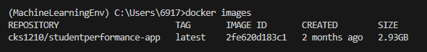

1. **Rebuild the Docker Images by adding the cks1210**

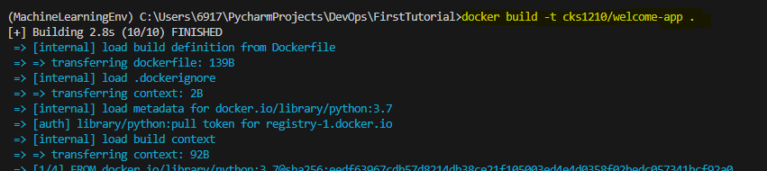

1. **Docker image is successfully built**

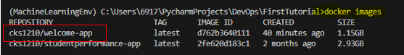

1. **Change the Image name from cks1210/welcome-app to cks1210/first-docker**

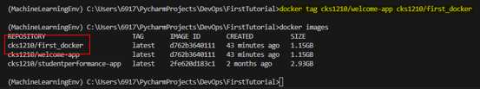

1. **Push the image to Docker Hub Repositories**

**Latest is the TAG**

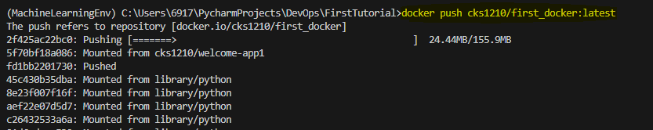

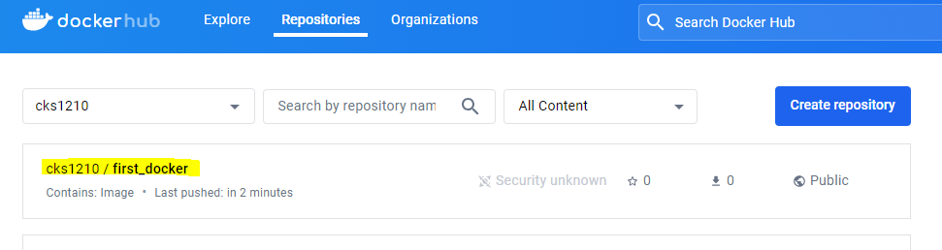

1. **Remove the docker image**

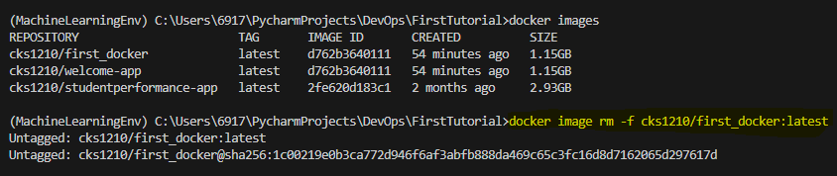

**try to pull**

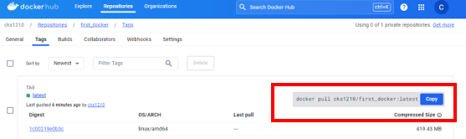

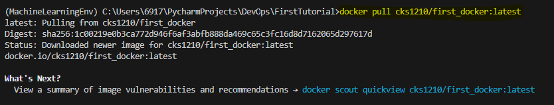

1. Run the docker

