Eleven’s Input Ports

(used to connect sensors to the EV3 Brick)

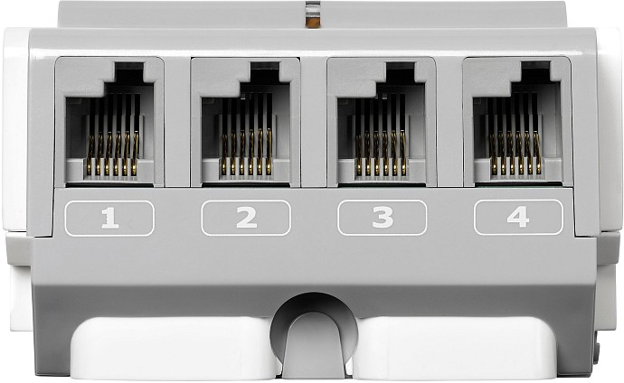

Eleven’s Output Ports

(used to connect motors to the EV3 Brick)

