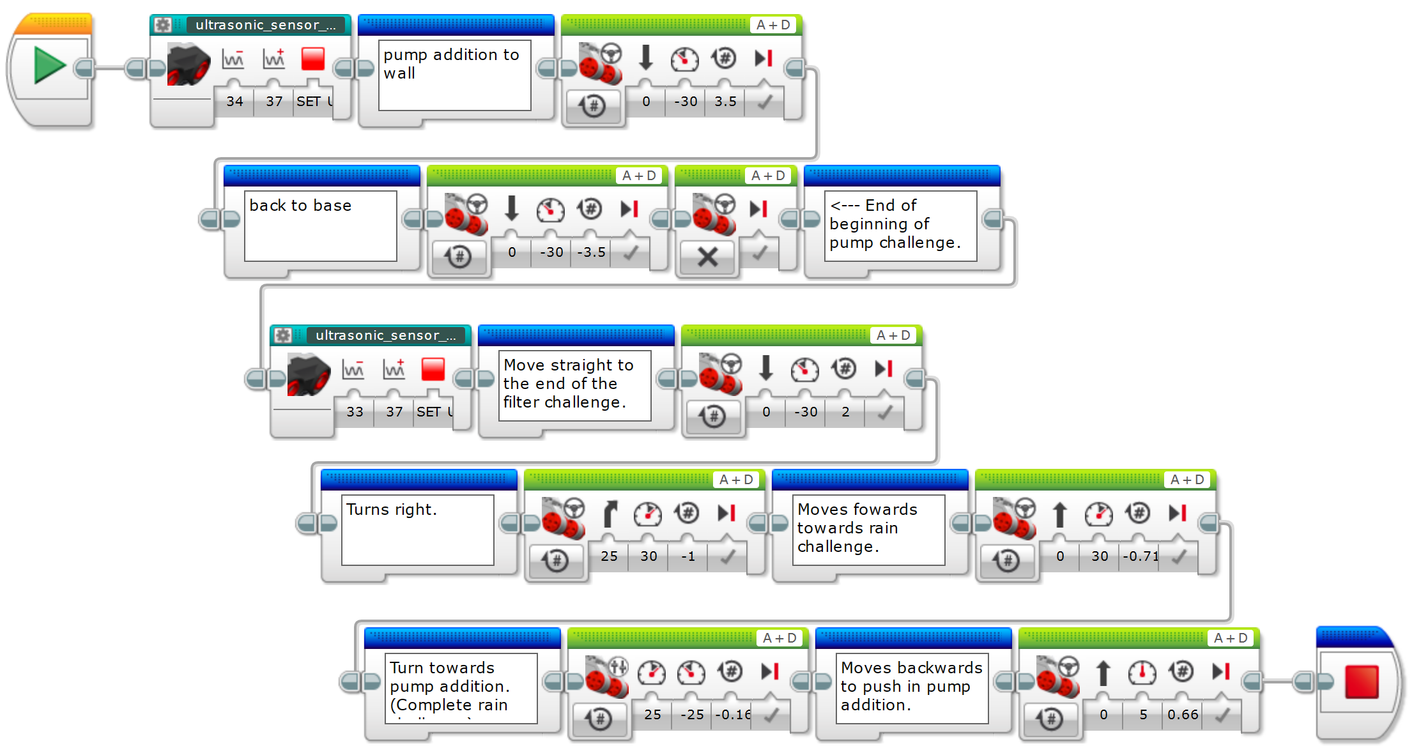

M03 – Pump Addition (20 points) M04 – Rain (20 points)

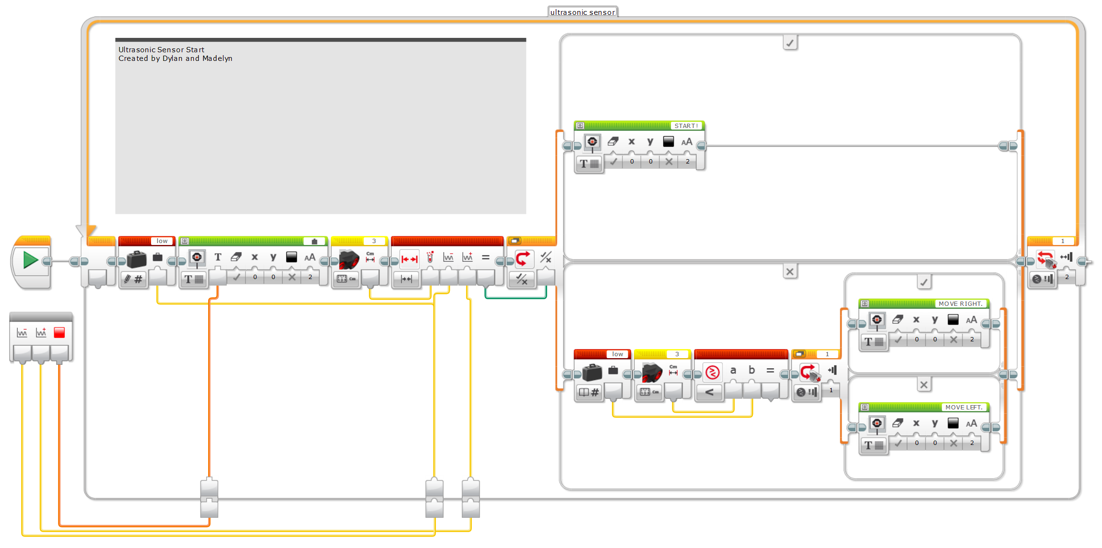

Ultra-Sonic Sensor Start Block

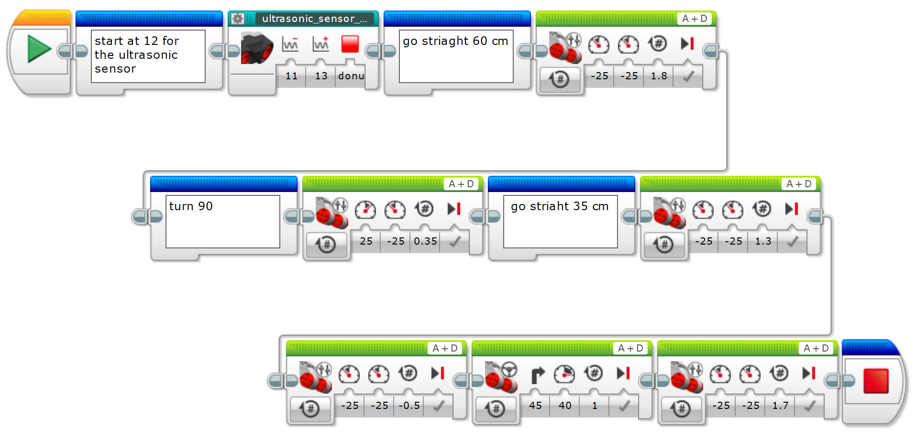

M05 – Filter (30 points)

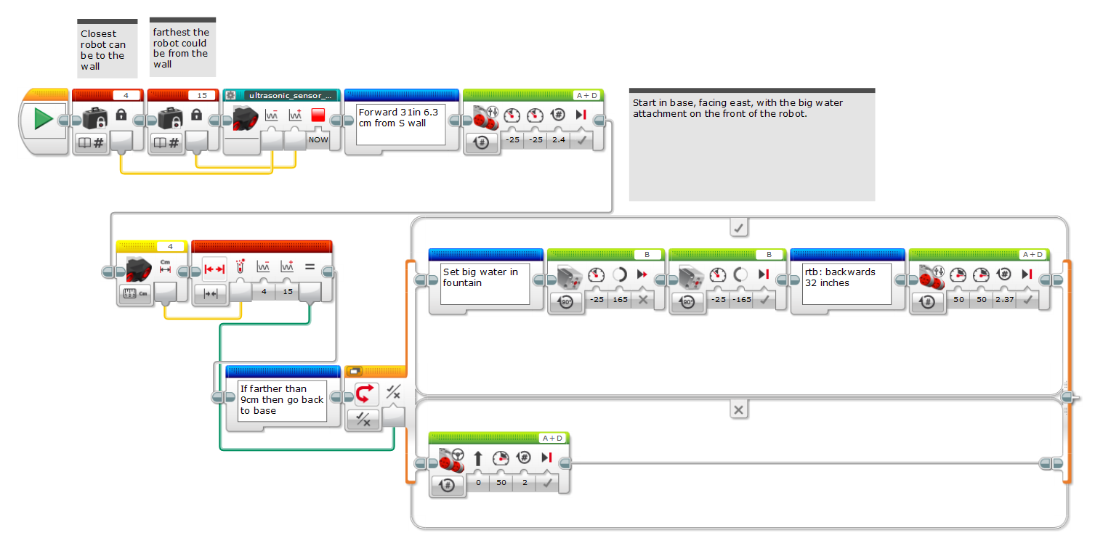

M07 – Fountain (20 points)