signup to dynatrace using company mailid
login
search for OneAgent and click setup
Install OneAgent
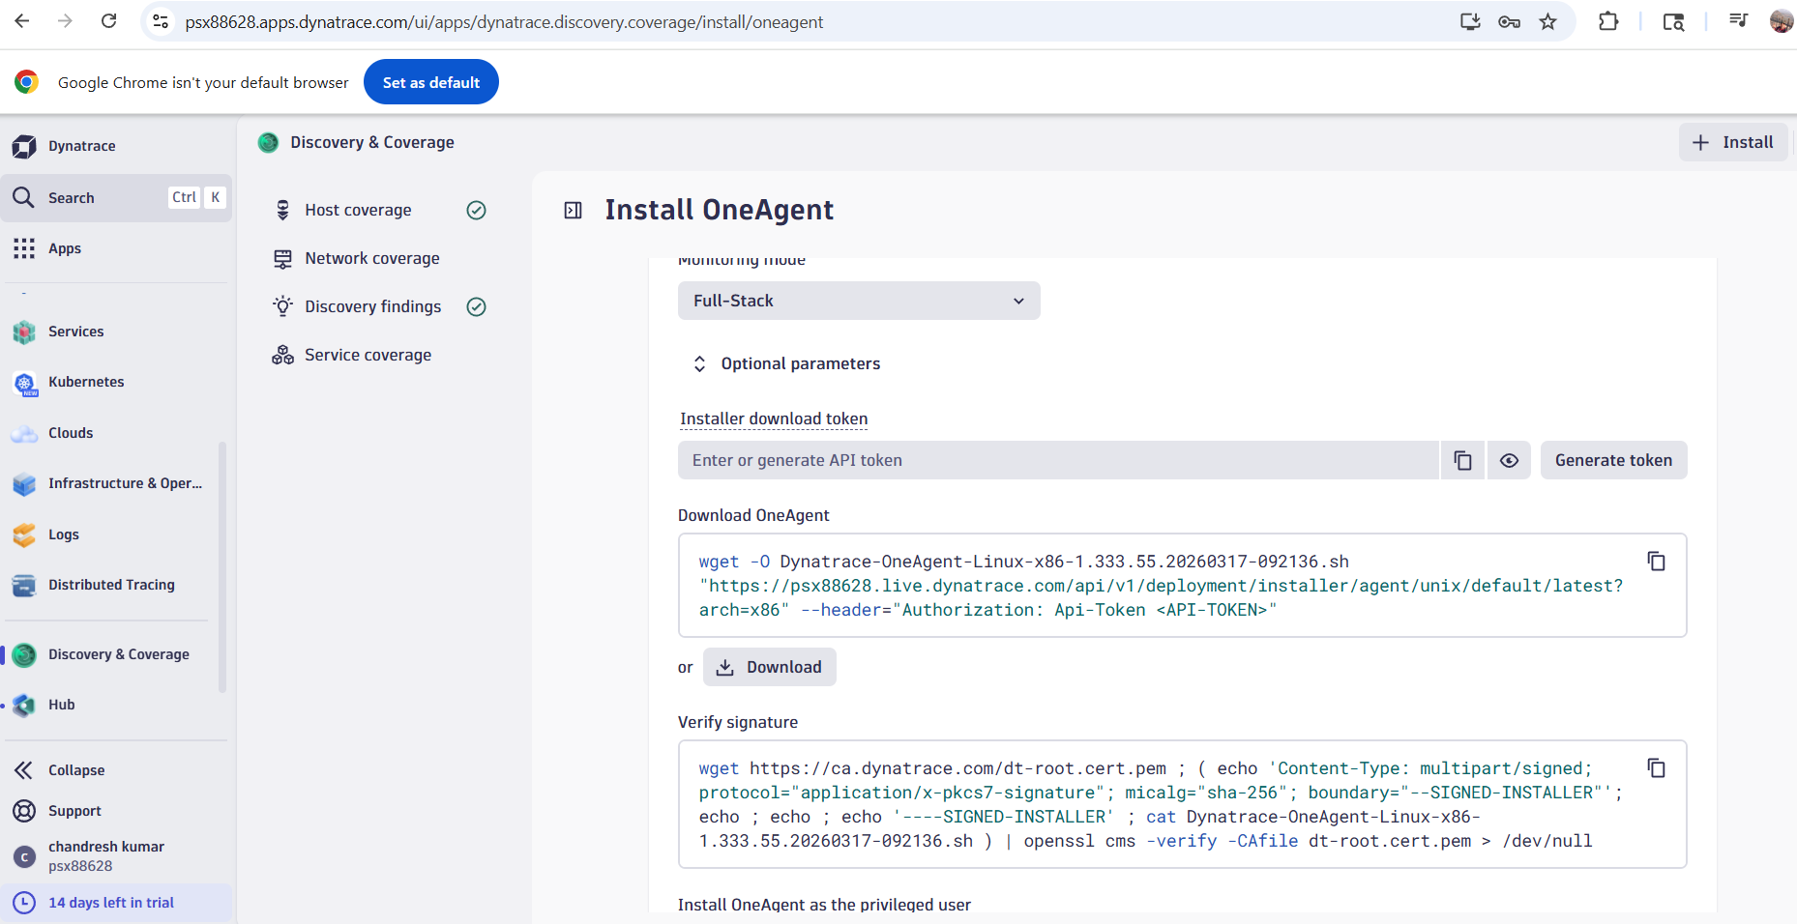

Download OneAgent

wget -O Dynatrace-OneAgent-Linux-x86-1.333.55.20260317-092136.sh "https://psx88628.live.dynatrace.com/api/v1/deployment/installer/agent/unix/default/latest?arch=x86" --header="Authorization: Api-Token <API-TOKEN>"

Verify Signature
wget https://ca.dynatrace.com/dt-root.cert.pem ; ( echo 'Content-Type: multipart/signed; protocol="application/x-pkcs7-signature"; micalg="sha-256"; boundary="--SIGNED-INSTALLER"'; echo ; echo ; echo '----SIGNED-INSTALLER' ; cat Dynatrace-OneAgent-Linux-x86-1.333.55.20260317-092136.sh ) | openssl cms -verify -CAfile dt-root.cert.pem > /dev/null

Install OneAgent as priviledged user
/bin/sh Dynatrace-OneAgent-Linux-x86-1.333.55.20260317-092136.sh --set-monitoring-mode=fullstack --set-app-log-content-access=true

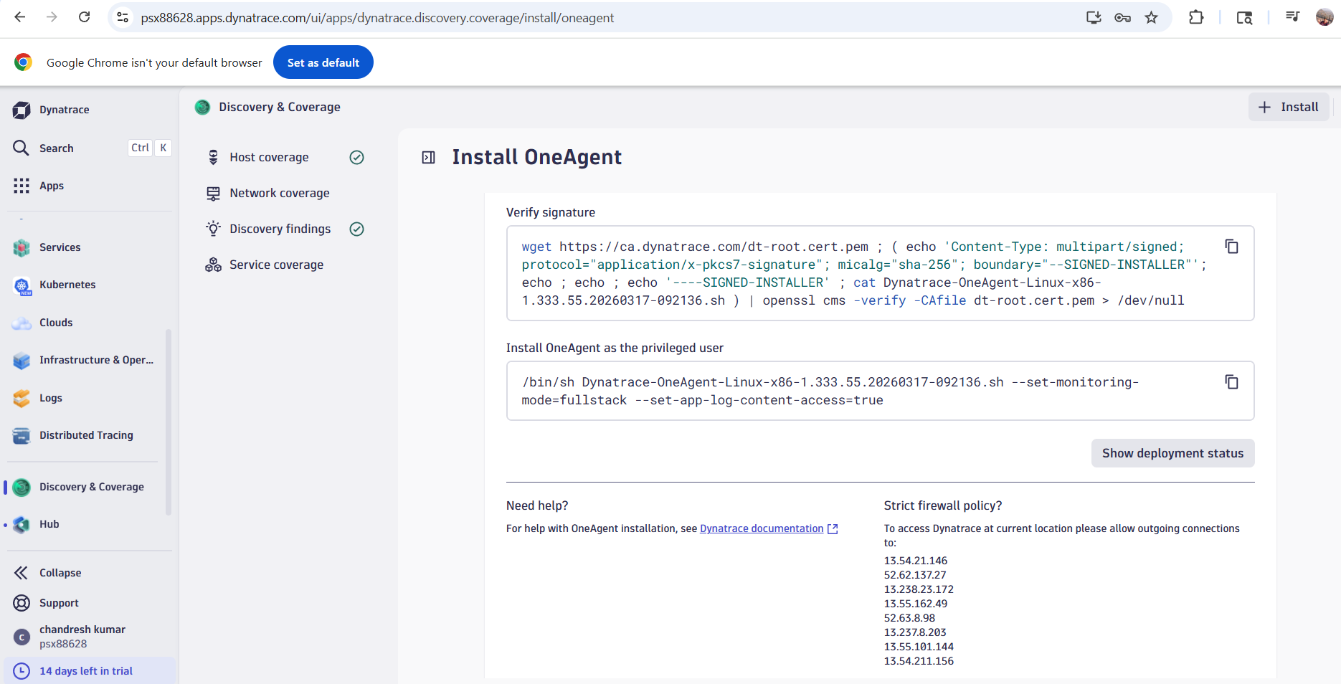

select windows OS
click generate token , autofills
dt0c01.NDJMCNMFZEIBDJEUFG5W64CY.XAKK72I36RB2ENTBMO5IFKH2OZBMLZR3GMNBKBDTALMH6FEYCN4J75UTNCM7UCWX
Click on download and then run the .exe file and install it.

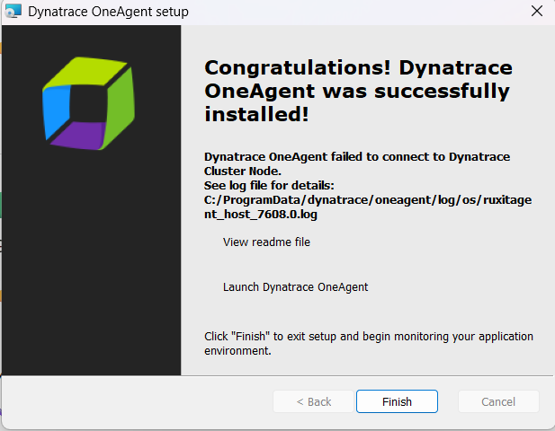

Go back to Dynatrace UI and check deployment status
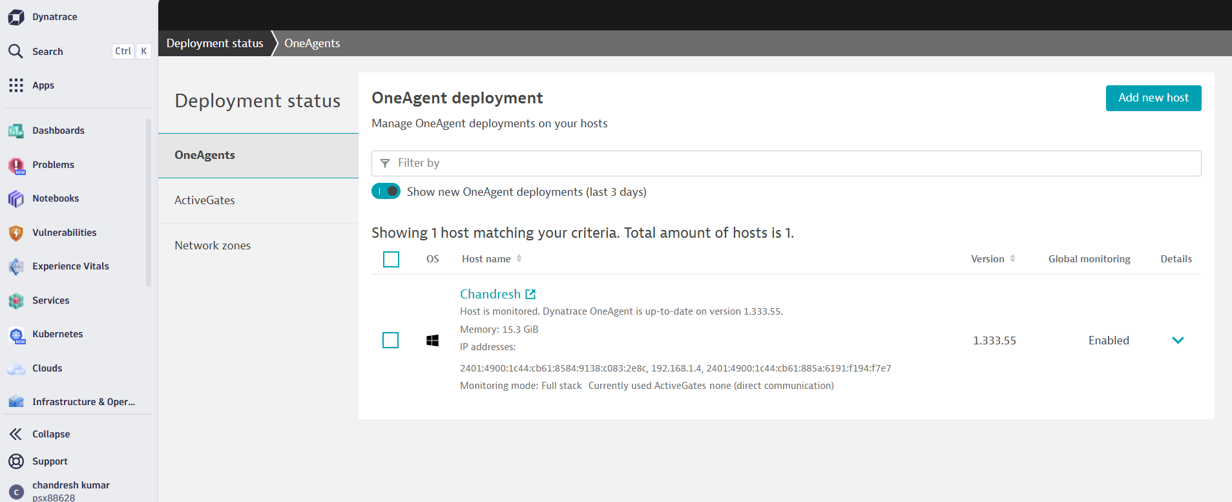

Installing OneAgent on your laptop :
Your application should be running on same machine

