《操作系统原理》
上机作业（报告）

作业： 磁 盘 调 度 算 法
班级： 计算机类19-1班
姓名： 赵希奥
学号： 2019015219
时间： 2020年12月20日

作业编号 |  | 7 | 题目 | 磁盘调度算法
作业要求 | 【题目要求】通过编程仿真几种常见的磁盘调度算法，包括：先来先服务(FCFS)、最短寻道时间优先(SSTF)、扫描算法(SCAN，初始为从里向外移动)和循环扫描算法（CSCAN，初始为由里向外移动并服务，归零时返回到最里侧请求的磁道）。  磁道访问请求序列为：55,58,39,18,90,160,150,38,184  （1）模拟磁盘调度过程并计算磁头的总移动的磁道数(总寻道长度)。  （2）计算磁头的平均移动的磁道数(平均寻道长度)。  其菜单如下：  *************磁盘调度算法实现***********  =================================  0. 退出  1. FCFS算法实现  2. SSTF算法实现  3. SCAN算法实现  4. CSCAN算法  5. 显示对比表  =================================  【实验要求】 可选编程语言：C/C++/Java/C#/Python；  实现在同一个程序文件中（C/C++）；  请适当注释；
报 告 正 文（运行屏幕截图及源代码）
- 模拟磁盘调度过程并计算磁头的总寻道长度和平均寻道长度
- FCFS算法:
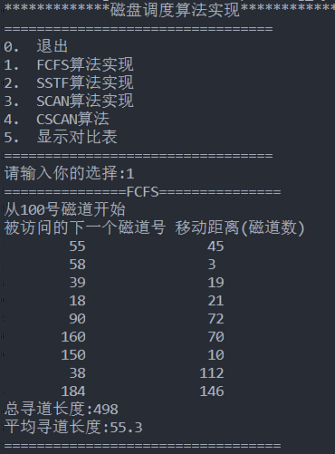
- SSTF算法:
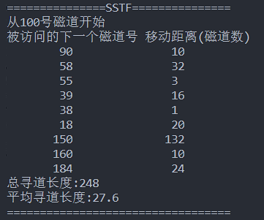
- SCAN算法:
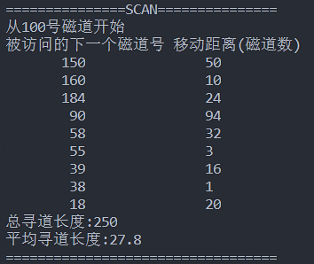
- CSCAN:
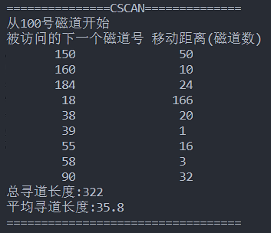
- 对比表:
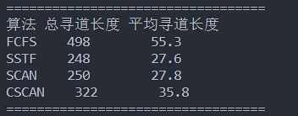

- 源代码:
from collections import OrderedDict

# 磁盘访问请求序列
request_sequense = [55,58,39,18,90,160,150,38,184]
correlation_table = {"FCFS":{"总寻道长度":0,"平均寻道长度":0},"SSTF":{"总寻道长度":0,"平均寻道长度":0},"SCAN":{"总寻道长度":0,"平均寻道长度":0},"CSCAN":{"总寻道长度":0,"平均寻道长度":0}}

def print_sequece(sch, begin = 100):
"""
用以输出调度序列
"""
print("从" + str(begin) + "号磁道开始")
print("被访问的下一个磁道号 移动距离(磁道数)")
for key, value in sch.items():
print("{:^18}{:^16}".format(key,value))
sum = 0
for value in sch.values():
sum += value
print("总寻道长度:" + str(sum))
print("平均寻道长度:" + "{:.1f}".format(sum/len(sch)))
return {"总寻道长度":sum,"平均寻道长度":sum/len(sch)}

def find_next(list, dict,begin):
"""
找到下一个距离最近的磁道号
传入参数分别为请求序列,调度序列字典,磁头当前位置
"""
min = float('inf')
for i in range(0, len(list)):
if list[i] not in dict and abs(list[i] - begin) < abs(min - begin):
min = list[i]
return min

def sequential_scan(request,begin,index = 0,op = 1):
"""
按某规则扫描序列,
如果op为1,则从index顺序扫描,op为0则从index逆序扫描,op为2时从0扫描到index
返回添加了扫描项和寻道时间键值对的字典
"""
t1 = begin
t2 = 0
dict = OrderedDict()
if 1 == op:
for i in range(index, len(request)):
t2 = abs(request[i] - t1)
t1 = request[i]
dict[t1] = t2
elif 0 == op:
for i in range(index)[::-1]:
t2 = abs(request[i] - t1)
t1 = request[i]
dict[t1] = t2
elif 2 == op:
for i in range(index):
t2 = abs(request[i] - t1)
t1 = request[i]
dict[t1] = t2
return dict

def print_table():
"""
打印对比表
"""
print("=" * 34)
print("算法 " + "总寻道长度 " + "平均寻道长度")
for key,value in correlation_table.items():
print("{} {:^10} {:^10.1f}".format(key,value["总寻道长度"],value["平均寻道长度"]))
print("=" * 34)

def FCFS(begin = 100):
"""
先来先服务(FCFS), 传入参数为开始磁道号, 默认为100
"""
t1 = begin
t2 = 0
sch_pro = OrderedDict()
for i in range(len(request_sequense)):
t2 = abs(request_sequense[i] - t1)
t1 = request_sequense[i]
sch_pro[t1] = t2
correlation_table["FCFS"] = print_sequece(sch_pro,begin)

def SSTF(begin = 100):
"""
最短寻道时间优先(SSTF), 传入参数为开始磁道号, 默认为100
"""
t1 = begin
t2 = 0
sch_pro = OrderedDict()
for i in range(len(request_sequense)):
t2 = abs(find_next(request_sequense, sch_pro, t1) - t1)
t1 = find_next(request_sequense, sch_pro, t1)
sch_pro[t1] = t2
correlation_table["SSTF"] = print_sequece(sch_pro, begin)

def SCAN(begin = 100):
"""
扫描算法(SCAN),电梯调度算法, 磁头开始位置默认传入为100
"""
sorted_sequence = sorted(request_sequense)
sch_dict = OrderedDict()
index = 0
for index in range(len(request_sequense)):
if request_sequense[index] == begin:
break
elif request_sequense[index] > begin:
index += 1
break
if index == 0:
correlation_table["SCAN"] = print_sequece(sequential_scan(sorted_sequence,begin,index,1), begin)
elif index == len(request_sequense) - 1:
correlation_table["SCAN"] = print_sequece(sequential_scan(sorted_sequence,begin,index,0), begin)
else:
sch_dict.update(sequential_scan(sorted_sequence,begin,index,1))
sch_dict.update(sequential_scan(sorted_sequence,list(sch_dict.keys())[-1],index,0))
correlation_table["SCAN"] = print_sequece(sch_dict,begin)

def CSCAN(begin = 100):
"""
循环扫描(CSCAN)算法,默认传入参数为磁头开始位置
"""
index = 0
sch_dict = OrderedDict()
sorted_sequence = sorted(request_sequense)
for index in range(len(request_sequense)):
if request_sequense[index] == begin:
break
elif request_sequense[index] > begin:
index += 1
break
sch_dict.update(sequential_scan(sorted_sequence,begin,index,1))
sch_dict.update(sequential_scan(sorted_sequence,list(sch_dict.keys())[-1],index,2))
correlation_table["CSCAN"] = print_sequece(sch_dict,begin)

def print_menu():
"""
打印菜单
"""
print("=" * 33)
print("0. 退出")
print("1. FCFS算法实现")
print("2. SSTF算法实现")
print("3. SCAN算法实现")
print("4. CSCAN算法")
print("5. 显示对比表")
print("=" * 33)

def main():
"""
程序入口
"""
print("*" * 13 + "磁盘调度算法实现" + "*" * 13)
print_menu()
choice = int(input("请输入你的选择:"))
while 0 != choice:
if 1 == choice:
print("=" * 15 + "FCFS" + "=" * 15)
FCFS()
print("=" * 34)
elif 2 == choice:
print("=" * 15 + "SSTF" + "=" * 15)
SSTF()
print("=" * 34)
elif 3 == choice:
print("=" * 15 + "SCAN" + "=" * 15)
SCAN()
print("=" * 34)
elif 4 == choice:
print("=" * 15 + "CSCAN" + "=" * 14)
CSCAN()
print("=" * 34)
elif 5 == choice:
print_table()
print_menu()
choice = int(input("请输入你的选择:"))

main()

