**KMeans - Agglomerative Clustering**

Computed silhouette coefficient for each k number to choose a better k number from the interval of k numbers [2,10]. Select k number as 7 that its silhouette coefficient has higher score.

1. **The same**

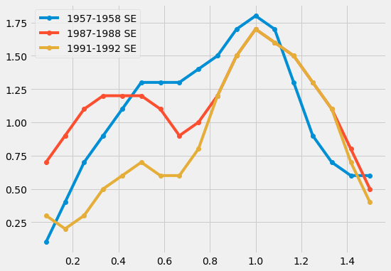

1. **The same**

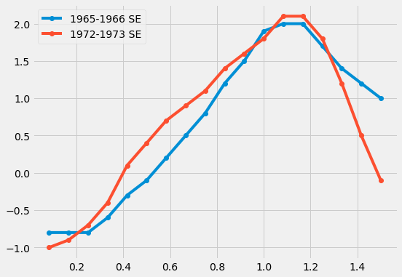

1. **KMeans**

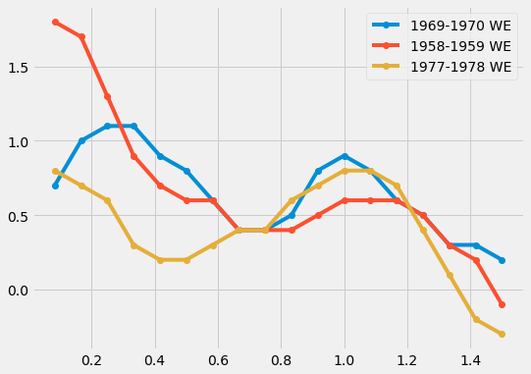

**Agglomerative**

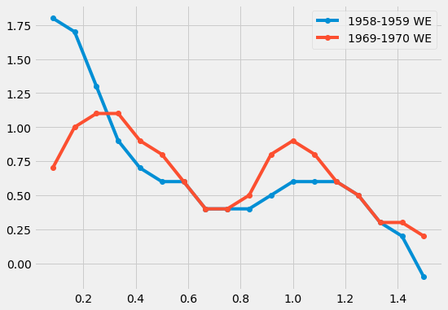

1. **The same**

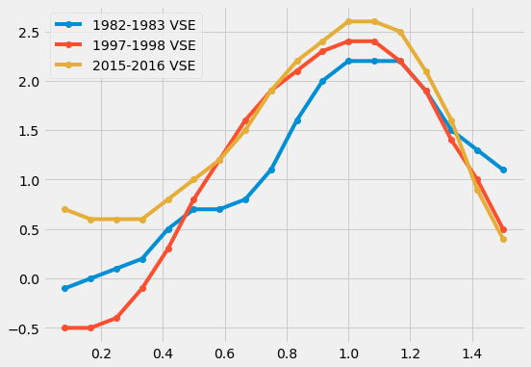

1. **KMeans**

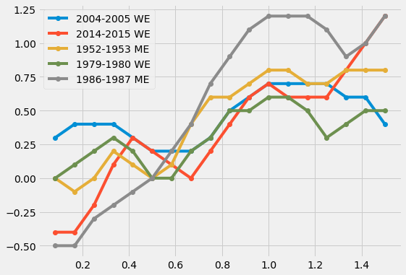

**Agglomerative**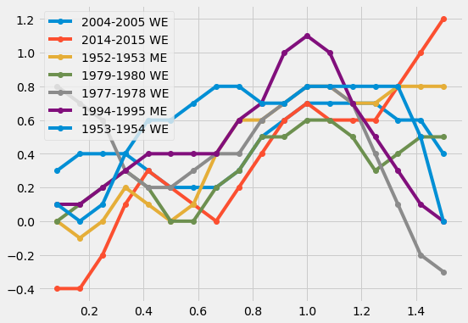

1. **KMeans**

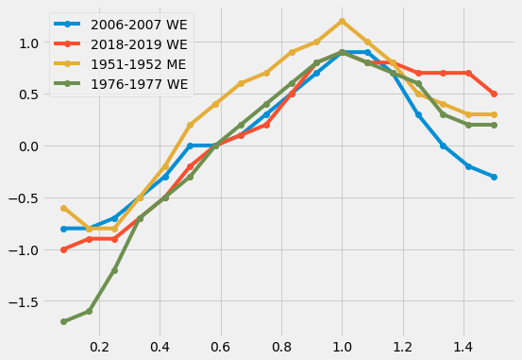

**Agglomerative**

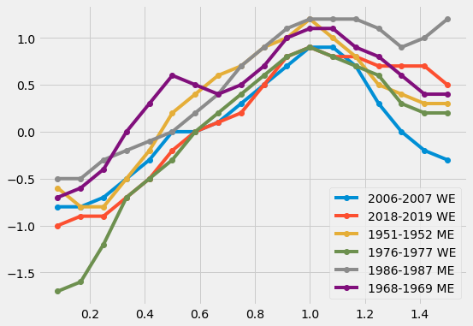

1. **KMeans**

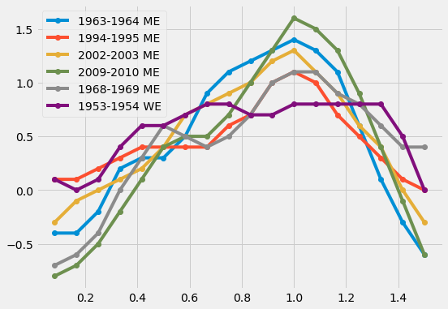

**Agglomerative**

