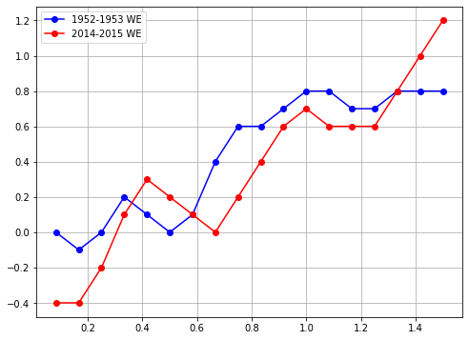

avg_eq = 0.128129*x*np.sin(8.64087653051526*x)+0.870872*x-0.2798906

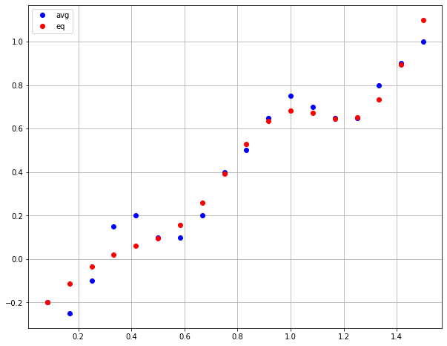

#change 2,4 #best fitness 10.079773

return 0.128129*x*np.sin(8.046256*x)+0.870872*x-0.228342

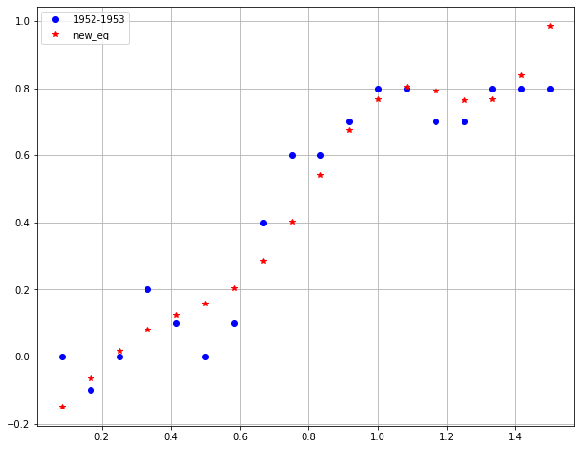

#change 1,4 #best fitness 13.7775

return 0.090792*x*np.sin(8.640880*x)+0.870872*x-0.326393

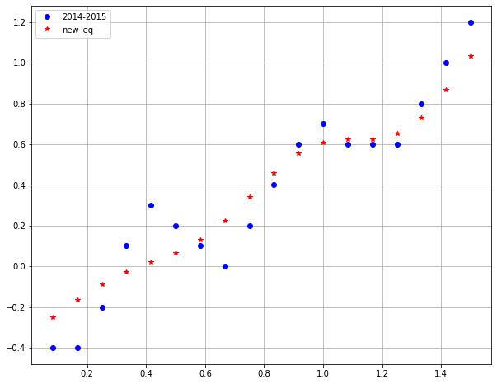

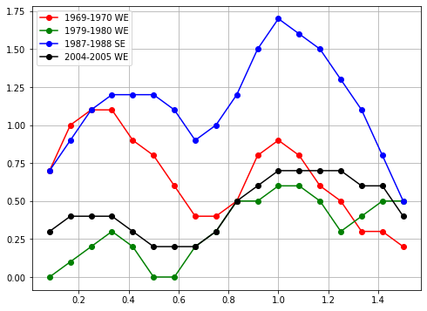

avg_eq =1.189035*np.sin(0.699276*x)+(-0.920625*x+0.755611)*np.sin(5.417646*x) +0.014571

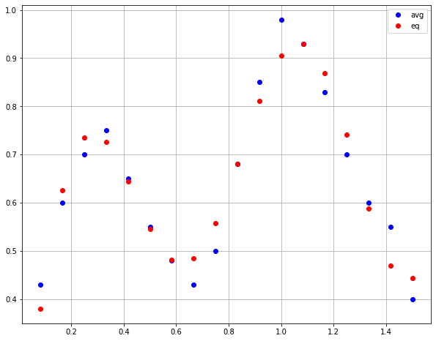

# change 1,2,4 #best fitness 10.5425

return 0.754583*np.sin(1.650590*x)+(-0.920625*x+0.991321) *np.sin(5.417650*x)+0.014571

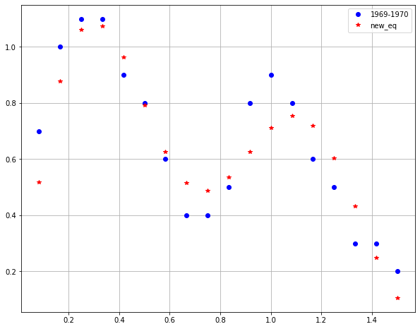

# change 1,2,4,6 #best fitness 10.750963

return 8.447183*np.sin(0.115486*x)+(-0.920625*x+0.731570) *np.sin(5.417650*x)+-0.483086

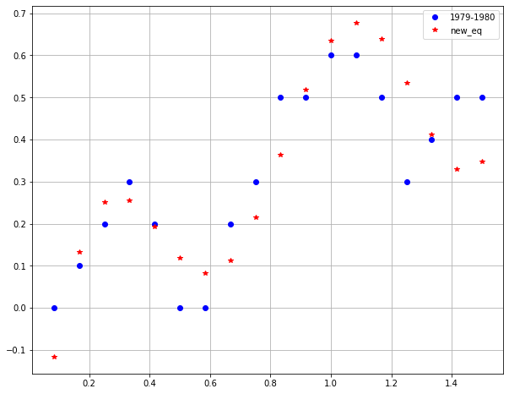

# change 1,2,4,6 #best fitness 7.96481

return 7.800660*np.sin(0.115838*x)+(-0.920625*x+0.782986) *np.sin(5.417650*x)+-0.296717

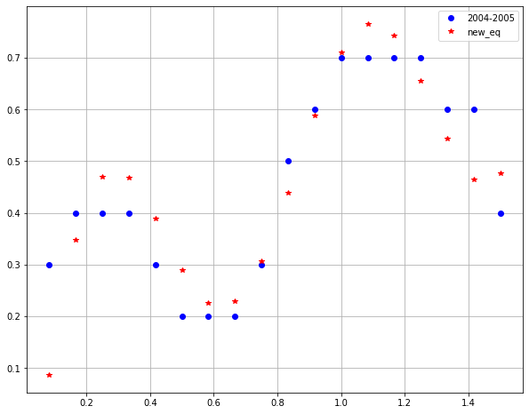

# change 1,2,4 #best fitness 10.6685

return 1.440270*np.sin(1.468600*x)+(-0.920625*x+0.845974) *np.sin(5.417650*x)+0.014571

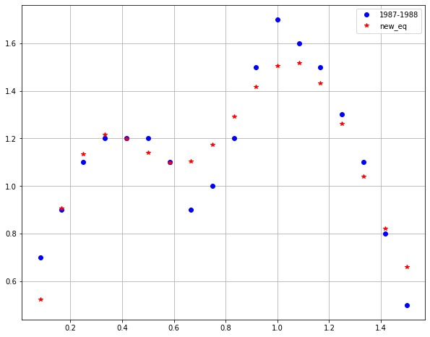

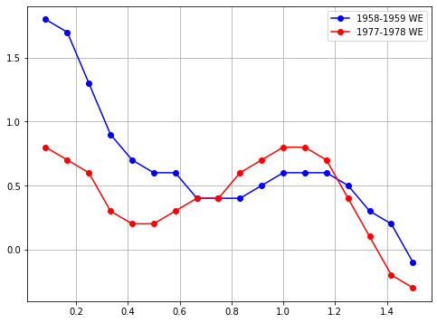

avg_eq = (1.4221796-x) * (2*x*(x-0.995554)+(2*x-0.64533426)*np.sin(x-0.694731)+1.0)

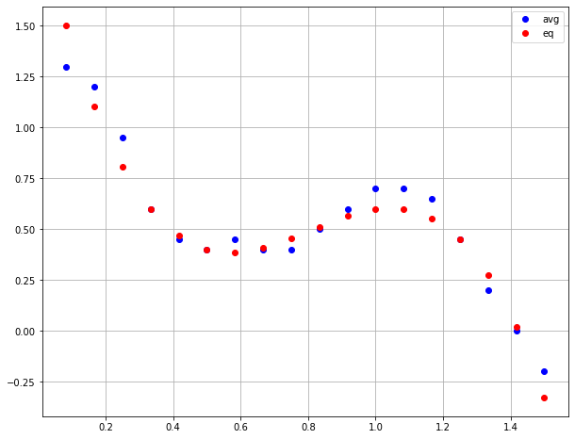

# change 3 #best fitness 11.8577

return (1.422180-x)*(2*x*(x-0.995554)+(2*x-1.339720) *np.sin(x-0.694731)+1.0)

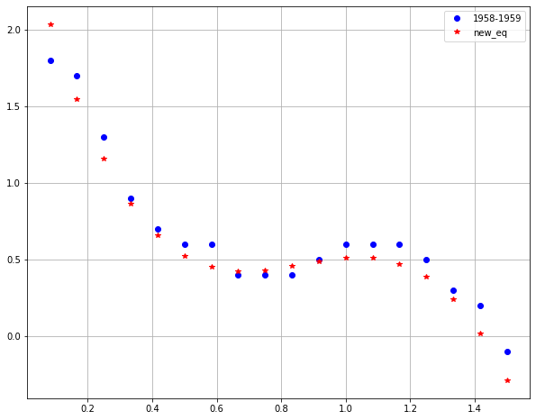

#change 3 #best fitness 10.795051

return (1.422180-x)*(2*x*(x-0.995554)+(2*x--0.114362) *np.sin(x-0.694731)+1.0)

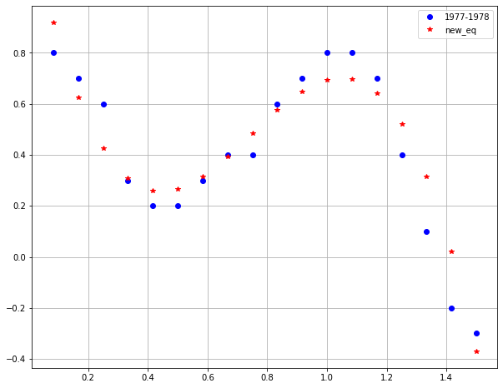

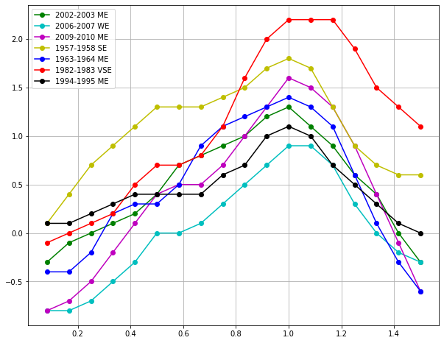

avg_eq = 0.660694*x+x*np.sin(3.211015*x-1.065241)-0.192678

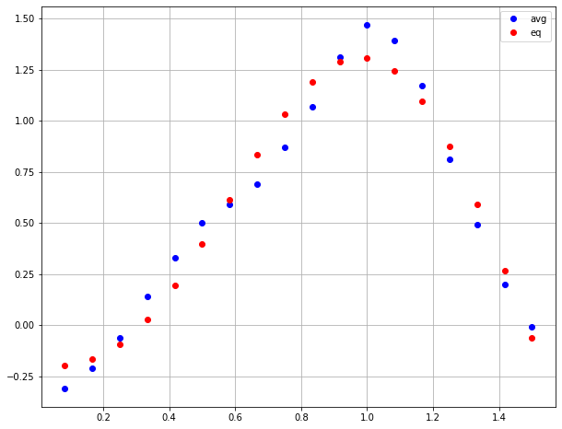

#change 3,4 #best fitness 11.641994

return 0.660694*x+x*np.sin(3.211010*x-1.164224)-0.756267

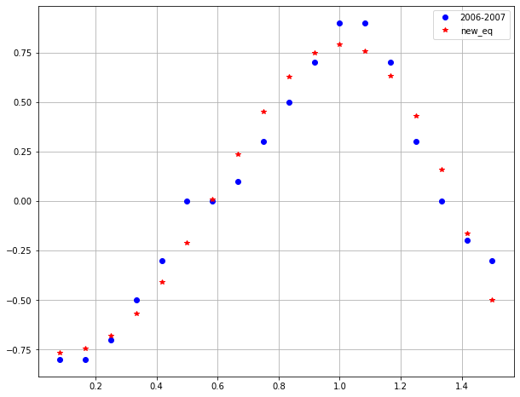

#change 1,3 #best fitness 18.105898

return 0.590984*x+x*np.sin(3.211015*x-0.908812)-0.192678

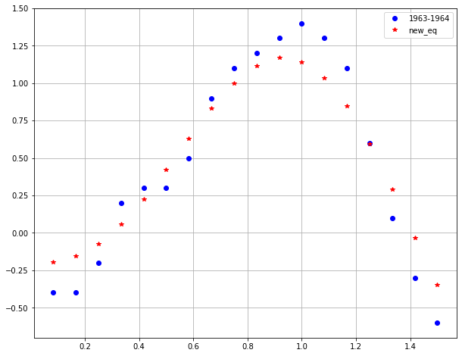

#change 1,3,4 #best fitness 15.751081

return -0.370771*x+x*np.sin(3.211010*x-1.542475)--0.396837

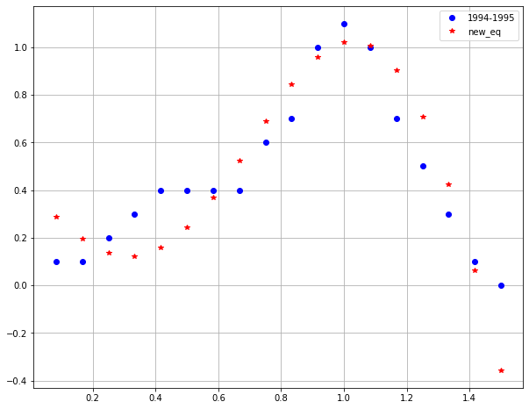

#change 1,3 #best fitness 6.638339

return 0.594481*x+x*np.sin(3.211010*x-0.952424)-0.192678

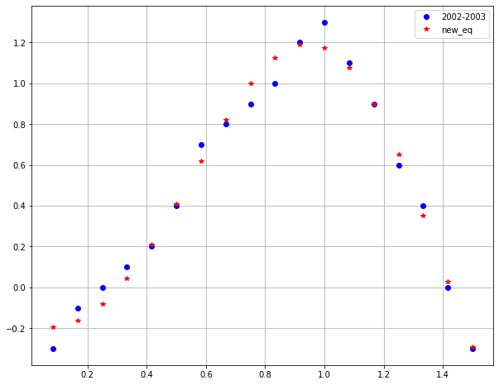

#change 1,2,4 #best fitness 23.579988

return 1.109158*x+x*np.sin(3.366371*x-1.065241)-0.645433

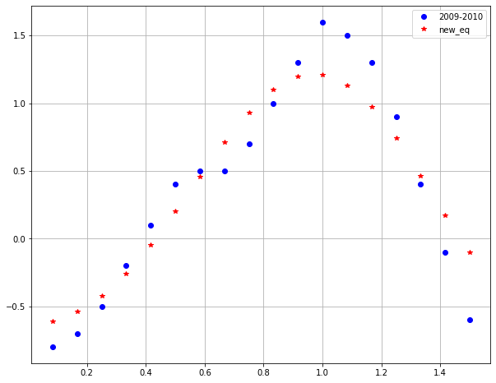

#change 1,3,4 #best fitness 16.024298

return 1.225919*x+x*np.sin(3.211010*x-0.332064)--0.114485

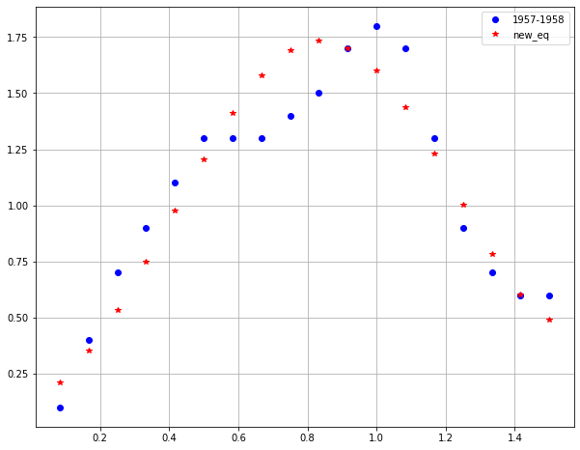

#change 1,3,4 #best fitness 15.245098

return 1.028580*x+x*np.sin(3.211010*x-1.417940)-0.039754

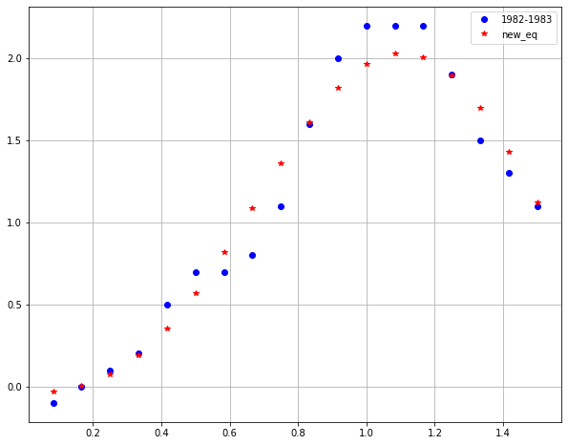

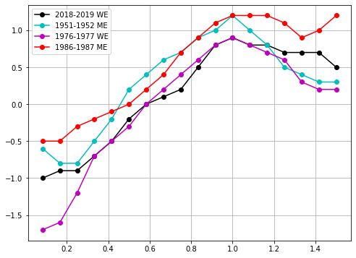

avg_eq = np.sin(2.892047*x+4.724232)

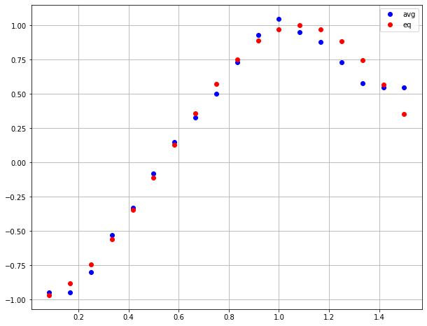

#change 1,2 #best fitness 11.6058

return np.sin(2.955150*x+4.485220)

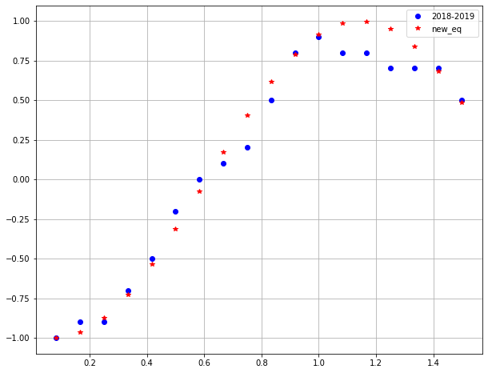

#change 1,2 #best fitness 13.713657

return np.sin(2.980902*x+4.894319)

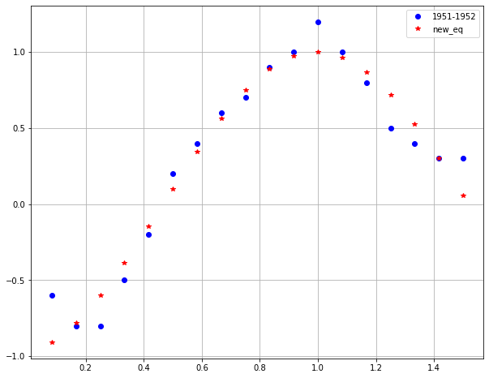

#change 1,2 #best fitness 26.215099

return np.sin(3.486610*x+4.227690)

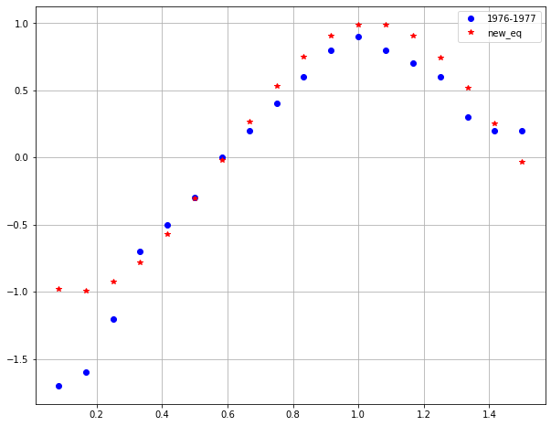

# change 1,2 #best fitness 16.749201

return np.sin(1.958630*x+-0.820861)

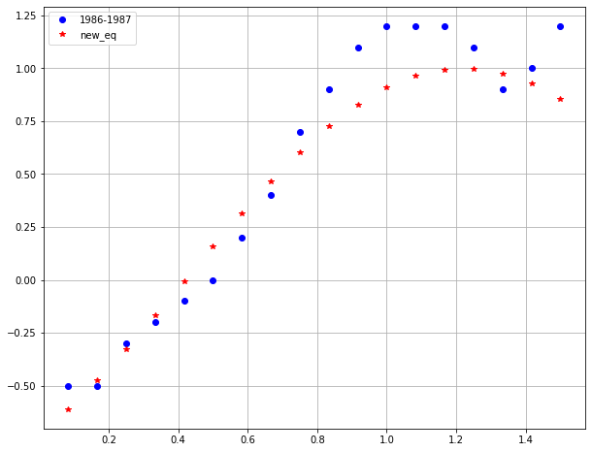



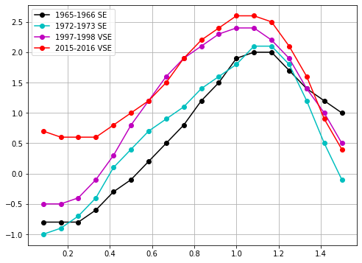

avg_eq = x+(-0.497150-3.264897*x)*np.sin(2.908535*x) +5.213310*x*np.sin(2.648657*x)-0.441066

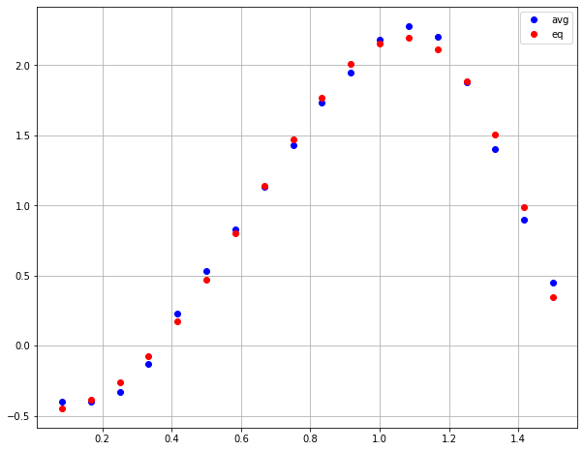

#change 1,3 #best fitness 11.954185

return x+(-1.145090-3.264897*x)*np.sin(2.849602*x) +5.213310*x*np.sin(2.648657*x)-0.441066

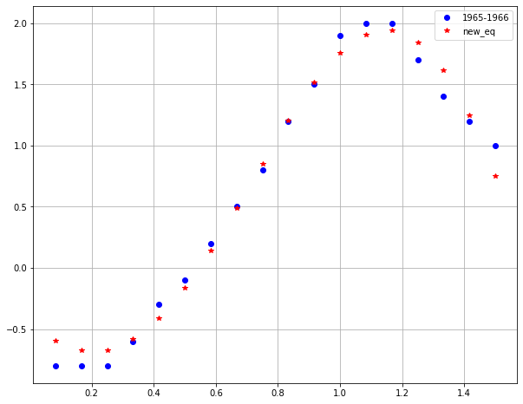

#change 1,3,6 #best fitness 14.265

return x+(-0.290019-3.264900*x)*np.sin(2.981270*x)

+5.213310*x*np.sin(2.648660*x)-0.924186

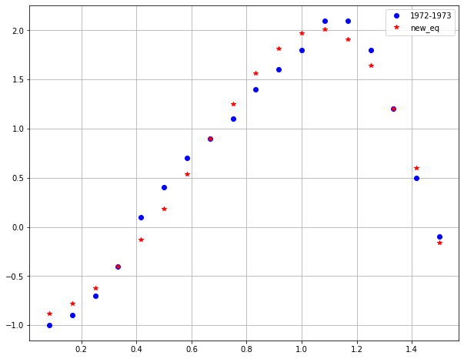

#change 1,3,6 #best fitness 15.091798

return x+(-0.220951-3.264897*x)*np.sin(2.973420*x) +5.213310*x*np.sin(2.648657*x)-0.488703

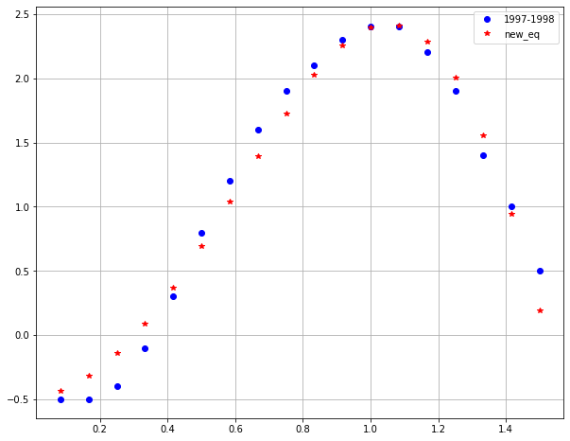

#change 1,3,5,6 #best fitness 10.043792

return x+(-11.884934-3.264900*x)*np.sin(0.300947*x)

+5.213310*x*np.sin(1.588590*x)--0.750941

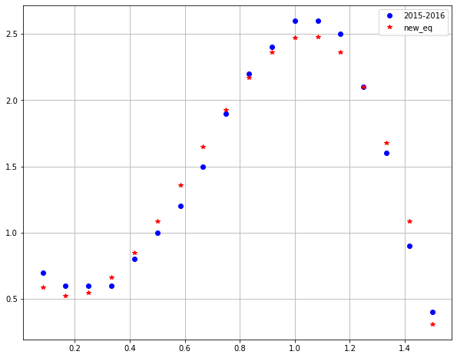



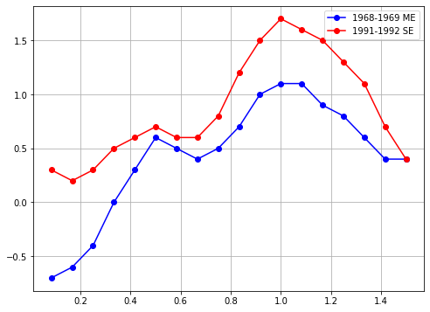

avg_eq = 1.270450*np.sin(0.869869*x)+(0.873001*x-0.504249)*np.sin(7.622553*x)

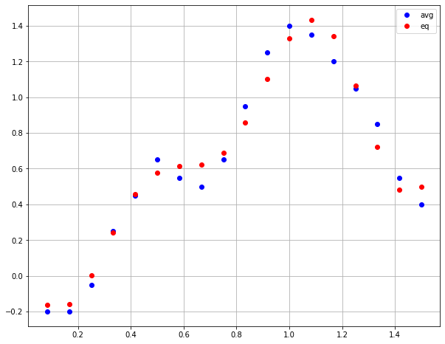

#change 2,4 #best fitness 15.224091

return 1.270450*np.sin(0.607653*x)+(0.873001*x-0.671472) *np.sin(7.622553*x)

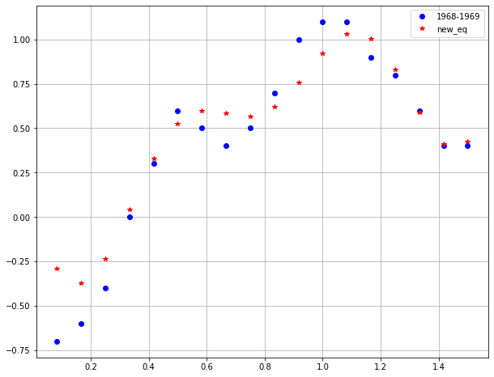

#change 2,4 #best fitness 15.917866

return 1.270450*np.sin(1.187490*x)+(0.873001*x-0.368266) *np.sin(7.622550*x)

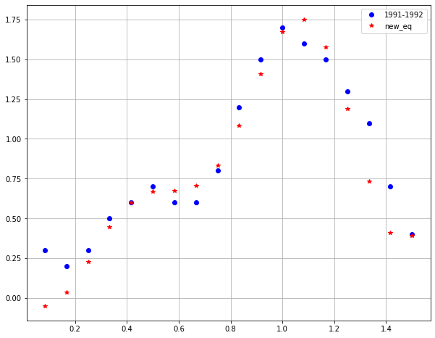



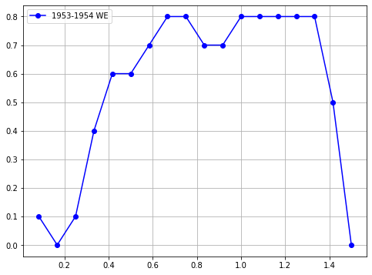

avg_eq = -0.513958*x-(4.298025*x-0.378910)*np.sin(x-1.612762) +(x-2.151642)*x*np.sin(2.249024*x)

