**Image-to-Geometry Registration on Mobile Devices – Concepts, Challenges and Applications**

Melanie Kröhnert*, Christian Kehl†‡, Herbert Litschke₮, Simon J. Buckley‡

*Institute for Photogrammetry & Remote Sensing, TU Dresden, Helmholtzstr. 10, D-01069 Dresden, melanie.kroehnert@tu-dresden.de

†Aix Marseille Uniersité, CNRS, IRD, CEREGE UM34, Sedimentary Systems and Reservoir Development, Marseille, France

₮Hochschule Wismar, Philipp-Müller-Straße 14, D-23966 Wismar

‡Uni Research AS – CIPR, Nygårdsgaten 112, NO-5008 Bergen

**Abstract.** Registering natural photos to existing 3D surface models, particularly on low-power mobile devices, gathers increasing attention to a variety of application domains. The paper discusses up-to-date computation insights of the technique, condensing available literature and knowledge obtained from experiments across multiple research groups. Challenges like smartphone camera calibration or the sensor-based estimation of location- and orientation are current research subjects, for which new data and experimental results are presented. Moreover, computing-related, practical challenges (e.g. device variability) are detailed to increase the technological understanding and reasoning on the limits of mobile devices. An overview of running projects utilising image-to-geometry registration methods shows the potential for mobile devices to, amongst other, improve flood hazard mitigation and hydrocarbon exploration with crowdsourced data.

**1 Introduction**

Considering the worldwide distribution of 5.3 billion unique mobile subscriptions with a smartphone percentage of 56 % compared to global population of ~7.5 billion people [10], a life without smartphones seems to be not imaginable nowadays. Smartphones with inbuilt cameras, powerful processing units and low-cost positioning systems seem to be very suitable wide-spread measurement devices that could be used for mobile mapping, measuring and visualisation purposes [1]. Here, image-to-geometry intersection describes an essential topic for the translation of mobile captured image data into object space which allows for metric interpretation on call. Section 2 illustrates state-of-the-art concepts for solving the issue of image-to-geometry intersection whereas section 3 depicts challenges regarding the precise determination of camera´s intrinsic and extrinsic parameters and points out the issue of their geometric stability. Furthermore, difficulties related to image mapping under natural illumination in comparison to required accuracies for measuring purposes and performance are addressed. Section 4 and 5 treat existing applications for geo-monitoring and end with a short outlook of current research activities.

**2 Concepts**

The group of algorithmic concepts for registering images to natural 3D object surfaces (e.g. for outdoor cases) consists of mutual information (MI) [12], horizon alignment [2], edge correlation [5,28], point feature-based registration and hybrids thereof [33].

The common approach for image registration onto coloured geometry on mobile devices is based on salient feature points of synthesised images and photos [4,1]. The 2D features are correlated with 3D coordinates for a Point-n-Perspective (PnP) optimisation [27,29], optionally refined via Levenberg-Marquardt [27]. The whole registration process is illustrated in Fig. 1. Research groups across domains, such as augmented reality [1,30], outcrop geology [17] and hydrology [1,9,21], utilise this approach in mobile applications for localisation, tracking and for interpretation purposes. Furthermore, the approach is integrated in common high-level concepts, such as simultaneous localisation and mapping (SLAM) and visual odometry [7]. 3D coordinates are supplied by raycasting or depthmap look-up from the camera’s vantage point at 2D feature point coordinates. Depthmap look-ups are specifically used for point set representation of the object’s surface, as this is directly provided by various 3D object scanning techniques in modern applications.

The remainder of this article focuses on feature-based registration as currently predominant concept on mobile devices due to its simple implementation, easy adaptability, generic applicability (e.g. in contrast to horizon alignment) and the achievable performance on even low-power devices.

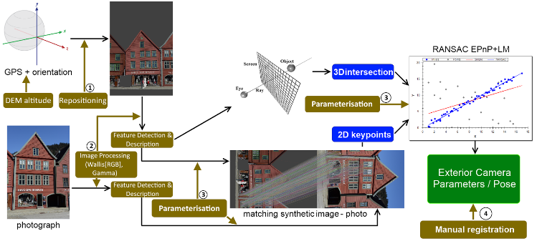

**Fig. 1.** Main workflow for feature-based, mobile sensor-assisted image-to-geometry registration.

**3 Challenges**

Despite being tested on synthetic- as well as domain-specific case studies (e.g. cultural heritage, hydrology, geology) in past years, the available methods for feature-based registration are still far away from being fully-automatic. Applying the previous concepts still presents distinct challenges in real-world scenarios and for mobile device platforms, which are discussed in this section.

3.1 Device Variability

Android by itself is a very open to use operation system and enables many manufactures the development of various smartphones using a wide-spread operation system. But, this high variability leads to abound in the market of on-board sensors, cameras and processing units. All kinds of sensors like the main camera vary strongly in their qualities (low-cost versus flagship phone). These are quite complicating factors for providing apps for e.g. crowdsourcing-based volunteered geographic information (VGI) acquisition [8,1,26] using the public equipped with several types of phones. Measurements resulting from smartphone images are strongly correlated with the camera quality itself regarding their reliability, accuracy and spatial resolution. Furthermore, a too small processing unit can refuse the whole data processing whereas a highly susceptible IMU impedes the acquisition of suitable initial orientation data which is indispensable for a precise image-to-geometry intersection.

Another concern deals with the graphics computing capabilities. 3D model rendering is done on the GPU via OpenGL. Besides common performance differences, the employed graphics chips (e.g. Qualcomm Adreno, ARM Mali, NVIDIA Tegra) support different rendering instructions. For textured surfaces, on-chip texture decompression makes a significant difference in rendering speed. Most tablet brands use Qualcomm’s system-on-a-chip (SoC) architecture, where CPU and GPU share the same memory. Other devices provide dedicated graphics memory, which accelerates render operations in general. On top of the rendering-related differences, some graphics processors (e.g. Mali and Tegra) provide general-purpose GPU (GPGPU) capabilities via OpenCL and CUDA, which allows for drastic runtime reductions for future image-to-geometry systems [14].

3.2 Camera intrinsics

For accurate results in terms of image processing the used camera for data acquisition should be calibrated. Camera calibration comprises the determination of its intrinsics (principle point, focal length and skew) and lens distortion (like radial and tangential distortion). Some approved methods are described in [36,38,6].

In case of typical consumer cameras, the calibration is valid for one camera setting concerning aperture, focal length and focus adjustments, and has to be fixed (e.g. avoid refocusing, aperture tuning). Today’s mobile devices are largely equipped with inbuilt autofocus cameras required by several apps (e.g. photo camera, QR scanner, AR games). Even if a camera application uses manual focussing, the camera will be refocused during each app start and thus affects the intrinsics (Tab. 1). For mobile measurements, self-calibration during actual data acquisition is advisable [32]. Otherwise, calibration and data acquisition may be done consecutively without closing the app. However, the battery charge empties rapidly when running the camera app in continuous mode. Beside this, the device’s temperature changes very fast when other apps or hardware components (like GPS) are started/closed in background. Obviously, this will influence the small inbuilt camera sensors and lenses due to hardware assembling and adhesive bond (Tab. 2).

|  |  |  |  |  |  |  |  |  |  |  |  |  |
| --- | --- | --- | --- | --- | --- | --- | --- | --- | --- | --- | --- | --- |
| **ObjectPoint** | | | **1st run** | | **2nd run** | | **3rd run** | | **Diff 1st – 2nd** | | **Diff 1st – 3rd** | |
| X | Y | Z | x | y | x | y | x | y | x | y | x | y |
| 0 | 0 | -0.0 | 1653.15 | 1222.70 | 1639.67 | 1220.53 | 1638.55 | 1213.08 | 13.48 | 2.16 | 14.60 | 9.62 |
| -2.5 | -2.0 | 0.0 | 3097.37 | 2378.07 | 3092.64 | 2382.90 | 3076.34 | 2363.32 | 4.73 | -4.83 | 21.03 | 14.75 |
| -2.5 | 2.0 | 0.0 | 3097.37 | 67.33 | 3092.66 | 58.14 | 3076.34 | 62.85 | 4.71 | 9.19 | 21.03 | 4.48 |
| 2.5 | -2.0 | 0.0 | 208.93 | 2378.07 | 186.71 | 2382.99 | 200.75 | 2363.32 | 22.23 | -4.83 | 8.18 | 14.75 |
| 2.5 | 2.0 | 0.0 | 208.94 | 67.33 | 186.69 | 58.14 | 200.76 | 62.85 | 22.24 | 9.19 | 8.18 | 4.48 |

**Tab. 1.** App restarts affecting camera intrinsics (configuration and focal length [∞] persist). Description of projected object points to image plane using re-determined camera parameters and radial distortion for three reboots.

|  |  |  |  |  |  |  |  |  |  |  |  |  |  |  |
| --- | --- | --- | --- | --- | --- | --- | --- | --- | --- | --- | --- | --- | --- | --- |
| **ObjectPoint** | | | **ImgPt (37°C)** | | **ImgPt (57°C)** | | **Diff** | | **ImgPt (37°C)** | | **ImgPt (57°C)** | | **Diff** | |
| X | Y | Z | x | y | x | y | x | y | x | y | x | y | x | y |
| 0 | 0 | -0.0 | 1653.15 | 1222.70 | 1634.76 | 1222.16 | 18.39 | 0.53 | 1639.67 | 1220.53 | 1652.13 | 1226.86 | -12.46 | -6.33 |
| -2.5 | -2.0 | 0.0 | 3097.37 | 2378.07 | 3076.65 | 2375.67 | 20.72 | 2.40 | 3092.64 | 2382.90 | 3100.15 | 2385.27 | -7.50 | -2.37 |
| -2.5 | 2.0 | 0.0 | 3097.37 | 67.33 | 3076.66 | 68.64 | 20.71 | -1.31 | 3092.66 | 58.14 | 3100.15 | 68.44 | -7.49 | -10.30 |
| 2.5 | -2.0 | 0.0 | 208.93 | 2378.07 | 192.87 | 2375.67 | 16.06 | 2.40 | 186.71 | 2382.99 | 204.12 | 2385.27 | -17.42 | -2.37 |
| 2.5 | 2.0 | 0.0 | 208.94 | 67.33 | 192.86 | 68.64 | 16.08 | -1.31 | 186.69 | 58.14 | 204.11 | 68.44 | -17.42 | -10.30 |

**Tab. 2.** Calefaction of device affecting camera intrinsics (configuration persists). Description of projected object points to image plane using re-determined camera parameters and radial distortion for two observations. Camera app in foreground.

3.3 Location- and Orientation Sensor Data Quality

Most of today’s smartphones share inbuilt micro-electronic-measurement-systems (MEMSs) for orientation tasks (e.g. screen orientation, navigation). Commonly, MEMSs comprise 3-axis accelerometers and gyroscopes, magnetometers and gravity sensors. Barometers are increasingly integrated. Considering the production costs, it seems to be obvious that these low-cost inertial measurement units (IMUs) cannot be compared in resolution and stability with approved IMUs (e.g. applied in UAV navigation). For Apple’s iPhone and Samsung’s Galaxy series (until 2014) it should be noted, that sensors share less than 5 % of the production costs and range between 1.60 and 7.00 USD [23]. In comparison to that, even light IMU’s for airborne applications amount to several hundred dollars. Nevertheless, due to complementary MEMS components, software-based sensor fusion and filter approaches, issues concerning noisy accelerometers and drifting gyroscopes that accumulate their errors respectively over time can be solved and orientation accuracy and stability improved significantly [18,31]. Fig. 2 shows stability test results of the azimuth, pitch and roll angles using the Android smartphone Samsung Galaxy S8 and a Kalman-filtered fusion of the accelerometer and compass combined with the calibrated gyroscope [31]. The azimuth includes magnetometer data pointing to the geographic north after correction by declination. During the measurements, the smartphone is mounted on a tripod and installed apart from magnetic impurities like other smartphones or computers.

Registration setups with a global reference frame (i.e. not based on motion- and temporal sensor correlation) rely on common GPS data and absolute, geomagnetic orientation. Magnetic orientation is measurably influenced by nearby magnetic impurities, as often found in urban areas [4]. This inhibits correct orientation in 3D inside cities, but for planar orientation it is less problematic. In most outdoor applications [35] and especially for 3D Image-to-Geometry registration, the sensor accuracy currently needs to be assessed on a per-case basis [16].

The GPS accuracy can be improved in urban areas via terrestrial network connection [37], which demands WiFi access. When dealing with raw GPS data, the location accuracy drops significantly. Lateral errors of up to 8 metres and vertical errors of tens of metres are realistic outdoor GPS limits [16]. Resolving the geo-positioning accuracy limitation in future may be a result of two major changes: (a) dropping differential GPS prices and (b) the computationally more manageable integration of real-time kinematics (RTK) and temporal sensor filtering (similar to sensor fusion for IMU approaches [31,25]) into the sensor software framework within Android. Currently, a comprehensible, user-driven repositioning via DEMs resolves drastic sensor errors occurring outdoors. These can be obtained via open-data media, e.g. Digital Earth Explorer. Currently, global improvement of sensor accuracy is the focus of intense investigations.

|  |  |  |  |  |
| --- | --- | --- | --- | --- |
|  | Time [sec] | **σAzimuth [°]** | **σPitch [°]** | **σRoll [°]** |
| 5 | 0,00572 | 0,00091 | 0,00205 |
| 10 | 0,00596 | 0,00301 | 0,00192 |
| 15 | 0,00605 | 0,00326 | 0,00417 |
| 20 | 0,00746 | 0,00681 | 0,00677 |
| 25 | 0,00860 | 0,01019 | 0,00891 |
| 30 | 0,01010 | 0,01108 | 0,01078 |
| 35 | 0,01186 | 0,01037 | 0,01210 |
| 40 | 0,01311 | 0,00985 | 0,01270 |
| 45 | 0,01291 | 0,01025 | 0,01222 |
|  | | | | |

**Fig. 2.** Stability test for orientation assessment using a Samsung Galaxy S8 smartphone and sensor fusion [31] for increasing precision and stability regarding azimuth, pitch and roll angles (displayed standard derivation respectively).

3.4 Image Mapping under Natural Illumination

Feature-based registration relies on an unambiguous, robust point-to-point correlation via distinctive feature vectors. As such, it is affected by distortions and content appearance changes, referred to as geometric- and radiometric variance. Radiometric variance, caused by environmental effects and natural illumination changes, still are still problematic for feature correlation. Recent studies have shown that some combinations of already-available techniques are robust against geometric- and radiometric distortion [15] as illustrated in Fig. 3. Still, feature descriptors that account for the radiometric variance are in high demand. A major contribution to this research track would be the integration of local colour attributes to the feature space, as formerly used for image classification methods [18].

3.5 Mapping requirements

Regarding accuracy requirements for environmental monitoring purposes and image-to-geometry intersection, the application is related to camera-to-subject distances of several meters. As figured out in section 3.1, inbuilt cameras of mobile devices vary widely in their capabilities. Considering the mid-price phone Google Nexus 5 (camera specs: sensor: 4.54x3.42 mm, pixel size:1.39 µm, focal length ~4 mm, crop~7.6) and a characteristic camera-to-subject-distance of 20 m, 1 pixel represents 1 cm in object space. Thus, natural features of a few centimetres should be in place to allow the application of the mentioned approach (see section 2).

a) MCER

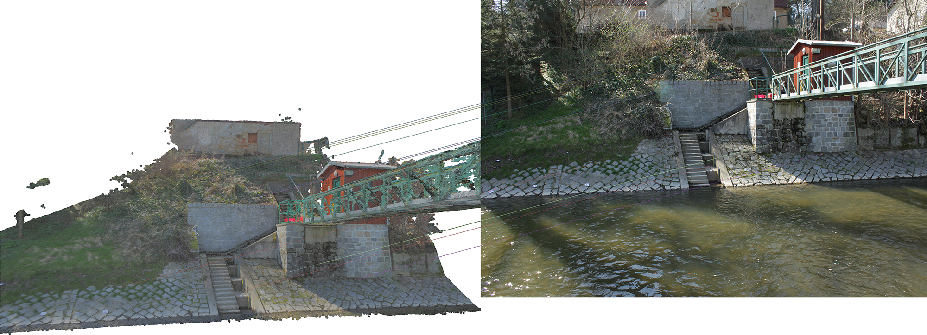

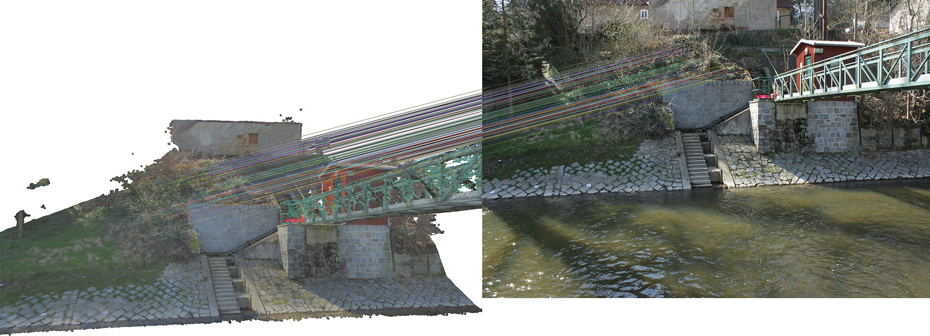

b) SIFT

**Fig. 3.** Feature detection using a) MSCR (inlier: 11, wide-centred distribution), b) SIFT (inlier: 186, highly-centred distribution).

3.5 Performance Requirements

The methods being employed for image-to-geometry registration on mobile devices are depended on the required performance (i.e. computation) time of the algorithm as well as the methodological constraints of the application domain. While mobile graphics and computations made significant advances in recent years [10,17], a major problem is to scale up lab-sized results (with respect to 3D model- and image size) to actual application demands. This is because mobile devices are memory-limited – in strict contrast to most desktop- and laptop computing platforms.

If the application constraints allow to use mobile devices as plain input sensors and output presentation platforms, it is common to use the WiFi connection for image- and sensor data transmission while the processing is done on remote servers (e.g. for mobile rendering). Using network connectivity also reduces the energy consumption of the registration process on the mobile devices itself, which makes sensor tracking more viable for increasing the location- and orientation accuracy. The specific challenge is to define a trade-off between network transmission load and tasks that are done locally on the device. When network connectivity is not available or not being used, performance is a much more limiting factor of what can algorithmically be achieved. The computational costs of feature-based geometry are linked to the image resolution and size of the 3D surface model (see Tab. 3).

|  |  |  |  |  |  |  |  |  |  |  |
| --- | --- | --- | --- | --- | --- | --- | --- | --- | --- | --- |
| **Mean runtime (min:sec.msec) – measurements on:  NVIDIA Shield K1 tablet, F: 3.92 mm; CCD: 4.6 mm x 3.52 mm** | | | | | | | | | | |
|  |  |  | |  |  | | mutual correspondences | | |  |
| rendering  preview | load photo | compute coarse matrix | | (re-)rendering | image processing | | detect & match | raycasting | | pose estimation |
| **image scale: 1632 x 1224 px** | | | | **model size: ~30.000 triangles (low-definition)** | | | | | | |
| **00:02.964** | 00:00.257 | 00:00.012 | | **00:02.646** | **00:00.864** | | **00:26.725** | 00:00.868 | | **00:00.076** |
|  |  |  | |  |  | |  |  | |  |
| **image scale: 816 x 612 px** | | | | **model size: ~30.000 triangles (low-definition)** | | | | | | |
| 00:02.674 | 00:00.211 | 00:00.005 | | **00:02.591** | **00:00.307** | | **00:08.880** | 00:00.779 | | 00:00.046 |
|  | | | | | | | | | | |
| **image scale: 1632 x 1224 px** | | | | **model size: ~30.000 triangles (low-definition)** | | | | | | |
| 00:02.964 | 00:00.257 | 00:00.012 | | 00:02.646 | 00:00.864 | | 00:26.725 | 00:00.868 | | 00:00.076 |
|  |  |  | |  |  | |  |  | |  |
| **image scale: 1632 x 1224 px** | | | | **model size: ~1.200.000 triangles (high-definition)** | | | | | | |
| **00:11.017** | 00:00.197 | 00:00.006 | | **00:10.757** | 00:00.658 | | **01:06.683** | **01:43.351** | | **00:00.347** |
| Performance impact/runtime: | | | **low/ ~1-2x** | | | **medium/ ~2-4x** | | | **high/ > 4x** | | |

**Tab. 3.** Check computation performance: varying image scales (fixed model size), registration of half-resolution images & low-resolution models or high-resolution models (valid for tablets with dedicated GPUs, e.g. NVIDIA Tegra).

The effect is commonly mitigated on desktop hardware due to CPU vectorisation, streamlined SIMD extension (SSE) instructions and GPU-based image filtering, which are not available on mobile hardware architectures. Lower-resolution images speed up calculation but result in less-accurate feature matching in general. Further on, the rendering of the 3D model, respecting its size, is slow and restrictive on mobile devices, meaning that it contributes majorly to the algorithmic runtime. The CPU load relates to a given energy budget used to register an image, which is a drawback for extended utilisation of the technology for some application domains.

**4 Applications**

Volunteered Geographic Information (VGI) becomes growing attention concerning multiple areas of geosciences. Section 4 highlights two important topics which could be highly improved by complementary VGI. Crowdsourcing seems to be very helpful for mobile data acquisition in case of “geo-events” (like floods or landslides) with high spatial and temporal resolution where they are needed most. Thus, captured smartphone data -comprising the image, position and orientation- must be fused and translated from the device to the object space where image-to-geometry intersection comes in. In the following, two major fields are presented that profit from mobile data acquisition depending on the mentioned topic.

4.1 Hydrology

Regarding worldwide increasing flood hazards, there is an enormous increase in the importance of river monitoring including flow velocities, water levels and river cross sections. Conventional gauging stations are most solely installed which would lead to an insufficient coverage of hydrographic data when they are most needed like sudden flood events. Even small running water catchments can turn in devastating streams that pose threat to the environment and to human health. With aid of the public, mobile data could be acquired quickly and could be used for spatio-temporal densification of hydrologic data [1,9,21]. Time lapse smartphone image sequences with known initial pose and orientation could be used to determine the river line that could be further intersected with prevailing object data and transferred into several water levels. For this, the shore area must be visible inside of the image and must provide sufficient information for image-to-geometry intersection like natural or artificial objects (e.g. stones, buildings; see section 2).

4.2 Petroleum Geology

The feature-based registration on textured triangle meshes is integrated in the Geological Registration and Interpretation Toolkit (GRIT), a 2D-3D mobile application for smartphones and tablets to study geological rock exposures (i.e. outcrops). Geological studies include several purposes ranging from sedimentary architecture reconstruction (e.g. SAFARI project [13]) over structural studies for flow analysis to structural studies for geothermal prospect evaluation. In the case of GRIT, the technology has been applied on sedimentology case studies at Mam Tor, Derbyshire, UK [16,15] and an oil reservoir analogue study at the Saltwick Formation, Whitby, North Yorkshire, UK (Fig. 4).

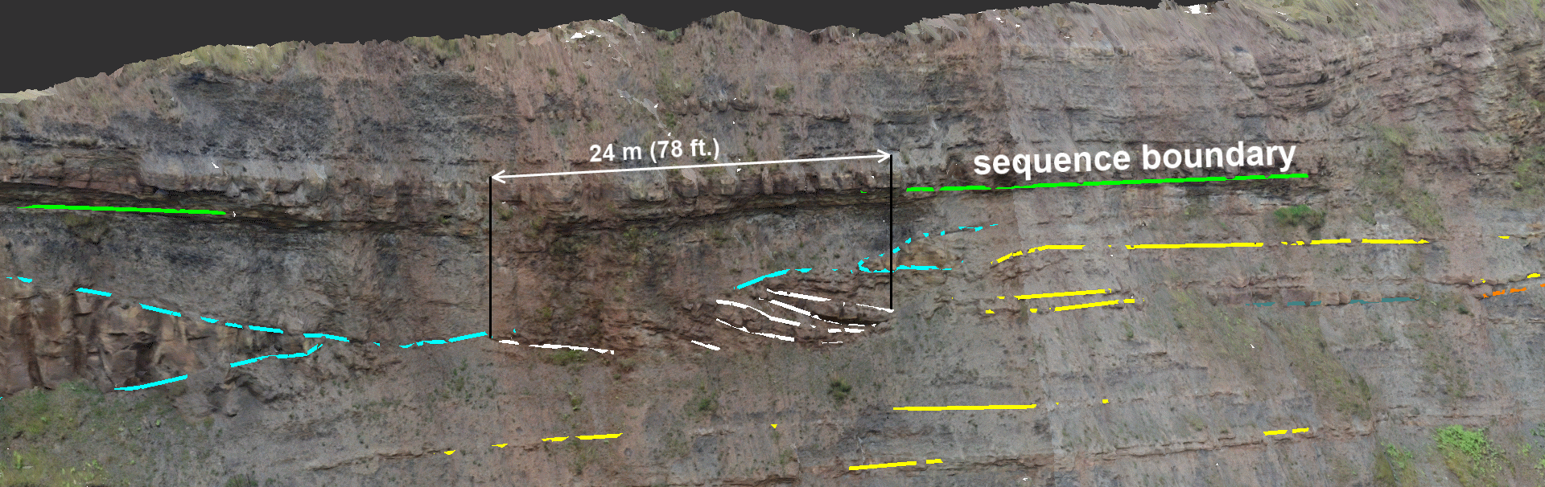

**Fig. 4.** 3D-registered interpretations of the Saltwick Formation (North Yorkshire, UK) geological case study highlighting the sandstone channel architecture of the North Sea cliff section outcrop.

**Acknowledgements**

The VOM2MPS (i.e. the research of Uni Research-affiliated authors) is funded as a Petromaks 2 project (no. 234111/E30) by the Research Council of Norway and the Force consortium, while data (e.g. Yorkshire datasets) are provided by SAFARI ([www.safaridb.com](http://www.safaridb.com)).

Gratefully, acknowledge is given to the European Social Fund (ESF) and the Free State of Saxony for their financial support on a grant (funding no. 100235479).

**References**

1. Agus, M., Gobbetti, E., Marton, F., Pintore, G., & Vázquez, P. P. (2017). Mobile Graphics. EuroGraphics 2017 – Tutorials. The Eurographics Association.
2. Baboud, L., Čadík, M., Eisemann, E., & Seidel, H. P. (2011, June). Automatic photo-to-terrain alignment for the annotation of mountain pictures. In Computer Vision and Pattern Recognition (CVPR), 2011 IEEE Conference on (pp. 41-48). IEEE.
3. Blum, J. R., Greencorn, D. G., & Cooperstock, J. R. (2012, December). Smartphone sensor reliability for augmented reality applications. In International Conference on Mobile and Ubiquitous Systems: Computing, Networking, and Services (pp. 127-138). Springer, Berlin, Heidelberg.
4. Bodensteiner, C., Hebel, M., & Arens, M. (2010, September). Accurate Single Image Multi-modal Camera Pose Estimation. In ECCV Workshops (1) (pp. 296-309).
5. Boerner, R. & Kröhnert, M. (2016). Brute force matching between camera shots and synthetic images from point clouds. Int. Arch. Photogramm. Remote Sens. Spatial Inf. Sci., XLI-B5, 771-777.
6. Brown, D. C. (1971). Close-range camera calibration. In Photogrammetric Engineering, 37(8), 855-866.
7. Caron, G., Dame, A., & Marchand, E. (2014). Direct model based visual tracking and pose estimation using mutual information. Image and Vision Computing, 32(1), 54-63.
8. Duchateau, R., & Mackaness, W. A. (2017). Smartphone-based volunteered geographic information for land registration: the case of the Scottish crofting community.
9. Eltner, A., Sardemann, H., Kröhnert, M. & Schwalbe, E. (2017). Camera based low-cost system to monitor hydrologic parameters in small catchments. EGU General Assembly Conference Abstracts 19.
10. Ericsson (2017). Ericsson Mobility Report. August 2017. Stockholm.
11. García, S., Pagés, R., Berjón, D., & Morán, F. (2015, June). Textured splat-based point clouds for rendering in handheld devices. In Proceedings of the 20th International Conference on 3D Web Technology (pp. 227-230). ACM.
12. Guislain, M., Digne, J., Chaine, R., & Monnier, G. (2017). Fine scale image registration in large-scale urban LIDAR point sets. Computer Vision and Image Understanding, 157, 90-102.
13. Howell, J. A., Martinius, A. W., & Good, T. R. (2014). The application of outcrop analogues in geological modelling: A review, present status and future outlook. Geological Society, London, Special Publications, 387(1), 1-25.
14. Hudelist, M. A., Cobârzan, C., & Schoeffmann, K. (2014, April). OpenCV performance measurements on mobile devices. In Proceedings of International Conference on Multimedia Retrieval (p. 479). ACM.
15. Kehl, C., Buckley, S., Viola, I., Viseur, S., Gawthorpe, R., Howell, J. (2017a): Automatic Illumination-Invariant Image-to-Geometry Registration in Outdoor Environments. The Photogrammetric Record 32(158).
16. Kehl, C., Buckley, S., Gawthorpe, R., Viola, I., Howell, J. (2016a): Direct Image-to-Geometry Registration Using Mobile Sensor Data. ISPRS Annals of Photogrammetry, Remote Sensing & Spatial Information 3(2), pp.121-128.
17. Kehl, C., Buckley, S., Howell, J. (2015a): Image-to-Geometry Registration on Mobile Devices - An Algorithmic Assessment. Proceedings of 18th 3D NordOst, Berlin, pp.17-26.
18. Khan, R., Van de Weijer, J., Shahbaz Khan, F., Muselet, D., Ducottet, C., & Barat, C. (2013). Discriminative color descriptors. In Proceedings of the IEEE conference on computer vision and pattern recognition (pp. 2866-2873).
19. Kok, M., Hol, J. D., & Schön, T. B. (2017). Using inertial sensors for position and orientation estimation. arXiv preprint arXiv:1704.06053.
20. Kröhnert, M. & Meichsner, R. (2017). Segmentation of environmental time lapse image sequences for the determination of shore lines captured by hand-held smartphone cameras. ISPRS Ann. Photogramm. Remote Sens. Spatial Inf. Sci., IV-2/W4, 1-8.
21. Kröhnert, M. (2016): Automatic Waterline Extraction from Smartphone Images. International Archives of the Photogrammetry, Remote Sensing and Spatial Information Sciences XLI(B5), pp.857-863.
22. Lepetit, V., Moreno-Noguer, F., & Fua, P. (2009). Epnp: An accurate o (n) solution to the pnp problem. International journal of computer vision, 81(2), 155-166.
23. Lewin, S. (2014). The smartphone recipe. IEEE Spectrum, 51(12): p 80.
24. Li, S., Xu, C., & Xie, M. (2012). A robust O (n) solution to the perspective-n-point problem. IEEE transactions on pattern analysis and machine intelligence, 34(7), 1444-1450.
25. Ligorio, G., & Sabatini, A. M. (2013). Extended Kalman filter-based methods for pose estimation using visual, inertial and magnetic sensors: Comparative analysis and performance evaluation. Sensors, 13(2), 1919-1941.
26. Linquist, M. & Galpern, P. (2016) Crowdsourcing (in) Voluntary Citizen Geospatial Data from Google Android Smartphones. Journal of Digital Landscape Architecture, 1-2016. Herbert Wichmann Verlag, VDE VERLAG GMBH, Berlin/Offenbach, p. 263-272.
27. Madsen, K., Nielsen, H. B., & Tingleff, O. (2004). Methods for non-linear least squares problems.
28. Meierhold, N. & Schmich, A. (2009). Referencing of images to laser scanner data using linear features extracted from digital images and range images. In: International Archives of Photogrammetry, Remote Sensing and Spatial Information Science Vol. XXXVIII-3/W8.
29. Novakova, L., & Pavlis, T. L. (2017). Assessment of the precision of smart phones and tablets for measurement of planar orientations: A case study. Journal of Structural Geology, 97, 93-103.
30. Nuernberger, B., Lien, K. C., Grinta, L., Sweeney, C., Turk, M., & Höllerer, T. (2016, November). Multi-view gesture annotations in image-based 3D reconstructed scenes. In Proceedings of the 22nd ACM Conference on Virtual Reality Software and Technology (pp. 129-138). ACM.
31. Pacha, A. (2015). Sensor Fusion for Robust Outdoor Augmented Reality Tracking on Mobile Devices. GRIN Verlag, USA.
32. Pollefeys, M., Koch, R., & Van Gool, L. (1999). Self-calibration and metric reconstruction inspite of varying and unknown intrinsic camera parameters. International Journal of Computer Vision, 32(1), 7-25.
33. Sottile, M., Dellepiane, M., Cignoni, P., & Scopigno, R. (2010). Mutual Correspondences: An Hybrid Method for Image-to-geometry Registration. In Eurographics Italian Chapter Conference (pp. 81-88).
34. Stelling, N.; Spehr, B.; Schilling, A.; Maas, H.-G.; Gumhold, S. (2010). Automatic feature matching between digital images and 2D representations of a laser scanner point cloud. In: International Archives of Photogrammetry, Remote Sensing and Spatial Information Sciences Vol. 38, Part 5.
35. Sweeney, C., Flynn, J., Nuernberger, B., Turk, M., & Höllerer, T. (2015, September). Efficient computation of absolute pose for gravity-aware augmented reality. In Mixed and Augmented Reality (ISMAR), 2015 IEEE International Symposium on (pp. 19-24). IEEE.
36. Tsai, R. (1987). A versatile camera calibration technique for high-accuracy 3D machine vision metrology using off-the-shelf TV cameras and lenses. IEEE Journal on Robotics and Automation, 3(4), 323-344.
37. Wang, J., Schindler, G., & Essa, I. (2012, September). Orientation-aware scene understanding for mobile cameras. In Proceedings of the 2012 ACM Conference on Ubiquitous Computing (pp. 260-269). ACM.
38. Zhang, Z. (2000). A flexible new technique for camera calibration. IEEE Transactions on pattern analysis and machine intelligence, 22(11), 1330-1334.