*Photogrammetric Record,* xx(xxx): 000–000 (Month 20##)

Image Synthetisation, Sensors Variability and Power Consumption In Mobile Device Field Applications

Melanie Kröhnert (melanie.kroehnert@tu-dresden.de)*

Hans-Gerd Maas (hans-gerd.maas@tu-dresden.de)

*Institute for Photogrammetry & Remote Sensing, TU Dresden, Helmholtzstr. 10, 01069 Dresden, Germany*

Christian Kehl (chke[@d](mailto:remondino@fbk.eu)tu.dk)

*Danmarks Tekniske Universitet, DTU Compute, Richard Petersens Plads, Building 324, 2800 Kongens Lyngby, Denmark*

* Corresponding author

Abstract

This is an example of an original article in the layout expected by The Photogrammetric Record. The abstract is a concise summary of the essential elements of the paper, and should not contain detailed results. It should be no longer than 150 words. This template indicates how a paper submitted to journal should be structured and formatted, including figures, tables, mathematics and references.

Keywords: photogrammetry, example, word or short phrase, layout, maximum 6 words

I. Introduction

A considerable number of domains within the geosciences rely on digitised natural observations and their interpretation to steer and constrain numerical models. Published (semi-)automatic interpretation methods (Nyberg, et al., 2015, Ruiu et al., 2015) emerged within the past decade that support the digital documentation of observations and interpretations. These advanced interpretation techniques require increasingly complex computing that is restricted to office-based work environments, which poses a problem for field-based studies. Domains such as hydrology, geology or glaciology (as illustrated in fig. \ref{fig:intro:interpretation}) hence established multi-stage procedures where observations are taken manually in the field and later digitised in the office. This is disadvantageous, so there is an increasing desire within the referred domains to facilitate digital interpretations in the field at the study location. Mobile computing equipment (e.g. smartphones and tablets) are one technological option to facilitate such digital field-based workflows, as shown in fig. \ref{fig:intro:mobileInterpretationInField}. These devices are nowadays ubiquitous and can easily be equipped in field-based research. Also, as seen in technical magazines and the general media, the range of available devices continuously increases, which allows to find a ''fit-for-purpose`` device to each specific situation. New application cases, which are demonstrated and discussed in this article, and commitment within geoscience- and computer technology industry lead to an increasing interest in this cross-disciplinary domain between mobile computing and geoscientific documentation.

|  |  |
| --- | --- |
|  |  |

Fig. 1. Illustrative examples for geological interpretation (a) and hydrological annotation (b).

Next to easily available, pocket-format computing devices, the required three-dimensional base data for modern applications also need to be available and be processed in a ''mobile-ready`` manner. The availability of topographic 3D surface data is steadily increasing due to easy-to-use software and instrumentation for surface generation (e.g. drones, \gls{SfM} \cite{Wu2013} and multi-view geometry \cite{Goesele2007}, satellite \glspl{DEM}). Furthermore, crowdsourced data and \gls{VGI} contribute to the geoscience data inventory, being acquired by citizen scientists. %amateur scientists and domain enthusiasts.

Domain-specific mobile software is required in order allow for data interaction on the available mobile devices. Specific challenges such as power consumption, multi-manufacturer support, smart sensor utilisation and device intercommunication distinguish mobile software from common desktop software. This leads to a very different electronics design of tablets and smartphones compared to desktop PCs and laptops. In return, this means that existing approaches for digital data processing and interpretation are not transferable as--is to this new computing domain. Even when considering the fast technological development, there are some challenges within mobile device software development that are rooted in the technology itself: user interfaces need to be designed specifically for touch screen interfaces, natural language interfaces and gesture interaction (e.g. ''swipe`` and ''optical lens`` motions). \Gls{GNSS}-based localisation accuracy, as delivered by the integrated-circuit sensor of mobile devices, is inferior to common user expectations and requirements in geoscientific studies. The modalities of sensor data delivery (be it hardware sensor or software emulation), photo capturing and processing, and the computational capabilities of mobile devices differ significantly between each vendors. Short-comings, such as inappropriate data structuring, visual object correlation and registration, increasing data volumes and the unavailability of off-the-shelf program codes further complicate the technological development. Addressing the demonstrated challenges distinguishes the mobile application development from common desktop software development for geoscience purposes.

This article demonstrates how the above-listed challenges can be addressed to provide, in the end, the desired added value for field-based research. This demonstration addresses the 3D data annotation and interpretation for two use cases within the domains of surface hydrology and (petroleum) geology. The content covered in the article is a detail-driven extension of earlier published research \cite{Kroehnert2017b}, focussing on extensive measurements to verify the reasoning and statements of previous studies.

The sections within this article adhere to the following structure: First, the use cases are presented as opening statements to introduce field-related tasks that are to be addressed with mobile device technology. Second, different 3D surface data representations are introduced that are employed within this article. Third, algorithmic baseline concepts that are key for annotating and interpreting 3D data on mobile devices are introduced, summarising project-internal development by the authors as well as referencing key literature on the subject. Fourth, the algorithms are mapped to the specific mobile technologies and components. The technologies and major parameters that impact the target applications are highlighted. Finally, we showcase and discuss how available mobile systems are used in application scenarios from surface hydrology (i.e. water level gauging) and petroleum geology (i.e. field interpretation and virtual field trips) to improve data analysis and integrate outdoor measurements in digital workflows. Then, the article is finalized with some concluding remarks and discussions for future developments in this research trajectory.

II. Target case studies

The focus in this study is to assess the applicability of mobile devices and the operational metrics impacting their application in scenarios that annotate or interpreted 3D surface data (commonly capturing surface topography) that are impacted by certain processes, such as surface fluid flow and sedimentary deposition. Other processes to which this scenario extends are erosional processes (e.g. coastal monitoring \cite{Letortu2017, Medjkane2018}), glacial processes (e.g. glacial motion and monitoring \cite{Schwalbe2017b}) and landslides.

These domain applications feature common challenges and tasks: Given a 3D surface model being observed from a given viewpoint (combining observation position and three-dimensional view direction), features in the topography are to be delineated in a pre-defined geo-referencing context. The delineation can be approximately horizontal to the average surface, as being the case for water level gauging, diagonal, as the case for tracking the moving front of glaciers relative to the embedding landscape, or embedded as free forms within the topography, such as for landslide boundaries as well as geological element boundaries. The delineations document observations or interpretations relative to the topography.

The specific case studies covered in this article cover surface hydrology and field geology. The former application attempts to document horizontal water level gauge observations for free surface flow hydrology in river catchments with a high degree of mapping accuracy. In order to meet the demanded accuracy, the presented *Open Water Level* software makes use of temporally correlated image sequences from time lapse series. The latter application maps user-defined free form interpretations on the rock face of an outcrop to delineate geological element boundaries, facies, and supplementary depositional information. Time lapse series acquisition requires multiple camera shots to be captured which draws extra power. Power consumption is a major concern for field geology, therefore reducing the mapping basis to single shots and short-term sensor interpolations. Due to the documentation of interpretations, the hard power requirement and the free-form delineation, the final line mapping accuracy is necessarily relaxed compared to water level gauging.

III. Representation basis – Geometry and Radiometry

Various representation forms for 3D terrain data are available. While early digital systems used gridded \glspl{DEM} for their simplicity and compact storage \cite{Trinks2005,McCaffrey2005}, \glspl{DSM} and \glspl{TIN} are dominating most terrain-based systems for application-specific analysis \cite{Buckley2008a,Caumon2013}. A useful example can be seen in \cite{Schwalbe2017b} for glaciology, where the authors use a triangulated digital surface model to represent a Patagonian glacier front.

For triangular surfaces, it is important to distinguish geometrically valid \glspl{TIN} from polygon soup surfaces (fig. \ref{fig:representations:meshDistinction}). While the latter is often employed in early stages of mesh-based software systems due to its simplicity and ease of implementation, valid \glspl{TIN} are employed in mature stages of the analysis. This is because some automated analysis (e.g. auto-interpretation, volume derivation) require clean surfaces with coherently outward-oriented surface normals.

|  |  |
| --- | --- |
|  |  |

Fig. 1. Illustrative distinction between valid \glspl{TIN} (a, consisting of one exclusive, smooth, closed surface) and polygonal soups (b). Non-textured model parts are coloured with respect to their actual segment number. Images taken from \cite{Kehl2017_PhDThesis}.

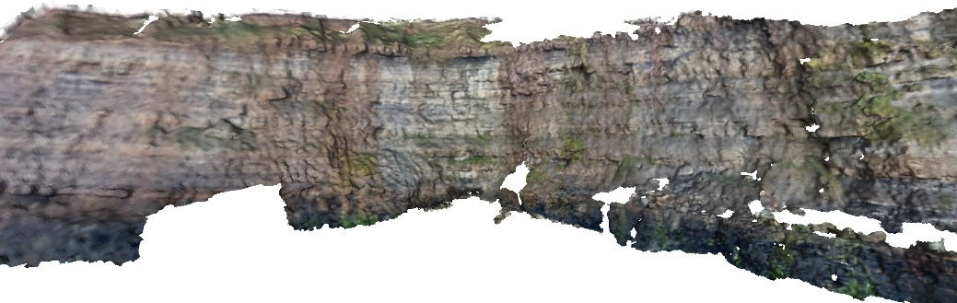

Fig. 1. Example of a \gls{DOM} as textured triangular surface.

In geoscience domains such as petroleum geology, texture- and color information are vital for interpretation- and analysis tasks. In these cases, as demonstrated by Buckley et. al \cite{Buckley2008a} and Caumon et. al \cite{Caumon2013}, the surface is supplemented with photographic information via texture projection. The models are referred to as \glspl{DOM} (see fig. \ref{fig:representations:DOM} as reference depiction).

In contrast, other geoscience domains, such as hydrology and free surface flow management, used georeferenced laser scanner point clouds and coloured point data streams provided by terrestrial photogrammetry for small- or \gls{UAV} for large-scale study cases. The \glspl{PSS} support tasks like coastal monitoring \cite{Letortu2017, Medjkane2018}, soil erosion and rain-induced landslide observation, and even monitoring river topography \cite{Watanabe2016} and flood protection management \cite{Leskens2015}. Nevertheless, new approaches for low-cost and on-the-fly river monitoring \cite{Kroehnert2017a} arise due to globally increasing flash flood events after heavy rainfalls \cite{Mueller2011} that are further addressed in section \ref{sec:water_level_gauging_intro}.

Since \gls{SfM} became state of the art in geosciences, the acquisition of (true-) coloured ''point cloud`` models is not that difficult and commonly employed because of its rapid processing, compared to conventional approaches like \gls{TLS}. Regarding 3D annotation, nearest neighbour analysis provides an opportunity whereby surface triangulation can be avoided.

The stated base concepts of geometric representation and radiometric texture information are also valid for mobile device software. Because of the limited processing speed of mobile chipsets, the usage of point clouds appears most common within the graphics literature (e.g. Garcia et. al \cite{Garcia2015}). The sparse vertex distribution in point clouds causes problems in the data analysis, which is why \glspl{DEM} have seen a revival in the mobile computing domain. \Glspl{DEM} provide dense, closed geometric models that can be rendered and processed efficiently. Furthermore, with the inferior memory capacity of mobile devices in comparison to laptops and workstations, the possible compression options for point clouds and \glspl{DEM} are advantageous. Base mapping applications such as Google Maps use \glspl{DEM}, derived from \gls{LiDAR} or satellite data \cite{Farr2007}, as their main topographic representation. Other 3D processing systems on mobile devices within the geosciences, such as \textit{Outcrop} and the \textit{\gls{GRIT}}, employ genuine textured triangulated \glspl{DSM}.

The chosen form of model representation significantly impacts the algorithms and analytical capabilities employed on the mobile device. Although all algorithms presented in this article work on either form of representation, some of the algorithms favour the treatment of triangulated surfaces (e.g. image-to-geometry registration, guided interpretation), while others clearly favour point-based representations (e.g. rendering).

IV. Algorithms

This section demonstrates novel- as well as existing algorithms and methods on mobile devices that provide the basis for case-specific field-based annotation, interpretation and analysis shown in section \ref{sec:case_studies}. As mentioned before, the effectiveness of each algorithm depends on the applied model representation.

4.1. Image-to-geometry registration

Image-to-geometry algorithms aim at registering 2D images to a given 3D surface, providing a transformation from the 2D image coordinate system to 3D model coordinate system as follows:

with – rotation matrix; – translation vector

– point of the object; – (projected) point of the image plane

– image plane coordinates; – world coordinates

Using this coordinate system transformation in combination with a known interior camera orientation, it is possible to project each image on the surface. Specific objects outlined in the image, such as image-based interpretations, can also be mapped on the surface. In the geosciences, these algorithms are employed to create a direct correlation between the 3D model and the screen- or image space on which annotations and interpretations are based on \cite{Kehl2016_ISPRS}.

Amongst the published literature, feature-based registration algorithms are most common. Here, salient points (e.g. SIFT, SURF, Harris corners) or edges within the photograph and rendered image of the target 3D model are used to establish an image-to-image correlation.

In order to establish a 2D--3D correlation, there are two prevalent approaches available: for triangle mesh models, the 2D feature locations within the rendered image are raycasted using the virtual camera's vanishing point, the imaging plane, and the 3D surface model (see fig. 2 in \cite{Kehl2016_ISPRS}). The intersection between the ray and a triangle within the mesh results in the correlated 3D coordinate of the 2D feature. An alternative approach is needed for point-based models because raycasting does not apply to point representations (i.e. points cannot be intersected directly due to their zero-extent). The alternative approach often applied (see \cite{Sibbing2013,Sattler2011,Rodriguez2012,Garcia2015}) employs smart rendering techniques that virtually expand the point into an area feature (e.g. blob, disk or sphere), which is subsequently rendered into a depth map. Afterwards, the 3D coordinate of a 2D feature can be inferred directly from the depth map. Though cleverly utilising graphics technology, this approach is limited by an accuracy-to-speed trade-off: low-resolution and low-quantisation depth maps introduce artificial accuracy errors in the registration process, whereas high-resolution depth maps cost considerable performance in the image generation. This last point is particularly important when employing depth map algorithms on mobile devices.

When 2D--3D point pairs are established, the coordinates are normalized and put into a least-squares optimization system, where the target is to determine the exterior camera parameters () from the 2D--3D point-based equation system. Non-linear optimisation systems (e.g. Levenberg-Marquardt) are applied to estimate the desired parameter set \cite{Torr2000}. The whole process can easily be executed on mobile devices \cite{Kehl2016_ISPRS}. One of the prevalent practical challenges when employing feature-based image-to-geometry registration is to achieve a reliable feature correlation, which is often achieved by introducing application-specific constraints (e.g. horizon alignment, straight-edge enforcement or object outlines).

Feature-based registration is the most common approach for establishing image-to-geometry correlation on mobile devices due to its implementation simplicity, its rapid execution speed, its option for application-specific constraints and the wealth of available code that can be used. Examples its application are ample within the literature, ranging from augmented reality \cite{Gauglitz2014,Sweeney2015} over field geology \cite{Kehl2016_ISPRS,Kehl2017_VGC} to surface hydrology \cite{Kroehnert2017a,Boerner2016}. These mobile apps utilize the open-source library *OpenCV4Android*[1], which is also employed in this work[2]. Problems in real-world cases are caused by imaging variances, resulting in reduced reliability (i.e. failing to determine any camera parameters) and stability (i.e. determining different parameters for the same sets of images) \cite{Kehl2017_PHOR}. A completely alternative technique to feature-based methods is \gls{MI} \cite{Viola1997,Corsini2013}. \Gls{MI} performs a pixel-wise comparison between the photo and the 2D rendering of the 3D scene and aims at minimizing the image discrepancies (i.e. ). The technique uses information theory quantities such as self-information and entropy in order to compare the similarity of both image (see \cite{Bonaventura2017} for further applications of \gls{MI} within the geosciences). In contrast to feature-based techniques, \gls{MI} faces challenges in the optimization process: the optimization of a 7 degree-of-freedom equation system (, for being the focal length) is unstable and prone to rest in local function minima. Only few optimisation solvers are known that can solve such equation systems reliably and provide stable results - most notably NEWUOA (i.e. Powell's method\cite{Powell2006}) used by Corsini et al. \cite{Corsini2013}. As these stable solvers are not available in modern- and mobile-device programming languages, the use of \gls{MI} is currently prohibited for mobile platforms.

While the task of image-to-geometry registration can be offloaded to remote computers in the network, it is advantageous to perform the registration on the mobile device itself. This is because, in the overall target of model annotation, the interaction and actual annotation (as explained in section \ref{sec:algorithms:interpretation}) is more intuitive for the user when being performed on photos and images. If the registration of the images is done on the mobile device, it allows for direct feedback and ad-hoc visual quality checks of the interpretations on the underlying 3D surface model (see fig. 7 in \cite{Kehl2017_VGC}). Furthermore, as shown by measurements in section \ref{sec:technology:power}, it can be argued that 2D interpretation are more energy efficient than direct 3D interpretations. Lastly, in settings where network access and offline processing is prohibited, an on-device registration procedure is without alternatives.

4.2 Mesh-based rendering

Rendering a surface model in this context refers to the image generation of the 3D data by projective rasterization to the 2D image plane of a virtual camera. This process is performed on mobile devices for the purpose to model presentation as well as for the generation of a synthetic reference image for image-to-geometry registration. Furthermore, it can be used to synthesize an image from available 3D data for interpretation and annotation in 2D.

Algorithms for rendering textured triangulated surfaces are well-known amongst technology-affine personnel. In the common rendering pipeline, the textured mesh is transferred as a set of (attributed) vertices and primitive sets (e.g. triangles, polygons) to the \gls{GPU}. The virtual camera is set up using the pre-defined view projection matrix while the graphics primitives are repositioned using the model-related transformation matrix. The rasterizer projects the available 3D information into the camera plane and performs hidden-surface removal. The result is a discrete-space pixel representation. Modern programmable shaders allow in-time vertex decompression (see \cite{Ponchio2016}) as well as texture decompression (see section \ref{sec:technology:graphics}). Available textures are mapped as images on the surface using the texture coordinate vertex attributes. The mesh-based rendering algorithms employed on desktop computers are analogous to mobile devices, whereas the technological details are posing the actual challenges.

4.3 A novel approach to mobile point-based rendering

In comparison to mesh-based rendering, simple point projection seems to be a nice alternative, saving computational resources and efforts for post-processing regarding outlier removal. Thus, we simply project object points onto an image plane using perspective projection, assuming a distortion-free ideal camera with centred principle point. Thus, the camera matrix equals identity matrix and can be neglected.

First, applying a six-parameter transformation transfers three-dimensional object points from world reference frame into a 3D camera system using

where is a orthonormal rotation matrix and the translation vector to camera's projection center. For simplicity, the usage of the planar Cartesian UTM system with pointing to the east and pointing to the north with respect to the prevalent zone number. For component, the height over the Earth Gravitational Model 1996 (EGM96) is advisable to use.

Counting for homogeneous coordinates, we can describe the relation between camera and image coordinates involving their depth components.

For camera's imaging plane, we introduce the constant that defines the distance between camera's sensor and its projection center in , which equals focal length . To separate camera sensor system and image system, we use the term when referring to the sensor , and for digital image coordinates . For conversion, must be divided by the sensor's pixel pitch. The normalization of the projected points to homogeneous coordinates is key in the further processing. This is analogous to the image-to-geometry projection in eq. \ref{eq:i2g:projection}, where the projection variable is replaced with the camera constant .

For a final transformation of 2D sensor coordinates into image pixels, we need to shift the image coordinate system to the origin to left upper corner and scale the coordinates from global units in meters per pixel using . Thus, we derive image coordinates for an ideal camera using

4.3.1 Calculation of 3D bounding box of interest and image plane

In the mobile rendering scenario, we need to define a region of interest regarding 3D point projection in order to cull the render content of the virtual camera to the user's field of view (figure \ref{fig:4_3_bounding_box}). The view frustum's bounding box corner points are calculated using the position and orientation from fused smartphone sensors. Thereby it must be noted that only the heading is used for estimating viewing direction; tilt and roll are excluded. Because of uncertainties regarding exterior information (section \ref{sec:technology:sensors}), the bounding box must be expanded to cover more object space than described by the sensors as well as the camera's field of view. Because of possible noise due to positioning, constants and describe the domain of projection center's uncertainties parallel to image plane. For errors in depth, we define the correction for shifting the projection center along camera axis.

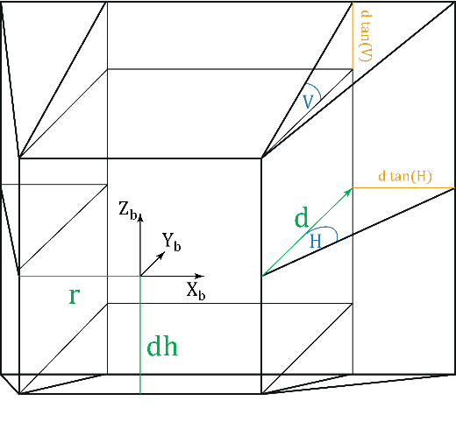

Fig. 1. Bounding box definition.

The box is widened by the horizontal and vertical opening angles with a fixed depth . In order to generate reference data for image-to-geometry registration to annotate 3D data by mobile imagery, the lateral accuracy given by the mobile positioning system as well as the prevalent camera characteristics solve for the mentioned parameters. For camera-based gauging, we set . Additional tiling of the 3D base data is advisable for a rapid geometry-in-frustum containment checks.

Using the defined frustum of a pyramid as region of interest with a local reference system, the image plane for 3D point rendering can be defined by perspective projection of the remote plane (\ref{fig:4_3_bounding_box}) with

For the bounding box’ background plane upper left and

for the lower right corner. Its height equals the height component in the world reference frame . Because of pyramid frustum, we subsequently eliminate points outside the near- and far clipping plane.

4.3.2 Pyramid approach for depth filtering

Because of a limited range of pixels with defined size inside a image plane it seems to be obvious that, in most cases, more than one 3D object points corresponds to the same image pixel. Due to inhomogeneous coordinates it is not possible to figure out afterwards which points are in foreground compared to the camera distances and which ones are behind and thus not visible. This problem can easily be solved during point cloud projection described above by a simple camera-to-object distance check. However, one problem still remains in case of e.g. glass fronts with lacking information (in \gls{TLS} due to deflected lidar or \gls{SfM} when having homogeneous surfaces) or small archs (see figure \ref{fig:4_3_dist_images}). Then, points might be visible pointing away from camera projection center. On the one hand, point normals may solve the problem but due to the data acquisition technique and the model's complexity, they are more or less easy to derive \cite{Sattler2011}.

Scale-space image pyramids are a nice alternative approach to overcome the issue. Our scale space is constructed from multiple synthetic images via step-by-step adjustment of (see eq. \ref{eq:final_ps}) with , resulting in halve the number of image rows and columns per layer. Then, the algorithm verifies if two pixels corresponds in two subsequent layers, preserving edges (figure \ref{fig:4_3_point_filtering},\ref{fig:4_3_dist_images}).

4.3.3 Filling gaps due to missing points

Because of pixel size and image plane definition with a specific resolution (i.e. depending on smartphone full-scale camera's resolution for image registration purposes) there will still be gaps between projected points (see figure \ref{fig:4_3_dist_images}, right). In order to fill these gaps, we recommend to use a simple nearest neighbour approach using binary search \cite{Bentley1975} in the 3D domain to fill these gaps, applying weights to average 3D points color attributes depending on their euclidean distances. For this, thresholds for maximum distances between 3D points must be applied to avoid unreasonable gap-filling. Exemplary for use case in section \ref{sec:water_level_gauging_intro}, a before--after comparison of the gap filling is shown in figure \ref{fig:4_3_fill_images_before_after}.

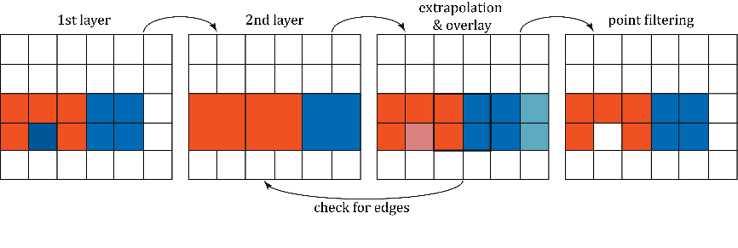

Fig. 1. Visualisation of hierarchical depth filtering to handle point occlusions.

|  |  |
| --- | --- |
|  |  |

FIG. 1. Obscured but visible 3D points close to arches and windows (a), edge preserving result after filtering (b).

4.4. Interpretation and Annotation

Interpretation and annotation techniques aim to map geometries (e.g. lines, polygons) of domain-specific information to the 3D base surface. The mapped geometries are used to delineate interest boundaries or to segment the surface into semantically meaningful units.

In hydrological cases, line interpretations are commonly used to mark current water levels as well as high-tide or high-surge water levels. Health monitoring of dykes and levees can use line interpretations to mark cracks within surge defense structures. In geological cases, a mixture of line- and polygon geometries are used. Line interpretations are more commonly related to structural rock features (e.g. cracks, fractures, fault zone boundaries, stratigraphic boundaries), while polygonal area segmentation is more common in sedimentology (e.g. depositional elements, sedimentary objects, sediment facies). That being said, application of the geometries within geology is flexible, as observed in the case of fault facies which use area marks for structural features.

The delineation and mapping can be performed in various ways, depending on the geometric representation of the 3D base surface geometry. Point clouds and 3D \glspl{TIN} can be annotated directly in 3D. In these cases, area markings can be directly embedded as vertex attributes while closest-vertex searches (for point clouds) or view-surface intersections (for \glspl{TIN}) provide the lines' corner points. The largest problems with such direct-3D approach on mobile devices are the data size of the underlying surface and the computational complexity of neighbourhood searches. Nearest neighbour search has a computational complexity of , where for 3D surfaces and $n$ being the number of vertices in the dataset. This results in non-interactive execution times for 3D vertex marking on mobile devices with real-world datasets (with . Performing interpretations in 3D on mobile devices also require supportive interaction schemes, including intuitive and easy-access switches between 3D space orientation and actual point selection for the user. Other issues for general direct-3D surface interpretation include the a sparse vertex distribution and open, non-convex geometry (being a particular problem for \glspl{TIN}), surface occlusion and intricate problems related to curved surfaces, where the Euclidean vertex distance and geodesic distance along the surface can differ significantly.

Utilising the aforementioned image-to-geometry registration (section \ref{sec:algorithms:I2G}), the given issues of direct-3D interpretation and 3D interaction can be circumvented. The raster image interpretation is computationally more efficient due to the gridded data arrangement and easier to use for novice practitioners on mobile devices. The interpretation geometries are generated as 2D vector graphics elements, which are projected on the 3D surface after the image registration using the estimated external camera orientation or pose.

V Technology

5.1 Sensors

What is the great difference between former mobiles and today's smartphones? Smartphones have many inbuilt sensors such as acceleration measurement units, compasses or gyroscopes, playing increasing rolls not only to have control over display or camera rotation. In the following we assess orientation accuracy and precision by applying different sensor fusion methods, which in their turn influence image-to-geometry registration. Furthermore, we give a short review over smartphones' positioning quality in relation to 3D annotation.

5.1.1 Localisation

Compared to the years 2008 and 2009, sales volume for navigation systems declined sharply and constantly by approximately 70 percent compared to 2017 in Germany[3].One of the most important factors behind this may lie in the distribution of smartphones with inbuilt positioning systems, providing quite interesting alternatives to former navigation systems.

For this, most of today's smartphones are equipped with \gls{aGPS} receivers that are able to receive data from American GPS, Russian GLONASS and increasingly European GALILEO as well as Chinese BAIDOU. Even within the geosciences, smartphones gain more and more popularity e.g. for mobile mapping \cite{Westhead2011,Masiero2016}, or actually 3D reconstruction \cite{Micheletti2015,Muratov2016,Ishihara2017}.

Based on these facts, many research groups recently discussed the potential of smartphone localisation strategies whereby we want to focus on outdoor use cases based on \glspl{GNSS}. Blum et al. (2013) \cite{Blum2013} observe the positioning for Android smartphone Samsung Galaxy Nexus and Apple Iphone 4 with different environmental conditions. Walking through the city they get lateral accuracies of about 10-15m close to buildings no taller than three stories. Near skyscrapers, errors of about 30m should be expected with local extremas up to 60m. Similar things are published by Fritsch et al. (2011) \cite{Fritsch2011} who determined a overall accuracy for Android smartphone HTC Hero of 15-25 m valid in 95 % of cases which was also estimated by Zhu et al. (2013) \cite{Zhu2013} and Zandbergen et al. (2011) \cite{Zandbergen2011}. Exemplary for open spaces, Meek et al. (2013) \cite{Meek2013} observe an average \gls{GPS} accuracy of 6.8m using a Google Nexus S smartphone. However, height estimation seems to be more critical where \cite{Liu2014} name error margins for altitude determination using smartphone's inbuilt \gls{aGPS} which seem to be 2.5 times more than the horizontal component and recommend the alternative usage of barometric approaches, providing height accuracies up to 3m. Unfortunately, only a few of common smartphones have inbuilt barometers and reference data, necessary for barometric altitudes, is quite difficult to obtain.

5.1.2 Location sensitivity

Pre-knowledge about an image's position is a prerequisite for image-to-geometry registration. Thus, we are asking for how do uncertainties in positioning affect feature detection and furthermore the matching results. We observe the behaviour on the example of *Open Water Levels* using manually registered reference data to derive the prevalent water level. Afterwards, we change the image's real position, defined in UTM33 WGS84 reference frame, in steps of 2.5 m up to a deviation of 25 m for northing, easting and height component and compare the detected water line with ground truth data from an administrative water gauge (see figure \ref{fig:sensor_sensi:easting}, \ref{fig:sensor_sensi:northing}) having an enclosing \gls{DEM}.

Surprisingly, all components are rather equal affected by erroneous locations which rapidly leads to infeasible matchings when location differs more than 2.5 m/ 5 m (northing/easting). For height component, the results are quite unstable regarding inlier occurrences and results for water levels.

Compared to observed accuracies of smartphone inbuilt \gls{GNSS}, the results refer to be non-negligible issues. Thus, in \textit{Open Water Levels}, the user can call Google Maps (if access to the internet is permitted) for manual position refinement, whereas \gls{GRIT} enables repositioning based on locally stored \gls{DEM} data for user-guided repositioning. To correct the even more erroneous height measurements, one option is the use of external \glspl{DEM} included in \gls{GRIT} or invoking third party models e.g. via Google Elevation API[4] , as it is implemented in *Open Water Levels*.

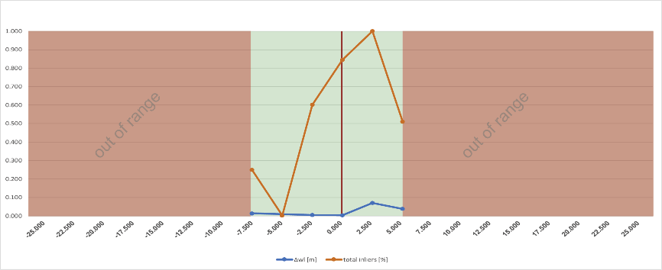

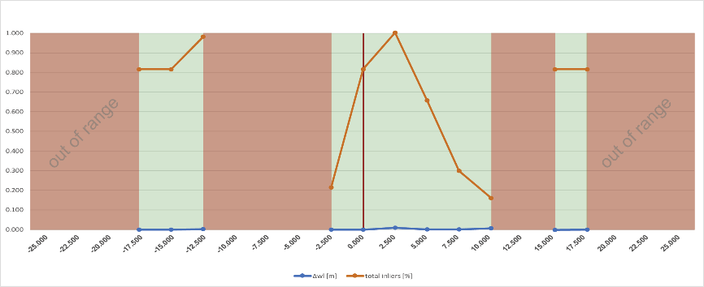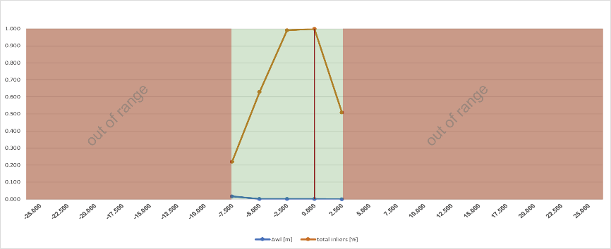

FIG. 1. Behaviour of image-to-geometry intersection depending on location uncertainties. Tuning the easting (a), northing (b) and height (c) component independently from each other whereas the others remained unchanged. ... absolute error for water level in meters, total inliers... number of image features in feature-based matching displayed in percent depending on most occurrence, red/yellow/green area... range of accuracy.

*5.1.3 Orientation*

Nothing to say that low-cost sensor systems for orientation determination, as they are integrated in smartphones, may not have precision and stability compared to professional \glspl{IMU}. Thus, we put forward the hypotheses that noise in smartphone sensor stability as well as their accuracies may not be in ranges comparable to navigation systems in autonomous navigation applications.

To give some basis, a smartphone orientation unit never depends on only one single sensor. It commonly consists of several components like accelerometers, magnetometers, gravity sensors or gyroscopes that measure in all three axes of the device. Due to single characteristics, sensors may complement each other’s, e.g. both, gyroscopes and accelerometers, measure the rotation of the smartphones in device-specific coordinate systems where gyroscopes are quite precise but suffer from drift effects. On the contrary, accelerometers are less sensitive for drifts but have poor signal-to-noise ratios. Applying sensor fusion helps to compensate for these negative characteristics in an ideal way.

Thus, Android divides sensors in two categories where, on the one hand, hardware sensors are true inbuilt components and on the other, virtual or soft sensors stand for fused hardware to generate a new synthetic sensor. That's why, when using Kalman filter approaches with different weights, more stability or accuracy can be given to smartphone's orientation.

Referring to Pacha \cite{Pacha2015}, he presents two alternative virtual sensors additionally to Android's Kalman filtered *Rotation Vector*[5], where the *Improved Orientation Sensor 1* should be more precise than Android's Rotation Vector but less stable whereas *Improved Orientation Sensor 2* seems to be less accurate but more robust. In the following, we check the three sensor types *Android Rotation Vector, Improved Orientation Sensor 1* and *Improved Orientation Sensor 2* for their stability and accuracy compared to a \gls{INS} that is commonly used for car and \gls{UAV} navigation. For this, we compare measurements taken at three different times for the devices Google Nexus 5, Samsung Galaxy S8 and the \gls{IMU} Spatial from the Australian company Advanced Navigation v6.1 (for sensor specifications refer to tables \ref{table:sensor:specs}[6] and \ref{table:sensor:imu}[7]).

Table I. Orientation sensor specifications for Google Nexus 5 and Samsung Galaxy S8.

|  |  |  |
| --- | --- | --- |
|  | Google Nexus 5 | Samsung Galaxy S8 |
| Accelerometer / Gyroscope | InvenSense MPU-6515 (6-axes) | ST Microelectronics LSM6DSL (6-axes) |
| Magnetic compass | Asahi Kasei AK8963 | Asahi Kasei AK09916C |
| Pricing | (-) | 6.50 USD |

Table I. IMU specifications for Advanced Navigation Spatial v6.1.

|  |  |
| --- | --- |
| Roll & pitch accuracy (static) | 0.1 ° |
| Heading accuracy (static) | 0.5 ° |
| Roll & pitch accuracy (dynamic) | 0.2 ° |
| Heading accuracy (dynamic with GNSS) | 0.2 ° |
| Heading accuracy (dynamic, magnetic only) | 0.8 ° |
| Pricing | 3.500 USD |

Each measuring epoch comprises six parts. We assume that the sensors will show different behaviour when they are rigid or in motion. Furthermore, magnetic disturbances may influence the heading angle which mainly depends on the magnetic compass sensor. Additionally, we assume that results of sensors in rest may be slightly better when they are able to calibrate themselves after a short running time in motion. All observations are independent from each other, measured over time periods of more or less 2min 30sec.

Chris: correction-read until here. The orientation part really reads quite 'bang-on' technical and I really suggest putting this - together with the battery part - into an actual PHOR paper and give a FAIRLY CONDENSED version of that in CAGEO. I fear (as I do with the 'graphics' technology section too) that we may loose the geoscience audience, because they may ask themselves 'how does this affect me' -- and it's also not that traditional of a writing for a CS audience.

For comparison, smartphone and \gls{IMU} are mounted on an inflexible non-metallic wooden stick at a distance of 1.0m (to avoid mutual magnetic interferences) with aligned (native) coordinate systems (see figure \ref{fig:technology:sensor:construction}). Only for pitch angle the opposite direction of rotation must be kept in mind.

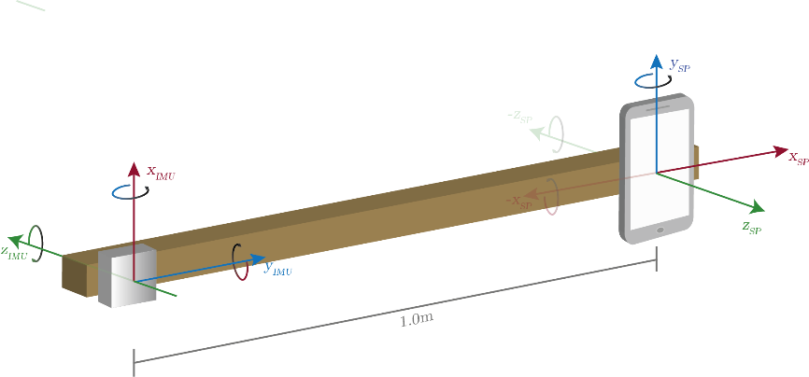

FIG. 1. Measurement setup to observe smartphone sensors accuracies and precisions. Heading (green circle)... rotation around positive/ negative z-axis referring to \gls{IMU}'s/ smartphone's native coordinate systems pointing away from sky. Pitch (red circle)... rotation around positive/ negative x-axis in \gls{IMU}'s/ smartphone's reference frame pointing out of smartphone's display to the left. Roll (blue circle)... rotation around positive x-axes for both \gls{IMU} and smartphone pointing to (true) north when smartphone is lying on a flat desk. Distance between devices on wooden stick is 1.0 m.

In the following figures \ref{fig:sensor_obs:s8:1st:fixed}, \ref{fig:sensor_obs:s8:1st:runin}, \ref{fig:sensor_obs:s8:1st:motion}, orientation tracking for Samsung Galaxy S8 in comparison with \gls{INS} (1st run) is documented whereas the others can be found in the supplementary material. The related figures collectively use the same legend, which is given in fig. \ref{fig:sensor_obs:s8:1st:legend}.

FIG. 1. Legend applicable for figure \ref{fig:sensor_obs:s8:1st:fixed} to \ref{fig:sensor_obs:s8:1st:motion}, contrasting heading, pitch and roll for different sensor fusion methods.

1. Construction fixed. Construction fixed + magnetic disturbances.

FIG. 1. Deviation between orientation angles [deg] from Samsung Galaxy S8 (dotted line) and Advanced Navigation Spatial v6.1 \gls{IMU} (straight line) captured with devices at rest. Heading, pitch and roll captured with frequencies of and matched by UTC time every .

1. Construction fixed + warm up
2. Construction fixed + warm up + magnetic disturbances

FIG. 1. Deviation between orientation angles [deg] from Samsung Galaxy S8 (dashed line) and Advanced Navigation Spatial v6.1 \gls{IMU} (straight line) captured with devices at rest after a short run-in period (device rotation around all three axes. Heading, pitch and roll captured with frequencies of and matched by UTC time every .

1. Construction in motion
2. Construction in motion + magnetic disturbances

FIG. 1. Deviation between orientation angles [deg] in-motion from Samsung Galaxy S8 and Advanced Navigation Spatial v6.1 \gls{IMU}. Heading, pitch and roll captured with frequencies of and matched by UTC time every .

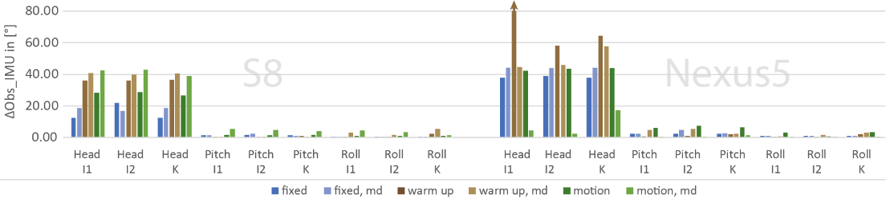

FIG. 1. Mean deviations between Samsung Galaxy S8 and Google Nexus 5 for heading, pitch and roll, respectively, use of *Improved Orientation Sensor 1, 2* (I1, I2) *and Kalman* (K) filtering

Ein Bild, das Text, Anzeigetafel, Wand enthält.

Mit sehr hoher Zuverlässigkeit generierte Beschreibung

FIG. 1. Correlation between observed orientation and reference IMU, respectively, use of *Improved Orientation Sensor 1, 2* (I1, I2) and *Kalman* (K) filtering.

Surprisingly, the results of all three virtual sensors of both smartphones show independently from each other almost the same behaviour as visualised in the figures \ref{fig:sensor_obs:s8:1st:fixed}, \ref{fig:sensor_obs:s8:1st:runin}, \ref{fig:sensor_obs:s8:1st:motion}. Especially *Improved Orientation Sensor 1* and \textit{Android Rotation Vector} are very similar whereas *Improved Orientation Sensor 2* seems to be slightly more stable as expected.

Beside this, note that pitch and especially roll angles of both smartphones are close to the orientation of the reference \gls{IMU} even if the correlations in figure \ref{fig:sensor_sensi:imu_correlation_s8_nex5} shows little similarity. This correlation issue is caused by slight synchronisation errors visible e.g. in the graphs of figures \ref{fig:sensor_obs:s8:1st:runin:4} and \ref{fig:sensor_obs:s8:1st:motion:5} which may be caused by averaging sensor values to establish comparability between both smartphones and \gls{IMU} respectively by UTC time.

Considering \glspl{RMSE} in figure \ref{fig:sensor_sensi:imu_mean_s8_nex5_tab}, good agreement with related studies can be resolved. Blum et al. (2013) \cite{Blum2013} determined orientation errors up to 30$^\circ$ for heading with significant drifts accelerating over 4$^\circ$/s while walking in the streets with an iPhone 4 for several minutes. Furthermore, Kok et al. (2017) \cite{Kok2017} show how magnetic disturbances affect all three orientation angles referring to errors of more than 30 degrees (especially for heading) which is recognizable in our studies too. They also figured out that the heading's accuracy is relatively low compared to roll and pitch, which are considered accurate. They justify the results with a worse signal-to-noise ratio of the magnetometer compared to that of the accelerometer and the local magnetic field vector, being commonly used for the compass direction that points to magnetic- instead of true north. In our case, we use the magnetic field to compute true north by location-dependent declination adding to sensor's heading and thus correct heading pointing to true north as it appears for our reference \gls{IMU}.

5.1.4 Parameter stability

Focussing on both rigid measurements, visualised in figures \ref{fig:sensor_obs:s8:1st:fixed:1} and \ref{fig:sensor_obs:s8:1st:fixed:2}, sensor stability can be assessed by comparing standard deviations summarised over full observation period of 2min 30sec (see figure \ref{fig:sensor_sensi:imu_sensor_stabi_s8_nex5}). Except heading angle, both devices show very stable measurements for all virtual sensors with standard deviations less than 0.1 °. Surprisingly, angles belonging to sensor \textit{Improved Orientation Sensor 2} show higher discrepancies although they should be less accurate but more stable. Nevertheless, for all virtual sensors the results are comparable to others studies like Fritsch et al (2011) \cite{Fritsch2011}, who measured standard deviations over 20 samples for heading, pitch and roll of 1.0 °, 0.2 ° and 0.1 ° respectively (using smartphone HTC Hero). Similar results are presented by Meek et al. (2013) \cite{Meek2013} for compass (heading) and tilt (pitch) angles referring to standard deviations of 5.1 ° and 0.75 °.

Including gyroscopes, heading is vulnerable for large drifts over time \cite{Kok2017} which is especially noticeable for our reference \gls{IMU}. Also, the \gls{IMU} seems to be rather susceptible to magnetic disturbances (see figures \ref{fig:sensor_obs:s8:1st:fixed:1} \& \ref{fig:sensor_obs:s8:1st:fixed:2} on the right hand side). As mentioned in the beginning, sensor fusion can compensate negative impacts regarding sensor hardware. We have no information for filter algorithms used in Advanced Navigation Spatial v6.1, but for smartphone orientation determination the applied virtual sensors try to compensate this deficiency.

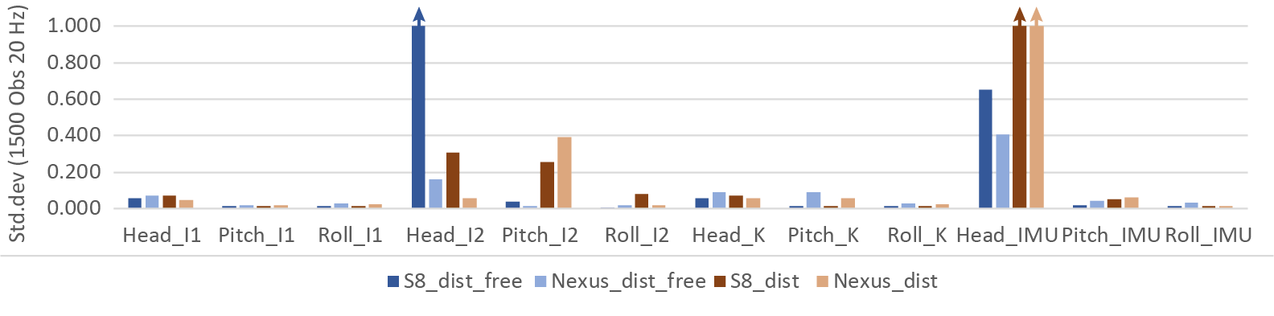

FIG. 1. Research of the orientation angles heading, pitch and roll when the devices Samsung Galaxy S8 and Google Nexus 5 are in rest, having an environment, free and full of magnetic disturbances (refer to sensor observation 1 and 2). Apply *Improved Orientation Sensor 1* and *2* (I1, I2) and *Kalman* (K) to filter the values.

*5.1.5 Parameter sensitivity*

When we talk about the registration of 3D objects and 2D image data, it becomes obvious that similarities between virtual representations and the corresponding captured photos are of pivot importance. Key drivers for this are matching extrinsics due to the projection provisions. As shown above, positioning and orientation using smartphones may be a serious problem caused by incorrect exterior orientation leading to different image contents.

We observe the behaviour of image-to-geometry intersection by the example of camera-based water gauging using the application \textit{Open Water Levels} on Samsung Galaxy S8. Thus, we compare the results of a manually selected image point of the water line that is transferred into object space using a \gls{DEM} of the scene captured at lower water (see figure \ref{fig:sensor_sensi}). For this, we changed the true angles of heading, pitch and roll (marked with red line) independently from each other in increments of five degrees turning clock- and counter-clockwise.

As shown in figure \ref{fig:sensor_sensi:heading} and \ref{fig:sensor_sensi:pitch}, changing the heading and pitch angle is correlated with the number of matching feature points essential for camera estimation. Surprisingly, the result for the determined water level seems to be almost unaffected if only $10\%$ of inliers, compared to the total amount of features being found inside the measurements series, remain due to changing view direction. Thus, the most critic angle (refer to fig. \ref{sec:technology:sensors:orientation}) can vary in range of $[-40,40]$ degrees. A similar picture emerges when assessing the angles for pitch, which can change in range of $[-25;25]$. If these limits are exceeded, the camera only sees the sky or the ground (for pitch) or looks in a completely wrong (compass) direction (regarding heading). Compared to these two angles, the roll angle show a different behaviour. For image matching we chose the rotation-invariant \gls{SIFT} descriptor \cite{Lowe2004} and thus, changing the roll angle does not have major influence on the outcome as shown in \ref{fig:sensor_sensi:roll}.

Chris: for this all-in-one article: okay. If we go for a split paper, this passage needs to be supplemented and compared to computer vision literature - there are at least 4 studies in THE MAJOR CV LITERATURE that discuss the topic.

Compared to sensor accuracy measurements in \ref{sec:technology:sensors:orientation}, the results give a comfortable feeling using smartphone sensor fusion for the determination of approximate orientation where pitch and roll show maximum errors up to 7.4 and 5.3 degrees. However, for heading there could be massive problems ahead showing errors in section \ref{sec:technology:sensors:orientation} up to 120.6 degrees.

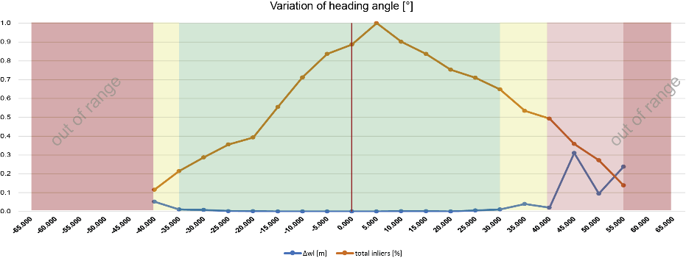

1. Heading observation

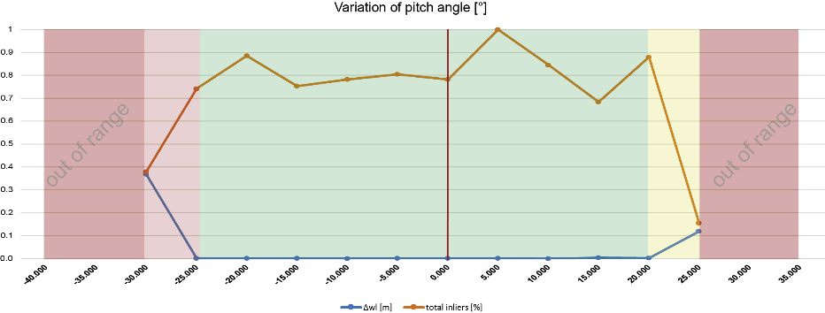

1. Pitch observation

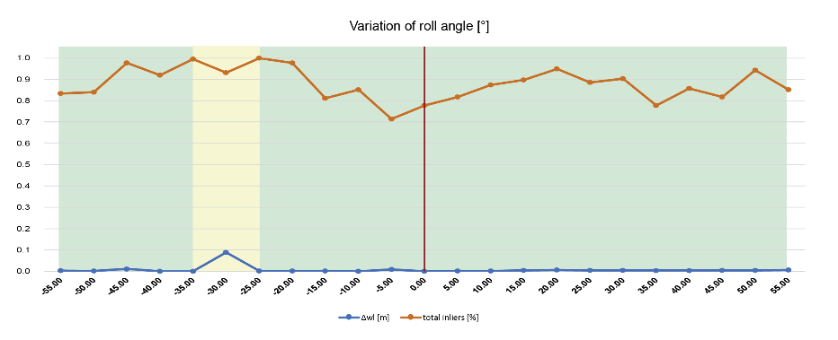

1. Roll observation

FIG. 1. Behaviour of image-to-geometry intersection depending on orientation changes. Tuning the angles heading, pitch and roll independently from each other whereas the others remained unchanged. … absolute error for water level in meters, total inliers... number of image features in feature-based matching displayed in percent depending on most occurrence, red/yellow/green area... range of accuracy.

5.1.5 Graphics

As shown in section \ref{sec:algorithms}, 3D rendering constitutes key algorithms for surface-based interpretation and annotation. Mobile devices can implement the rendering in two distinct ways: directly on the device using the integrated \gls{GPU}, or via remote rendering over the network and the transmission of images.

In cases where the app's target environment are urban settings and locations of well-developed infrastructure, the mobile device can utilise the wireless network connectivity and apply \textit{remote rendering} for the image generation. This allows externalising the rendering tasks for 3D models and supplementary data (as in Ponchio et al. \cite{Ponchio2016}), where the mobile device only submits render requests (supplemented with current view parameters) and receives the generated image. This makes the usage of larger and higher-resolution models more tangible as they are not affected by mobile device limitations. In contrast, the limitations on remote rendering are set by the requested target image size- and resolution, the target refresh rate, and the limited bandwidth of the mobile network \cite{Ponchio2016,Evans2014}. Moreover, the process is agnostic to the individual mobile device specifications when sending the request, making the rendering process work across all major mobile device system manufacturers (e.g. Google, Apple, Microsoft/Nokia). A positive side affect as a result of remote rendering is the reduced energy consumptions (see section \ref{sec:technology:power} for details), which allows for the application of advanced algorithms for sensor tracking in localisation and orientation (see section \ref{sec:technology:sensors:orientation}).

The internet access may be restricted or expensive to establish (e.g. up to 70 euro per month\footnote{see \url{www.skydsl.eu}, skyDSL2+ flatrate with 30 MBit/s download}) for other outdoor applications in remote areas. Thus, outdoor applications operating in remote areas are prohibited from web-based rendering and need to perform rendering on the device. In this case, the 3D data reside in the device memory and the rendering process is affected by the performance-restricted mobile device hardware.

The emergence of mobile graphics libraries such as Khronos \gls{GLES}, Vulcan and Open Scene Graph on Android\footnote{osgAndroid - original at \url{https://github.com/miragetech/osgAndroid}, extended by the second author at \url{https://github.com/CKehl/osgAndroid}}, as well as the continuously improving mobile graphics chipsets (e.g. Qualcomm Adreno, ARM Mali, NVIDIA Tegra), makes on-device rendering a feasible option for apps targeting field-based geosciences. Pinhead example software for field-based studies using mobile device graphics in some way are \textit{Open Water Levels} \cite{Kroehnert2017a}, \textit{\gls{GRIT}} \cite{Kehl2016_VGCabstract} and \textit{Outcrop} \cite{Viseur2014_VGCabstract}. Mobile graphics itself is still a hot topic within the principle science discipline of computer graphics, visualisation and virtual reality \cite{Rodriguez2012,Rodriguez2014,Garcia2015,Agus2017}. Scaling up the principle graphics lab results (in terms of data size, image resolution and texture utilisation), often demonstrated on small-extent individual objects in cultural heritage, to actual requirements within the geosciences is a prime challenge. Although mobile manufacturers provide more powerful devices to allow for more data and higher resolutions, these devices need to sacrifice capabilities such as hardware sensor availability as well as physical size and weight in order to provide larger memory space and higher-performance processors. Examples for this trade-off manufacturing can be seen in special-purpose and high-performance tablets such as NVIDIA Shield\footnote{NVIDIA Shield - \url{https://developer.nvidia.com/develop4shield}}, Project Tango (respectively: ARCore)\footnote{Google Augmented Reality - \url{https://developers.google.com/ar/}} and Google Pixel C\footnote{Google Pixel C- \url{https://www.android.com/tablets/pixel-c/}}. Another problem rarely considered in scientific literature on mobile graphics is power consumption, which is of pivot importance for field practitioners (see section \ref{sec:technology:power}). A specific problem that impacts geoscientists and domain experts with respect to on-device rendering settings is the trade-off between app responsiveness, image quality, hardware utilization and cross-device operability, illustrated in fig. \ref{fig:technology:graphics:imagingTrinity}.

In interviews conducted amongst field geologists at the dept. of earth science at the university of Bergen, a major demand by the target user base (i.e. domain experts and practitioners) of such mobile app is the interoperability between Android, Microsoft and Apple devices. This demand possibly originates from the platform-agnostic functioning of common geoscience software (e.g. \glspl{GIS}, geomodelling software) on desktop computers for Apple and Windows. On the other hand, app responsiveness and high image quality are amongst the next common priorities behind interoperability. Moreover, the interviewed geoscientists expect to receive visibly improved image quality- or functionality when advanced equipment (e.g. special-purpose tablets, novel- and high-performance tablets) is available. These demands are conflicting because making use of specialised hardware (e.g. \gls{GPU} Computing such as CUDA\footnote{CUDA - \url{https://developer.nvidia.com/cuda-zone}} for image processing \cite{Heymann2007,Hudelist2014}, texture compression \cite{Chait2015}) in turn means reducing the range of devices being able to operate the software. Still, these specialised technologies are key to achieve the required responsiveness and image quality.

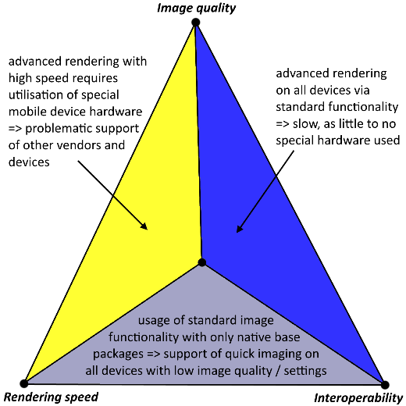

FIG. 1. Conflicting trinity of image (i.e. rendering) quality, rendering speed (a collective term is this context for special hardware utilisation and responsiveness) and interoperability (between devices of the same vendor as well as between vendors).

5.3 Power consumption

Power consumption is an important metric for mobile field applications, which is at the same time also distinct to the mobile device platform. This metric governs the operation time of an app in an outdoor field setting for specific studies. In application domains such as field geology, the target operation time is in the range of four hours to eight hours without device recharging. The original operation time can be extended with external battery packs, although there is a limit of how many battery packs can be taken into the field before their total weight renders the mobile device impractical as a field tool.

We measured the energy consumption of \textit{Open Water Levels} and \textit{\gls{GRIT}} in realistic settings for case studies in waterline detection and field interpretation. Measuring the power consumption on an app-specific level is not supported by default on mobile devices. Formerly, the power consumption has only been assessed on a hardware component level \cite{Carroll2010}. This study utilised the Trepn Profiler \footnote{Trepn Profiler - \url{https://developer.qualcomm.com/software/trepn-power-profiler}}, which is currently the only known app on Android devices that facilitate app-specific measurements. Trepn Profiler also allows for the simultaneous logging of technical indicators (e.g. \gls{GPU}- and \gls{CPU} load, memory consumption, \gls{CPU} temperature), which is used in this study to draw higher-level conclusions on the utilisation of the apps. The presented measurements were obtained on a Google Nexus 5 smartphone (4-core ARM \gls{CPU}, Qualcomm Adreno \gls{GPU}). Additional measurements have been obtained with a Samsung S8 (8-core ARM \gls{CPU}, ARM Mali \gls{GPU}), which can be located in the supplementary data of this article.

In an initial test, we compare the power consumption relative to the \gls{CPU}- and \gls{GPU} load. Our initial hypothesis was that a higher \gls{GPU} load results in an increased power consumption compared to \gls{CPU}-dominated operations, because mobile \glspl{GPU} draw more power than \glspl{CPU} to realise the increased graphics performance. The results are shown for \gls{GRIT} and for Open Water Levels, split in \gls{CPU} (fig. \ref{fig:power:CPU_2D_contrast}) and \gls{GPU} (fig. \ref{fig:power:GPU_2D_contrast}) contributions.

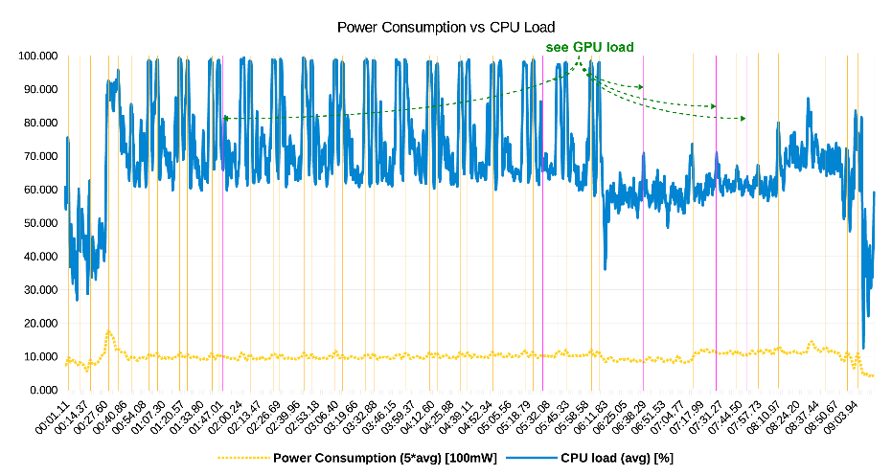

(a) Open Water Levels

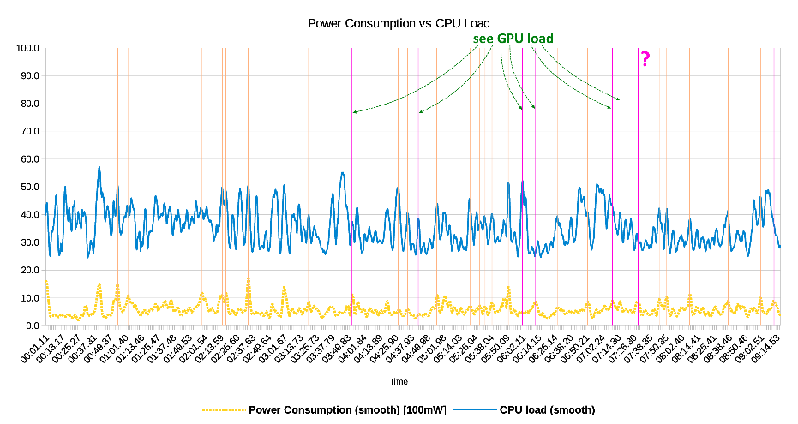

(b) GRIT

FIG. 1 Diagram of power measurements with respect to the CPU load, comparing *Open Water Levels* and GRIT in 2D mode. The less saturated lines show direct correlations between peak CPU load and peak power consumption, while fully saturated lines show missing peak correlations where they are expected.

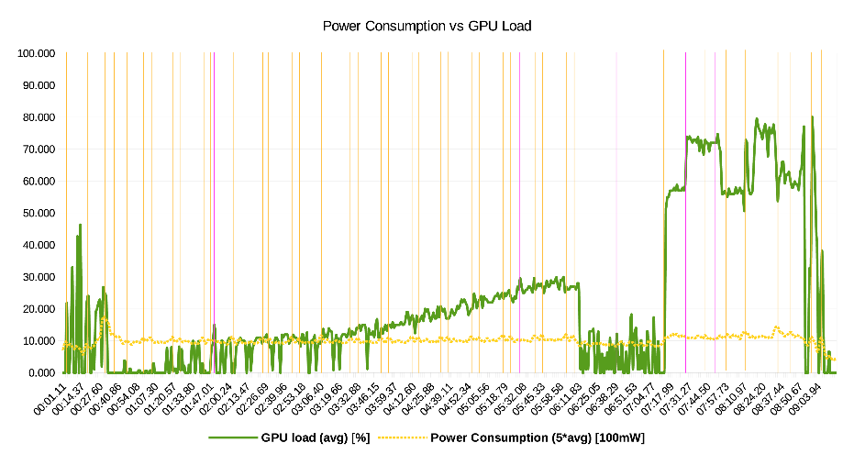

(a) Open Water Levels

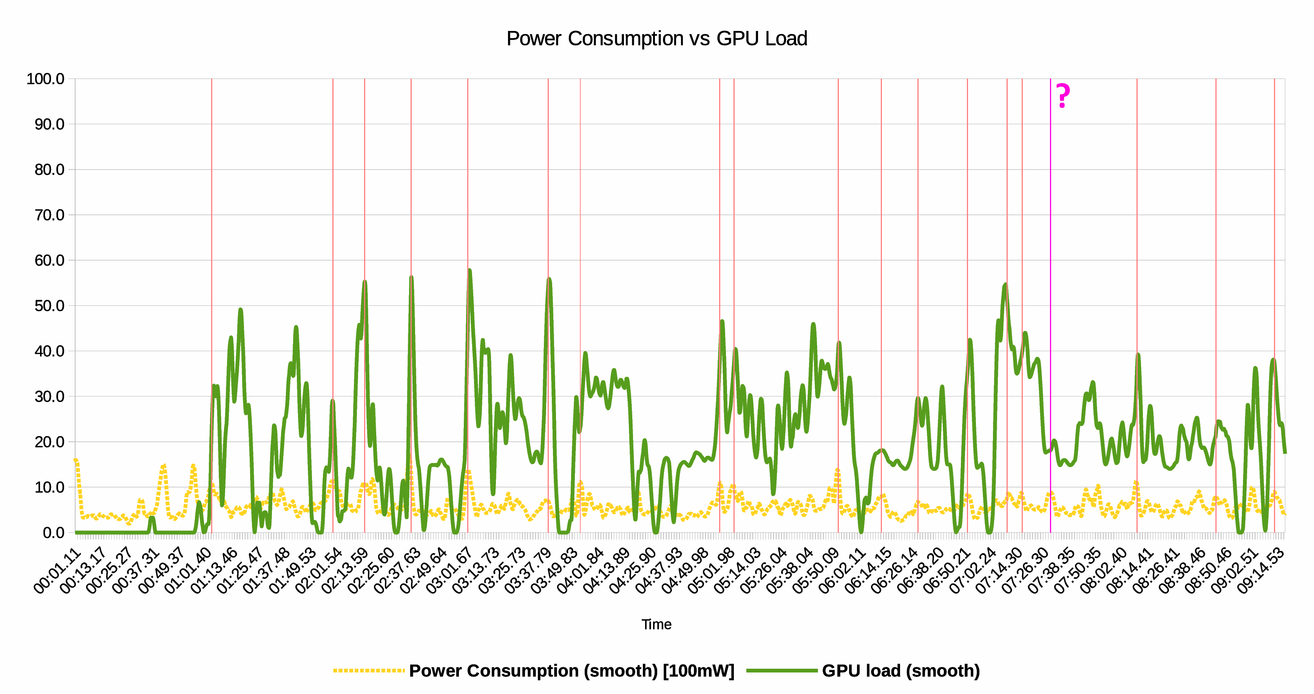

(b) GRIT

FIG. 1 Diagram of power measurements with respect to the GPU load, comparing \textit{Open Water Levels} and GRIT in 2D mode. The less saturated lines show good peak correlations between GPU load and power consumption; the tagged, fully saturated line shows a missing peak correlation. Compared to fig. \ref{fig:power:CPU_2D_contrast}, the majority of missing peak correlations from the CPU band are explained by increased GPU utilisation.

In both apps, a clear dependency with \gls{CPU} load and power consumption is observable. In Open Water Levels, one can observe the reoccurring ''double-hump`` series within CPU process and power consumption, whereas \gls{GRIT} displays a more irregular peak distribution with direct correlations. We can therefore conclude that the mobile processors adapt their clock frequency when less operations are performed, which leads to a reduced power consumption. When comparing \gls{CPU}-related and \gls{GPU}-related states, we conclude that while the \gls{CPU} drives the average power consumption, the GPU (being used for rendering images and annotations within them) drives the peak power consumption.

\Gls{GRIT} has two distinct sets of operations, each dominated by either 2D- or 3D tasks, which makes a difference in the ratio of \gls{CPU} load to \gls{GPU} load. The 2D operation mode includes tasks such as photo acquisition and the image-based photo interpretation, whereas the 3D operations include the image-to-geometry registration \cite{Kehl2017_VGC} and the 3D outcrop viewing. Previous figures \ref{fig:power:CPU_2D_contrast:GRIT} and \ref{fig:power:GPU_2D_contrast:GRIT} depict the 2D-dominated cases, whereas fig. \ref{fig:power:CPU_GPU_3D} shows the power consumption relationships in 3D-dominated cases.

Figure \ref{fig:power:Power_CPU_GPU_OWL:2D} visualises the relationship of power consumption, \gls{CPU}, as well as \gls{GPU} for 2D data processing in \textit{Open Water Levels}. For water line detection, a spatio-temporal texture must be calculated using time lapse images. Thus, the CPU load locally exceeds and falls significantly for each single frame processing (here 15 peaks for 15 images). Unlike \gls{CPU} behaviour, \gls{GPU} load is steadily increasing while storing each co-registered image. After image processing, both \gls{CPU} as well as \gls{GPU} load are released whereas app modifications via the user interface leads, as expected, once more to higher loads.

As clearly observable in fig. \ref{fig:power:Power_CPU_GPU:2D} in comparison to fig. \ref{fig:power:Power_CPU_GPU:3D}, the 3D operations result in a drastic energy cost, raising the average power consumption by around 1220.21 mW. In contrast to novice expectation, the \gls{CPU} load also increases in a 3D data processing setting because the main processors delivers the geometric- and texture data to the \gls{GPU}. Additionally, for the Google Nexus 5 smartphone, the \gls{CPU} needs to decompress the texture image files, resulting in a higher processing load.

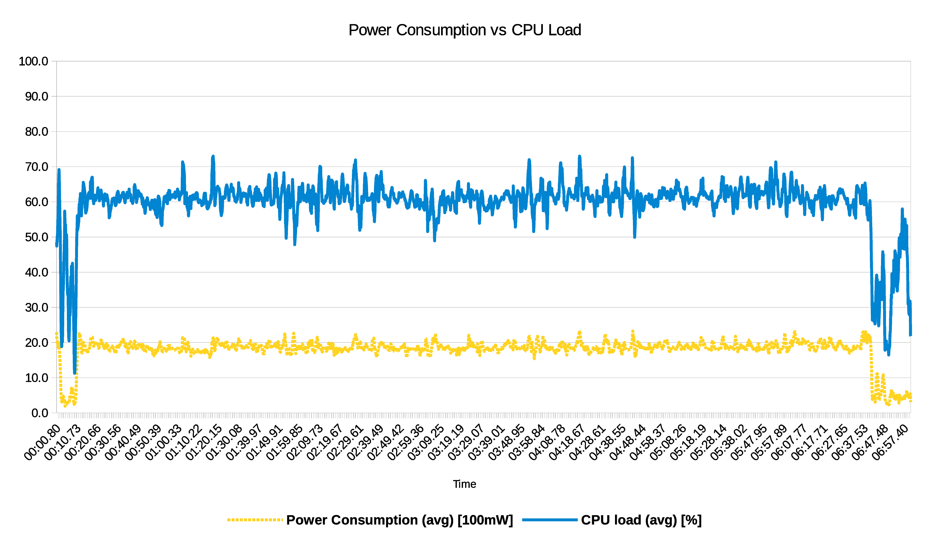

(a) Power to CPU

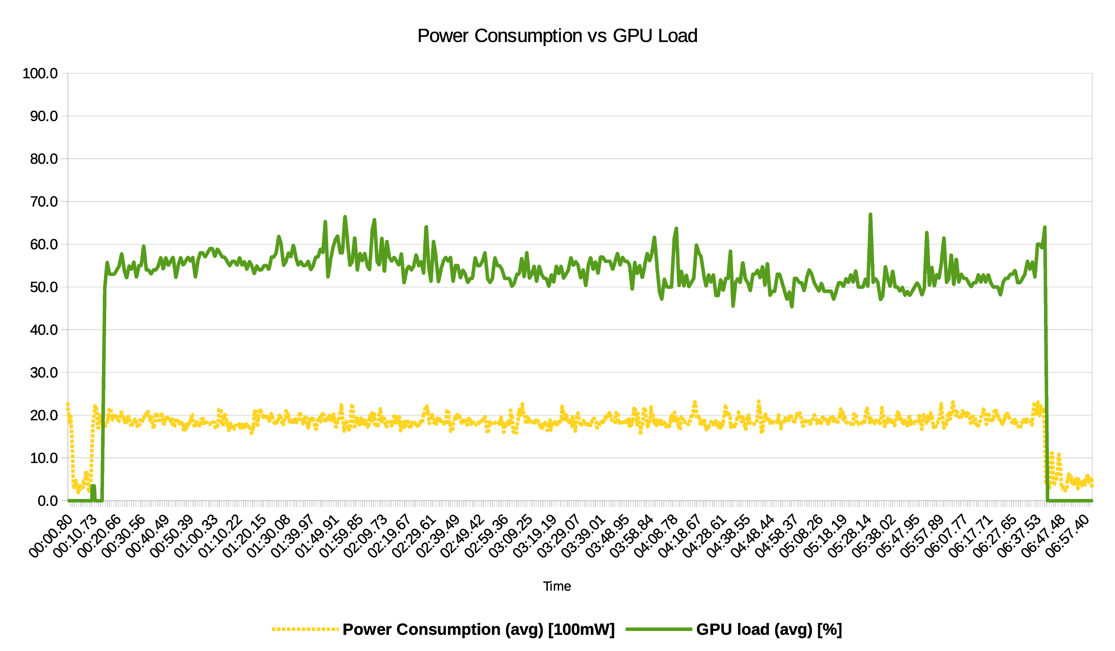

(b) Power to GPU

FIG 1. Diagram of power measurements with respect to the CPU- \& GPU load of GRIT in 3D mode.

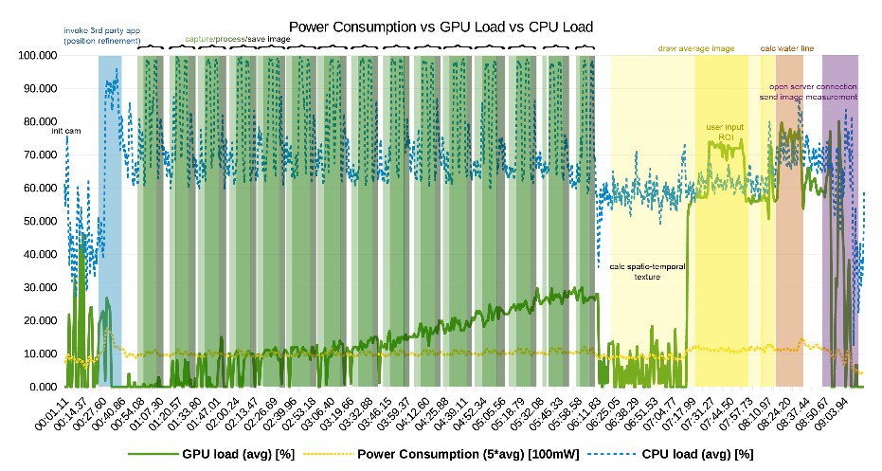

FIG 1. Integrated diagram of power consumption, CPU- \& GPU load of *Open Water Levels* in 2D mode.

The conclusions of this power consumption study for field apps is manifold. We obtained benchmark measurements for specific target apps in hydrology (\textit{Open Water Levels}) and geology (\gls{GRIT}), and explained how to replicate the study on Android devices with other field apps in the future. For \textit{Open Water Levels}, the app can be operated on an average of of 1090.41 milliampere per hour (natively measured in milliampere), allowing a theoretical operability of 2.11 hours on the Google Nexus 5. For \gls{GRIT}, we have to distinguish between the mode in which it is operated: when conducting 2D operations, the app consumes 568.50 milliwatt per hour, which results in an operation time of 14.56 hours at an average current of 3.6V. When making full use of the 3D capabilities of \gls{GRIT} all the time, the average power consumption rises to 1788.80 milliwatt per hour, which results in an operation time of only 4.63 hours at an average current of 3.6V. The applied current for the GRIT measurements is of theoretical nature, applied because the measurements were taken in watt exclusively while the battery capacity of mobile devices is commonly given in milliampere hours (mAh). Furthermore, we highlight these measurements as being the \textit{theoretical} operation time because most users have other apps and background services open on their mobile device that simultaneously consume power, further reducing the operation time. Lastly, as stated by Carroll et al. \cite{Carroll2010}, the app-specific consumption (in particular with ''visual apps`` and the sensor applications) also depends on the screen brightness and the sensor usage. Key measures on power consumption, and related metrics of processor temperature and memory usage, are given in table \ref{table:power:GRIT} for \gls{GRIT} and table \ref{table:power:OWL} for \textit{Open Water Levels}.

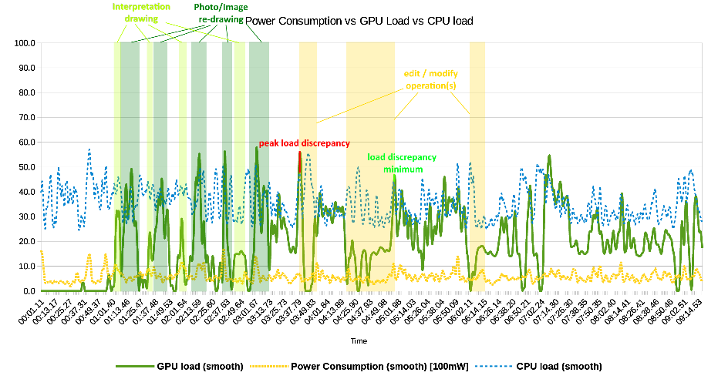

(a) 2D mode.

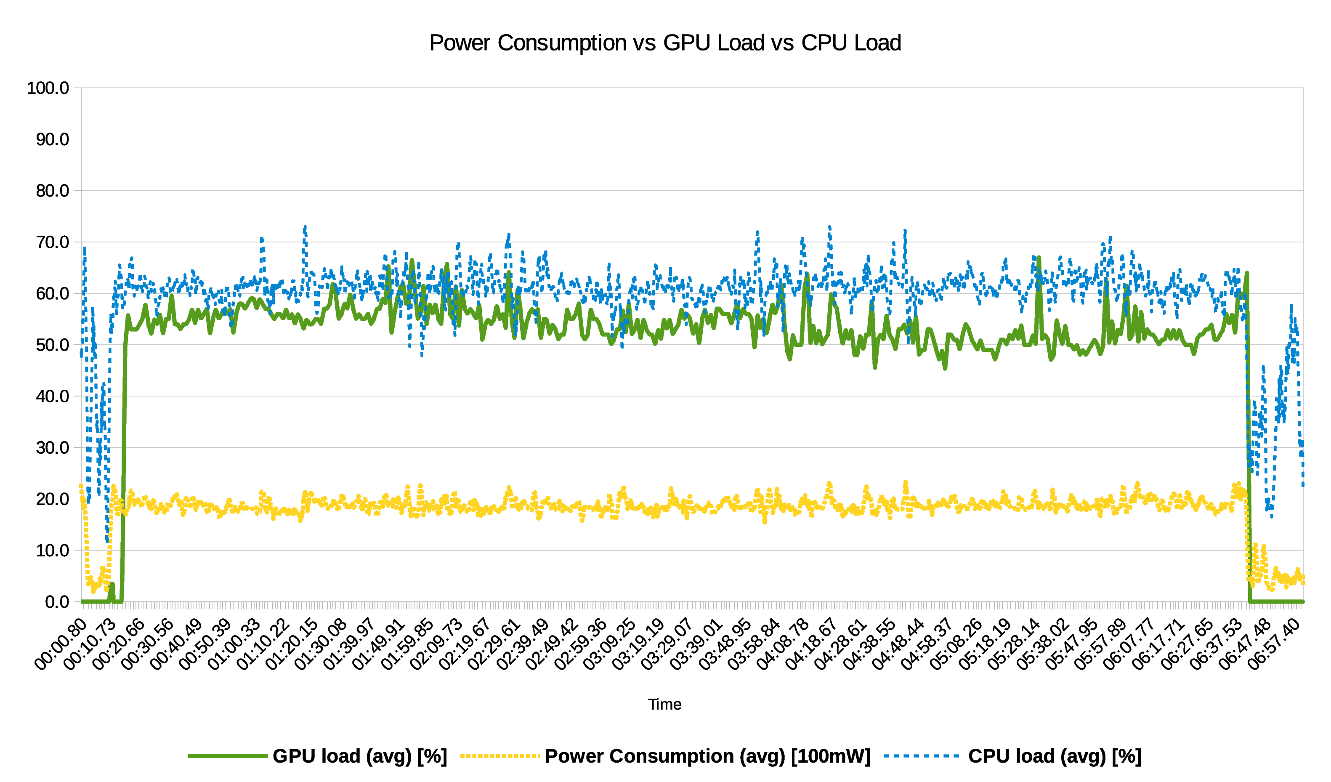

(b) 3D mode.

FIG 1. Integrated diagram of power consumption, CPU- \& GPU load of GRIT in 2D- \& 3D mode. Particular operations, such as image rendering and interpretation editing, are interpreted within the bands as they result in a distinct \gls{CPU}--\gls{GPU} behaviour.

Table I. Orientation sensor specifications for Google Nexus 5 and Samsung Galaxy S8.

|  |  |  |
| --- | --- | --- |
| *Metric* | 2D ops. | 3D ops. |
| *Power consumption []* | 568.59 | 1788.80 |
| *Power consumption []* | 157.94 | 498.89 |
| *Memory usage (avg.) [GB]* | 1.75 | 1.72 |
| *Temperature [°C]* | 49.91 | 52.05 |

Table I. Average measurements of *Open Water Levels*.

|  |  |  |
| --- | --- | --- |
| *Metric* | Google Nexus 5 | Samsung Galaxy S8 |
| *Power consumption []* | 1090.41 | n.a. |
| *Memory usage (avg.) [GB]* | 1.54 | n.a. |
| *Temperature [°C]* | 58.55 | n.a |

In more general terms applicable to the geoscience domain, the study shows that users need to be aware of what data they are dealing with in order to get the maximum operation time and most efficient workload done during the field study. This will have implications for fieldwork planning for expert users and practitioners, as they can modify their study plan to first collect photos, observations and interpretations from several viewpoints of their study objective and then use 3D operation features ''in burst`` for visual checks and data interrogation before moving on to subsequent study locations. Insufficient planning and an overuse of 3D field app features can reduce the effective ''digital fieldwork`` time using \gls{GRIT} to 9.26 hours at best when carrying one external battery pack. Also, with this measure we want to highlight that the operation time error in the measurements is significant because we need to assume an average current of 3.6V, which may be far off when comparing the measurements to \textit{Open Water Level}. Considering the \gls{CPU} load behaviour in 3D-mode of \gls{GRIT}, we can also hypothesize about the positive impact of utilising hardware-specific operations, such as \gls{GPU} texture decompression, on the energy consumption: while using the \gls{GPU} requires generally more power, it is also more efficient in operations such as texture decompression, therefore potentially having a positive effect on the overall power consumption of 3D mobile field apps.

VI Applications and Requirements

Due to the increasing usability of mobile devices for field study annotations, several use cases concerning geosciences has become apparent. In the following, two key applications are subsequently presented: water level gauging through field observations for small and medium-sized catchments, geological interpretation of sedimentary features in field geology, and the use of mobile devices in virtual field trips.

6.1 Derivation of hydrological parameters: Water level gauging

The past decade is characterized by a continued increase of globally devastating flash floods after heavy rainfalls. Even smallest creeks turned into hazardous streams resulting in floodings and landslides. Conventional gauging stations provide precise information about water levels measured over short time periods. State of the art techniques for administrative water gauging comprise water pressure sensors, floating gauges and conventional tide gauges. They are characterised by long-term stability and outdoor robustness providing accuracies of several millimetres up to one centimetre \cite{Siedschlag2015}. Averaged over defined time intervals, it is advisable to remain cautious regarding these accuracies possibly being too optimistic \cite{Horner2018}. Because of high costs in purchase and maintenance, gauging stations with their complex sensing devices must be sparsely installed. A prime example here is the hydrological network in Saxony, Germany where 184 gauging stations are installed for permanent observation on 154 of 259 rivers rising from small, medium and large catchments\footnote{see Saxon Flood Centre, Water Levels \& Flow Rates \url{https://www.umwelt.sachsen.de/umwelt/infosysteme/hwims/portal/web/wasserstand-uebersicht}} \cite{Buettner2015}. Thus, around a third is not monitored neither during flood events when the most protection is required. Recently, commercial smartphone applications arose to provide tools for crowd sourcing-based water level estimation (see \cite{CrowdWaterApp2017a,Kisters2014} for details). All of them have one thing in common: the water level is entered manually by engaged citizens who photograph tide gauges close to rivers that presents potential danger to themselves. Beside this, the technique is still limited to open and visible gauges.

Improvements can be achieved by the registration of situation-dependent images to 3D point surfaces for automatic water level determination on running waters without requiring reference gauges.

For this, the Android application \textit{Open Water Levels} is developed, which uses the freely available open source camera framework \textit{Open Camera}\footnote{see Open Camera, \url{https://sourceforge.net/projects/opencamera/}, used version 1.3.8}. \textit{Open Water Levels} allows for free stationing water level detection using short, handheld time-lapse image sequences \cite{Kroehnert2017a}.

As figured out in section \ref{sec:technology:sensors}, a good approximation of extrinsic parameters is a basic prerequisite for successful 3D annotation whereby precision and stability is strongly correlated with measuring environment. Especially magnetic perturbations affecting user's orientation (see section \ref{sec:technology:sensors:sensitivity}) can represent a special problem (e.g. due to metallic railings close to rivers). The issue can be circumvented for stationary perturbation sources by re-calibration of magnetic sensors just before the measurement, as it is often been done for advanced car navigation. Unfortunately, the magnetic strengths attaching the phone may change substantially in short time especially in natural or urban environments. A typical scenario might look like this: a citizen scientist walks along street, carrying his phone in a baggage close to a bunch of keys. He passes several street lamps, signs, etc. Finally, he arrives at a bridge over a urban river, takes out the phone, looks down to the river and records the time lapse image sequence a few centimetres above a metallic railing. Meanwhile, several cars passing the same bridge. In this simple use case, the magnetic field around the smartphone changes countless times due to several unpredictable disturbances. Described in section \ref{sec:technology:sensors:sensitivity}, image to geometry registration is very error-prone for inaccurate exterior parameters except roll angle. The reason for this lies in rendering a synthetic image from coloured 3D reference point clouds using a person's location and orientation (see \ref{sec:algorithms:I2G}). Thereby, heading and pitch mainly define the depth direction, incorrect angles provide a false viewing direction resulting in a synthetic image that has little-to-no similarity with the time lapse sequence. Consequently, the water level detection will fail or give false results caused by adverse inlier distribution in image matching that impedes a correct positioning (e.g. when images have too little overlap). Described in section \ref{sec:technology:sensors:location_sensitivity}, inbuilt \gls{GNSS} receivers should be considered as another major source of error for 3D annotation. In urban scenes with several shadow effects due to high-rise buildings, as well as in situations of heavy cloud coverage, errors of several metres in latitude and up to more than 30 metres in altitude are highly possible. However, assistance is provided by external data sources and it is very likely that, in the near future, smartphone \gls{GNSS} modules are rolled out, solving lateral accuracies of 50 centimetres \cite{Moore2017}. Thus, having internet connection is indispensable but not a problem in urban environments. It is worth mentioning that UMTS/LTE are furthermore needed to enable online water line processing after transmitting a compressed package containing the master image, the derived water line in 2D space and some meta data to describe the prevalent object scene.

For now, an issue is the availability of free available 3D representations captured close to rivers with focus on shore environment. However, first attempts from Google Street View to cover near shore environments by river cruises are published\footnote{USA Today - Google Maps launches 'river view' of Grand Canyon, \url{https://www.usatoday.com/story/tech/personal/2014/03/13/google-maps-grand-canyon-colorado-river/6339489/}}. In the future, this option is expected to expand to other rivers on a global scale. Furthermore, some research projects deal with autonomous river crossing to acquire hydrological parameters as well as shore land information in short timespans \cite{Sardemann2018}. Thus, 3D point sets can be acquired very fast (e.g. using \gls{LiDAR} or \gls{SfM}) covering the same place at different times to deal with multiple representations caused by season-dependent vegetation, snow coverage or changed illumination due to the ambient conditions at specific times of the day. Referring to this, issues in image-to-geometry registration still remain when the visual appearances of both, the photo and the synthetic image vary widely (e.g. strong back lighting or shadows that let appear everything totally black).

6.2 Field geology

The goal of geological fieldtrips is to gather insight in the rock record and the structural- and sedimentary rock architecture of a given location. Rock architecture can be studied within subsurface seismic records, but this approach suffers from inferior imaging resolutions and physical limitations of the surveying technique. Therefore, surface outcrops are used for the study. Outcrops can be scanned with modern equipment (e.g. \gls{LiDAR} \cite{Buckley2008a,Buckley2010}, drones \cite{Dewez2015} and \gls{SfM} \cite{Chandler2016}) to generate digital surface representations. The most common representations of digital outcrops are coloured point clouds and textured \glspl{TIN}.

The geological aspect is introduced by interpreting the outcrop models. In this case, interpretations refer to (i) line marks for separating stratigraphic layers, (ii) surface-projected polygons to highlight structural- and sedimentary facies or specific architectural elements and (iii) minor ticks (e.g. lines, points, patterns) to indicate supplementary attributes such as deposition orientation or grain geometry. The interpretations was, until recently, performed in a two-step process: sketches are drawn by hand in a dedicated fieldbook to document the geologist's observation of the architecture. After the fieldtrip, the observations are digitised in the office by transferring the sketched architecture on the available digital outcrop. From there on, further study goals (e.g. geomodelling) are pursued. As recently published, this workflow is currently being transformed into an integrated digital workflow in the field using mobile devices (see \cite{Kehl2018_AGU} for further details).

Geological interpretations can be documented on various scales, but from observations of the author most interpretations are conducted on medium-range. This results in an average observation distance for architectural interpretations of between $100m$ to $500m$ to document individual depositional elements, and further distances of around $400m$ to $1400m$ to document the overall stratigraphic framework of an outcrop. These distances can vary to some degree depending on the physical accessibility of an outcrop. Therefore, as a result of perspective observations, the required lateral localisation accuracy is in the range of $\leq 2.5m$ for the individual element setting and $\leq 8m$ for the wide-angle stratigraphic setting. While achieving the former resolution can still be challenging with mobile sensors (see section \ref{sec:technology:sensors:localization}), the latter resolution is almost guaranteed for \gls{GPS} localisation. The more important problem is in the vertical resolution: the vertical position has, especially in close-distance observations, a drastic impact on the view perspective. Even more important, a vertical localisation error of $\geq 1.5m$ may result in positioning the mobile device ''under ground'', making any image-based registration impossible. It is this vertical accuracy that is crucial for mobile device interpretation systems to work. Several improvements, such as \glspl{DEM} and barometric altitude \cite{Kehl2017_VGC}, have been proposed to reduce the vertical positioning error (see section \ref{sec:technology:sensors:localization}). There is still room for novel research proposals to provide more accurate vertical positioning or ground-based constraints on the altitude estimation.

One of the dominant challenges for digital field geology is the free availability of 3D surface models. Currently, research groups in the domain (e.g. from the University of Manchester \cite{Hodgetts2013}, Durham University \cite{McCaffrey2005}, University of Aberdeen \cite{Howell2014}, University of Bergen and UniResearch CIPR \cite{Dreyer1993}) are building their own digital outcrop databases. Due to the strong industry involvement, these and other databases (see SAFARI \cite{Dreyer1993} and FAKTS \cite{Colombera2012a}) are excluded from public access. Recent developments aim at providing digital outcrops in an open-access manner \cite{Cawood2018} to resolve the issue. Furthermore, due to the vertical positioning problem above, easy access to high- and medium resolution \glspl{DEM} is important. As demonstrated by recent measurements, the usage of \glspl{DEM} has a significant influence on the projection accuracy of image-based interpretation on mobile device towards 3D surface models \cite{Kehl2017_VGC}.

One particular challenge in digital field geology is the treatment of environmental changes. Digital outcrops are infrequently collected and the textured models are used for field study all across the year. Therefore, in image registration terms, there is a drastic difference in local illumination, moisture content as well as fog and snow between acquired 3D surface models and the outcrop images collected during field trips. The issue has been previously discussed in terms of illumination differences \cite{Kehl2017_PHOR}, but drastic changes in terms of fog and moisture are still problematic to treat in an automatic, computational manner. Therefore, it is advisable to collect digital outcrop models for prominent locations in different seasonal conditions to allow for variety in model selection when planning field trips.

Currently available systems that provide digital outcrop interpretation capabilities on mobile devices in 3D include \gls{GRIT} \cite{Kehl2016_VGCabstract} and Outcrop \cite{Viseur2014_VGCabstract}, though earlier prototypes have been demonstrated \cite{Hama2013}. Outcrop, developed by \gls{CEREGE} at Aix-Marseille Universit\'{e}, is a mobile device app for Android devices that is able to load and process various forms of numerical outcrops. Its major focus is the documentation of structural features (e.g. fault areas, fractures and rock deformations) on outcrops using line interpretations. Furthmore, it is possible to pin extended note annotations to the model. \gls{GRIT}, developed as a collaboration between UniResearch AS CIPR, University of Bergen, University of Aberdeen and \gls{CEREGE}, is a mobile app for Android devices that can handle large-area digital outcrops of tens of kilometres in surface length in 3D. Its major focus is the documentation of the sedimentary- and stratigraphic architecture (e.g. strata boundaries, depositional object envelopes, facies areas) on outcrops via lines, polygons and brushes. The interpretations are mapped in a 2D--3D interplay between outcrop surface and field photograph.

|  |  |
| --- | --- |
| (a) GRIT | (b) Outcrop |

Fig. 1. Visual comparison between two 3D mobile apps for \gls{DOM} interpretation, namely \gls{GRIT} (a) and Outcrop (b), with a model of the Calvisson quarry (Calvisson, département Gard, région Occitanie, France). Images taken from \cite{Kehl2017_PhDThesis}.

VII Conclusions and Discussion

This article assessed the possibility of interactive interpretation and annotation of 3D surfaces (pre-acquired by \gls{TLS}, drones or \gls{SfM}) on mobile devices in multiple geoscientific domains. Due to the research effort in recent years, novel mobile applications such as *Open Water Levels* for surface hydrology and *GRIT* for field geology were introduced to the community to bridge the gap between lab assessment and outdoor field work for data annotation and interpretation. This article also showed further application areas that build upon mobile device technology and the interactive annotation of 3D surface data for geoscientific problem solving.

McCaffery et al. proposed the use of mobile devices for field interpretation in geology in 2005 \cite{McCaffrey2005}. The technological specifics of mobile device app development hampered the progress on this goal for years -- for geology as well as other branches of the geosciences. Only recent advancements in efficient treatment of 3D data \cite{Kroehnert2017b}, algorithmic proposals for image-to-geometry registration (see \citep{Gauglitz2014,Kehl2017_VGC}) and on-device 3D rendering (as presented in \cite{Agus2017} and in this article for point-based surfaces) specifically designed for mobile devices, make the actual use for mobile apps in the field possible. The utilisation of crowdsourced \gls{VGI} and the introduction of mobile devices as low-cost measuring devices for real-world problems \cite{Eltner2017} contribute to the acceptance of this mobile device technological development within the geoscientific community. Computer Vision challenges such as image registration under changing illumination conditions and with reduced image resolution can be viewed as ''sufficiently solved`` to make photogrammetric- and vision-based algorithms applicable to real-world outdoor settings, while still leaving space for improvement and quality and performance. Potentially significant improvement will be achieved in the future when an increasing number of advanced algorithms in numerics, graphics and vision (e.g. NEWUOA \cite{Powell2006}, out-of-core rendering \cite{Borgeat2005}, \gls{MI} \cite{Viola1997}) are ported to mobile platforms (e.g. Android). This allows realising the most state-of-the-art techniques on mobile devices that require the additional precision and performance, instead of being limited by the small function collections currently available.

The measurements presented in this article as well as its related studies suggest that localisation and orientation of mobile device sensors with respect to the application-specific accuracy requirements is a persisting challenge. The sensors employed by low-cost devices have accuracy limitations. Sensor filtering- and fusion techniques are required to even moderately consider the use of such sensor data. Environmental effects such as device-internal heating processes and the system-internal handling of sensor initialisation further complicate the calibration of such sensors without user involvement.

Furthermore, this study gives a representative overview about the energy consumption of mobile apps employing 3D surfaces, computer vision and computer graphics procedures. It was shown that the distinction between 2D- and 3D data used by mobile apps significantly drives the power consumption, and therefore the operation time of the mobile field apps during a study. Means of reducing the power consumption in the future have, next to extended periods of app use by domain experts, beneficial secondary effects: power-reduced main functions of the mobile app allow energy-expensive \gls{SLAM} techniques to be used for sensor data augmentation.

This article also compared two specific apps, namely *Open Water Levels* and *\gls{GRIT}*. Both software applications are working on different data structures but, in the end, utilise the same process -- namely image-to-geometry registration and user-selected corner point surface intersection -- to generate surface-based annotations and interpretations. A persisting challenge with respect to the relation between power consumption and sensor accuracy is the user feedback: it is currently rarely possible to guarantee the user a correct pose estimation for his base photo, be it individual image or time lapse, upon which annotations and interpretations are done. On mobile devices, it is important to provide the software user early (visual) feedback about the prospective success and quality, so that potential image capture repetitions can be decided early. This is also in the interest of power conservation on mobile devices by only expending computing power where necessary. Early steps in this direction have been taken \cite{Kehl2017_VGC}, but there is considerable room for improvement.

Lastly, the treatment of vegetation within scanned- and photographed data during mobile field studies remains a challenge in the context of interactive interpretation. 3D reference data are obtained less frequent than they are used in a given outdoor setting. Vegetation itself is visually dynamic content that complicates image registration to existing 3D data, which complicates interpretations in common outdoor settings. While current procedures of data processing try to segment and remove vegetation data from scans, it leaves the mobile device app with less information to work with when registering photos. Therefore, proposing means of 3D topographic data processing that homogenizes vegetation in 3D scans and photos without removing the related data will have an impact on accurate outdoor photo registration on 3D base data.

Acknowledgements

First, we would like to thank M.Sc. Richard Boerner from TU Munich, Germany for his assistance with the development of an alternative approach for synthetic image generation using perspective 3D--to--2D image projection with respect to object space definition and to solve for point occlusions (see section \ref{sec:algorithms:pbr}). Furthermore, we want to graduate the European Social Fund and the Free State of Saxony for their financial support (funding no. 100235479).

REFERENCES

Ackermann, F., 1984. Digital image correlation: performance and potential application in photogrammetry. *Photogrammetric Record*, 11(64): 429–439.

Granshaw, S. I., 2016. Photogrammetric terminology: third edition. *Photogrammetric Record*, 31(154): 210-251.

Gruen, A., 1996a. Digital photogrammetric stations revisited. *International Archives of Photogrammetry and Remote Sensing,* 31(B2): 127–134.

Gruen, A., 1996b. Least squares matching: a fundamental measurement algorithm. Chapter 8 in *Close Range Photogrammetry and Machine Vision* (Ed. K. B. Atkinson). Whittles, Caithness, Scotland. 371 pages: 217–255.

Hosseininaveh Ahmadabadabian, A., Robson, S., Boehm, J. and Shortis, M., 2014. Stereo-imaging network design for precise and dense 3D reconstruction. *Photogrammetric Record*, 29(147): 317-336.

ISPRS, 2014. www.isprs.org/publications (Accessed 23rd November 2014).

Pierrot-Deseilligny, M. and Paparoditis, N., 2006. A multiresolution and optimization-based image matching approach: an application from SPOT5-HRS stereo imagery. *International Archives of Photogrammetry, Remote Sensing and Spatial Information Sciences*, 36(1/W41): 5 pages (on CD-ROM).

Toldo, R., Fantini, F., Giona, L., Fantoni, S. and Fusiello, A., 2013. Accurate multiview stereo reconstruction with fast visibility integration and tight disparity bounding*. International Archives of Photogrammetry, Remote Sensing and Spatial Information Sciences*, 40(5/W1): 243-249.

Vosselman, G. and Maas, H.-G. (Eds.), 2010. *Airborne and Terrestrial Laser Scanning*. Whittles, Caithness, Scotland.. 318 pages.

Wiley, 2016. http://onlinelibrary.wiley.com/journal/10.1111/(ISSN)1477-9730 (Accessed 23rd November 2014).

Zhang, L., 2005. *Automatic Digital Surface Model (DSM) Generation from Linear Array Images*. Doctoral thesis. Mitteilungen 88. Dissertation No. 16078. Institute of Geodesy and Photogrammetry, ETH Zurich, Switzerland. 218 pages. <http://e-collection.library.ethz.ch/view/eth:28126>

*Résumé*

L’histoire de l’appariement d’images remonte à plus de cinquante ans, lorsque les premières …

Zusammenfassung

Die digitale Bildzuordnung hat seit den ersten analogen Ansätzen für die automatisierte ...

Resumen

La correspondencia de imágenes tiene una historia de más de 50 años, desde los primeros …

摘要

影像匹配技术在模拟摄影测量中首次应用开始，已经有50年的发展 …

1. OpenCV4Android 2.4.10 - https://opencv.org/platforms/android
2. OpenCV4Android extensions - https://github.com/CKehl/opencv4Android_extension
3. see Statista (accessed 2018-04-25) *Survey: Sales development in Germany for navigation systems since 2005* https://de.statista.com/statistik/daten/studie/3902/umfrage/entwicklung-der-verkaufszahlen-von-navigationsgeraeten-seit-2005/
4. see Android Developer Guide (accessed 2018-04-25) *Google Elevation API* https://developers.google.com/maps/documentation/elevation/intro?hl=de
5. See Android developers guidance (accessed 2018-04-25) *Sensor event values* https://developer.android.com/reference/android/hardware/SensorEvent.html\#values
6. See specifications for Samsung Galaxy S8 and Google Nexus 5 (both accessed 2018-04-25) https://technology.ihs.com/api/binary/592077, https://de.ifixit.com/Teardown/Nexus+5+Teardown/19016
7. See specifications for Advanced Navigation Spatial v6.1 (accessed 2018-04-25) http://www.advancednavigation.com.au/product/spatial\#specifications