**MODELADO, DINAMICA DE SISTEMAS Y SIMULACION**



**Nombres: Cristopher Castro Inofuentes  
 Dylan Mariscal Salas**

**Alejandro Martínez Fuertes**

**Fecha: 09/02/2020**

**Practica 1**

$\sum_{i=1}^{5}{\sum_{J=1}^{3}{\frac{i*j}{i+j}}}$

**Código:**

public class Main {

public static void main(String[] args) {

System.out.println("Calculo sumatoria i=1 hasta 5 de la sumatoria

j=1 hasta 3 de i*j/i+j");

System.out.println(calculo());

}

private static double calculo(){

double res=0;

for(int i=1;i<=5;i++){

for(int j=1;j<=3;j++){

double den = i*j;

double num = i+j;

System.out.print(den+"/"+num);

if(i!=5 && j!=3)

System.out.print(" + ");

else

System.out.print(" = ");

res+=den/num;

}

}

return res;

}

}

**Resultado:**

$\frac{\sum{x}*\sum{y}}{\sum{\sum{xy}}}$

**Código:**

import java.util.Scanner;

public class Ejercicio {

public static void main(String[] args) {

Scanner read = new Scanner(System.in);

System.out.println("Ingrese tamano: ");

int n = read.nextInt();

double []x = new double[n];

double []y = new double[n];

for (int i = 0; i < n; i++)

{

System.out.println("Ingrese x: ");

x[i]=read.nextDouble();

System.out.println("Ingrese y: ");

y[i]=read.nextDouble();

}

mostrarLista(n, x, y);

double sx = sumatoriax(x);

double sy = sumatoriay(y);

double denominador = denominador(x, y);

System.out.println("Resultado: "+sx*sy+"/"+denominador+" = "+solucionar(sx, sy, denominador));

}

public static void mostrarLista(int n, double []x, double []y)

{

for (int i = 0; i < n; i++)

{

System.out.println(x[i]+","+y[i]+"\n");

}

}

public static double sumatoriax (double []x) {

double s = 0;

for (int i = 0; i < x.length; i++)

{

s += x[i];

}

return s;

}

public static double sumatoriay (double []y) {

double s = 0;

for (int i = 0; i < y.length; i++)

{

s += y[i];

}

return s;

}

public static double denominador (double []x, double []y) {

double denominador = 0;

String cadena = "("+sumatoriax(x)+" * "+sumatoriay(y)+") / ";

for (int i = 0; i < x.length; i++) {

cadena += "(";

for (int j = 0; j < y.length; j++) {

denominador += x[i]*y[j];

cadena += "("+x[i]*y[j]+") + ";

}

cadena += ") + ";

}

System.out.println(cadena);

return denominador;

}

public static double solucionar(double sx, double sy, double denominador) {

return (sx*sy)/denominador;

}

}

**Resultado:**

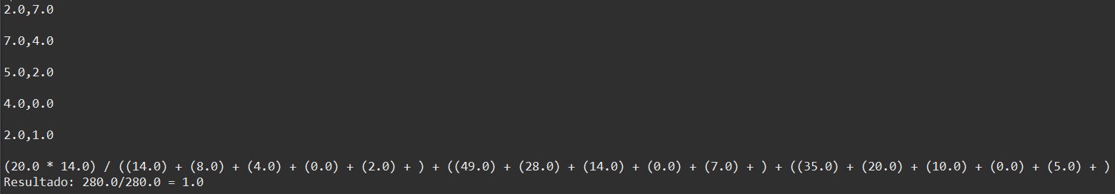

$\sum{y+α_{0}+α_{1}x=0} \sum{\left(x\right)\left(y-α_{0}-α_{1}x\right)=0}$

**Código:**

public static void main (String [] args)

{

/*

Este programa sirve para resolver un sistema de ecuaciones de dos incognistas y de primer grado.

Del Tipo:

Ax+By=C

Dx+Ey=F

*/

float alfa0=0.f, alfa1=0.f, a, b, c, d, e, f;

Scanner read = new Scanner(System.in);

System.out.println("Ingrese a: ");

a = read.nextFloat();

System.out.println("Ingrese b: ");

b = read.nextFloat();

System.out.println("Ingrese c: ");

c = read.nextFloat();

System.out.println("Ingrese d: ");

d = read.nextFloat();

System.out.println("Ingrese e: ");

e = read.nextFloat();

System.out.println("Ingrese f: ");

f = read.nextFloat();

alfa1 = resolverAlfa1(a,b,c,d,e,f,alfa0,alfa1);

alfa0 = resolverAlfa0(a,b,c,alfa1,alfa0);

System.out.println("El valor de alfa 0 es: "+alfa0+"\nEl valor de alfa1 es: "+alfa1);

}

public static float resolverAlfa1(float a, float b, float c, float d, float e, float f, float alfa0, float alfa1)

{

float res = 0;

alfa1 = ((f * a) - (d * c)) / ((e * a) - (d * b));

alfa0 = (c - (b * alfa1)) / a;

return alfa1;

}

public static float resolverAlfa0(float a, float b, float c, float alfa1,float alfa0)

{

float res = 0;

alfa0 = (c - (b * alfa1)) / a;

return alfa0;

}

**Resultado:**

