TSAnalyzer, a GNSS Time Series Analysis Software

WU Dingcheng1,2, YAN Haoming1*, SHEN yingchun1,2

1State Key Laboratory of Geodesy and Earth’s Dynamics, Institute of Geodesy and Geophysics, Chinese Academy of Sciences, Wuhan 430077, China

2University of Chinese Academy of Sciences, Beijing 100049, China

*Corresponding author, yhm@whigg.ac.cn

**Abstract**: In Geodesy and Geophysics, the GNSS technique with high precision and continuous observation has been widely used. As the increasing number of GNSS observation stations, GNSS time series analysis software should be developed with more flexible formats support, better man-machine interaction and more robust analysis programs. To meet this requirement, a new software written in Python was developed for preprocessing and analyzing continuous GNSS position time series individually as well as batch processing. This software can read different formats of GNSS position time series, pick epochs of offsets or seismic events interactively, remove outliers and estimate linear, polynomials and multiple seasonal signals. It also provides Lomb-Scargle spectral analysis. Based on Python, it is cross-platform. This software is referred to as TSAnalyzer.

**Keyword**: TSAnalyzer, GNSS Time Series Analysis, Harmonic and Trend Analysis,® GNSS offsets, Lomb-scargle, Python

# Introduction

Over the past decades, the continuous GNSS technique has been widely used to monitor tectonic movement, crustal deformation over the world. And there are many high precision GNSS processing softwares, GIPSY-OASIS, GAMIT/GLOBK, Bernese, Panda, etc. However, few software packages were designed specifically for GNSS coordinates time series analysis for meeting the analysis requirements of numerous solutions . Among them, GGMatlab (tsview), iGPS and GITSAV are open sources and Analyze_tseri is an executable file in Linux system(Herring, 2003; Tian, 2011; Goudarzi and Cocard et al., 2013). Despite their good efforts and great work, A new and updated packages are highly demanded for time series analysis in Geodesy and Geodynamics studies as well as user-friendly and formats flexible.

For example, Analyze_tseri is a Linux software and have very strict formats. GGMatlab and GITSAV are written in MATLAB, which is a commercial software as well as iGPS, written in IDL. All of the above packages could not provide the function to pick the epochs of offsets or support very well at least. As for formats support, they could only deal with fixed formats and have a very limited extension for varieties of formats. Based on previous work, the Python GNSS Time Series Analysis and Visualization (TSAnalyzer) software was developed.

# Program Language and Installation

TSAnalyzer was developed by using Python programming language with a QT Graphical User Interface (GUI). In the scientific study, Python becomes more and more fashionable with the development of scientific modules and its high-level, code readability and development efficiency. In addition, Python is a cross-platform programming language for many operating systems. Move over, by using third-party tools, Python code can be packaged into stand-alone executable programs for major operating systems.

TSAnalyzer is freely available as open source software and can be downloaded from:

The TSAnalyzer package includes code files, icons and documents. To install the software, the TSAnalyzer Manual should be carefully read and following its instructions, and some troubles may occur and solutions are provided. By typing python main.py in the command line prompt or double-clicking the main.pyw (windows operation) file will bring up the TSAnalyzer main window (Figure 1, time series file has been loaded).

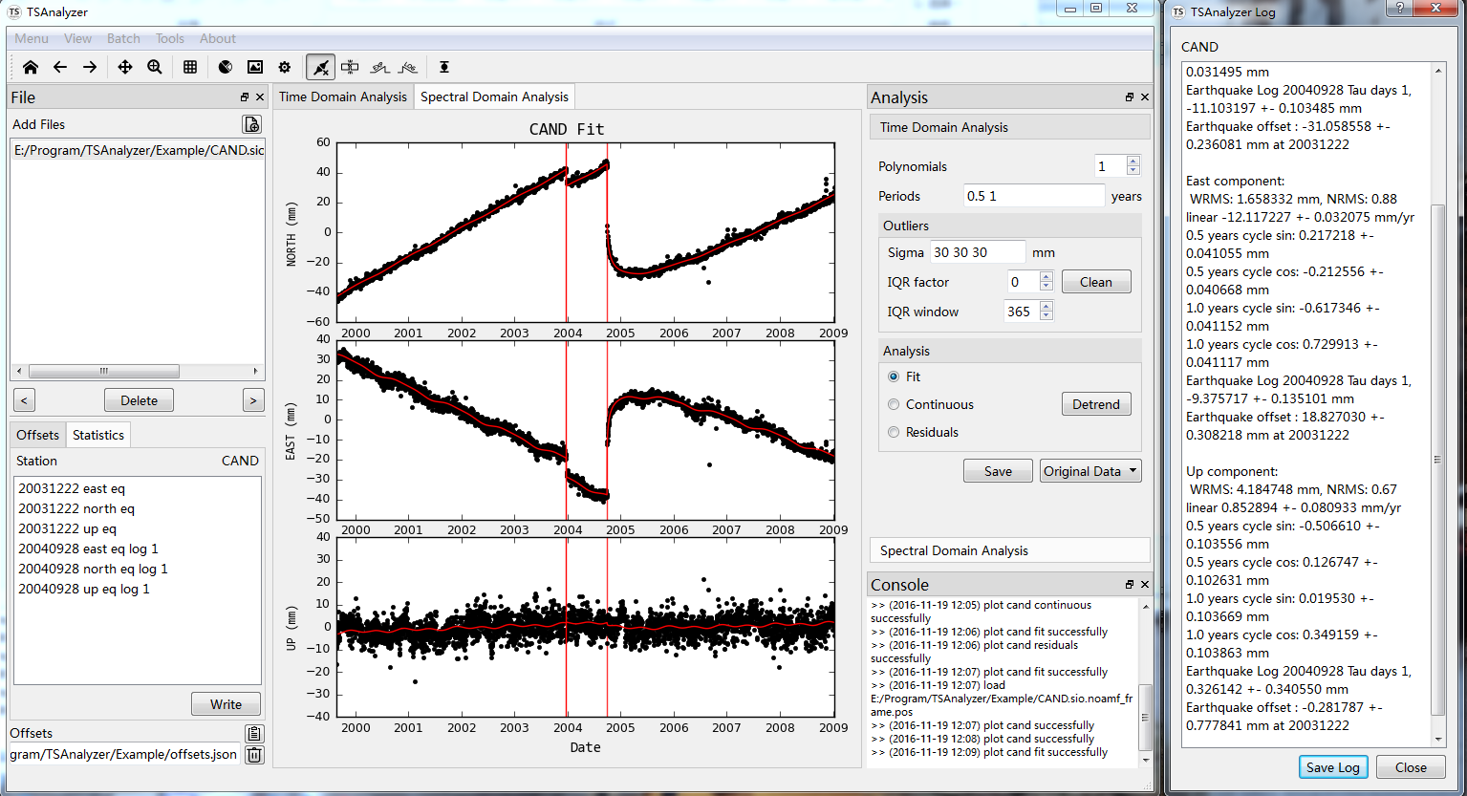Figure 1 TSAnalyzer Main Window displaying the three components of CAND and the fit results of trend plus seasonal periods separately (in the middle plot area). The left top panel shows the available time series files, the left down panel is to provide offsets view and edit, as well as some basic statistic information of current working file. On the right of plot area is analysis panel and console dock. The right dialog displays the fit results.

# Features and Time Series Analysis

The functions provided by TSAnalyzer covers the least square analysis, spectral analysis and human-interactive inspecting offsets. TSAnalyzer can also read varieties time series format files and provides some tools, such as date conversion and header comment tool. In this paper, only some key features are explained.

## Time Series Visualization and Interaction

With the widely used of GNSS technology in Earth Science, many organizations or research centers publish daily GNSS position products in different formats. The position product is not similar to GNSS data, which has universally formats, RINEX. Now the TSAnalyzer can support the products provided by the following centers:

* Plate Boundary Observatory (PBO) format (.pos)
* NASA Jet Propulsion Laboratory (JPL) tseries format (.tseries)
* NEU format described in CATS software (Williams, 2008)

The TSAnalyzer can read the above time series without any format conversion. For other formats of time series file, we provide header comment tool to add some comments which can be supported by TSAnalyzer (Figure 2). For more detail information, please refer to the user manual tutorial.

Figure 2 TSAnalyzer Header Tool

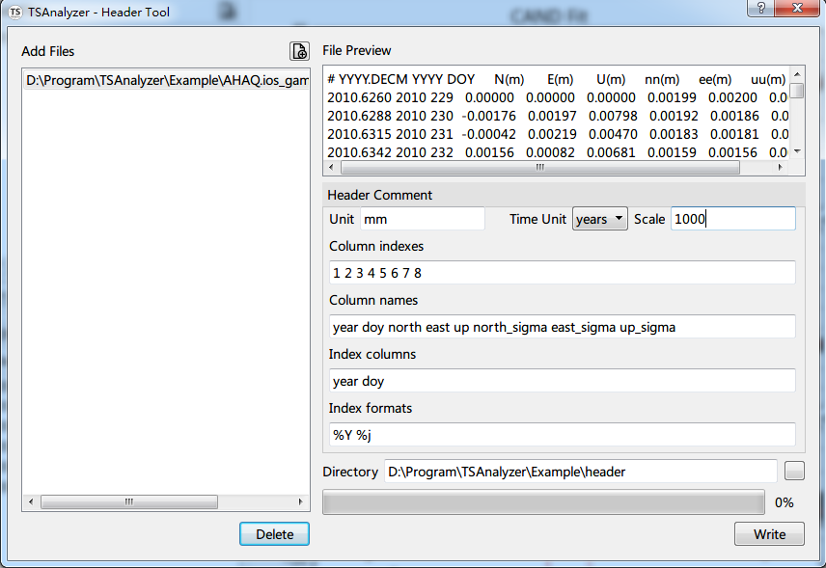

After a time series file loaded, coordinates can be plot automatically. Some tools are provided for interactive with the figure.

One of the key features in TSAnalyzer is interactive for detecting offsets manually. There have some mathematical theories applied for auto detect jumps in GNSS position time series (Gazeaux and Williams et al., 2013), however the most accurate and efficient method is still manual inspection. TSAnalyzer provides four types offsets, equipment changes, co-seismic deformations, post-seismic relaxations for logarithmic and exponent decay, and a very clearly format for offsets record (Figure 3) was designed. For hundreds of position time series, it can save considerable time with shortcuts-assisted.

After the offsets file loaded, it will plot the breaks in different colors, blue stands for equipment event, and red means earthquake eruption. One can also add offsets if the offsets information is not complete. Click the corresponding tool buttons, and then pick on one of the three figures (Exp and log events should be clicking and dragging). A dialog will pop up and ask you to add to another components or not. If the date selected is not appropriate, you can double click the offsets items in the offsets tab and edit it in a dialog.

Figure 3 Offsets Selection

|  |  |
| --- | --- |
| 1. Interactively Selection | 1. Dialog for Modification |
|  |  |

The Figure 3 a) displays select the epoch in time series figure and Figure 3 b) shows edit the offset event in detail. Figure 4 demonstrates the offsets file formats.

Figure 4 Offsets Format

{

"cand": {

"20040928": {

"east": "eq log 1",

"north": "eq log 1",

"up": "eq log 1"

},

"20031222": {

"east": "eq",

"north": "eq",

"up": "eq"

}

},

"chum": {

"20070613": {

"east": "ep",

"north": "ep",

"up": "ep"

}

},

…

}

## Time Series Analysis Model

The TSAnalyzer provides the mathematic model include polynomials, periodical signals and also step function including exponential and logarithmic decay.

It is different from the others who can only fit by linear, annual and semi-annual, which is necessary because of the GNSS position time series’ complex signals. The maximum order of polynomials can reach to 10 and the periodical signals can be any combinations.

### Outlier detection and removal

Firstly, sigma criterion is adopted to mask out the epochs whose sigma is larger than the given value. After that, it is based on residuals which is estimated by user input model, whether satisfy mean-standard deviation and IQR criterions or not.

### Time Series detrend

All parameters are estimated by the least square method and the covariance matrix uses the sigma of the position time series. After analysis, the figures will show the residuals or the fit lines according to the radio button checked status, and a log dialog will show the parameter values and their uncertainties. The user could save the residuals data or the log in text format. The mathematic models TSAnalyzer adopted can be found in Nikolaidis, 2002.

### Spectral Analysis

Spectral analysis is a powerful method for time series analysis, which can estimate the main frequencies and find some interesting signals in a time series. TSAnalyzer provides the Lomb-Scargle spectral analysis for GNSS position time series. This algorithm evaluates the time series regardless of the evenly sampled or gap existence in a time series (Scargle, 1982; Zechmeister and Kürster, 2009). In this paper we adopted the Astropy’s code(Robitaille and Tollerud et al., 2013). When a data file is loaded, this module can work, if the time series’ linear signal is removed, it can also analysis the residuals data without any other prior information. Figure 5 exhibits station CAND’s spectrum.

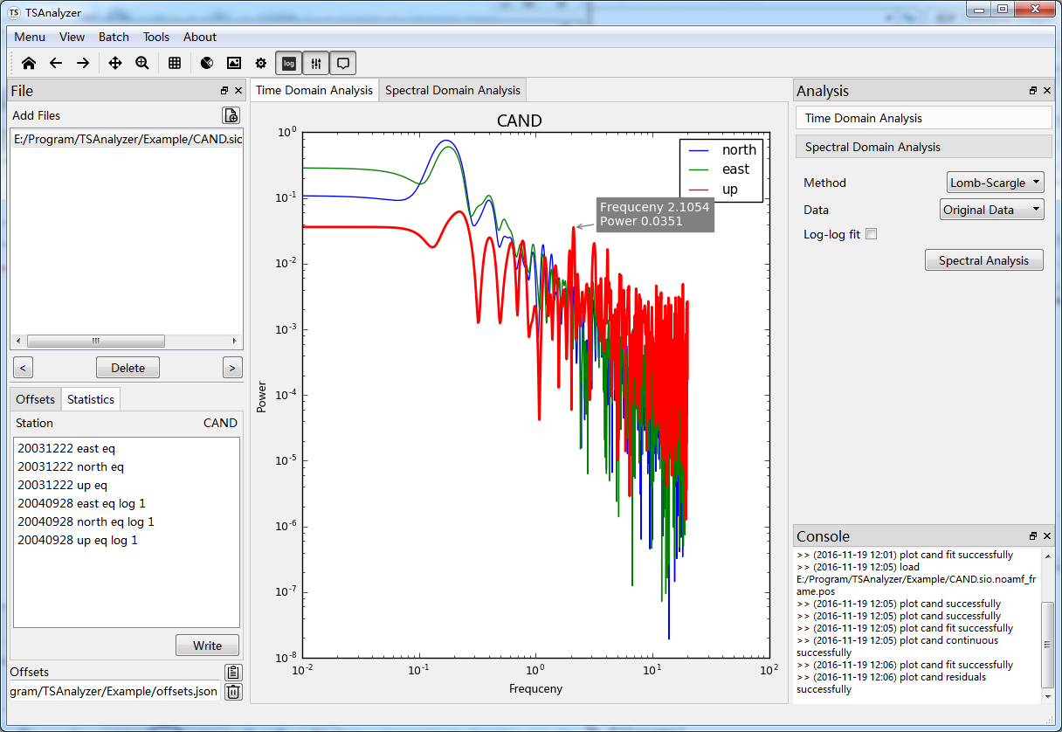Figure 5 TSAnalyzer Spectral Analysis, the power spectral for the CAND station using the Lomb-Scargle method. The highlight and annotation functions can be triggered by click the toolbar menus.

## Batch Analysis

The three softwares mentioned above provide time series analysis but no batch function, the analyze_tseri, which is powerful for batch analysis, has a rigid format and is difficult for a user to learn. For a better position time series software, TSAnalyzer not only can visualize the time series one by one, but also equip with flexibility batch widget for the user. TSAnalyzer has the functions of analysis batch (Figure 6) and figure batch (plotting time series, Figure 7).

Figure 6 TSAnalyzer Analysis Batch

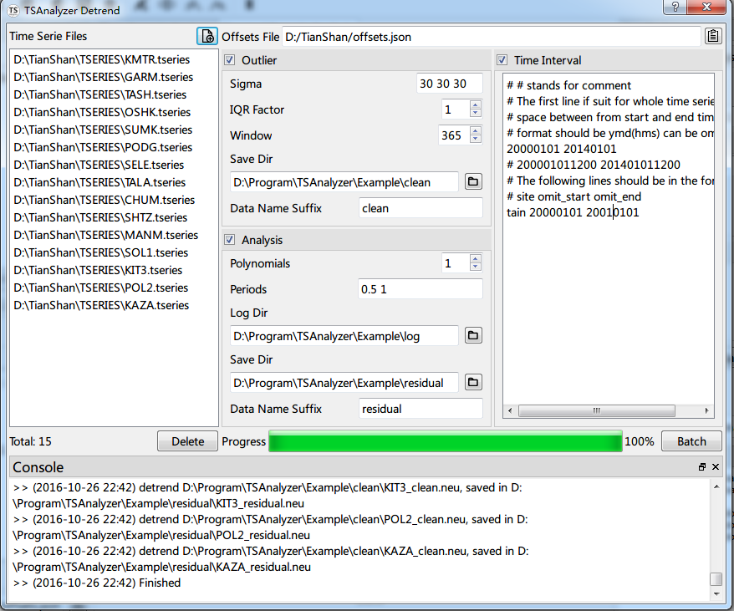

Figure 7 TSAnalyze Figure Batch

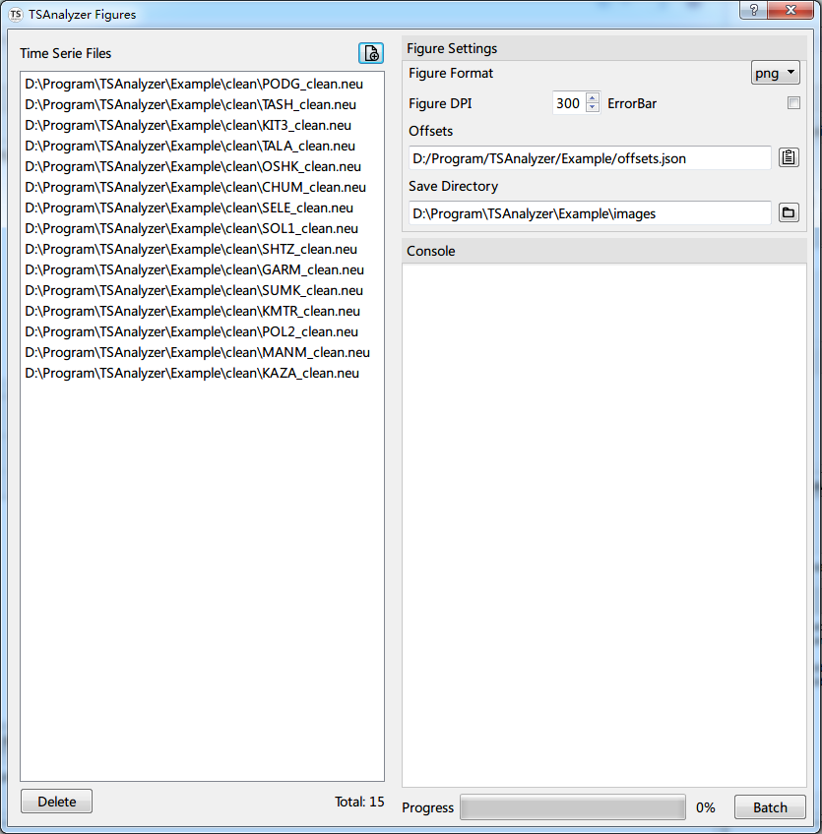

# Future Development

Apart from the improvements of the current modules, some new time series analysis methods will be integrated to TSAnalyzer, for example, Singular Spectrum Analysis (SSA), Empirical Mode Decomposition(EMD).

And it is widely accepted that there exists color noise or even same other types of noise in GNSS position time series, the noise models for time series models is in development for a better time efficient.

As for common mode errors (Wdowinski and Bock et al., 1997; Nikolaidis, 2002; Dong and Fang et al., 2006), some Spatial filtering methods will be applied in the further for batch analysis.

For the software’s convenience use, TSAnalyzer will be packaged into stand-alone executable programs the major operating systems.

# Acknowledgements:

I am grateful to the authors mentioned above, Herring, Tian, Williams, and Goudarzi, for their open source and dedications. I also want to thank the developers of Numpy, Matplotlib, Astropy and so on, for their selfless contribution to the Python community.

# References:

Dong, D. and P. Fang, et al. (2006). "Spatiotemporal filtering using principal component analysis and Karhunen-Loeve expansion approaches for regional GPS network analysis." Journal of Geophysical Research: Solid Earth **111** (B3): n/a-n/a.

Gazeaux, J. and S. Williams, et al. (2013). "Detecting offsets in GPS time series: First results from the detection of offsets in GPS experiment." Journal of Geophysical Research: Solid Earth **118** (5): 2397-2407.

Goudarzi, M. A. and M. Cocard, et al. (2013). "GPS interactive time series analysis software." GPS Solutions **17** (4): 595-603.

Herring, T. (2003). "MATLAB Tools for viewing GPS velocities and time series." GPS Solutions **7** (3): 194-199.

Nikolaidis (2002). Observation of geodetic and seismic deformation.

Robitaille, T. P. and E. J. Tollerud, et al. (2013). "Astropy: A community Python package for astronomy." Astronomy & Astrophysics **558**: A33.

Scargle, J. D. (1982). "Studies in astronomical time series analysis. II - Statistical aspects of spectral analysis of unevenly spaced data." The Astrophysical Journal **263**: 835.

Tian, Y. (2011). "iGPS: IDL tool package for GPS position time series analysis." GPS Solutions **15** (3): 299-303.

Wdowinski, S. and Y. Bock, et al. (1997). "Southern California permanent GPS geodetic array: Spatial filtering of daily positions for estimating coseismic and postseismic displacements induced by the 1992 Landers earthquake." Journal of Geophysical Research: Solid Earth **102** (B8): 18057-18070.

Williams, S. D. P. (2008). "CATS: GPS coordinate time series analysis software." GPS Solutions **12** (2): 147-153.

Zechmeister, M. and M. Kürster (2009). "The generalised Lomb-Scargle periodogram." Astronomy and Astrophysics **496** (2): 577-584.