TSAnalyzer, a GNSS Time Series Analysis Software

WU Dingcheng1,2, YAN Haoming1*, SHEN Yingchun1,2

1State Key Laboratory of Geodesy and Earth’s Dynamics, Institute of Geodesy and Geophysics, Chinese Academy of Sciences, Wuhan 430077, China

2University of Chinese Academy of Sciences, Beijing 100049, China

*Corresponding author, yhm@whigg.ac.cn

**Abstract**: In geodesy and geophysics, the continuous GNSS observation has been used globally. As the increasing number of GNSS observation stations, GNSS time series analysis software should be developed with more flexible formats support, better man-machine interaction and robust analysis characteristics. To meet this requirement, a new software TSAnalyzer written in Python was developed for preprocessing and analyzing the continuous GNSS position time series individually as well as batch processing. This software can read GNSS position time series with different formats, pick epochs of offsets or seismic events interactively, remove outliers and estimate linear, polynomials and harmonic signals. It also provides Lomb-Scargle spectrum analysis. Based on Python, it is cross-platform.

**Keyword**: TSAnalyzer, GNSS Time Series, Harmonic and Trend Analysis, offsets, Lomb-Scargle spectrum, Python

# Introduction

Over the past decades, the continuous GNSS technique has been widely used to monitor tectonic movement, crustal deformation over the world. And there are many high precision GNSS data processing software, such as GIPSY-OASIS, GAMIT/GLOBK, Bernese, Panda, etc. However, only a few limited software packages were designed specifically for GNSS coordinates time series processing and analysis to meet the post-analysis requirements of numerous GNSS data solutions. Among them, GGMatlab (tsview), iGPS and GITSAV are open sources and Analyze_tseri is an executable program in Linux system (Herring, 2003; Tian, 2011; Goudarzi and Cocard et al., 2013). Despite the occurrence of these software improve the GNSS coordinates time series processing, there are still a big gap between these software and the indeed requirements. For example, all the above software could only deal with fixed formats and have a very limited extension for varieties of input data formats. GGMatlab and GITSAV were written in MATLAB language, which is a commercial software as well as iGPS, written in IDL. More important, none of the all above packages could provide a friendly human-interactive visualization function for the offsets selection and processing. Thus, a new package with user-friendly, cross-platform, formats flexible, free of commercial and more powerful processing and analysis functions characteristics is highly demanded for GNSS coordinate time series processing and analysis in geodesy and geodynamics studies and researches. We thus develop a GNSS Time Series Analysis and Visualization (TSAnalyzer) software written in free commercial language of Python.

# Program Language and Installation

TSAnalyzer was developed by using Python programming language with a Qt Graphical User Interface (GUI). In the scientific research domain, Python becomes more and more fashionable due to not only the development of scientific modules, but also benefit from Python’s high-level, code readability and development efficiency. In addition, Python is a cross-platform programming language for popular operating systems, such as Linux, Windows, and Mac. etc. Furthermore, by using third-party tools, Python code can be packaged into a stand-alone executable program for popular operating systems.

TSAnalyzer is freely available as open source software and can be downloaded from:(upload to our ftp server or can be required from the authors???)

The TSAnalyzer package includes code files, icons, examples and documents. To install the software, the TSAnalyzer manual instruction should be carefully read and followed. By typing “python main.py” in the command line prompt or double-clicking the main.pyw (Windows OS), the main GUI window of TSAnalyzer will bring up (Figure 1).

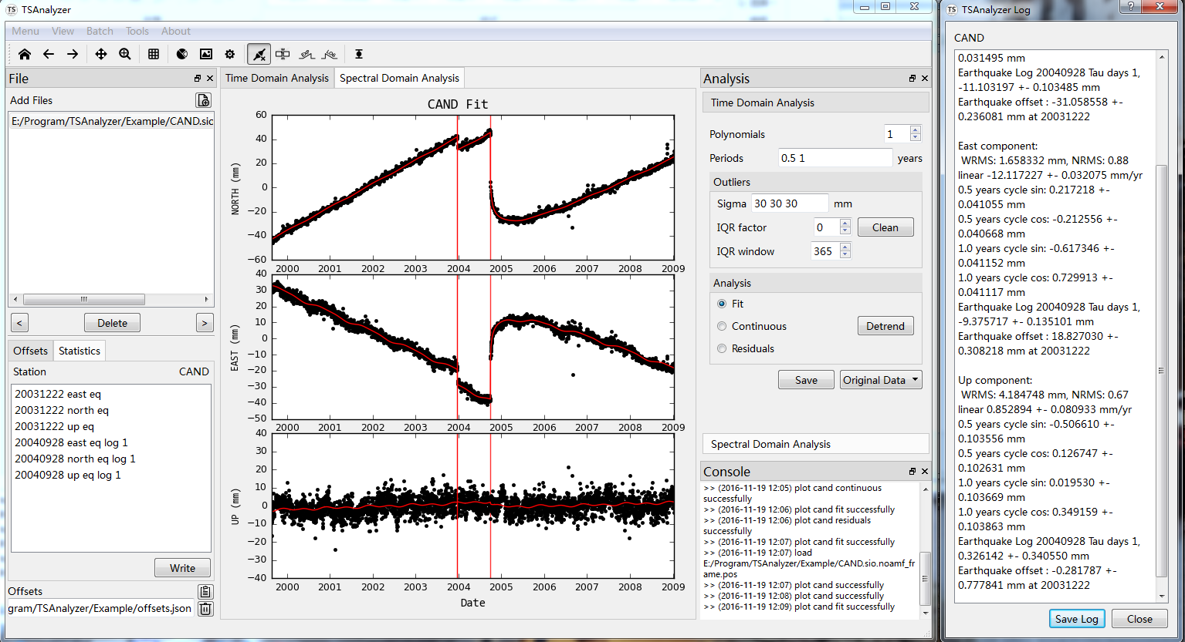Figure 1 TSAnalyzer Main Window displaying the three components of CAND GPS stations time series and corresponding fit results of trend plus seasonal periods separately (in the middle plot area). The left top panel shows the available time series files, the left down panel provides data offsets view and edit, as well as some basic statistic information of current working file. On the right of plot area is the analysis panel and console dock. The right dialog displays the fit results.

# Features and Time Series Analysis

The functions provided by TSAnalyzer cover the least squares analysis, spectral analysis and human-interactive inspecting for data offsets. TSAnalyzer can also read varieties time series with different data format through the date conversion and header comment tools in the software. In the following, some key features of TSAnalyzer are introduced.

## Time Series Visualization and Interaction

We all know that the GNSS data provided by different data center have the universal data format, i.e., RINEX format. While the GNSS coordinate time series generally have different data format, which can vary from one GNSS analysis center to another. Till now, the TSAnalyzer software can recognize and support the coordinate time series products provided by the following data centers directly:

* Plate Boundary Observatory (PBO) format (.pos)
* NASA Jet Propulsion Laboratory (JPL) tseries format (.tseries)
* NEU format described in CATS software (Williams, 2008)

For other formats of coordinate time series, we provide a Header Comment Tool (HCT) to convert the input file to a suitable data format, which can be supported by TSAnalyzer (Figure 2). More details about HCT can be found in software user manual and tutorial.

Figure 2 TSAnalyzer Header Comment Tool

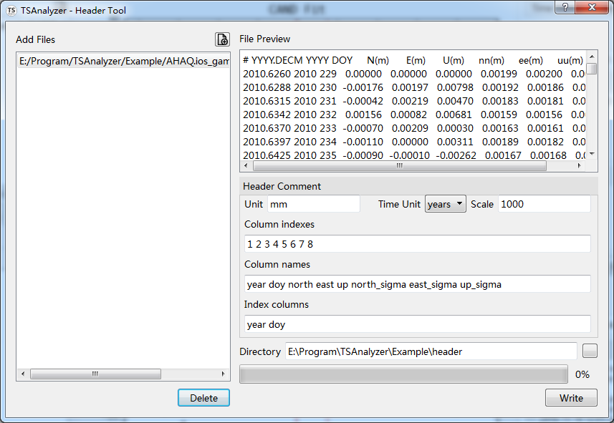

When a time series file was loaded successfully, the dimension(s) of coordinates can be plotted automatically in middle dock of TSAnalyzer software for visualization (Figure 1). We thus can do some interactive work with these coordinate figures separately or together at the same time.

The most important key feature in TSAnalyzer is to do interactive work for detecting and repairing data offsets manually. Due to the earthquake, instrument interruption and any other reasons, generally the GNSS coordinate time series will hold some data offset, which will affect the further post-analysis. Thus, these data offsets must be first detected and removed. Though there are some mathematical theories presented for auto detecting these offsets in GNSS position time series (Gazeaux and Williams et al., 2013), the most accurate and efficient method is still manual inspection. TSAnalyzer provides four types of offsets detection and removal, i.e., equipment changes offset, offset induced by co-seismic deformations, offset caused by post-seismic relaxations with logarithmic and exponent decay, respectively (Figure 3). TSAnalyzer also design a json format in text format to record these offsets event, and can be loaded. After the offsets file loaded, it will plot the breaks in different color lines, blue line stands for equipment event, and red line means earthquake eruption. One can also add offsets if the offsets information is not complete. TSAnalyzer provides picking offsets directly on figures and modifying them on the offsets list (left down panel in Figure 3) by double-click the specific event (Figure 3b).

Figure 3 Offsets Selection

|  |  |
| --- | --- |
| 1. Interactively Selection | 1. Dialog for Modification |
|  |  |

The Figure 3a) displays select the epoch in time series figure and Figure 3 b) shows edit the offset event in detail.

## Time Series Analysis Model

The TSAnalyzer provides some mathematic data fit models, such as linear and polynomials fit with auto BIC criterion for the best polynomials order determination, harmonic data fits with any frequency signals combination. TSAnalyzer also provides fit models that can be used to combine with the exponential or logarithmic decay step functions to do accurate data analysis directly and preliminarily and show the results in the plot window. This new data fit models are superior to the other similar previous packages, due to these previous packages only can fit linear, annual and semi-annual signals. Furthermore, TSAnalyzer provides three more functions as below.

### Outlier detection and removal

Because of poor observation situation and some other reasons, some outliers in GNSS time series coordinates can be found. If not cleaned correctly, they may disturb the analysis results. In TSAnalyzer, there are two criterions for outlier removal. (i) uncertainty criterion: which is adopted to mask out the epochs point value larger than the given threshold value by user experience. (ii) Mean-standard deviation and sliding window IQR method: which are combined to remove the outliers.

### Time Series detrend

All parameters are estimated by the weight least squares method. After analysis, the residuals and/or the fit lines can be shown in the plot window, and a log dialog will show the fit parameter values and their uncertainties. The user could save the residuals data, the log, and the figures to the output files conveniently.

### Spectral Analysis

Spectral analysis is a powerful method for time series analysis, which can estimate the spectral power at each frequency and help to find some interesting signals in a time series. TSAnalyzer provides the Lomb-Scargle spectral analysis for GNSS coordinate time series. The obvious merit of this spectral analysis method is that it can evaluate the time series spectrum regardless of the evenly sampled or gap existence in a time series (Scargle, 1982; Zechmeister and Kürster, 2009). While the traditional FFT spectrum method cannot hold the uneven data interval case, which is often encountered in the GNSS coordinate time series. We here realize the Lomb-Scargle spectral analysis by using the Astropy’s code (Robitaille and Tollerud et al., 2013) and show GNSS station CAND’s spectrum in Figure 5.

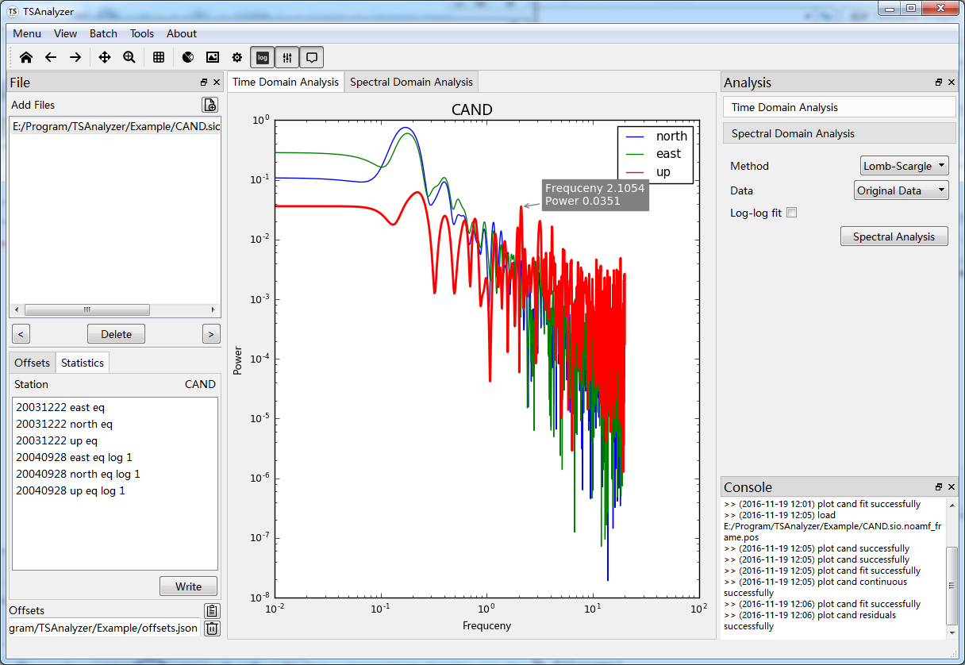Figure 5 TSAnalyzer Spectral Analysis for the CAND station. The highlight and annotation functions can be triggered by click the toolbar menus.

## Batch Analysis

TSAnalyzer not only can visualize and analyze the time series one by one, but also equip with flexibility batch widget for the user. Using TSAnalyzer batch widget, the user can analyze and plot the multi-station time series at the same time (Figure 6, Figure 7), which will be benefit the multi-station processing encountered continually.

Figure 6 TSAnalyzer Analysis Batch

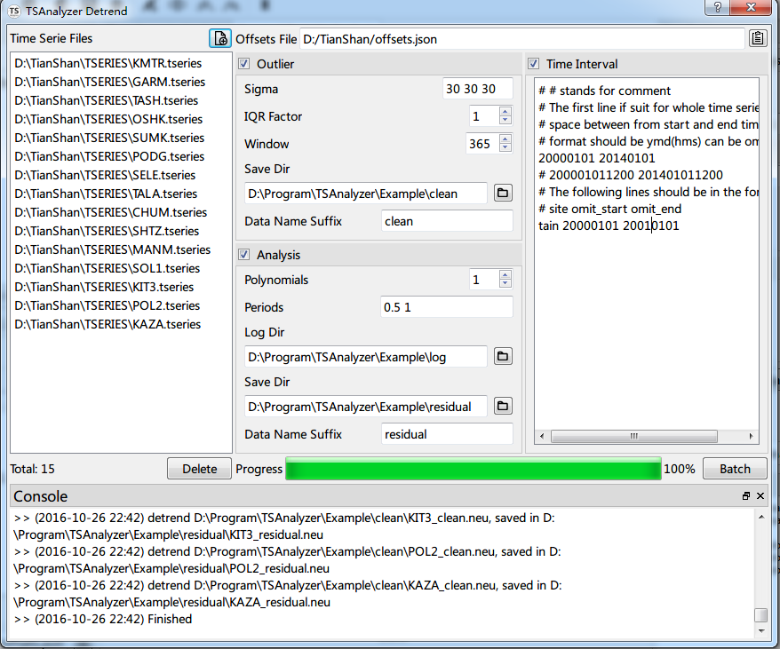

Figure 7 TSAnalyze Figure Batch

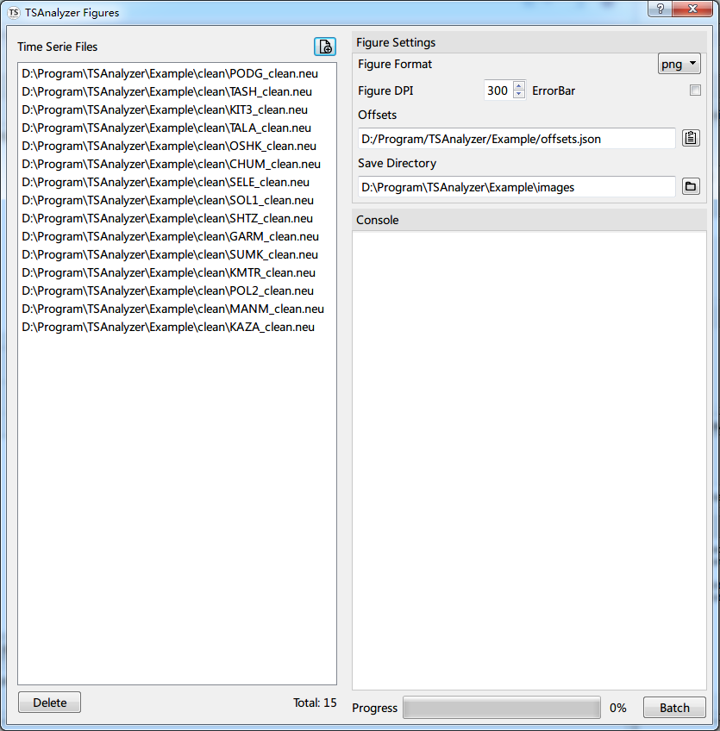

# Future Development

Apart from the improvements of the current modules, some new time series analysis methods, such as Singular Spectrum Analysis (SSA), Empirical Mode Decomposition (EMD), etc., will be integrated to TSAnalyzer in the future. Otherwise, the noise analysis of the GNSS coordinate time series, common mode errors analysis (Wdowinski and Bock et al., 1997; Nikolaidis, 2002; Dong and Fang et al., 2006), spatial filtering and Monte Carlo simulation etc. will be developed too. We hope that the TSAnalyzer software can benefit the users who want to do post-analysis of GNSS coordinate time series and develop it under the open source frame.

# Acknowledgements:

I am grateful to the authors mentioned above, Herring, Tian, Williams, and Goudarzi, for their open source and dedications. I also want to thank the developers of Numpy, Matplotlib, Astropy and so on, for their selflessness contribution to the Python community. This research is supported by research projects of the National Natural Science Foundation of China (grant No. 41621091, 41374087 and 41674084).

# References:

Dong, D. and P. Fang, et al. (2006). "Spatiotemporal filtering using principal component analysis and Karhunen-Loeve expansion approaches for regional GPS network analysis." Journal of Geophysical Research: Solid Earth **111** (B3): n/a-n/a.

Gazeaux, J. and S. Williams, et al. (2013). "Detecting offsets in GPS time series: First results from the detection of offsets in GPS experiment." Journal of Geophysical Research: Solid Earth **118** (5): 2397-2407.

Goudarzi, M. A. and M. Cocard, et al. (2013). "GPS interactive time series analysis software." GPS Solutions **17** (4): 595-603.

Herring, T. (2003). "MATLAB Tools for viewing GPS velocities and time series." GPS Solutions **7** (3): 194-199.

Nikolaidis (2002). Observation of geodetic and seismic deformation.

Robitaille, T. P. and E. J. Tollerud, et al. (2013). "Astropy: A community Python package for astronomy." Astronomy & Astrophysics **558**: A33.

Scargle, J. D. (1982). "Studies in astronomical time series analysis. II - Statistical aspects of spectral analysis of unevenly spaced data." The Astrophysical Journal **263**: 835.

Tian, Y. (2011). "iGPS: IDL tool package for GPS position time series analysis." GPS Solutions **15** (3): 299-303.

Wdowinski, S. and Y. Bock, et al. (1997). "Southern California permanent GPS geodetic array: Spatial filtering of daily positions for estimating coseismic and postseismic displacements induced by the 1992 Landers earthquake." Journal of Geophysical Research: Solid Earth **102** (B8): 18057-18070.

Williams, S. D. P. (2008). "CATS: GPS coordinate time series analysis software." GPS Solutions **12** (2): 147-153.

Zechmeister, M. and M. Kürster (2009). "The generalised Lomb-Scargle periodogram." Astronomy and Astrophysics **496** (2): 577-584.