ECE5725: Homework 1

1. Cornell academic integrity quiz result:

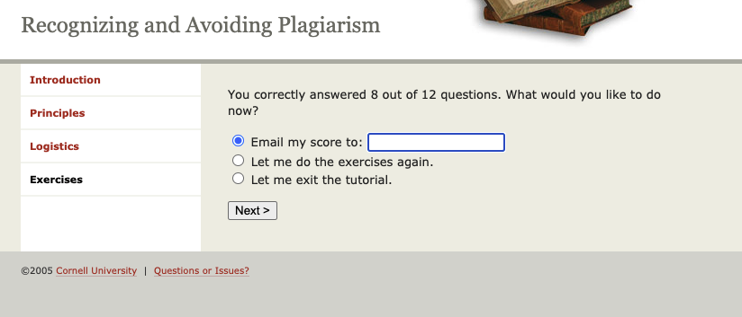

1. The SD card has been set up and backed up, I will show them to TA at Lab1.
2. The principle of Linux file permission is “-/d/l rwx rwx rwx”. The three group of “rwx” are for user, group, global, respectively. And the rwx is usually calculated by binary number. For example, 111 means readable, writable, executable; however, 000 means unreadable, unwritable, and un-executable.

We used Integer to represent the binary number, so 777 means 111 111 111, that this file can be read, written, executed by the user, group, as well as anyone that reaches this file. This is dangerous because all users can change the file, making it totally unsecure. 644 means 110 100 100, that the user can read and write the file, while others can only read that file. 700 means 111 000 000, that the user has all authorities for the file, while others have none.

1. Screenshot:

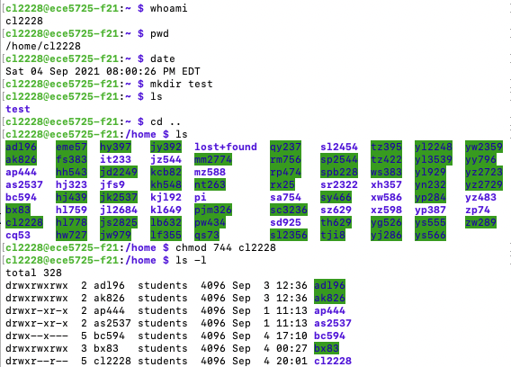

1. Screenshot:

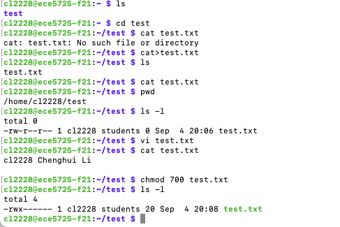

1. Already done that.
2. The full name of ‘df’ is disk free, used to show the free space of disks, the /home directory is used to store data of all students participating in ECE 5725 so it is allocated the largest space by using an external driver which is 1TB. Using ‘df -h’ can make display human-readable by showing B/KB/MB/GB.

Screen shots:

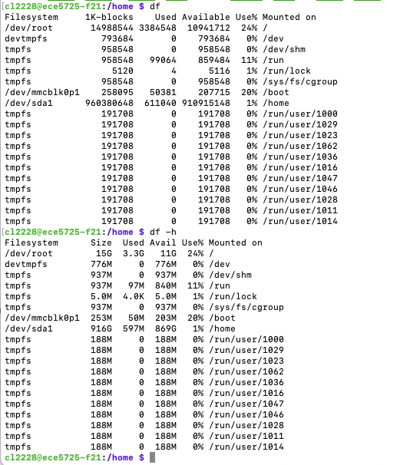

1. Screenshots:

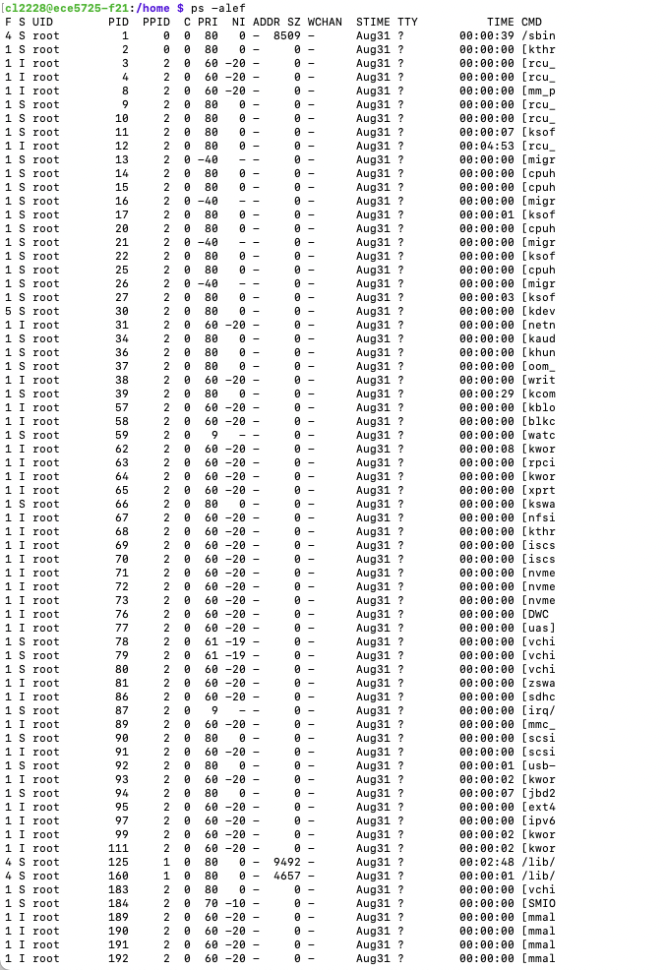

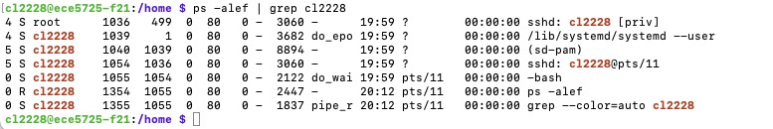

1. Components of the Raspberry Pi are quite similar to those in servers or laptops. Our SD card can be regarded as Raspberry’s disk; Raspberry’s core, the Raspberry Pi 4 for example, is a 1.5GHz 64-bit quad-core ARM Cortex-A7x processor, this is different from laptops, which usually use Intel or AMD or Apple M1 as CPUs. Raspberry Pi is absolutely a money saver because a server that perfectly allows all students use in the ECE5725 only costs no more than $100, if we use a PC, it will cost more than $1,000, much more expensive than the Raspberry Pi. But if we need to run some programs or models that need high computing resources such as deep-learning model training, then raspberry Pi cannot fulfill the needs as the task need high-performance GPUs and CPUs. In general, raspberry Pi is winner in the price, but it has capability limit.
2. The main differences between top and htop is that htop is colorful and has a nicer interface, allows users to scroll the process list, allows many operations with mouse. More importantly, htop allows us to kill a process without finding and entering PIDs. According to the above advantages, htop is a better choice to use.