1. The continuous rotation servo has the gearing set and it has the built-in motor driver. Servo motors are always assembled by four things: a DC motor, a gearing set, a control circuit and a position-sensor while DC motor only have no assemble set, only the motor. And the servo motors always contain three wires (power, ground & control), while DC motor only have two wires for power and ground. Besides, dc motors are also cheaper and have lower power consumption for most applications.

DC motor needs a motor controller to control the speed of the motor to better operate DC motors, while the servo motor does not need that due to its control circuit inside.

1. The best way is powering the motor by using a 6V battery through the motor controller and power the controller by raspberry pi though 3.3V pin where this 3.3V pin also power the standby. Then the pi is powered by the AC power supply. And the GND for these three components are connected together to the ground. The diagram is as following,

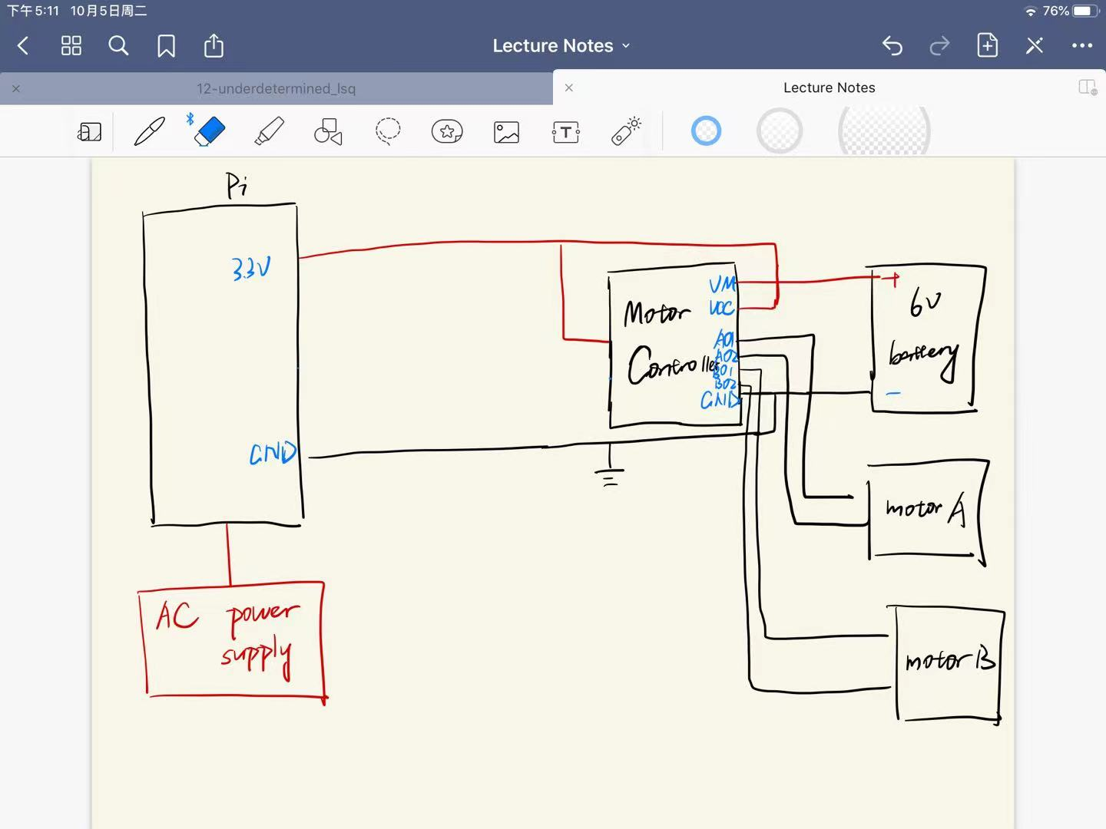

1. The circuit diagram including control signals are shown in the following diagram. This version contains the PWM control and some protection resistors

