Planning and Reinforcement Learning in AI Systems (02360765)
Spring 2026

Alternative Project: Caldera Return Mission
Lecturer | Dr. Sarah Keren
TA | Guy Azran
Release date | Tuesday, October 6th
Submission deadline | Wednesday, November 4th, 23:59

1. About this project
This project replaces the final exam for students who could not take the exam, or could not prepare for it, due to military reserve duty. The project grade replaces only the exam grade. Homework grades count as usual.
You will work on one mission in the caldera environment from the homework. You will model the mission, plan for it, learn to act in it, and compare the results. Every student gets a different version of the mission, generated from their ID number.

2. Rules
- Individual work. You may discuss course concepts with other students. Do not share code, results, or report text.
- AI tools. You may use AI assistants for help with Python and with debugging. You are responsible for every line of your code and every sentence in your report. Write a short file ai_use.txt that lists the tools you used and what you used them for.
- Questions about your code. If the course staff suspect that a submission was produced mostly by AI tools, without real understanding by the student, they may call the student in to explain the code and the results. If the student cannot explain them, the grade may be reduced.
- Libraries. Use only the packages in environment.yml from the starter package. Do not use MCTS or RL libraries (for example gymcts or Stable-Baselines) or packages that solve MDPs. Write these algorithms yourself.
- Starter files. Do not change mission.py. We grade your code with our own copy of this file.
- Seeds. Every experiment must use fixed random seeds. Rerunning your code must give the numbers in your report.
- Lambda server. We will run your code on the faculty lambda server, with the conda environment from environment.yml. Your code must run there without any changes. Test it on lambda before you submit. The README.md of the starter package explains how to set it up.

3. The mission
An autonomous vehicle starts at a dock next to the research ship. The science team wants a sample from the bottom of each of the three pits in the caldera. The vehicle should collect as many of these samples as it can and then come back to the dock before its energy runs out. Ocean currents sometimes push the vehicle off course, and other vehicles in the area make some cells dangerous.
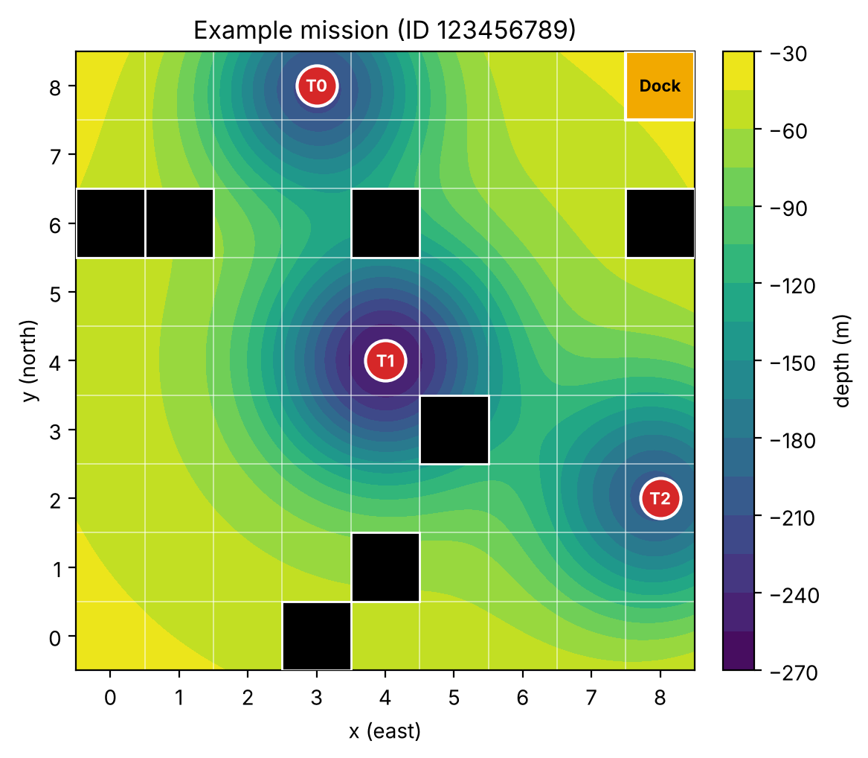
The mission follows these rules.
- The map is a grid of 9 by 9 cells. A cell is written (x, y), where x and y are whole numbers from 0 to 8. Some cells contain obstacle vehicles. Obstacles never move.
- The vehicle starts at the dock cell with energy E.
- The actions are MOVE_NORTH, MOVE_SOUTH, MOVE_EAST, MOVE_WEST, SAMPLE and DOCK. Every action costs 1 unit of energy.
- The vehicle may choose a move action only if the neighbor cell in that direction is inside the map and has no obstacle.
- A move goes to the intended neighbor cell with probability p. With probability 1 − p, the current turns the vehicle to the right of the intended direction. North becomes east, east becomes south, south becomes west, and west becomes north. The current never affects SAMPLE or DOCK.
- If the move that actually happens would enter an obstacle cell, the vehicle crashes. If it would leave the map, the vehicle stays in its cell.
- There are three target cells, one at the bottom of each pit. The first SAMPLE in a target cell collects that target. SAMPLE in any other cell, or in a target that was already collected, only costs energy.
- The vehicle may choose DOCK only when it is at the dock cell and has collected at least one target.
- The episode ends when the vehicle docks, when it crashes, or when its energy reaches 0.
- Every action gives a reward of −1. Collecting a target adds +25. If the vehicle crashes, or its energy reaches 0 while it is not at the dock, the vehicle is lost and this adds −50. There is no discounting (γ = 1).
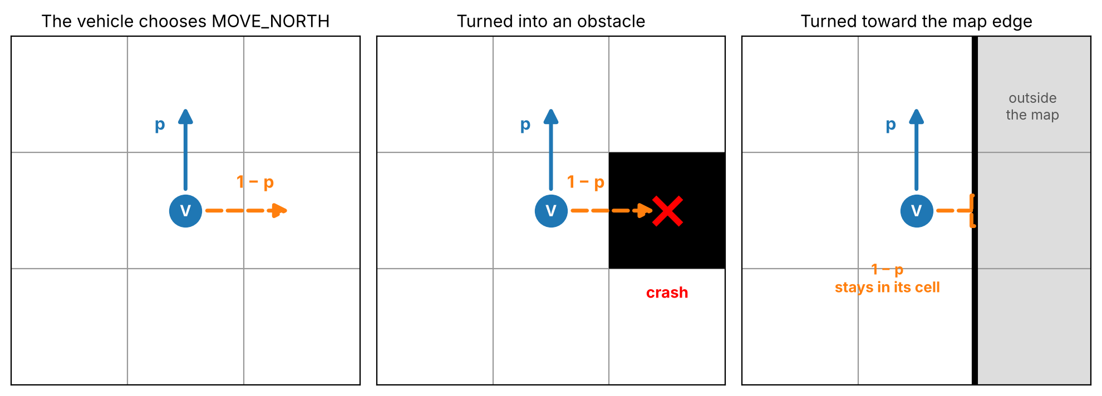
Some terms used in the rest of this document.
- The return of an episode is the sum of its rewards.
- An episode is a full success if the vehicle collected all three targets and was not lost.
- The full-success rate and the loss rate are the fractions of episodes that were a full success, and in which the vehicle was lost.
- The standard error of a mean return is the sample standard deviation of the returns divided by the square root of the number of episodes.
- s₀ is the start state of the mission. V*(s₀) is its optimal value.

4. Starter Files
The starter package is a folder named alternative-project-starter. It contains everything you need, so you do not need any files from the homework. It has the following files.
- mission.py builds your mission and its environment. Do not change it.
- environment.yml describes the conda environment that we use to run your code.
- README.md explains how to set up the environment on the lambda server and how to use mission.py.
- py-sbatch.sh runs a Python script on a lambda compute node through slurm.
- check_setup.py checks that your setup works and draws your mission.
- part1_currents.py, part2_planning.py, part3_learning.py and part4_summary.py are where you write your code. They contain function names and short descriptions to help you start.
- pddl/domain.pddl is where you write your PDDL domain for 2.1.
- results and figures are the folders for your saved results and figures.
- ai_use.txt is the file described in Section 2.
You may add functions and files. Each part file must run with python <file name> --id <your ID> and must reproduce every number and figure of its part.
mission.py builds your mission. Call make_mission(student_id) with your 9-digit ID number. It returns two objects.
- env is a Gymnasium environment for your mission with reset() and step(action). The observation holds the cell, the energy and the collected targets. The info dictionary holds a mask of the available actions. env.get_state() returns the state as (cell, energy, collected), and env.set_state(cell, energy, collected) puts the environment in any state. Use set_state only where the table below allows it.
- info is a dictionary with the map, the dock, the target cells, the obstacle cells, the energy E, the success probability p, the parameters of the ocean-current model for Part 1, and a log of 60 move outcomes for Part 1.
mission.py also has evaluate(policy, env, n_episodes, first_seed), which runs episodes and returns the mean return, its standard error, the full-success rate, the loss rate and the result of each episode. For figures it has plot_mission, plot_path and plot_arrows. Figure 3 shows an episode drawn with plot_path.
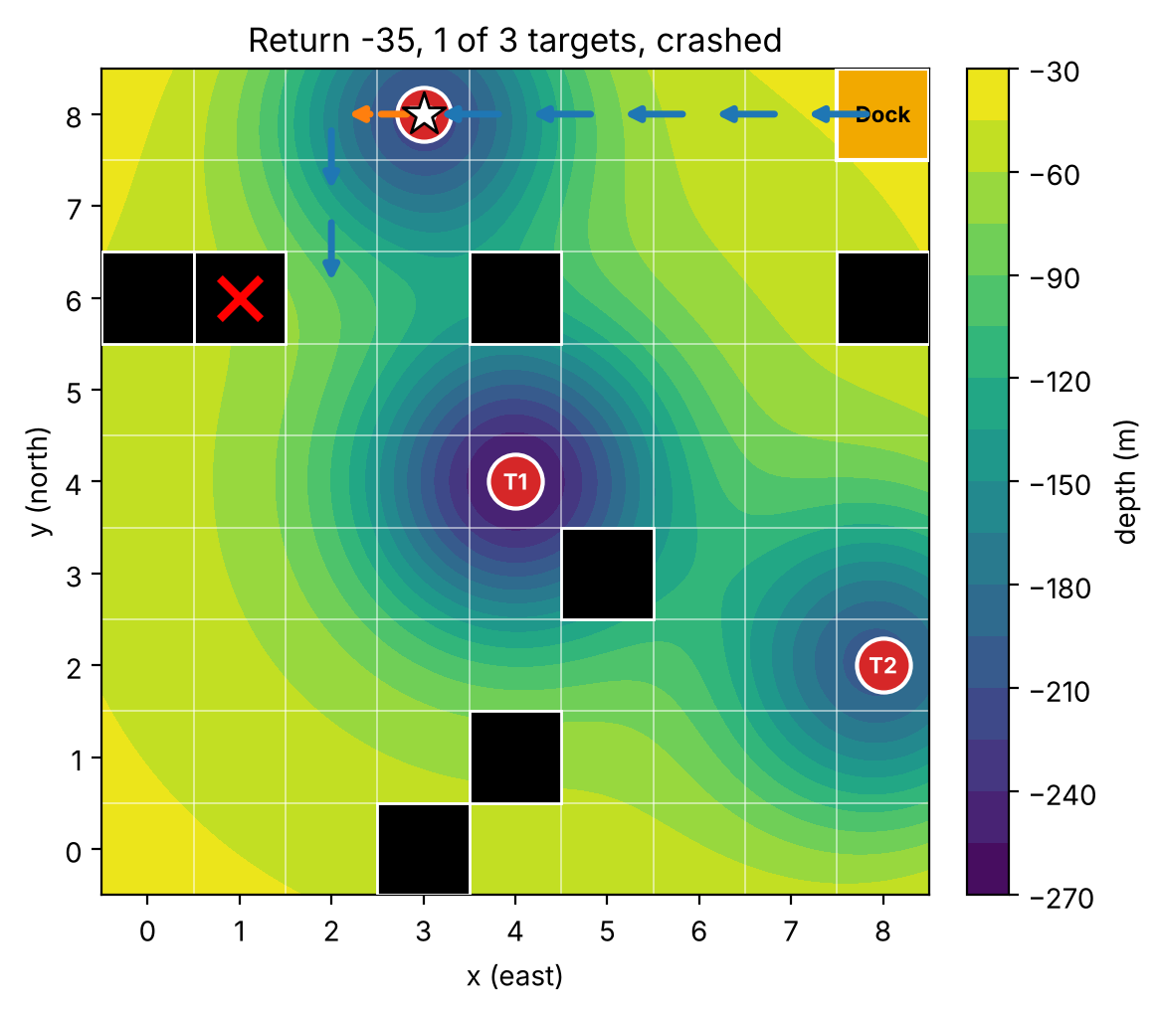
Start your report with the output of describe_mission(info) and the figure from plot_mission.
Each agent may use only some of the information about the mission. The table lists what each agent may use.
Agent | May use | May not use
Value iteration (2.3) | Your transitions function | No limits
Plan and replan (2.4) | The deterministic version of the problem and the current state | The success probability p
UCT (2.5) | Your transitions function as a simulator | V* and π*
Q-learning and Monte Carlo control (3.1, 3.2) | env.reset and env.step | transitions, env.set_state, V* and π*
Behavior cloning and DAgger (3.3, 3.4) | π* as the expert, env.reset and env.step | transitions and V* inside the learned policy

5. Part 1. The ocean currents (15 points)
The currents switch between two regimes, Calm and Strong. Let R_{t} be the regime during move t. If R_{t} is Calm, then R_{t+1} is Strong with probability a. If R_{t} is Strong, then R_{t+1} is Calm with probability b. Let O_{t} = 1 if move t went in the intended direction and O_{t} = 0 if the current turned the vehicle. In Calm, O_{t} = 1 with probability p_{C}. In Strong, O_{t} = 1 with probability p_{S}. The vehicle sees O_{t} after every move, but it never sees the regime. Your values of a, b, p_{C} and p_{S} are in info.
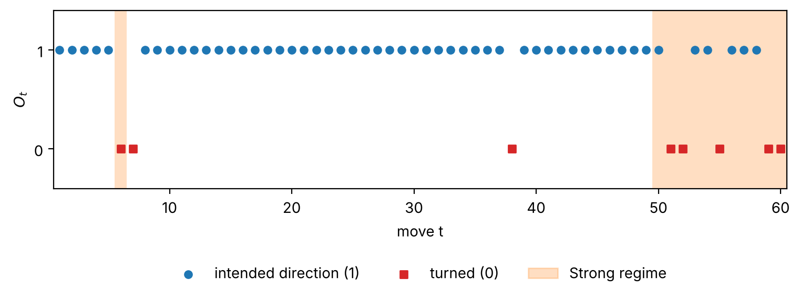
In Parts 2 and 3 the environment does not switch regimes. It uses one fixed success probability p, equal to the long-run value p̄ that you compute in 1.1.

1.1 Long-run behavior, by hand (3 points)
Write the transition matrix of the regime chain. Compute its stationary distribution. Compute p̄, the long-run fraction of moves that go in the intended direction. Does the regime distribution converge to the stationary distribution from any starting regime? Explain using properties of the chain.

1.2 Checking by computation (2 points)
Starting from Calm, compute the regime distribution after 1, 2, 5, 10 and 20 moves with powers of the transition matrix. Then simulate 100,000 moves and report the fraction of moves made in Strong and the fraction of moves that went in the intended direction. Compare with 1.1.

1.3 A dynamic Bayesian network (2 points)
Describe one move of the vehicle as a two-slice dynamic Bayesian network with the variables R_{t}, O_{t}, the action A_{t}, the cell X_{t} and the energy E_{t}, and their versions at time t+1. Here X_{t+1} and E_{t+1} are the cell and energy after action A_{t}. Give the parent sets of R_{t+1}, O_{t}, X_{t+1} and E_{t+1}. Which variables are hidden from the vehicle?

1.4 Exact belief filter (4 points)
Let b_{t} be the belief about R_{t} after seeing O₁, …, O_{t}. Before any outcome is seen, use the stationary distribution as the belief about R₁. The log in info["current_log"] has 60 outcomes and the true regimes.
(a) Compute b₁, b₂ and b₃ by hand for the first three outcomes in your log.
(b) Implement the filter with a prediction step and a correction step. Plot b_{t}(Strong) for t = 1 to 60 together with the true regimes.
(c) Find one place in your plot where the belief is slow to follow a change of regime. Explain why, using p_{C} and p_{S}.

1.5 Particle filter (4 points)
Implement a particle filter for the same log. Each particle holds a regime. Start with N particles drawn from the stationary distribution as guesses of R₁, each with weight 1/N. In each later step, move every particle by sampling its next regime, multiply its weight by the likelihood of the observed outcome, and normalize the weights. Resample when the effective sample size N_{ess} = 1 / Σ_{i} (w_{i})² is below N/2, where N is the number of particles.
For N = 10, 100 and 1000, with and without resampling, run the filter 20 times with different seeds. Report the mean absolute difference between the particle estimate of b_{t}(Strong) and the exact value from 1.4, averaged over t and over runs. Explain the results.

6. Part 2. Planning with a known model (38 points)

2.1 Deterministic planning (8 points)
In this question only, ignore the currents (p = 1) and the energy. The vehicle must collect all three targets and then dock.
(a) Write the problem as a STRIPS problem ⟨F, I, A, G, C⟩ with unit action costs. Give the fluents, the initial state and the goal. For each action, written with parameters as in PDDL, give its preconditions, add effects and delete effects. Make sure that no action can be applied after DOCK.
(b) Write domain.pddl by hand. Write a Python function that creates problem.pddl from info. Solve the problem with Fast Downward through the Unified Planning Framework with an optimality guarantee, as in Tutorial 4. Report the plan, its cost h*(s₀) and the solving time. Check that h*(s₀) is at most E.
(c) Write a relaxed plan for your initial state, that is, a plan for the problem with all delete effects removed. Make it as short as you can and report its length. Explain why it is shorter than h*(s₀). Name two facts that are true together during your relaxed plan but can never be true together in the real problem.

2.2 A model of the stochastic mission (5 points)
From now on the currents are on, with the probability p from info. A state is (cell, energy, collected), the same tuple that env.get_state() returns. Complete the function transitions(state, action, info) in part2_planning.py. It returns every possible outcome as a tuple (probability, next state, reward, done).
Test it against env. Choose at least 50 pairs of a state and an action, including states next to obstacles and next to the edge of the map. For each pair, use env.set_state and run the action 2,000 times. Report the largest difference between an observed frequency and the probability your function gives.

2.3 Value iteration (8 points)
(a) Compute V* and an optimal policy π* for all states with value iteration. Energy goes down by 1 with every action. Explain how this lets you compute every value in one pass over the states, and in which order you must visit them. Report V*(s₀) and the number of states.
(b) Choose a state in which all targets are collected, the vehicle is one cell away from the dock, and the energy is 2. Compute V* of this state by hand and compare it with your code.
(c) Run π* in env for 1,000 episodes with seeds 0 to 999. Report the mean return, its standard error, the full-success rate and the loss rate. Check that V*(s₀) is within two standard errors of the mean return. If it is not, find the bug.
(d) Plot π* as arrows on the map for two cases. In the first case no target is collected and the energy is E. In the second case all targets are collected and the energy is 10. Point to one place where π* does not take a shortest path and explain why.

2.4 Plan and replan (6 points)
Build an agent that follows your optimal plan from 2.1. After each step, if the vehicle is not in the state that the plan expected, the agent plans again from its current state. You may plan with Fast Downward or with your own breadth-first search, as long as the plans are optimal for the deterministic problem. Your agent also needs a rule for the case where the new plan needs more energy than it has left. Describe your rule.
Run 200 episodes with seeds 0 to 199 and report the same numbers as in 2.3(c). How many of the losses were crashes? Show one episode on the map where this agent loses value compared to π*, and explain what π* would do differently in that situation.

2.5 Online planning with UCT (11 points)
Implement Monte Carlo tree search with the UCT rule yourself. Do not use gymcts. Your implementation must do the following.
- Build a new search tree from the real current state before every action.
- Use your transitions function as the simulator. Sample a new outcome every time the search tries an action, so the same action can lead to different child nodes. This plays the role of the chance nodes discussed in Tutorial 5.
- Inside the tree, select actions by Q(s, a) + c √(ln N(s) / N(s, a)).
- Use a rollout policy of your choice.
- After the simulations, choose the root action with the most visits.
(a) Use a random rollout policy. Run with N = 25, 100 and 400 simulations per step, with c = 1 and with one larger value of c that you choose based on the size of the returns in this mission. Explain your choice of c. Use at least 100 episodes per setting and report the mean return, its standard error and the average time per decision. UCT does not have to come close to V*(s₀) with these budgets.
(b) Explain why random rollouts give poor value estimates in this mission. Design a better rollout policy, describe it, and repeat the runs of (a) with your best value of c.
(c) Is UCT an anytime algorithm? Compare UCT with value iteration in planning time and in return. In which situations would you prefer UCT for this vehicle?

7. Part 3. Learning from experience and from an expert (32 points)

3.1 Q-learning and Monte Carlo control (14 points)
The agents in this question may use only env.reset and env.step. Implement tabular Q-learning and on-policy first-visit Monte Carlo control, both with ε-greedy exploration, as in Tutorial 6. You choose the state key, the schedule for ε and the step size α. Train each method for 30,000 episodes with 3 different seeds. Every 1,000 training episodes, run the greedy policy (ε = 0, no updates) for 100 episodes with seeds 0 to 99 and record its mean return. Neither method has to reach V*(s₀) within this budget.
(a) Plot the evaluation return of both methods during training, averaged over the seeds, with a shaded band for the spread between seeds and a horizontal line at V*(s₀).
(b) Report at least one change to your settings that improved one of the agents. Show the curves before and after the change.
(c) Which method gets closer to V*(s₀) within the budget? Explain using the bias and the variance of the two update targets.
(d) Plot one greedy episode of each trained agent next to an episode of π*. Compare how close each one passes to obstacles. Explain the difference using on-policy and off-policy learning.
(e) Do your settings meet the conditions for convergence from Tutorial 6? Which of these conditions cannot hold in a finite run?

3.2 The state key (4 points)
Train Q-learning again with a state key that leaves out the energy. Use the same settings and seeds as in 3.1. Compare the results and explain what you see. Describe a situation in your mission where an agent with this key must make a mistake.

3.3 Behavior cloning (8 points)
Use π* as the expert. Collect k = 5, 20 and 100 expert episodes in env. Choose the features that describe a state and a classifier, for example a decision tree, k-nearest neighbors, or a small neural network as in Tutorial 3. Train one policy for each k. If the classifier picks an action that is not available, use the available action with the highest score.
Run each policy for 500 episodes and report the mean return, the full-success rate and the loss rate. Also report the fraction of the states visited by each policy that never appear in its training data. Show one state where your policy picks a different action than π*. Explain how the policy reached this state and what happens next.

3.4 DAgger (6 points)
Start from the policy you trained with k = 5. Run 5 rounds of DAgger. In each round, run the current policy for 5 episodes, label every state visited in these episodes with the action of π*, add the labeled states to the data set, and train again.
Plot the mean return against the total number of expert labels, for behavior cloning with k = 5, 20 and 100 and for DAgger after each round. Does DAgger reach a higher return than behavior cloning with the same number of labels? It does not have to. Explain what you see using distributional shift.

8. Part 4. Comparison and discussion (15 points)

4.1 Summary table (4 points)
Make one table with one row for each of the following agents. Evaluate every agent on the same 200 episodes, with seeds 0 to 199.
- π* from 2.3
- Plan and replan from 2.4
- Your best UCT setting from 2.5
- Q-learning and Monte Carlo control from 3.1
- Your best behavior cloning policy from 3.3
- DAgger after the last round of 3.4
The columns are the mean return with its standard error, the full-success rate, the loss rate, what the agent needs (a model, a simulator, an expert, or only experience), and what this costs (planning time, simulations per step, training episodes, or expert labels).

4.2 Discussion (11 points)
Answer in at most one page.
(a) In Parts 2 and 3 the success probability was fixed at p̄. In the real caldera the currents switch between Calm and Strong as in Part 1. Describe one situation in your mission where an agent that plans with p̄ makes a bad choice. What would the agent need to know to avoid it, and how could your filter from 1.4 provide this?
(b) The vehicle will next work in a different caldera with a new map. For each agent in your table, say what work is needed before it can act well there.
(c) Which agent would you choose for the real vehicle? Explain your choice.

9. What to submit
Submit one zip file named alt_project_<ID>.zip with the following contents.
- report.pdf, at most 12 pages on A4 paper, with 11-point font and margins of at least 2 cm. We do not read pages after page 12. Answer the questions in order and use the question numbers.
- The starter folder with all your code, including pddl/domain.pddl. Each part file must reproduce every number and figure of its part when we run it on lambda.
- The folders results and figures, with the raw results (CSV or JSON files) and the figures behind every table and figure in the report.
- README.txt, which says how long each part file takes to run on lambda and anything else we need to know to run it.
- ai_use.txt, as described in Section 2.

10. Grading
Component | Points
Part 1. The ocean currents | 15
Part 2. Planning with a known model | 38
Part 3. Learning from experience and from an expert | 32
Part 4. Comparison and discussion | 15
Total | 100

- About half of the points in each question are for explanations. An explanation gets full credit only when it refers to your own numbers or figures.
- Your grade does not depend on reaching a particular return. It depends on correct methods, numbers that match your code, and clear reasoning. In 2.5 and 3.1 we also expect a real attempt to improve the agent.
- We will run make_mission with your ID and rerun your part files on lambda with environment.yml. The numbers in your report must match the results of these runs. A question whose code does not run on lambda may get no credit.
- Late submissions without an approved extension lose 5 points per day.

11. Tips
- Run check_setup.py on lambda in your first days of work, so that setup problems come up early.
- Test transitions in 2.2 carefully. Questions 2.3, 2.5, 3.3 and 3.4 all depend on it.
- The training runs in 3.1 and 3.2 take a few minutes each. Run them as batch jobs on lambda and save the results to disk.
- Use few episodes while debugging, and the full numbers only for the final runs.
- When you ask the Unified Planning Framework for an optimal plan, it selects Fast Downward with an optimality guarantee but may still report the status SOLVED_SATISFICING. This is expected.
- nd ε decaying from 0.3 it ended between 13 and 27.

