Programmer Documentation

# Introduction:

After downloading all the files, you need to check if all the libraries are installed.

You need to create a txt file and fill it like that (you don’t have to write the name but it’s better I think):

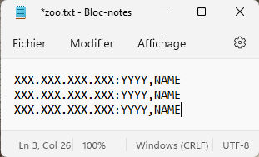

1: You need to verify that there is no empty line

# Run the code:

If you want to run the code, to simplify the interface, I have made a specific option so you need to open the Terminal and write like that:



And it will open the hub perfectly with the address and the port wrote in the txt.

# Things I used to improve my code:

I used little cool things to improve my code and simplify it:

1. I used “.lower()”
2. I used functions to structure my code Server.py like the function restart, ping, command_linux, command_powershell, command_dos etc...
3. I did a cool thing that makes the windows not open on top of each other which makes the run better.

# Details for Programmers:

