User Documentation

# Introduction:

After downloading all the files, you need to check if all the libraries are installed.

You need to create a txt file and fill it like that (you don’t have to write the name but it’s better I think):

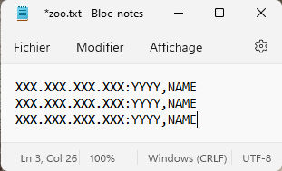

1: You need to verify that there is no empty line

# Run the code:

If you want to run the code, to simplify the interface, I have made a specific option so you need to open the Terminal and write like that:



And it will open the hub perfectly with the address and the port wrote in the txt.

You can see that if the txt contains 6 lines, the code will open 6 interfaces, I made sure that the first 6 windows do not open on each other.

# Test all the commands:

Don’t forget to run the Server.py before trying to connect with the Client.py.

Now, all the windows are opened before testing all commands, you need to connect to the server by clicking in the button “Se connecter au server”.

Now that you are logged in, you can test all the commands. To simplify some errors, I use a specific option so whether you write “OS” or “os” it will be the same results.

# Details about the interface:

# 