**The Study:** In today’s task, you will be presented with a series of decisions about different monetary options. You will be asked to select between a gamble and a guaranteed alternative. The gamble is made up of two possible outcomes and the alternative is made of one possible outcome. The figure below shows an example of a guaranteed alternative (left) and a gamble (right).

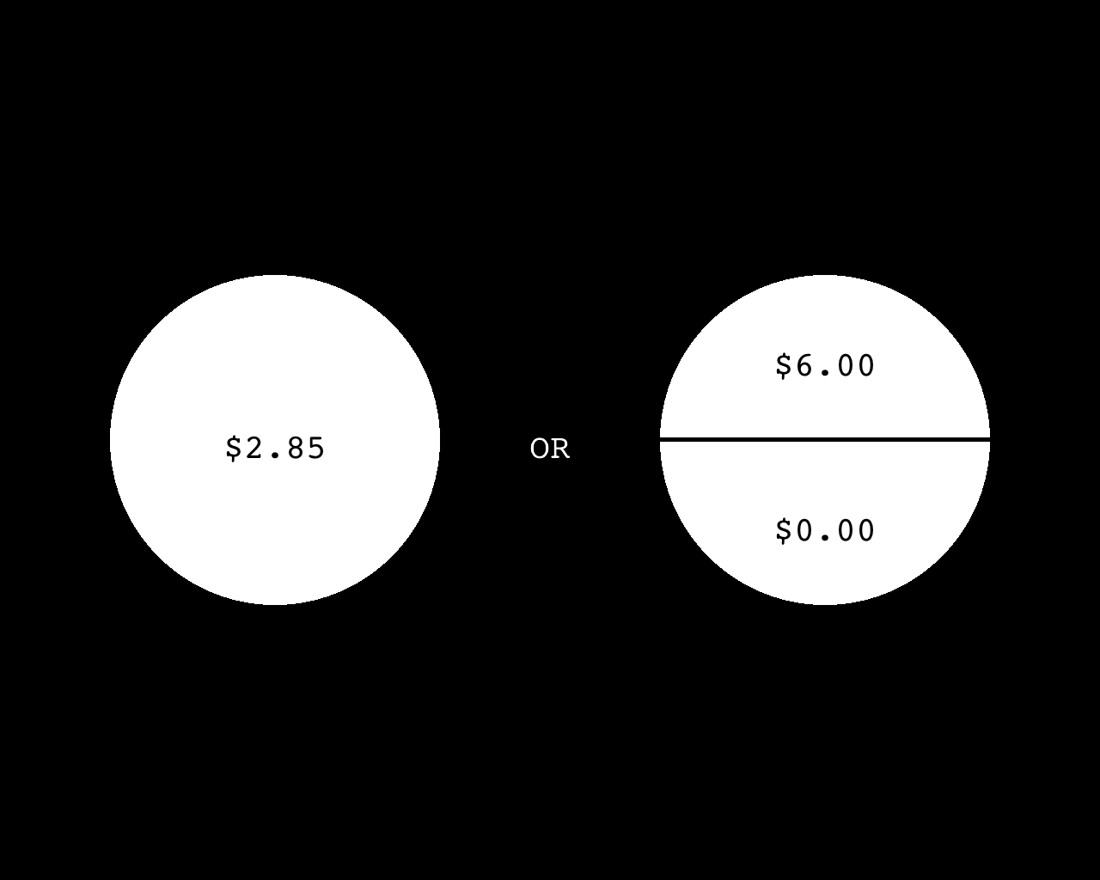

***Figure 1.*** *An example choice set: a guaranteed alternative (left) and a gamble (right).*

If you select the gamble, half of the time you will receive the amount on the top (in this example, $6.00) and half of the time you will receive the amount on the bottom (in this example, $0.00). If you select the guaranteed alternative (in this example, $2.85), you will receive the alternative 100% of the time (in this case, $2.85).

The two options will appear on the screen for 2 seconds. After 2 seconds, the response options “V - Left” and “N - Right” will appear below the corresponding gamble and alternative (see figure below).

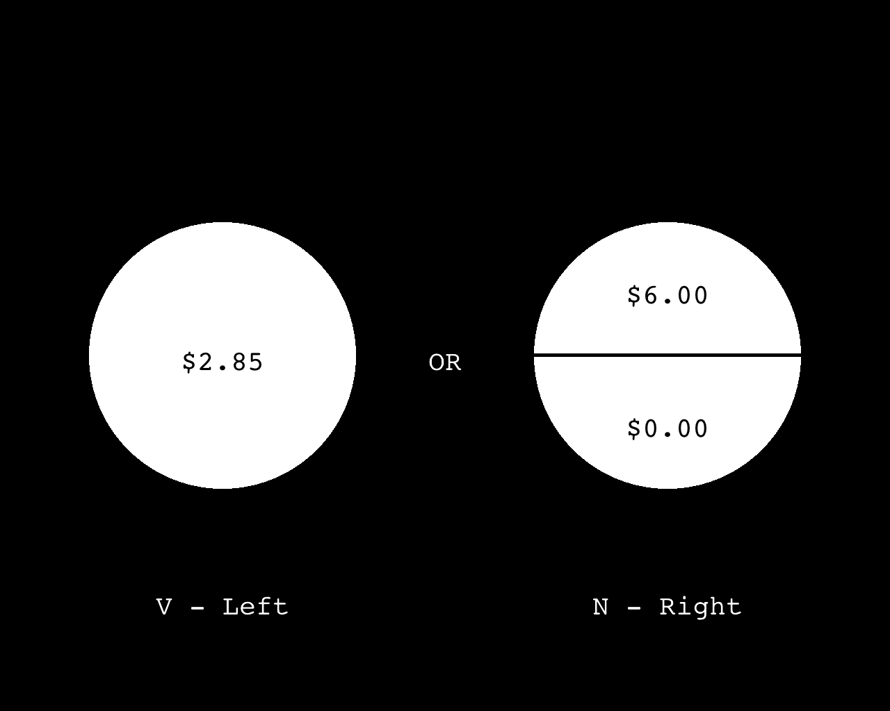

***Figure 2.*** *Note that sometimes the gamble will be on the right and the guaranteed alternative on the left, and sometimes vice versa****.*** *Use the “V” key to choose whichever is on the left, and the “N” to choose whichever is on the right.*

Once the “V-Left” and “N-Right” appear on the screen, you have two (2) seconds to enter your decision, but you should have already started trying to figure out your answer before the response options appear on the screen. Please keep your hand on the response buttons at all times, and please do your best to enter your response in time! Once you respond in time, the outcome will remain on the screen for 1 second. See figures below.

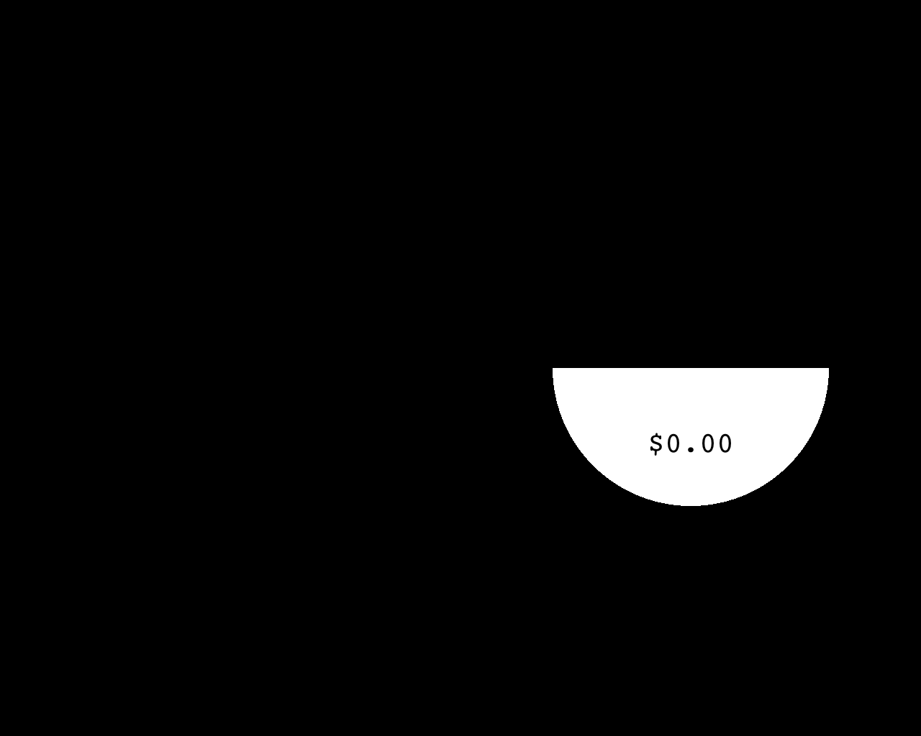

***Figure 3.*** *Possible outcome screen. Example shows the outcome for choosing a gamble and not winning. If you choose the gamble and do not win, everything on the screen will go away, displaying only the bottom portion of the gamble for 1 second.*

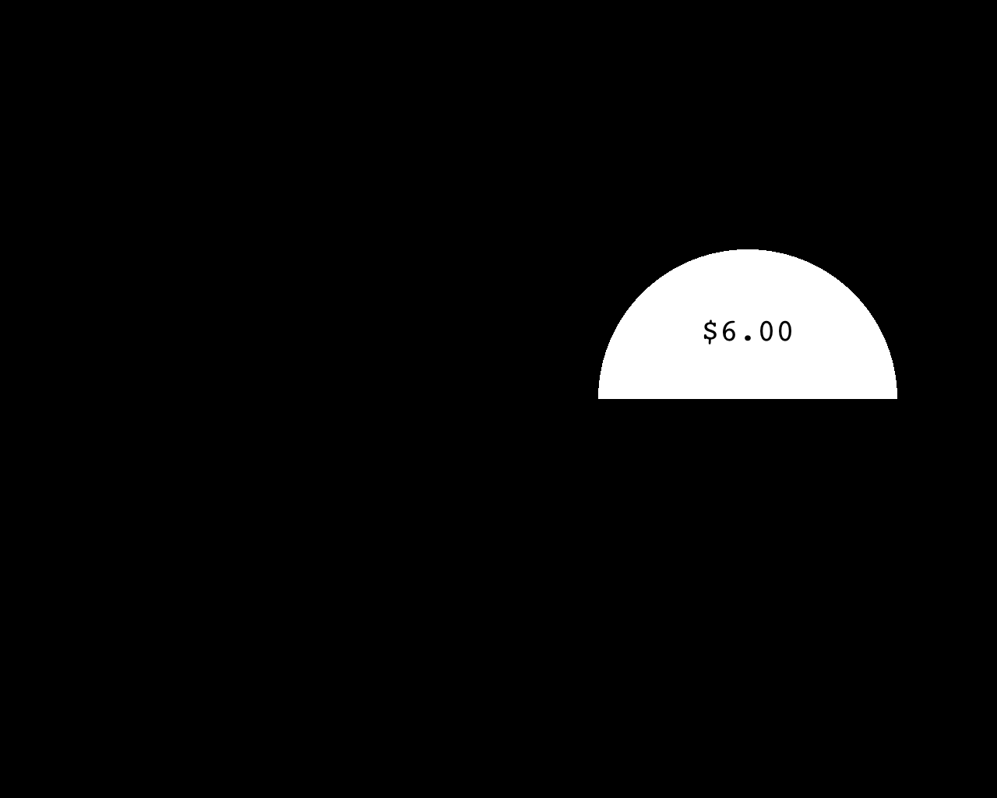

***Figure 4.*** *Possible outcome screen. Example shows the outcome for choosing a gamble and winning. If you choose the gamble and win, everything on the screen will go away, displaying only the top portion of the gamble for 1 second.*

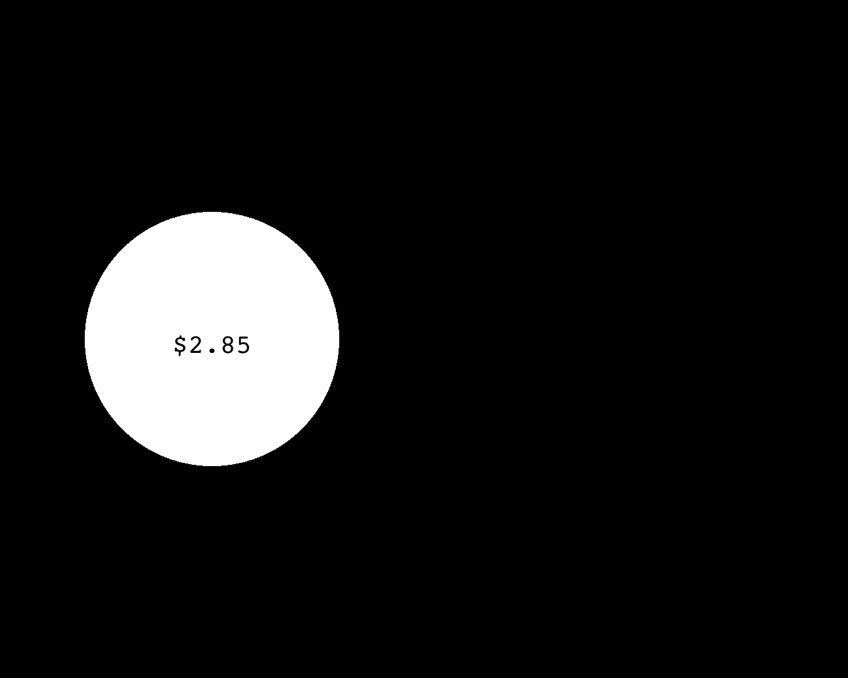

***Figure 5.*** *Possible outcome screen. Example shows the outcome for choosing the guaranteed alternative. If you select the alternative, everything on the screen will go away, displaying only the alternative for 1 second.*

Once the outcome is displayed for 1 second, there will be a brief delay and the next trial will begin. There will be a total of 219 trials today.

**Practice:** Before we begin the task, you’ll have 5 practice trials. The structure of the practice trials is identical to what you will encounter in the real task, but the practice trials will not count.

**Payment:** You will be compensated for your time in either chits (at a rate of 1 chit per 30 min) or dollars (at a rate of $5 per 30 min) for your time today.

At the end of the study, the computer will randomly select **ONE** *(and only one)* of the outcomes from the task. You will be paid (in cash) 1/4 of the outcome of the randomly selected trial. For example, if the randomly selected trial has an outcome of $60, you will be paid 1/4 of $60, which is $15. Possible outcomes in the task range from $0-$60, so 1/4 of that range is $0-15.00. Possible payments range from $0-$15.00; however, the average pay out is $5.

If you have any questions, ask your experimenter now. Otherwise we’ll begin the practice trials, and then the study itself!