***Use Figure 1 to answers questions 1-3***

1. What is the probability of receiving $2.24 if you select the alternative?

____%

1. What is the probability of receiving $5.00 if you select the gamble?

____%

1. What is the probability of receiving $0.00 if you select the gamble?

**____**%

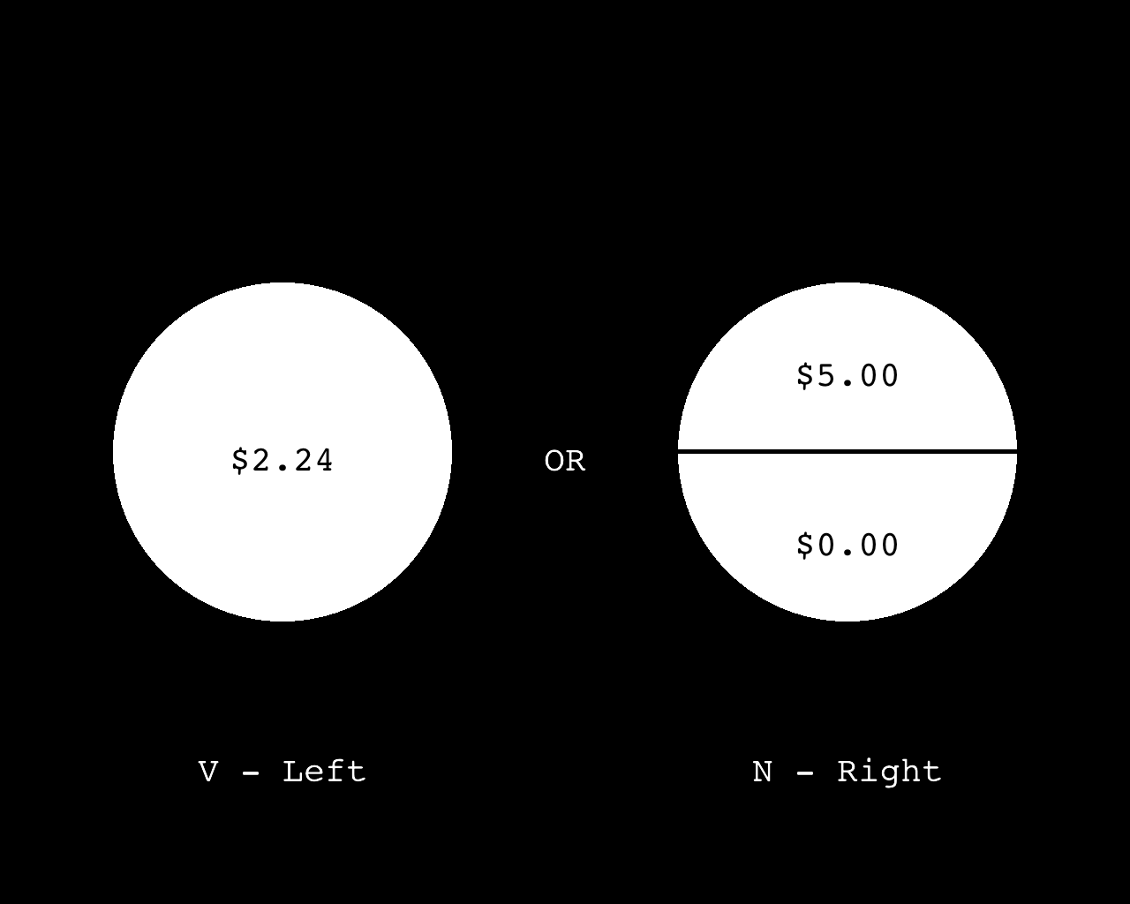

***Figure 1.***

1. In the figure below, which button will you press to select the gamble?

[ ] “V”

[ ] “N”

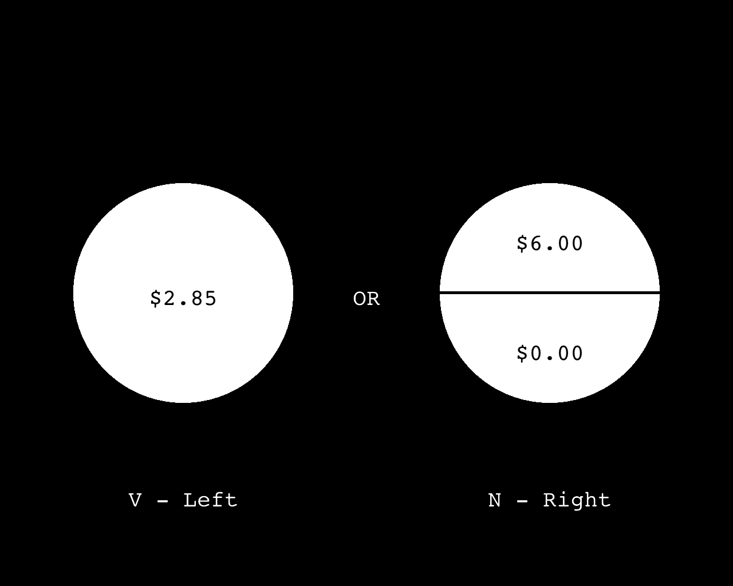

1. In the figure below, which button will you press to select the gamble?

[ ] “V”

[ ] “N”

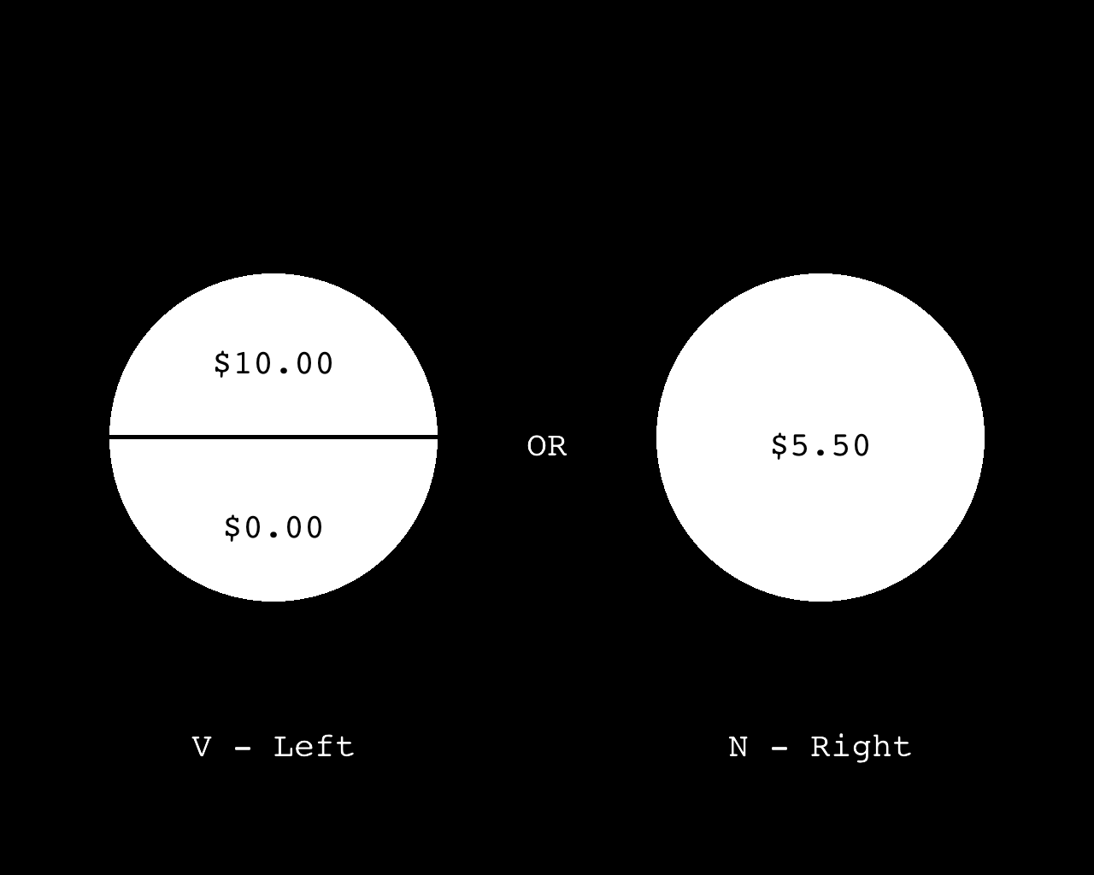

1. At the end of the study, how many trial outcomes does the computer randomly select?

[ ] All of the trials

[ ] None of the trials

[ ] One trial

1. How long do you have to respond?

[ ] 2 seconds

[ ] 1 second

[ ] 5 seconds

1. At the end of the study, if the outcome of the randomly selected trial is $20, how much of the $20 will we pay you in cash?

_____

1. How many chits or dollars will you receive for participating in this study (not including the randomly selected trial outcome at the end)?

_____chits/hr

_____dollars/hr