A Level Projectile Motion Project

Table of Contents
Analysis 2
Introduction 2
Background of the Problem 2
Reasons for Developing a new System 2
Original Solution 3
Outline of the Proposed Solution 3
Technical Features 4
Interview With Mr C 5
Key Objectives (SMART) / User Needs 7
Acceptable Limitations 7
Documented Design 7
General Explanation 7
Exception Handling 8
Storing the Variables in JSON files 9
Using OOP in Python 10
The Mathematics of Calculating the Path of a Projectile With Air Resistance 10
Structure of the Classes (Object Oriented Programming) 11
Projectile Class 11
Goal Class 12
Obstacle Class 12
Further Explanation of the Collision Detection Method 13
The Old Collision System 13
The New Collision System 13
Cannon Class 14
Projectile Image Class 15
Wind Arrow Class 15
Game Class 16
__init__(self) 16
obstacleManager(self) 16
levelManager(self, state) 17
run(self) 17
Testing 18
Test 1: 22
Test 2: 23
Test 9: 23
Test 15: 23
Test 19: 24
Test 28: 25
Test 29: 25
Evaluation 26
Appraisal 26
Comparison of Project Performance Against Objectives 26
User Feedback 27

Analysis

Introduction
My project is an educational game and simulator of how objects will move through space when under the effects of gravity and air resistance, with the goal of being a good demonstration tool for institutions such as colleges or universities who are looking to visually show students how air resistance can affect motion in order to aid their understanding.

Background of the Problem
Mr C is a Maths and Physics Tutor who runs his own business called OS Tuition, located in Devon. He tutors all ages from secondary school to university level students and thus has a wide variety in the complexity of the topics he needs to teach.

Mr C used to run in-person lessons, however due to the pandemic, transitioned to online teaching and has since stayed online due to it being more convenient for students who often find they have little free time while studying at school. It also allows him to reach students who may live further away, or even in other countries.

One such topic that Mr C often is teaching is Projectile Motion. This is a Maths and Physics topic that is first introduced at GCSE and continues to be taught through to A level and beyond. At each Key Stage level, the complexity of the maths increases to make results of calculations more accurate to reality.

He would like a tool that can clearly demonstrate the different methods of calculating projectile motion, and that can be shown to students, and demonstrates how the predicted motion changes as more variables are added to the calculations. This model should be easy to integrate into his current workflow.

Reasons for Developing a new System
Mr C makes good use of computers to aid in his teaching, and is familiar with different technologies and operating systems. This would make a computer based application ideal as it could be screen-shared in lessons, rather than a physical model that requires space in his office, and would need a camera to show online students.

Currently, he has a few different computers used for different tasks.
A Windows machine runs the bulk of remote lessons and is where his microphone and cameras are connected.
A Chromebook is used for web browsing, spreadsheets, document editing and other lesson related tasks that are not directly a part of the student’s learning.
A raspberry-pi for running light-weight Linux applications such as personal projects like hosting his home a web-server and database.

There are not any applications that are cross-platform, and no web-apps that satisfy the features he wants. For this reason, a new system should be developed.

Original Solution
This flow chart demonstrates the old system of Mr C setting up and running one of his regular lessons.
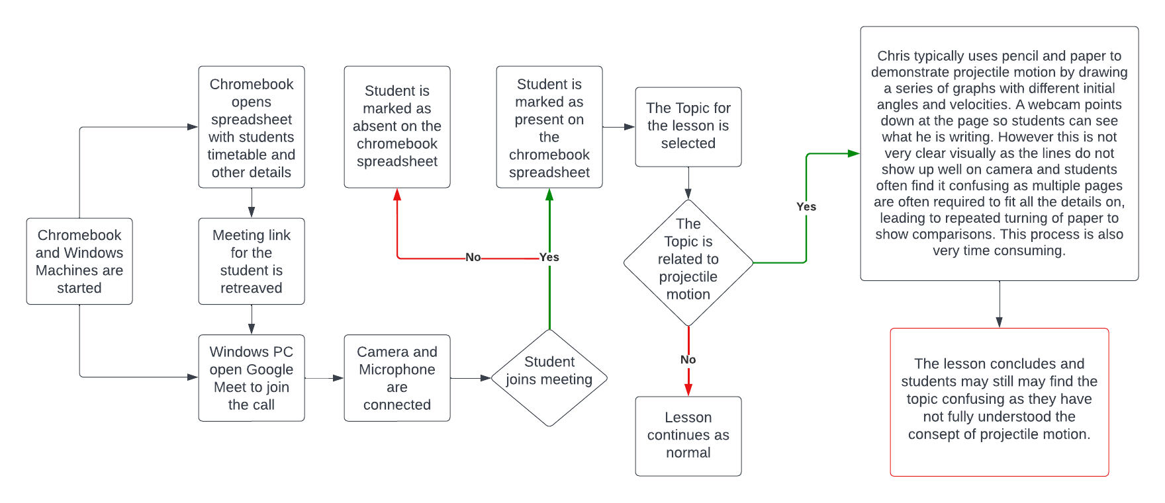Figure 1: Mr C's workflow without the new tool

Outline of the Proposed Solution
The proposed solution is to develop a computer-based educational game and simulator that demonstrates how objects move through space under the effects of gravity and air resistance. This tool will allow Mr C to easily demonstrate the different methods of calculating projectile motion and how the predicted flight path changes as more variables such as wind, are added to the calculations. The game and simulator should be easy to use and integrate into Mr C's current workflow.
To achieve this, the following steps can be taken:
Research and gather information on the physics of projectile motion, including the equations and variables involved. This will ensure that the game and simulator accurately represents the real-world physics of projectile motion.
Design the user interface for the game and simulator, taking into consideration the needs of the users (students and teachers) and the desired features of the tool.
Develop the game and simulator using a programming language that is cross-platform and can run on different operating systems (such as Windows, macOS, Linux.).
Test the application to ensure that it is robust and the solution is valid for the end user.
Integrate the game and simulator into Mr C’s current workflow. This flowchart is how the new system will fit into his workflow.
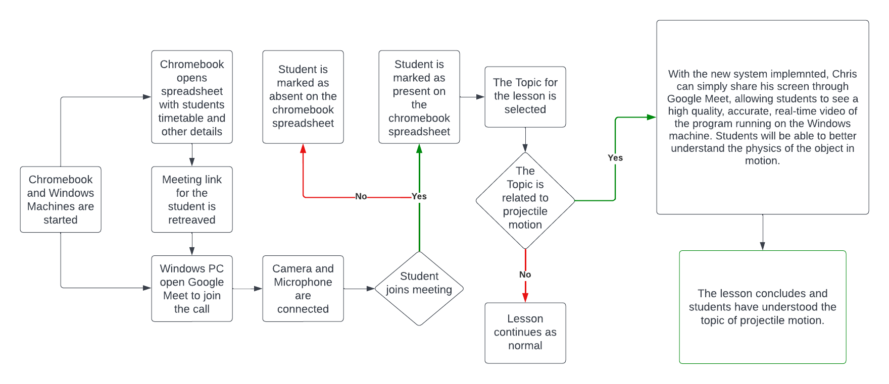Figure 2: Mr C's workflow with the new tool

Overall, the proposed solution will provide Mr C with a useful and effective tool for demonstrating the physics of projectile motion to his students, and will allow him to effectively teach this complex topic in a visual and interactive way.

Technical Features
This will outline the specifics of what the application needs to include in accordance to Mr C’s needs.
The game will take place in a 2D level that will contain a projectile and a cannon. The user should be able to aim the cannon and control its power, in order to launch the projectile. The aim is to reach a goal on the other side of the level. When the projectile makes contact with the goal, the next level is created. Levels will be procedurally generated as the user progresses through the game.
For calculating the motion of the projectile with accurate air resistance and wind, there are some variables that will be required to track the motion. This table outlines all the variables that will be needed.
Variable | Variable Type | Description | Units
x0 | Integer | The initial Position of the projectile in the x axis | m (Meters)
y0 | Integer | The initial Position of the projectile in the y axis | m (Meters)
vx0 | Integer | The initial Velocity of the projectile in the x axis | m/s (Meters Per Second)
vy0 | Integer | The initial Velocity of the projectile in the y axis | m/s (Meters Per Second)
Cd | Float | The Drag Coefficient of the projectile | n/a
B2 | Float | The Constant for Air Resistance | n/a
gravity | Float | The Gravity acting on the projectile | m/s² (Meters Per Second Squared)
mass | Float | The Mass of the projectile | Kg (Kilograms)
Trajectory | Array | A List of Points to store the positions of the projectile | Degrees/Radians
dt | Float | The Time Step for updating the position and velocity of the projectile | n/a
Fx | Float | The X-Component of the air resistance force acting on the projectile | n/a
Fy | Float | The Y-Component of the air resistance force acting on the projectile | n/a
ax | Float | The X-Acceleration of the projectile | m/s² (Meters Per Second Squared)
ay | Float | The Y-Acceleration of the projectile | m/s² (Meters Per Second Squared)
xs | Float | A List of the projectile’s x-positions | n/a
ys | Float | A List of the projectile’s y-positions | n/a

Interview With Mr C
I sat down with Mr C and asked him some questions about what he would need / like to have in the program. I then asked him to also give a priority to each feature so I can develop the most important features first, then more quality of life features and finally some “nice to haves”

Question | Answer | Priority
Can you describe your current workflow for teaching projectile motion and how a computer-based educational game could fit into it? | My current workflow involves a combination of lectures, demonstrations, and problem sets. I would like the game and simulator to complement these methods and provide a more interactive and engaging way for students to learn about projectile motion. | High
What specific features would you like to see in the game and simulator to make it an effective teaching tool for projectile motion? | I would like the game and simulator to include a variety of variables to represent different shapes, sizes, and weights, and allow students to adjust different parameters such as velocity, angle, and air resistance. | Highest
How important is it to you that the game and simulator accurately model the effects of air resistance on the motion of objects? | It's very important to me that the game and simulator accurately model the effects of air resistance. This is a crucial component of understanding how objects move through the air and it's essential that students are able to see this in action. | High
Would you like the game and simulator to include different levels of difficulty for students with varying levels of proficiency in physics? | Yes, I think it would be great if the game and simulator could offer different levels of difficulty to accommodate different levels of proficiency. This could include more complex calculations or more challenging scenarios. | Medium
How important is it for the game and simulator to be interactive and engaging for students? | Interactivity and engagement are key to keeping students interested and motivated. I would like the game and simulator to be fun and enjoyable to use so that students are more likely to engage with the material. | Medium
Do you have any specific ideas or suggestions for how the game and simulator could be made more engaging? | Some ideas that come to mind include incorporating game-like elements such as rewards or achievements, and allowing students to compete against each other or against the computer. | Low
How would you like the game and simulator to integrate with your current teaching materials, such as lesson plans and assessments? | With teaching online, the application will need to be screen-shared so that students can see it. Since I only have one monitor I would prefer if it ran in a window and not full screen, so that I can still see other windows such as the meeting. | High
Would you like the game and simulator to be available on multiple platforms, such as desktop and mobile devices? | Yes, it would be great if the game and simulator could be accessed on multiple platforms to maximize accessibility for students. This could include desktop computers, laptops, tablets, and smartphones. | Medium
How important is it to you that the game and simulator be easy to use and intuitive for students to navigate? | Ease of use is very important, particularly for younger or less experienced students. The game and simulator should be intuitive and easy to navigate so that students can focus on learning the material rather than struggling with the interface. | High
Are there any specific learning objectives or standards that you would like the game and simulator to address? | The game and simulator should align with common physics learning objectives and standards. It should cover topics such as Newton's laws of motion, gravity, and air resistance. | Medium
How important is it to you that the game and simulator be visually appealing and have high-quality graphics? | I don't think the graphics need to be photo-realistic, it's important that they are simple and clear. This will help students to see the effects clearly. | Lowest
Are there any specific features or tools that you would like to see included in the game and simulator to help students understand projectile motion? | Some tools that I would like to see included in the game and simulator include the ability to adjust variables such as the angle and velocity of the launch, and to change the properties of the objects being launched. It would also be helpful if the simulator could display the predicted landing location of the object based on the current settings. | Medium

Key Objectives (SMART) / User Needs
Here is a list of requirements for the final program to fulfil in order of importance.
- The program should be a game with a cannon, a projectile and a goal. The player’s aim is to hit the goal.
- The projectile should have a mathematical model of air resistance and act accordingly in motion.
- The player should be able to control the angle and velocity that the projectile is launched at.
- To compose levels, there should be obstacles to the player such as wind and physical barriers.
- The game should have a level system where as the player progresses, the levels get harder.
- After each level, the game should save so students can com
- Players should be able to modify the variables such as mass and drag in a JSON file.
- The code should be easy to understand so that students can tinker and learn from the program.
- The program should be clear and interpretable, visually and otherwise. Text should display the important variables of the projectile and level.

Acceptable Limitations
To start with the system will have the following limitations which have been agreed with Mr C:
- Students will not be able to control the program remotely and will either have to tell Mr C what values to enter or download the program themselves.
- Students will need to edit a text file to change the variables of the projectile
- The goal may load in a position that is covered by an obstacle.

Documented Design

General Explanation
As this project is designed to be used by students taking mainly Maths and Physics GCSE / A level, I chose to write the code in python. This is because python is designed to be extremely readable and is easy for an end user to understand. This means that students can download and modify the code however they see fit. By them having access to the code, it will further enhance their understanding as they can learn how projectile motion is calculated through tweaking and modifying the program.
Some other reasons python is beneficial for Mr C and his students:
Wide Range of Libraries: Python has a vast library of scientific computing and visualization tools, such as NumPy, SciPy, and Matplotlib, which are specifically designed for scientific computing and numerical analysis. These libraries make it easy to perform complex calculations and data analysis. While not used in this project for the sake of demonstration, students may like to use them to add graphing tools or running tests with the underlying code.
Cross-Platform Support: Python can be run on a variety of platforms, including Windows, macOS, and Linux, making it easy to develop and deploy applications across multiple platforms.
Interpreted Language: Python is an interpreted language, which means that code can be executed directly without the need for compilation. This makes it easy to test and debug code and allows for faster development.
Large Community: Python has a large and active community of developers who contribute to the development of libraries and frameworks, share knowledge, and provide support to other developers.
For these reasons, Python is an ideal language for scientific computing and data analysis, making it well-suited for projects like simulating the trajectory of a projectile with air resistance.

Exception Handling
While in the game, the user has a narrow set of inputs. They can only move the mouse or click a location and because of this the game loop needs minimal exception handling. User input is very binary and will be accounted for by simple “if” “else” statements, exception handling would be inefficient when there are only two outcomes.
However reading and writing files is very different. There are many cases where my program could be, for example, trying to write to a file and the file has become inaccessible. It may have deleted by accident, getting scanned by an anti-virus, or moved to another location. This is unpredictable behaviour, where there are many cases for failure and the most efficient solution is exception handling.
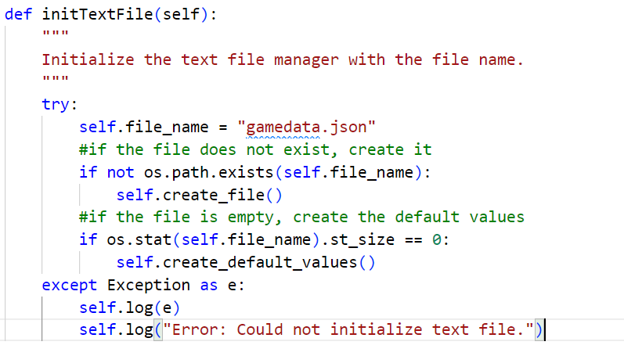Figure 3: Exception Handling in a method to initialise gamedata.json
I added exception handling to all read and write functions to prevent game crashes when performing such operations fails. I also wrote a method to log any exceptions that occur. When an exception is caught, it is logged to a text file to be later assessed.

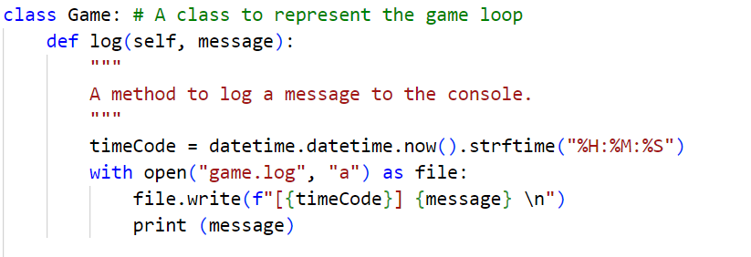Figure 4: The log function to store messages into a text file

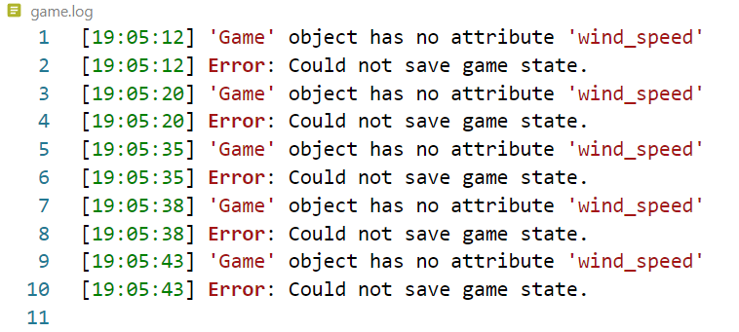Figure 5: An example of the data that gets written to the game.log file

Storing the Variables in JSON files
To store the variables outside of memory, and in a format that students could easily edit, I used a JSON file. JSON files are a type of text file and have a simple and easy to read file structure making them ideal for students to edit the variables of the program.
I created two functions, one for reading and one for writing to the file. To integrate this into the program I simply replace the variables that are to be stored in the JSON file with a respective read or write function. This function can then be passed a “key” which determines the target variable.
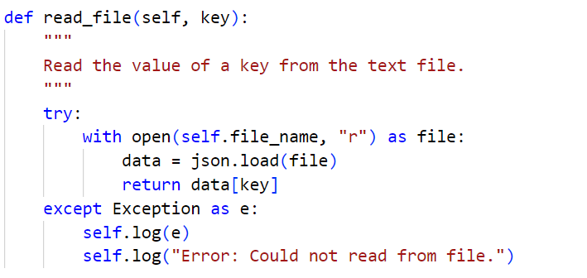Figure 6: The read_file method

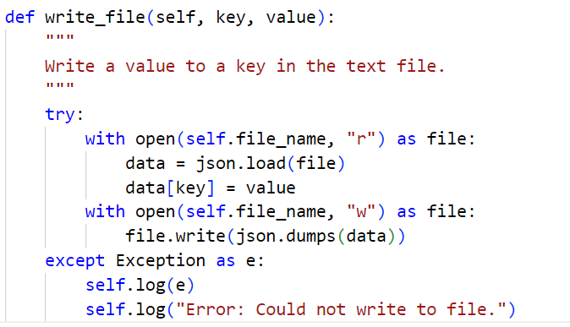Figure 7: The write_file method

Using OOP in Python
Object Oriented Programming in Python is fairly straight forward since it is a dynamically typed language. However I will briefly explain the structure and design philosophy I used when writing this program.
Firstly, all objects that are represented in the game, should belong to a class. Each class will have a __init__ method, this is the constructor method and is run when the class is instantiated. It will define all variables that directly relate to the object the class represents. It will not store variables that are just used as placeholders in calculations within methods, as these do not need to exist once a calculation is complete and will just waste memory if they were defined in the __init__ method.
Next is the self keyword that can be seen throughout the code. This simply means the variable being referenced is within the class. For example, if I am inside the Cannon class, I could call a Cannon variable by writing something like self.cannon_angle. Or access a variable from another class by using projectile.vx.
For rendering things on the screen, I used a module built-in to python called Pygame. This module contains classes and methods for drawing images and playing audio. This made it ideal for creating a simple but flexible interface.
Here is an example of what calling a Pygame method looks like:
pygame.display.set_mode((self.SCREEN_WIDTH, self.SCREEN_HEIGHT))
In this example, a method from Pygame, defined as set_mode(), is called from the display class. This sets the game window to be self.SCREEN_WIDTH, self.SCREEN_HEIGHT

The Mathematics of Calculating the Path of a Projectile With Air Resistance
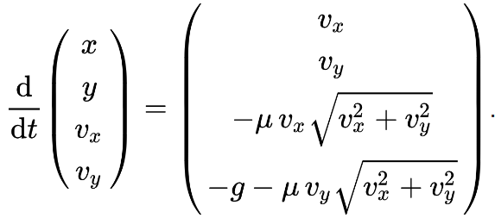Figure 8: The Differential Equation to be Solved by the Method
This code calculates the position and velocity of a projectile (such as a ball) moving through the air with air resistance via the Newton Drag Formula. This method is created from Newton's second law of motion, which states that the force acting on an object is equal to its mass times its acceleration. In the case of an object moving through a fluid (such as air), the drag force is proportional to the velocity squared and is opposite in direction to the object's motion. This is known as Newton's drag force formula. The calculation is performed in discrete time steps, where the time step is given by the variable dt.
The air resistance force acting on the projectile is calculated using the drag coefficient Cd, the cross-sectional area of the projectile B2, and the velocity of the projectile in the x- and y-directions vx and vy. The x-component of the air resistance force is given by -0.5 * Cd * B2 * vx^2, where ^2 means "squared". The negative sign indicates that the force opposes the direction of motion. The y-component of the air resistance force is given by -0.5 * Cd * B2 * vy^2 + gravity, where gravity is the acceleration due to gravity. The negative sign before Cd indicates that the force opposes the direction of motion in the y-direction.
Wind speed is also taken into account by adding the wind speed wind_x and wind_y to the x- and y-components of the air resistance force, respectively.
The acceleration of the projectile in the x- and y-directions is calculated by dividing the x- and y-components of the air resistance force by the mass m of the projectile.
The position and velocity of the projectile are then updated using the kinematic equations of motion. The new x-position of the projectile is given by x + vx * dt, and the new y-position is given by y - vy * dt, where the negative sign before vy indicates that the y-axis points up. The new x-velocity is given by vx + ax * dt, and the new y-velocity is given by vy - ay * dt, where the negative sign before ay indicates that the y-axis points up.
Finally, the code updates the distance travelled by the projectile in the x- and y-directions by calculating the distance between the last two positions of the projectile in the x- and y-directions using the Pythagorean theorem. The total distance travelled by the projectile is given by the sum of the distances travelled in the x- and y-directions. The current position of the projectile is added to the list of points in its trajectory, as well as to the lists of x- and y-positions.

Structure of the Classes (Object Oriented Programming)
The program has been structured in a way so that everything belongs to a class or method so that it easy to call methods from other classes. This also means the code is very clean and readable, creating an environment that is quick to develop features in.
In python, classes will have a similar layout. Firstly a class will define an __init__ method. This method will initialise the class by running as soon as the class is instantiated. This is known as a constructor. After this, the class will have all the required methods for the class. These can be anything and typically use the variables initialised in the __init__ method.

Projectile Class
The given code defines a class called Projectile which simulates the flight of a projectile. The constructor method __init__ initializes the properties of the projectile such as initial position, velocity, mass, drag coefficient, constant for air resistance, gravity, and sets default values for maximum velocity, wind speed and direction, hit_target, and distances travelled in x and y directions.
The class has six methods:
- set_wind: which takes in wind speed and angle as parameters and calculates the x and y components of wind speed.
- set_position: which sets the position of the projectile.
- update_position: which updates the position and velocity of the projectile based on the air resistance, acceleration, wind speed, and time step. It also adds the new position of the projectile to the list of positions.
- set_vx_vy: which sets the velocity of the projectile while limiting the velocity to a given maximum
- get_position: which returns the current position of the projectile
- get_velocity: which returns the current velocity of the projectile
The class also contains variables trajectory, xs, and ys which are lists of points that follow the projectile path and positions of the projectile, respectively. The class has other properties such as acceleration in x and y directions, air resistance force, and time step. These were outlined in the previous section.

Goal Class
This class is a representation of a Goal object. The Goal object is initialized with its position (x,y) and its width and height.
The class has two methods:
- draw: used to draw the goal on the screen using the Pygame library.
- check_collision: used to check whether a projectile has collided with the goal by comparing the position of the projectile to the position and size of the goal.
The class also has a pre-defined attribute 'colour', which is a tuple of integers representing the RGB values for a light green colour. This class can be used to create instances of a goal object with specified positions and dimensions, and to check for collisions with a projectile.

Obstacle Class
This class represents an obstacle object that inherits from the Goal class. It has a colour attribute set to a pre-defined light red, a bounceAbsorption attribute set to 0.7, and a friction attribute set to 0.05.
colour will set the colour of obstacles.
bounceAbsorption will set the multiplier of the amount of force to take out of a bounce.
friction will stop the ball sliding on a surface forever.
The class also has three methods: get_coordinates(), check_collision(), and __init__().
The get_coordinates() method returns the coordinates of the obstacle as a tuple.
The __init__() method initializes the obstacle with its position and size. It calls the constructor of the Goal class using the super() method.
The check_collision() method takes a projectile and projectileImage as arguments and checks if the projectile has collided with the obstacle using Separating Axis Theorem. If there is a collision, it resolves the collision along the smallest overlap axis, updates the position and velocity of the projectile, and plays a ball sound with a random volume. Finally, it returns True if there was a collision and False otherwise.

Further Explanation of the Collision Detection Method

The Old Collision System
In my first attempt writing the collision system, the method check_collision detected collision between a projectile and an obstacle by checking if any of the lines between the last five positions of the projectile intersected with the obstacle. The method first extracted the last five positions of the projectile using the xs and ys lists. These positions were used to create a list of lines by iterating over the positions and adding the lines between adjacent positions to the list.
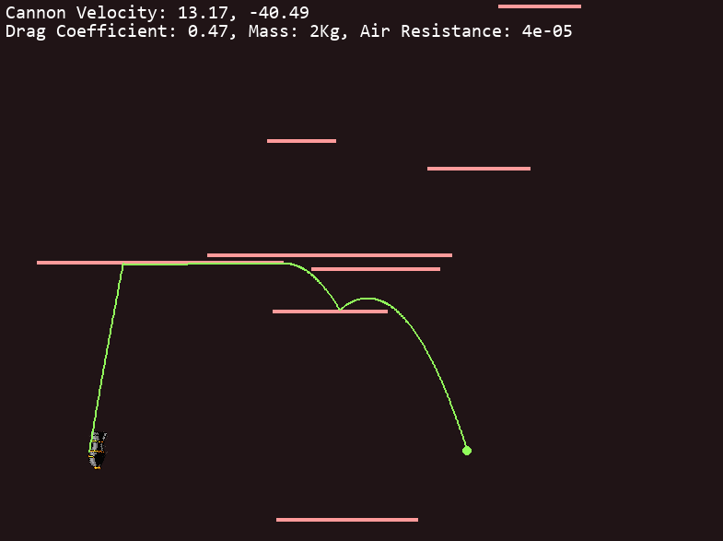Figure 9: A collision bug in game
Once the list of lines had been created, the method checked each line to see if it intersected with the obstacle using the intersect method. This method was likely defined elsewhere in the code and determined whether a given line intersected with the obstacle. If any of the lines intersected with the obstacle, the method returned True, indicating that a collision had occurred. If none of the lines intersected with the obstacle, the method returned False, indicating that there was no collision.
This method caused an issue I describe as “gliding”. This is where the projectile would glide across a surface instead of bouncing. This is due to the intersection of the lines being between the boundary of the obstacle.
Overall, this method used a simple approach to detect collision between a projectile and an obstacle by checking if any of the lines between the last five positions of the projectile intersected with the obstacle. It was a relatively efficient method that could provide accurate collision detection in some cases. However, it was not suitable for more complex scenarios where the projectile was moving at higher speeds.

The New Collision System
The method check_collision is used to detect whether a projectile has collided with an obstacle. It uses the Separating Axis Theorem to check for collisions. The Separating Axis Theorem (SAT) is a method for detecting collisions between convex polygons. The theorem states that if there is a line that separates two convex polygons, then the polygons do not intersect. If no such line exists, then the polygons must be intersecting.
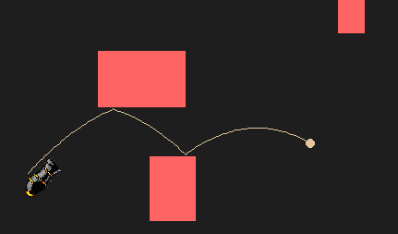Figure 10: New and improved collision system in action
The method first extracts the necessary information from the projectile and the obstacle. The position and size of the projectile are obtained, as well as the coordinates, position, and size of the obstacle. The position of the obstacle is calculated as the midpoint of its x and y coordinates. The width and height of the obstacle are calculated by subtracting the x and y coordinates of its vertices.
The next step is to calculate the overlapping distance along the X and Y axes. The overlap is calculated by finding the difference between half the sum of the widths/heights of the projectile and obstacle and the absolute value of the difference between their respective positions along the axis. If there is no overlap along either axis, then there is no collision, and the method returns False.
If there is overlap along both axes, the method determines which axis has the smallest overlap and resolves the collision along that axis. The projectile is moved along the axis with the smallest overlap until it is no longer overlapping with the obstacle. The velocity of the projectile is adjusted based on the properties of the obstacle, such as its friction and bounce absorption.
Finally, the method plays a sound effect of a bouncing ball using Pygame's mixer library. The volume of the sound effect is determined by the speed of the projectile, with faster projectiles producing louder sounds. The position and velocity of the projectile are updated based on the collision, and the method returns True to indicate that a collision has occurred.
The check_collision method is an important function for implementing realistic collisions between game objects and creating a more realistic gaming experience.

Cannon Class
This is a class to represent a Cannon object. The class has an __init__ method that is called when an object of the Cannon class is created. The method takes two parameters, x and y, which represent the position of the cannon on the screen. The method initializes several instance variables, including self.x and self.y, which store the position of the cannon. It also loads two images of the cannon from the "assets" folder using pygame.image.load(), and stores them in self.cannon_image and self.rot_cannon_image. The scale variable is set to 1.1, and both images are resized using pygame.transform.scale() to the specified dimensions. Finally, self.power is initialized to 0, which represents the initial power of the cannon.
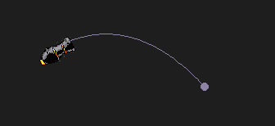Figure 11: The cannon object in game
The get_center method returns the centre point of the cannon as a tuple. This method is used to determine where to place the projectile being fired from the cannon and to be the origin or rotation.
The set_power method is used to set the power of the cannon. It takes a single parameter power and assigns it to the self.power instance variable.
The get_power method returns the power of the cannon as an integer.
The draw method is used to draw the cannon on the screen. It takes a screen parameter which is the Pygame display surface to which the cannon will be drawn. It uses screen.blit() to draw the self.rot_cannon_image at the position self.x and self.y.
The rot_center method is used to rotate the cannon image to a specified angle. It takes an angle parameter and uses pygame.transform.rotate() to rotate the self.cannon_image by the specified angle. The rotated image is then stored in self.rot_cannon_image.

Projectile Image Class
This is a class to represent the projectile on the screen. As the projectile class is just the mathematical model, the projectileImage class is what actually gets drawn to the screen.
The __init__ method is the constructor of the class, which is called when a new instance of the class is created. It takes three arguments, x, y, and size, which are used to initialize the position and size of the projectile image. The self parameter refers to the instance of the class being created.
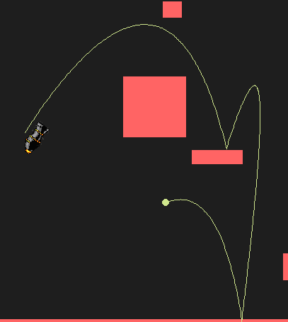Figure 12: An example of wind effecting the projectile
The attributes of the class include x, y, size, width, height, and projectile_colour. x and y represent the coordinates of the centre of the projectile image on the screen. size represents the diameter of the projectile image. width and height are equal to size, and are used to represent the width and height of the projectile image. projectile_colour is a tuple that represents the RGB colour of the projectile image.
The draw method takes two arguments, screen and x, y. It is used to draw the projectile image on the screen using the Pygame library. The screen parameter represents the screen object on which the projectile image will be drawn. The x and y parameters represent the coordinates of the centre of the projectile image on the screen.
The set_position method is used to set the position of the projectile image on the screen. It takes two arguments, x and y, which represent the new coordinates of the center of the projectile image.
The set_colour method is used to set the colour of the projectile image on the screen. It takes one argument, colour, which represent the colour of the projectile image.

Wind Arrow Class
The WindArrow class is a Python class that represents a wind arrow, which can be drawn on a screen. It has several methods that allow the arrow to be positioned, rotated, and drawn.
The __init__ method is a constructor that initializes the WindArrow object with its starting position and size. It takes two arguments, x and y, which are the coordinates of the arrow's starting position on the screen. The method sets the self.x and self.y instance variables to these values, and also sets the self.size variable to 5 and the self.colour variable to white.
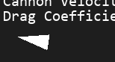Figure 13: An image of the wind arrow pointing to the left

The draw method is used to draw the wind arrow on the screen. It takes a single argument, screen, which is the Pygame surface on which the arrow should be drawn. The method uses the pygame.draw.polygon function to draw a triangle on the screen, using the self.colour variable as the colour of the triangle. The triangle is drawn using three points: the arrow's starting position (self.x and self.y), a point to the right of the starting position (self.x + 40 and self.y + 10), and a point to the left of the starting position (self.x + 40 and self.y – 10).
The set_position method is used to change the position of the wind arrow on the screen. It takes two arguments, x and y, which are the new coordinates of the arrow's position on the screen. The method updates the self.x and self.y instance variables to these values.
The draw_rotate method is used to draw the wind arrow at a rotated angle. It takes two arguments, angle and screen. The angle argument is the angle (in degrees) by which the arrow should be rotated, and the screen argument is the Pygame surface on which the arrow should be drawn. The method first calculates the centre point of the arrow (which is the starting position plus half the width of the triangle). It then calculates the new positions of the three points of the triangle after rotating them by the specified angle, using trigonometric functions. Finally, the method uses the pygame.draw.polygon function to draw the rotated triangle on the screen, using the self.colour variable as the colour of the triangle.

Game Class
The given code defines a Python class called Game that represents a simple game loop. It initializes the game environment, manages the obstacles, and controls the game's levels. Let's look at each of its functions in detail:

__init__(self)
This is the constructor method of the Game class, which sets up the game environment and initializes some variables. The method does the following:
- It initializes the Pygame library.
- It sets the game window's frame rate, width, and height.
- It sets the background colour, the projectile's drag coefficient, the target's position, and size, and the projectile's initial position, velocity, mass, and colour.
- It creates an empty obstacle list where all obstacles are instantiated, and sets the level and counter variables to 0.
- It loads the game's background image and creates a Cannon object and a Goal object.

obstacleManager(self)
This function manages the obstacles in the game by creating and appending objects to the obstacleList. It creates a floor, a ceiling, a right wall, and levelCounter number of randomly generated obstacles with various sizes and positions.

levelManager(self, state)
This function manages the game's levels. If state is True, it increments the levelCounter, creates a new Goal object with a new position, generates a new set of obstacles, sets the projectile's wind velocity, and changes the projectile's colour. If state is False, it sets the game_over flag to True.

run(self)
This function represents the game loop, which runs continuously until the game is over. It initializes the start conditions, including the level, obstacle list, and projectile, and then enters the main loop, which does the following:
- It handles events by checking if the user quits the game, gathers mouse coordinates to calculate the cannon’s angle and the projectile’s angle, and reads any key presses such as a left click on the mouse to launch the cannon.
- If the projectile is launched, it calculates the projectile's new position, velocity, and acceleration based on the projectile's mass, drag coefficient, and the wind velocity.
- It checks for collisions between the projectile and the obstacles or the goal.
- If the projectile hits the goal, it calls the levelManager function to progress to the next level.
- It updates the screen by redrawing the game objects.
- It sets the game's frame rate using the clock variable, which limits the number of frames per second.
- It renders text to the screen to display information to the user, such as what level they are on, how many bounces they used, the velocity, angle, velocity, etc of their projectile and so on.

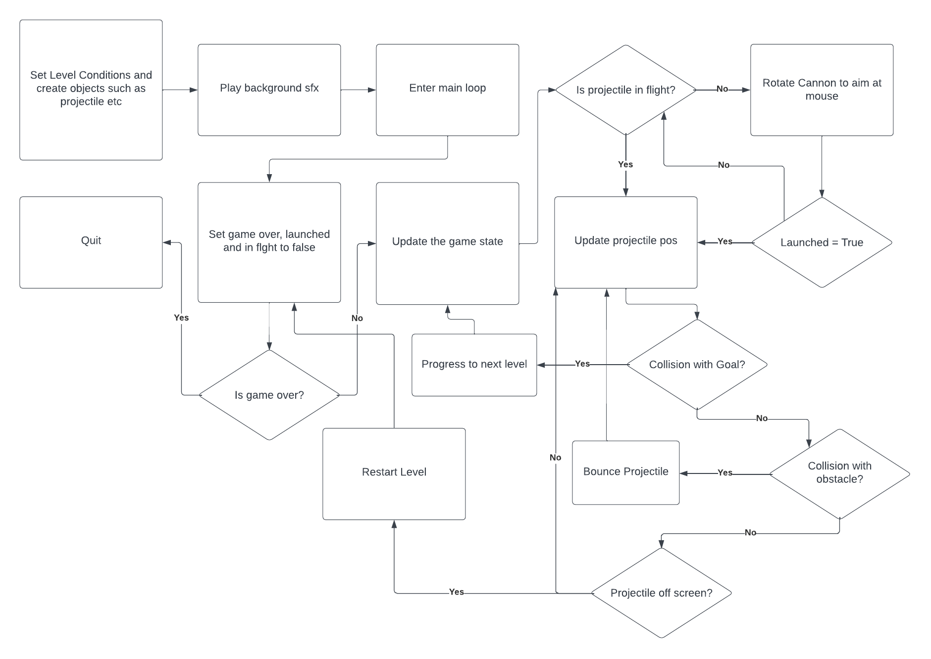Figure 14: A flow chart of the game loop. (Frame rendering not included as it occurs along every line in the diagram)

Testing

Test Number | Class | Method | Purpose | Test Data | Expected Result | Type | Result
1 | Projectile | set_wind | Check that the vector output is correct. I.e – points in the correct direction and has the correct magnitude. | 3, 30 | X=0.46  y=2.96 | Normal | Pass
2 | Projectile | set_wind | Check that the vector output is correct with a magnitude and direction of 0. | 0,0 | X=0  y=0 | Extreme | Pass
3 | Projectile | set_wind | Check that the vector output is correct when given an angle larger than 360 degrees. | 10,99999 | X=-5.09  y=8.60 | Extreme | Pass
4 | Projectile | set_wind | Check that the vector output is correct when given inputs than are not numbers. | aaa,bbb |  | Erroneous | Fail
5 | Projectile | set_vx_vy | Check that the velocities are set to their intended values without exceeding the max. | 50,50 | 50,50 | Normal | Pass
6 | Projectile | set_vx_vy | Check that the velocities are set to their intended values without exceeding the max. | 100, 100 | 100, 100 | Extreme | Pass
7 | Projectile | set_vx_vy | Check that the velocities are set to their intended values without exceeding the max. | 200, 200 | 100, 100 | Erroneous | Pass
8 | Goal | check_collision | Test to see if the projectile lands in the box it will count a goal. |  | 1 | Normal | Pass
9 | Goal | check_collision | Test to see if the projectile lands on the box boundary it will count a goal. |  | 1 | Extreme | Pass
10 | Goal | check_collision | Test to see if the projectile lands out of the box it will count a goal. |  | 0 | Normal | Pass
11 | Obstacle | check_collision | Test to see if the projectile collides with the obstacle it returns the inverted velocity of the respective axis with the applied reduction in speed. | 10,10 | 10,-7 | Normal | Pass
12 | Obstacle | check_collision | Test to see if the projectile collides with the obstacle at max speed it returns the inverted velocity of the respective axis with the applied reduction in speed. | 100, 100 | 100,-70 | Extreme | Pass
13 | Obstacle | check_collision | Test to see if the projectile collides with the obstacle over max speed it returns the inverted velocity of the respective axis with the applied reduction in speed. | 10000,10000 | False (Collision not detected) | Erroneous | Fail
14 | Obstacle | check_collision | Test to see if the projectile collides with the obstacle over max speed it returns the inverted velocity of the respective axis with the applied reduction in speed. | 10000,10000 | False (Collision not detected) | Erroneous | Fail
15 | Obstacle | check_collision | Test to make sure the collision sound will play if the current audio channel is in use | Audio channel 5 in use | Play on channel 6 | Normal | Pass
16 | Obstacle | check_collision | Test to make sure the collision sound will play if the current audio channel is in use | Audio channel 40 in use | Play on channel 5 | Extreme | Pass
17 | Obstacle | check_collision | Test to make sure the collision sound will play if the current audio channel is in use | Audio channel 5-40 in use | No sound | Erroneous | Fail
18 | Cannon | rot_center | Test to see if the image rotates by an angle between 0 and 360 degrees | 40 | Image rotated by 40 degrees | Normal | Pass
19 | Cannon | rot_center | Test to see if the image rotates by an angle greater than 360 degrees | 400 | Image rotated by 400 degrees | Extreme | Pass
20 | Cannon | rot_center | Test to see if the image rotates by an angle that is negative | -400 | Image rotated by -400 degrees | Extreme | Pass
21 | Cannon | rot_center | Test to see if the image rotates by NAN | aa | Not rotated | Erroneous | Pass
22 | WindArrow | draw_rotate | Test to see if the image rotates by an angle between 0 and 360 degrees | 40 | Image rotated by 40 degrees | Normal | Pass
23 | WindArrow | draw_rotate | Test to see if the image rotates by an angle greater than 360 degrees | 400 | Image rotated by 400 degrees | Extreme | Pass
24 | WindArrow | draw_rotate | Test to see if the image rotates by an angle that is negative | -400 | Image rotated by -400 degrees | Extreme | Pass
25 | WindArrow | draw_rotate | Test to see if the image rotates by NAN | aa | Not rotated | Erroneous | Pass
26 | Game | ObstacleManager | Test the list size to see how many obstacles the list can store | 50 | List will store 50 objects | Normal | Pass
27 | Game | ObstacleManager | Test the list size to see how many obstacles the list can store | 2^32 | List will store 2^32 objects | Extreme | Pass
28 | Game | ObstacleManager | Test the list size to see how many obstacles the list can store | 2^32 + 1 | List will not store 2^32 objects. Memory Error | Erroneous | Fail
29 | Game | LevelManager | Test to make sure the game will end when being passed false | False | Self.gameover = True | Normal | Pass
30 | Game | LevelManager | Test to make sure the game will end when being passed false | True | Variables are set to start the next level | Normal | Pass

Test 1:
This is an example and test of a typical input that may be passed to this function. The input does not exceed the size of a 32bit integer and is possible to reproduce in game. After passing a wind speed and angle of (3,30) respectively, the function outputs a correct answer as seen by the console log. This result was checked with a ClassWiz Fx-991Ex calculator, which is a standard issue A-level mathematics calculator.
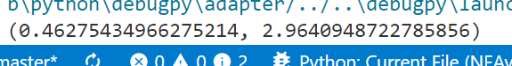
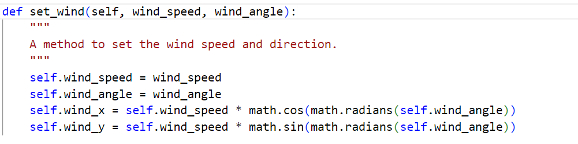

Test 2:
This is an example of less ordinary data. Inputs of 0 are possible in the game, yet uncommon. This is an important test as it will clearly show if there is any points in the function where a “divide by 0 error” may occur, or if any data is being added that should not be. The output should be a clean (0,0). As shown by this console log, this is the case.
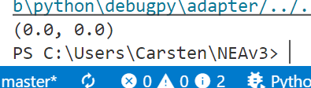

Test 9:
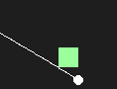
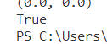
This test will check how accurate the collision detection is when launching the projectile on the boundary of the goal. In this case we can see that the line contacts the very most edge of the goal, and the console prints True to reflect this. This is important because it means there will be no discrepancy between what the player thinks is a goal and the game not registering it.

Test 15:
This test is to check that a sound effect is triggered when the first choice audio channel is occupied. The code allocates 35 channels to sound effects. Before the sound is played it will check to see if the channel is occupied, if so then it will increment the channel counter and try on that channel. If this fails, no sound is played. This avoids sound build-up where a ball may collide may times in quick succession and playing all the sounds would be very loud.

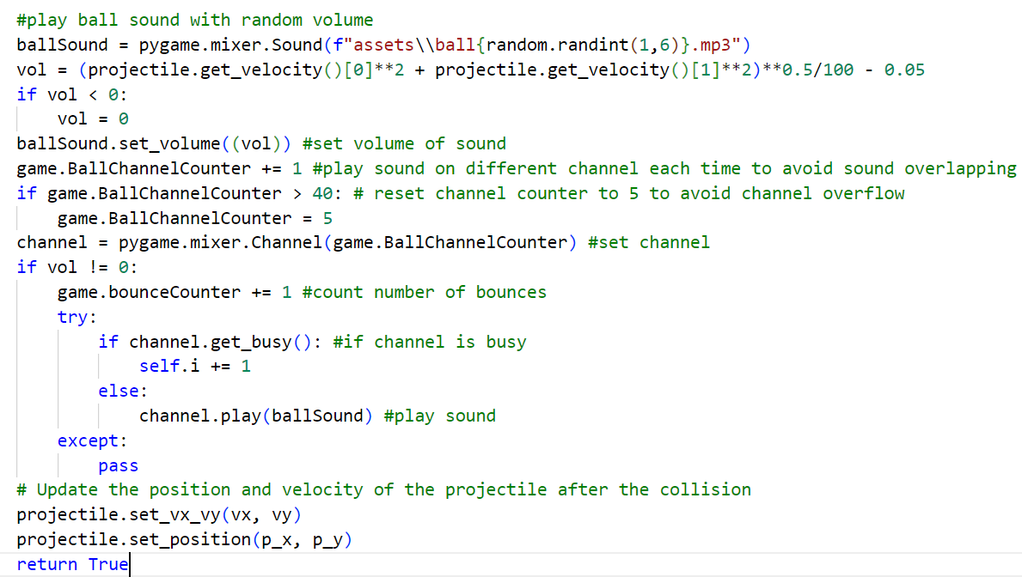
This is an auditory effect so I cannot provide a demonstration here, however the effect of it performing correctly can be described as both sounds playing in succession and overlapping whereas only one could play at a time if the test failed.

Test 19:
This test is to check the rotation of the cannon object. By giving the cannon an amount of 400 degrees we should see a resultant angle of 40 degrees as 360 + 40 = 400. This test shows how robust the function is even with values outside of the range achievable in game.
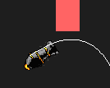Figure 15: The cannon aimed at 40 degrees after taking an input of 400

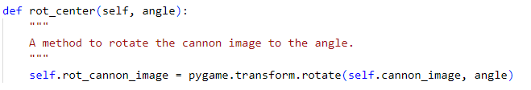Figure 16: The rot_center function to rotate the cannon image by a given angle of 400 degrees

Test 28:
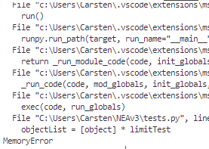Figure 17: The program halting from a memory error after exceeding the maximum number of objects in the list.
This test is to see how many objects can be stored in the list before encountering a memory error. This is effectively the max level a player could ever reach before the program can no longer store level data. Lists in python can store up to 2^32 elements. In this case I tested up to, then over this maximum to determine how many levels could be played until the game runs out of memory.

Test 29:
This test is to make sure the game will end if the level manager function is passed False. In this case, the self.gameover variable being set to true will cause the game to exit after no the rest of the game loop requires the flag to be true to continue.
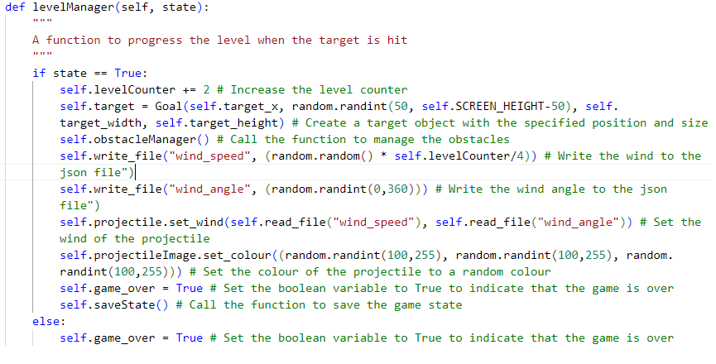Figure 18: The levelManager Function

Evaluation

Appraisal

Comparison of Project Performance Against Objectives
- The program should be a game with a cannon, a projectile and a goal. The player’s aim is to hit the goal. This objective has been met. The user has a cannon to launch the object and a goal as a target.
- The projectile should have a mathematical model of air resistance and act accordingly in motion. This objective has been met. There is a sufficiently complex mathematical model that governs how the projectile will act as it travels through the level based on a set of variables.
- The player should be able to control the angle and velocity that the projectile is launched at. This objective has been met. The user can move the mouse to a location on the screen and this position will determine the power of the cannon and the angle, relative to the cannon position.
- To compose levels, there should be obstacles to the player such as wind and physical barriers. This objective has been met. Each level has a randomly generated set of obstacles that the projectile will bounce off of if it collides.
- The game should have a level system where as the player progresses, the levels get harder. This objective has been met. These obstacles become more frequent the higher the level the player has achieved.
- After each level, the game should save so students can come back to their progress. This objective has mostly been met. After each level, the current state of the game is saved into the JSON file. Upon loading the game, these variables are read from the file and passed back into the games functions, so that the level how the user left it. The only thing that is not saved into the game state is the position and size of the obstacles in the level. With more time I would have added a function to retrieve the size and position of all the objects in the obstacleList and save it into the gamedata.json.
- Players should be able to modify the variables such as mass and drag in a JSON file. This objective has been met. The JSON file is a flat structure of all the necessary variables for a level. JSON is a type of text file that can be opened by any text editor. This allows it to be easily modified by students.
- The code should be easy to understand so that students can tinker and learn from the program. This objective has been met. The program is written with clear variable names that identify what they are storing, the structure of the code is in a layout where all classes are defined first, then the main game loop which creates the objects and calls them as needed.
- The program should be clear and interpretable, visually and otherwise, and text should display the important variables of the projectile and level. This objective has been met. All objects in the level contrast with the background and are simple bold shapes that will display well over an internet call. There is text in the top left that clearly displays the current number of bounces, the level number, the position, the velocity, drag coefficient, mass, gravity and air resistance.

User Feedback
I have received feedback from Mr C and a few students about the final game. He used the game in a few lessons to get his students first impression and feedback was generally positive. Students liked the gameplay of having a target to aim at while avoiding obstacles in the level. They also found it very educational as they could visualise the effects of air resistance on a projectile. Mr C was pleased that the students could clearly see what was happening when he was screen sharing the program even when the call bitrate was limited as the colours were high contrast and objects were simple shapes. Students agreed that having to edit a JSON file to change the variables of the projectile was a bit inconvenient and would have preferred a method of entering the values in game. If I had more time I could have added this feature to make it more appealing to the students. Mr C was also impressed by the level of complexity of the algorithm that solved the equations for the air resistance. He commented that the accuracy it produced was very close to real life situations when variables were entered to mimic a real life object such as a baseball.

