1. 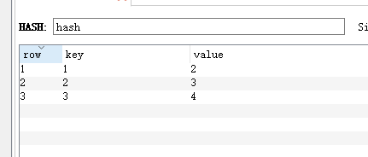
2. 是一个string类型的字段和值的映射表，hash特别适合用于存储对象。可以看做是一个存放key、value类型数据的容器
3. client.SetEntryInHash(“Hash”,”Name”,”lily”);
4. client.SetEntryInHash(“Hash”,”Age”,”18”);
5. client.SetEntryInHash(“Hash”,”Sex”,”女”);
6. client.SetEntryInHash(“Hash”,”Address”,”初中高中英语课本”);
7. Dictionary<string,string> dic = new Dictionary<string,string>();
8. Dic.add(“1”,”2”);Dic.add(“2”,”3”);Dic.add(“3”,”4”);
9. Client.SetRangeInHash(“hash”,dic);
10. List<string> HaskKey = client.GetHashKeys(“Hash”);
11. List<string>HashValue = client.GetHashValues(“Hash”);
12. Client.GetAllEntriesFromHash(“hash”)