Somaiya Vidyavihar University
K. J. Somaiya School of Engineering
Department of Electronics and Telecommunication Engineering
Artificial Intelligence (216U03E721)
Mini Project Report
Domain-Specific Question Answering System
on AI Use Cases using
Retrieval-Augmented Generation (RAG)

Submitted by
Name: Viraj Sawant
Roll No.: 16010323036
LY B.Tech EXTC, Semester VII

Under the guidance of
Prof. Baishakhi Dutta

Academic Year 2026-27 (Term: July to November 2026)

Abstract
For this mini project I built a question answering system for the five AI use case documents shared by the department. The documents cover a sugarcane irrigation advisory system, heatwave early warning, EV battery thermal management, a urine test strip reader and the SomaiyaSat PocketQube mission. Instead of training or fine-tuning a model, the system uses Retrieval-Augmented Generation (RAG). The PDFs are cleaned and split section by section into 100 chunks, embedded with nomic-embed-text and stored in ChromaDB. When a question comes in, the most relevant chunks are fetched using a hybrid of dense (embedding) search and BM25 keyword search, and these chunks are given to Llama 3.1 8B, which runs locally through Ollama. The model is told to answer only from those chunks and to cite them, and a Streamlit interface shows the answer together with the exact chunks it was based on.
I evaluated the system on a test set of 25 questions that I wrote from the documents. With hybrid retrieval, the correct chunk was in the top 5 for 21 of the 22 answerable questions (Hit@5 = 0.955), the generated answers contained 93.2% of the expected keywords, and all 3 out-of-scope questions were refused. Compared with a baseline that uses the raw text cut into fixed-size chunks, the cleaned, section-aware chunks raised Hit@1 from 0.545 to 0.773 with dense retrieval. Since the test set is small and the numbers come from a single run, they should be read as indicative rather than as general performance figures.
Keywords: Retrieval-Augmented Generation, LangChain, ChromaDB, Ollama, Llama 3.1, BM25, Reciprocal Rank Fusion, Streamlit

1. Introduction
Large language models like ChatGPT or Llama are good at answering general questions, but they have no knowledge of documents they were never trained on. Asked about SomaiyaSat or the KIAAR irrigation project, a model may say it doesn't know, or it may give a plausible answer that is not supported by any source. Fine-tuning the model on the documents is one alternative, but it needs a GPU, has to be repeated whenever a document changes, and still does not show where an answer came from.
Retrieval-Augmented Generation takes a simpler route. The documents are split into small pieces and stored in a searchable index. For every question, the system first searches this index, picks the few pieces that look most relevant, and pastes them into the prompt as context. The LLM then answers from that context. Because the context is known, the answer can be checked against the exact page it came from.
The department released five AI use case profiles as part of the AI Use Case Integration in Teaching-Learning initiative. Each one is 4 to 7 pages long and follows the same template: problem statement, objectives, solution approach, workflow, expected outputs and an AI governance table. Reading all 29 pages to find out, say, which tools are used for mission analysis in the PocketQube mission is slow. A question answering system over these documents is a natural fit for RAG, and that is what this project does.
I chose to run everything locally with Ollama rather than calling a cloud API. That means there are no API keys or usage limits, and no document text leaves the laptop. The trade-off is speed, which I discuss in the results.

2. Problem Statement and Objectives

2.1 Problem Statement
To design and implement a domain-specific question answering system that answers natural language questions about the five KJSSE AI use case documents, using only the content of those documents, with a citation to the source section and page for every answer, and that clearly says so when a question cannot be answered from the documents.

2.2 Objectives
- Extract the text from the five PDFs, including the tables, and clean it without losing the structure of the documents.
- Split the text into meaningful chunks, generate embeddings and store them in a vector database along with metadata (use case, section, page) for citation and filtering.
- Implement semantic, keyword and hybrid retrieval, and connect the retriever to a locally running LLM that answers only from the retrieved context and cites it.
- Build an interactive Streamlit interface that shows answers, the source chunks behind them, a use case filter and support for follow-up questions.
- Evaluate retrieval and answer quality on a fixed set of test questions and compare different design choices.

2.3 Scope
The knowledge base is limited to the five use case PDFs. Figures and diagrams in the PDFs are not read, only the text and tables. The system is a single-user application running on one laptop.

3. Literature Survey

3.1 Retrieval-Augmented Generation
The term RAG comes from Lewis et al. [1], who combined a pre-trained sequence-to-sequence model (the parametric memory) with a dense vector index of Wikipedia (the non-parametric memory). A retriever fetches relevant passages and the generator conditions on them. Their model did better on open-domain question answering than models that relied only on their weights, and its answers were more specific and more factual. An important practical point from that paper is that the knowledge can be updated by simply replacing the index, without retraining anything.
Gao et al. [2] later surveyed how RAG systems have evolved and grouped them into three types. Naive RAG is the basic index, retrieve and generate pipeline. Advanced RAG adds steps before retrieval (like rewriting the query) and after retrieval (like re-ranking). Modular RAG treats these steps as swappable modules. My system is closest to Advanced RAG, since it rewrites follow-up questions and fuses two retrievers before generation.

3.2 Sparse, Dense and Hybrid Retrieval
BM25 [3] is the classic keyword ranking function from the probabilistic relevance framework. It scores a document by how often the query terms appear in it, with a saturation so that repeating a word many times doesn't keep adding score, and with normalisation for document length. It does not model meaning, but it tends to work well for exact matches such as part numbers or acronyms.
Dense retrieval encodes both the question and the passages into vectors and ranks passages by vector similarity. Karpukhin et al. [4] showed with Dense Passage Retrieval (DPR) that a dual-encoder trained on question and passage pairs beat a strong BM25 system by 9% to 19% in top-20 passage accuracy on several open-domain QA datasets. Dense search finds passages that use different words for the same idea, which keyword search misses.
Since the two approaches fail in different ways, they are often combined. Reciprocal Rank Fusion (RRF), proposed by Cormack et al. [5], adds up 1/(k + rank) for each document over all the ranked lists, with k = 60. It only uses ranks, not scores, so there is no need to make cosine similarities and BM25 scores comparable. In their experiments this simple method beat the individual systems and also more complex rank-learning methods.
For embeddings I used nomic-embed-text [6], an open-source text embedding model with a 768-dimensional output and an 8192-token context window. It is trained with task prefixes, so documents should be embedded with "search_document:" and queries with "search_query:" in front.

3.3 Hallucination and Grounding
Ji et al. [7] describe hallucination as generated text that sounds fluent but is not supported by the source or by facts. Giving the model retrieved evidence and asking it to cite sources reduces this, but does not remove it completely. This is why the system prints the retrieved chunks next to every answer, and why I also added questions to the test set that sound answerable but are not, to check whether the model makes something up.

3.4 Language Model
The generator is Llama 3.1 8B from Meta's Llama 3 family [8]. Through Ollama it runs as a 4-bit quantised model of about 4.9 GB, which was small enough to run on the laptop used for this project. The lighter Llama 3.2 3B also works and is faster on machines with 8 GB of RAM, but all results in this report were produced with the 8B model.

3.5 The Five AI Use Cases
Table 1 gives a short overview of the five documents that form the knowledge base.
Table 1: The five AI use cases used as the knowledge base
ID | Use case | Domain | Collaborating organisation
KJS-AGR-01 | Irrigation advisory system for sugarcane using AI and sensors | Agriculture | KIAAR and Godavari Biorefineries Ltd.
KJS-CES-01 | Heatwave monitoring, prediction and early warning | Climate, Energy & Sustainability | India Meteorological Department, Pune
KJS-CES-02 | AI-enabled micro-channel battery thermal management for EVs | Climate, Energy & Sustainability | SVU funded research project
KJS-HLC-01 | Urine test strip reader using colorimetry (point-of-care) | Healthcare | K. J. Somaiya Hospital, Paramcare Lifesciences
KJS-SRS-01 | AI-based data routing and amateur radio for PocketQube missions | Space Technology & Remote Sensing | ReOrbit, Finland

4. Dataset Description
The dataset is the set of five PDFs in Table 1. Together they are 29 pages and about 68,000 characters of text. All five follow the same numbered template ("1. Use Case ID:", "7. Problem Statement:", "9. Objectives:" and so on), with 13 to 15 sections each. Every document ends with a Modern AI Governance and Paradigms table that rates areas like privacy, responsible AI and human-in-the-loop as High, Medium or Low, and the sugarcane document also has a large workflow table that runs over three pages.
Table 2: Size of each document after extraction and chunking
Use case | Pages | Characters extracted | Sections found | Chunks
KJS-AGR-01 | 6 | 14,037 | 15 | 21
KJS-CES-01 | 5 | 13,402 | 15 | 19
KJS-CES-02 | 7 | 14,552 | 14 | 22
KJS-HLC-01 | 4 | 10,553 | 15 | 16
KJS-SRS-01 | 7 | 15,518 | 13 | 22
Total | 29 | 68,062 | 72 | 100

One small thing I noticed: the urine strip reader PDF is named KJS-HLC-01, but inside the document its ID is written as KJS-HC-03. I used the ID from the file name everywhere so the five IDs stay consistent.

5. Preprocessing and Chunking

5.1 Problems with the Raw Text
Inspecting the raw PyMuPDF output page by page showed five recurring problems:
- Every page has the same header (AI USE CASE INTEGRATION IN TEACHING-LEARNING) and a Page x of y footer, which repeat throughout and add noise to the embeddings.
- Bullet symbols are extracted as a private-use character (\uf0b7) or "●", usually on a separate line from the bullet text.
- Sentences are split wherever the PDF wrapped a line, sometimes inside a hyphenated word ("human-" / "in-the-loop").
- Tables are flattened to one cell per line, which separates each governance area from its relevance level. Some rows also continue onto the next page.
- Figure captions remain in the text although the figures themselves are not extracted.

5.2 Cleaning
Tables are detected with PyMuPDF's find_tables() and read row by row, and text blocks that overlap a table are skipped. A row whose first cell is empty is appended to the previous row, including across a page break. Each governance row is then written as a single line (Table 3).
Table 3: Governance table row before and after cleaning (KJS-SRS-01, page 6)
Raw PyMuPDF output | After cleaning
Privacy & Data / Protection / Low / Mission data (telemetry, SSTV imagery, housekeeping) is / non-personal; ensure amateur radio transmissions comply / ... (one fragment per line) | - Privacy & Data Protection (Relevance: Low): Mission data (telemetry, SSTV imagery, housekeeping) is non-personal; ensure amateur radio transmissions comply with open-access norms while protecting any sensitive ground-station credentials/command links via encryption/authentication.

For the rest of the text, the header and footer lines and figure captions are removed with regular expressions, bullet symbols are replaced with a plain "- ", and a line is joined to the previous one unless it starts a new item (a bullet, "1)", "a.", "Step 3", "Stage 2" or a numbered heading).

5.3 Section-Aware Chunking
A common approach is to cut the text every N characters. For these documents that produces chunks that start in one section and end in another, for example the end of Objectives followed by the start of Solution Approach. Since all five documents share a template, I split them by section instead, using a regular expression for headings of the form "N. Heading:".
- The short metadata sections (use case ID, title, domain, collaborating organisation, faculty owners, beneficiaries and dataset link) are merged into one Overview chunk per use case.
- Every other section becomes one chunk. Sections longer than 900 characters are split with LangChain's RecursiveCharacterTextSplitter (chunk size 900, overlap 150 characters), which prefers to break at line endings.
- Each chunk is prefixed with a header line such as [KJS-CES-02 | AI-Enabled Micro-channel Battery Thermal Management System for Electric Vehicles | Section: Objectives], so that every chunk names its use case and section.
- Metadata stored with every chunk: use case ID, title, section name, page range and source file name.
The result is 100 chunks with an average length of 799 characters and a maximum of 1,452. Five retrieved chunks therefore add about 4,000 characters (roughly 1,000 tokens) to the prompt.

6. System Architecture
The system has two parts. The offline part (ingestion.py) runs once: it reads the PDFs, cleans and chunks them, embeds the chunks and saves them in ChromaDB on disk. The online part (rag.py, used by app.py) runs for every question. Figure 1 shows both.
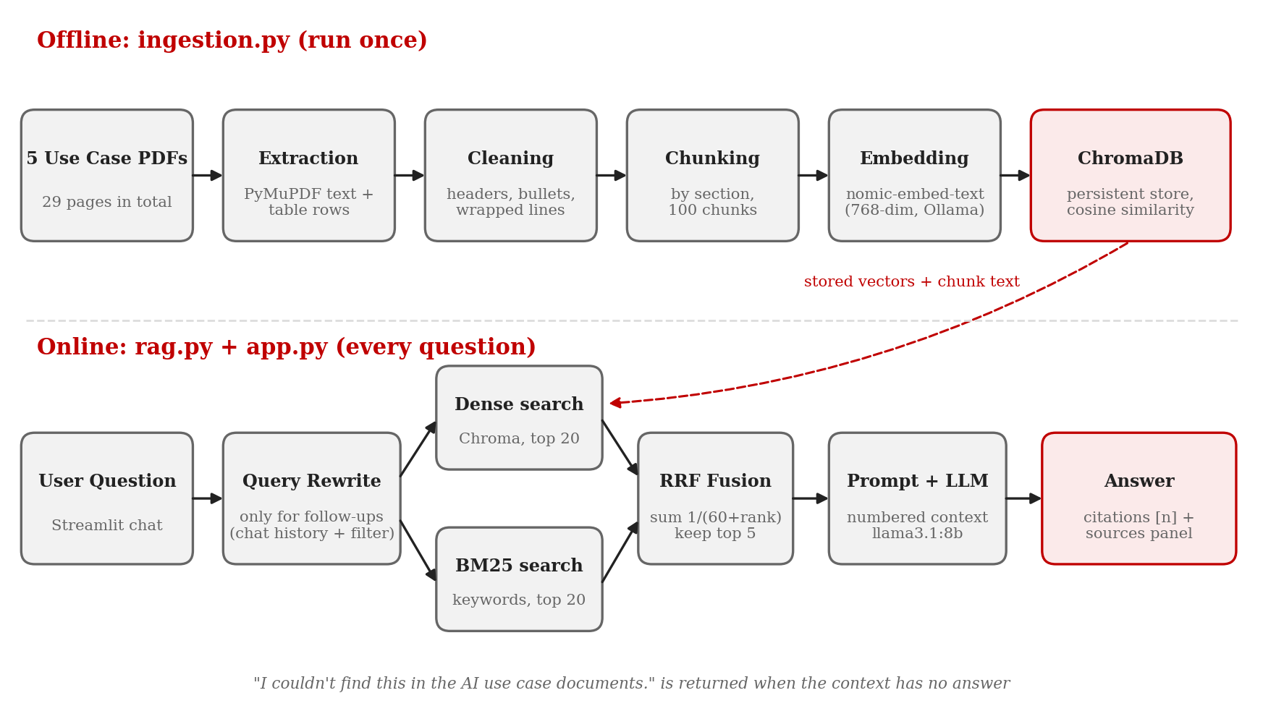
Fig. 1: Overall architecture of the system
For a new question the online flow is:
- If chat history is enabled and earlier messages exist, the LLM rewrites the question as a standalone question (for example, "what are its challenges?" becomes "What are the challenges associated with the heatwave use case?").
- The question is searched with dense retrieval (ChromaDB) and BM25, taking the top 20 candidates from each.
- The two candidate lists are fused with Reciprocal Rank Fusion and the top 5 chunks are kept.
- The 5 chunks are inserted into the prompt as numbered blocks [1] to [5], each with its use case, section and page.
- Llama 3.1 8B generates the answer with inline citations. The citation numbers are parsed from the answer to mark which chunks were cited.

7. Implementation

7.1 Tools and Libraries
Table 4: Software used
Component | Tool / version | Purpose
Language | Python 3.12.10 | ChromaDB 1.5.9 failed to import on Python 3.14 during setup, so 3.12 was used
Framework | LangChain (langchain-core 1.6.6) | Prompts, text splitter, LLM and vector store wrappers, LCEL chain
Vector database | ChromaDB 1.5.9 (langchain-chroma) | Persistent storage of chunk vectors with cosine similarity and metadata filters
Model runtime | Ollama (langchain-ollama 1.1.0) | Runs the embedding model and the LLM locally
Embedding model | nomic-embed-text (274 MB) | 768-dimensional embeddings with search_document / search_query prefixes
LLM | llama3.1:8b (4.9 GB, 4-bit) | Answer generation and follow-up question rewriting
PDF parsing | PyMuPDF 1.28.2 | Text blocks and table extraction
Keyword search | rank-bm25 | BM25 Okapi ranking
User interface | Streamlit 1.64.0 | Chat interface with source display
Analysis | pandas, matplotlib | Evaluation tables and charts
Editor / OS | VS Code on Windows | Development and running

7.2 Project Structure
Table 5: Files in the project
File | What it does
config.py | All settings in one place: model names, paths, chunk size, top-k, Ollama URL. Also wraps the Ollama embeddings to add the nomic task prefixes.
check_setup.py | Checks the Python version, packages, Ollama models and that all five PDFs are present and readable.
ingestion.py | Extraction, cleaning, section-aware chunking and building the Chroma vector store. Also builds the naive chunks used as a baseline in evaluation.
rag.py | RAGPipeline class with dense, BM25 and hybrid retrieval, the prompts, query rewriting and answer generation. Can also be used from the command line.
app.py | Streamlit user interface.
eval.py | Runs the test set and saves all results as CSV files and a chart in the results folder.

7.3 Embeddings and Vector Store
Ollama serves nomic-embed-text locally. A wrapper class prepends "search_document: " to every chunk and "search_query: " to every question before embedding, as the model expects. The Chroma collection uses cosine distance, and every chunk has a fixed ID, so re-running ingestion rebuilds the store instead of adding duplicates. Embedding all 100 chunks took 30.6 s on the test laptop.

7.4 Retrieval
Dense search uses Chroma's similarity search, with the cosine distance converted to a similarity score (1 minus the distance). BM25 runs over the same chunk texts, read back from Chroma at startup. For BM25 the text is lowercased and split into alphanumeric tokens, and subscript and dash variants are normalised so that "Al₂O₃" matches "Al2O3" and "400–700" matches "400-700".
Hybrid search takes the top 20 from each and fuses them with RRF:
score(d) = Σ 1 / (60 + rank_i(d))
where rank_i(d) is the rank of chunk d in list i, and a list in which d does not appear contributes nothing. The constant 60 is the value used by Cormack et al. [5]; it was not tuned, and neither were the candidate pool size (20) or k (5). All three modes accept an optional use case filter, applied as a metadata filter in Chroma and as a use case ID check in BM25.

7.5 Prompt Design and Generation
The system prompt gives the model five rules: use only the numbered context blocks, cite them inline like [1] or [2][4], reply with exactly "I couldn't find this in the AI use case documents." if the answer is not in the context, mention the use case ID when the question is not about a single use case, and keep numbers and units exactly as written. A fixed refusal sentence makes refusals easy to detect automatically in the evaluation. The temperature is set to 0.2 because this is factual question answering.
Ollama's default context window (a few thousand tokens, depending on the version) can be shorter than the assembled prompt, and when it is exceeded the start of the prompt is dropped without an error. num_ctx is therefore set to 8192 tokens.

7.6 Follow-up Questions
A follow-up like "what are its challenges?" means nothing on its own to the retriever. When chat history is enabled, the last few messages and the new question are first sent to the LLM with a short prompt asking it to rewrite the question as a standalone one, and the rewritten question is what gets searched.
While testing the interface I found a bug in this step. I had asked about the PocketQube mission, then switched the use case filter to KJS-AGR-01 and asked "What are the challenges?". The rewriter, which only saw the chat history, turned this into a question about the PocketQube mission, while the filter only allowed sugarcane chunks through. The model correctly said it couldn't find the answer, but that was obviously not what the user wanted. The fix was to also pass the selected use case to the rewriter, with an instruction that the rewritten question must be about that use case. After the fix the same sequence gives the sugarcane challenges (Figure 5).

8. User Interface
The interface is built with Streamlit. The sidebar has the Ollama model name, a use case filter, a choice of retrieval mode (hybrid, dense, BM25), a top-k slider, a checkbox for using chat history and a button to clear the chat. Answers are streamed word by word. Under each answer there is a Sources box listing every retrieved chunk with its use case, section, page and score, and the chunks that the answer actually cites are marked with a tick.
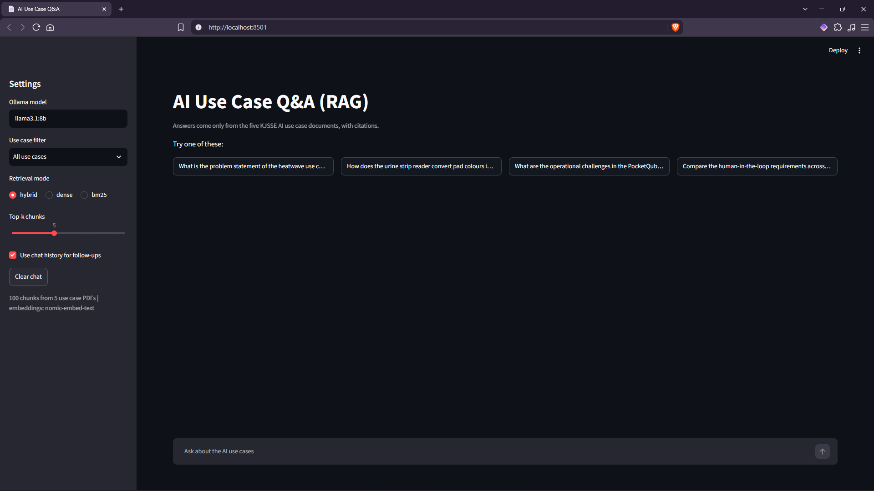
Fig. 2: Home screen with settings in the sidebar and example questions
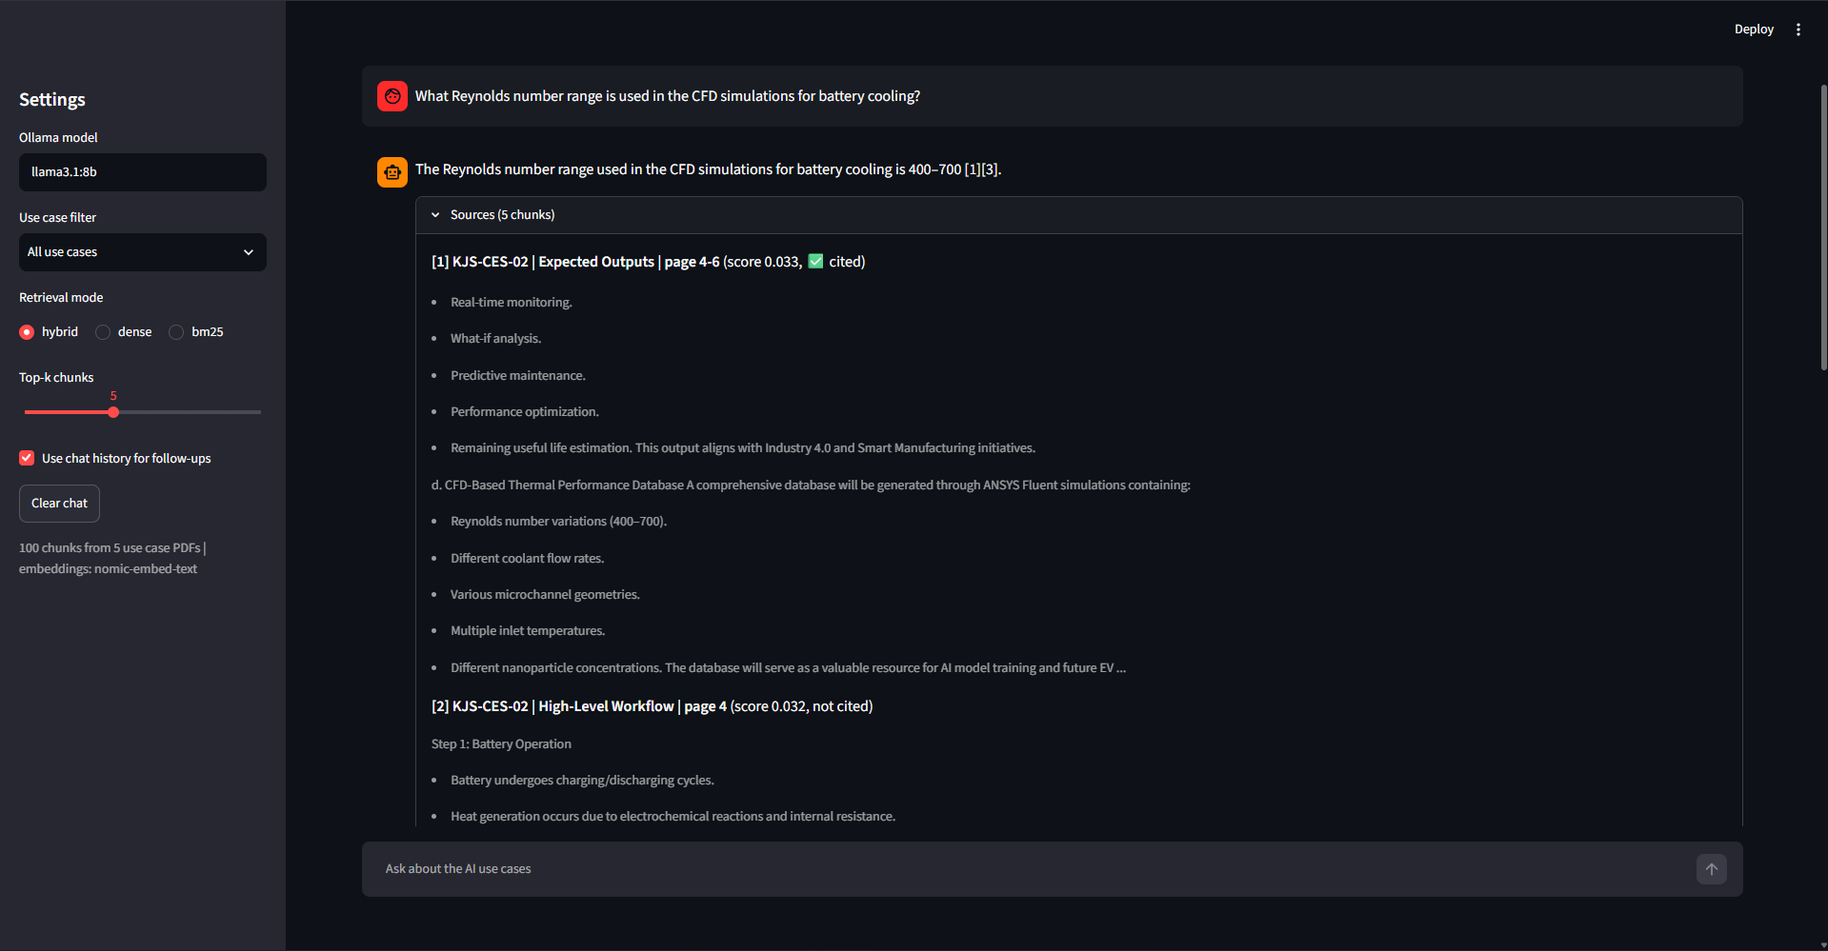
Fig. 3: Answer with citation and the sources panel (Reynolds number question)
Figure 3 is a typical single-fact question. The answer "400–700" is cited to the Expected Outputs chunk of KJS-CES-02, and the same range appears in the source text below it, so it can be checked directly.
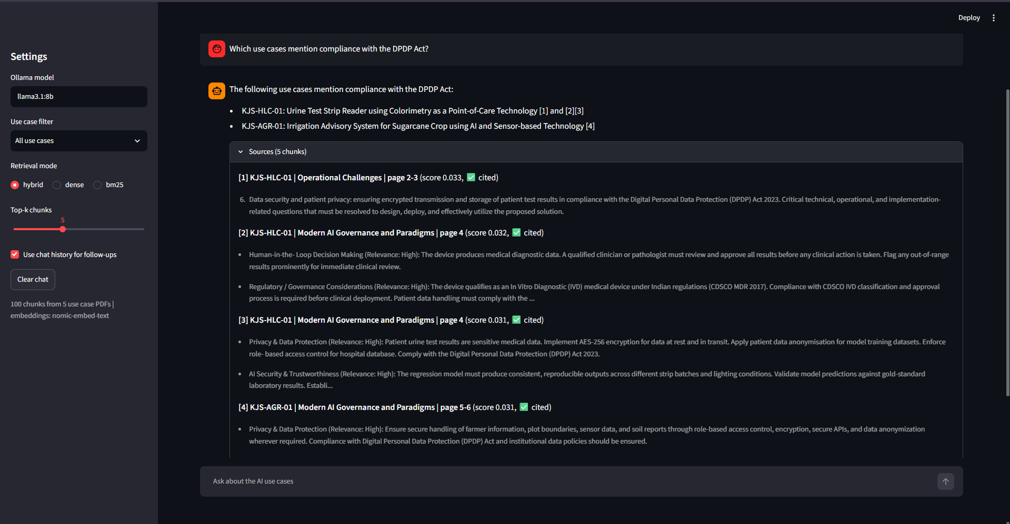
Fig. 4: Question spanning several use cases: which documents mention the DPDP Act
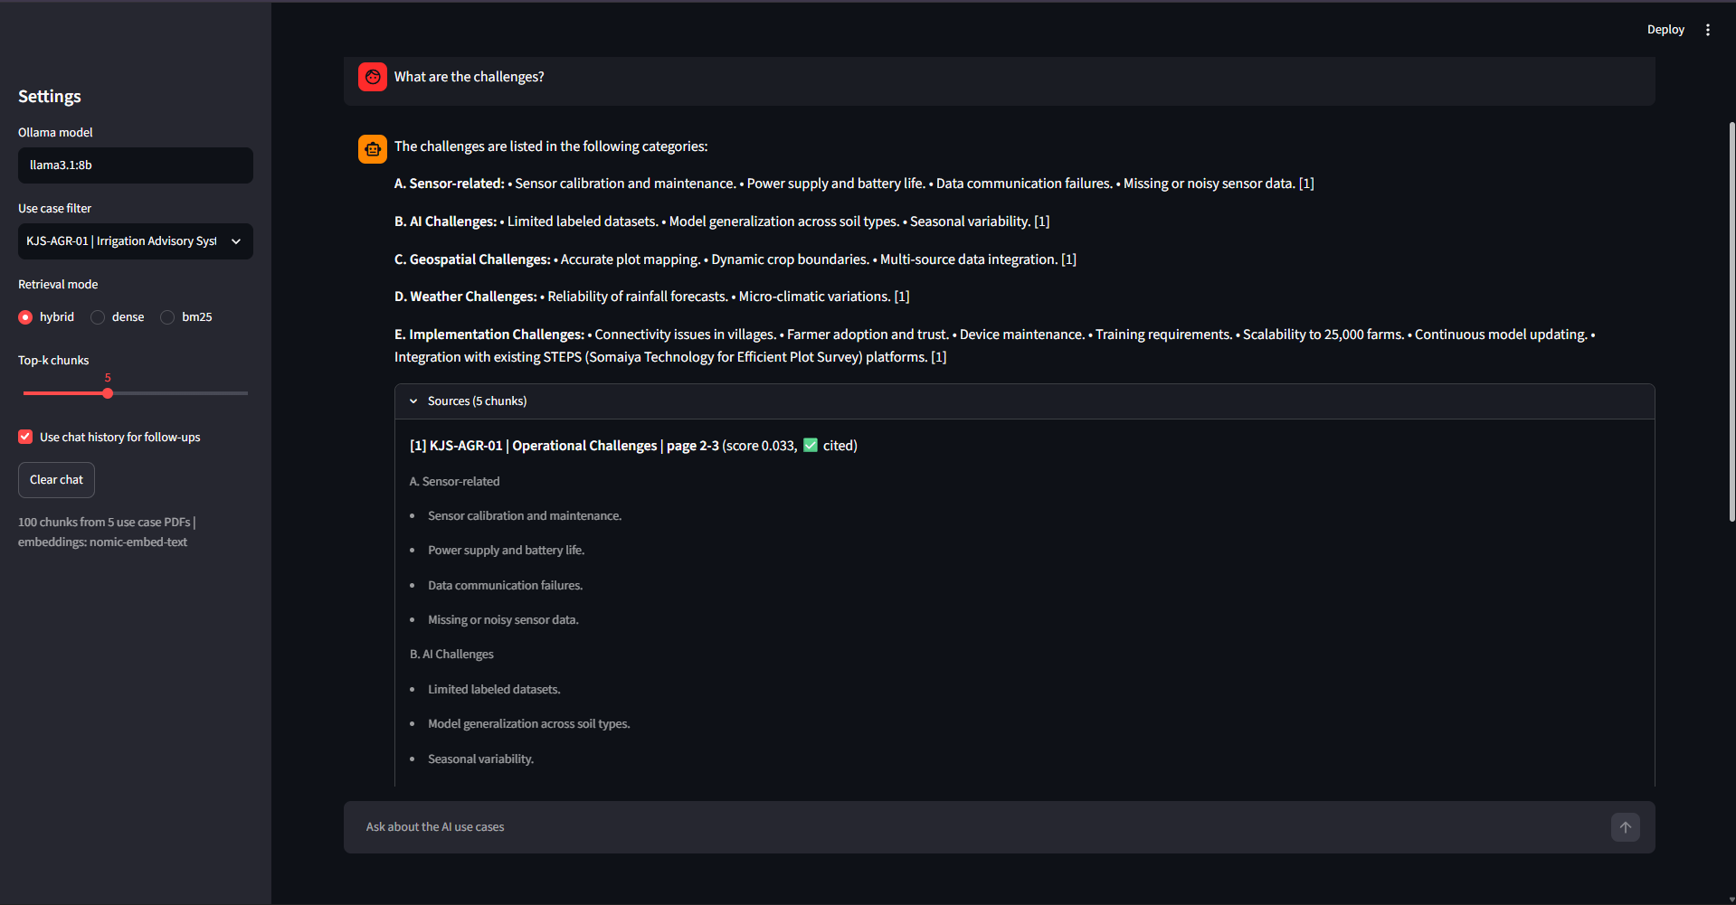
Fig. 5: Use case filter set to KJS-AGR-01; all sources come from the sugarcane document
With the filter on (Figure 5), all five sources are from KJS-AGR-01 and the answer lists the sensor, AI, geospatial, weather and implementation challenges of the sugarcane project, including the full form of STEPS (Somaiya Technology for Efficient Plot Survey). This becomes relevant again in the analysis, because without the filter the system could not answer a direct question about STEPS.

8.1 Effect of Chat History
Figures 6 and 7 show the same two questions asked with chat history on and off. With history on, "what are its challenges?" is rewritten into a question about the heatwave use case and the answer gives the four operational challenges of KJS-CES-01. With history off, the retriever has nothing to resolve "its" against, so it returns challenge sections from several documents and the answer begins with the challenges of the sugarcane and PocketQube projects.
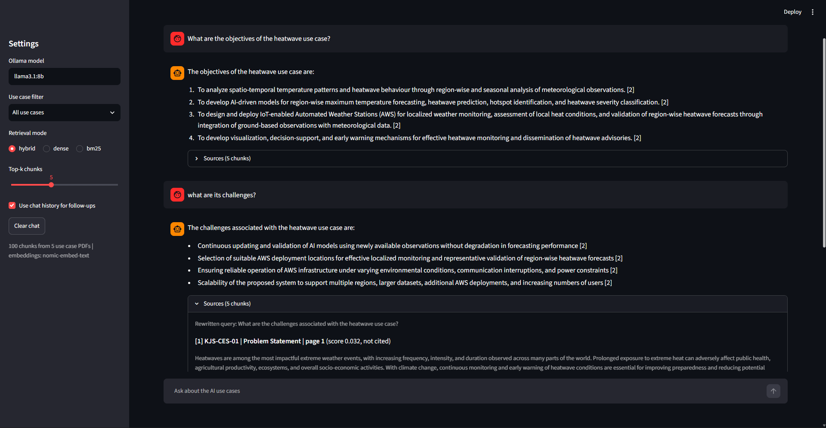
Fig. 6: Follow-up with chat history ON: the rewritten query names the heatwave use case
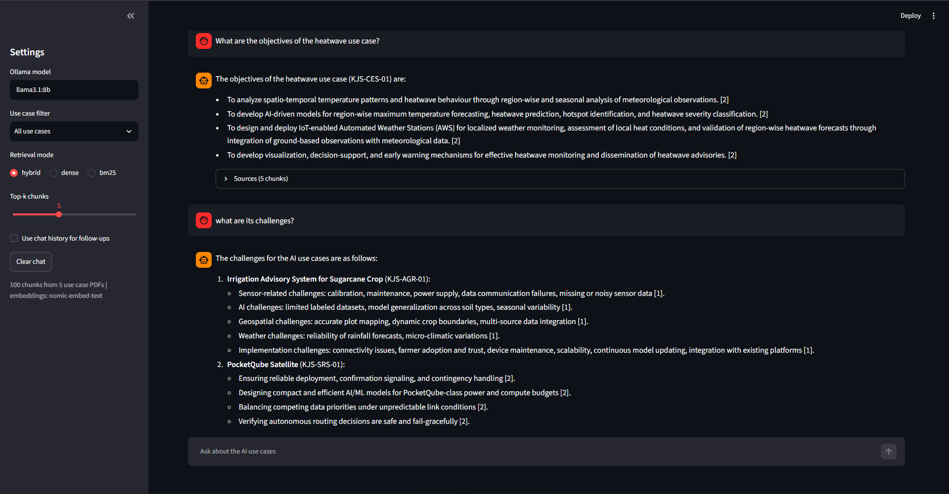
Fig. 7: The same follow-up with chat history OFF: challenges from unrelated use cases

8.2 Questions Outside the Documents
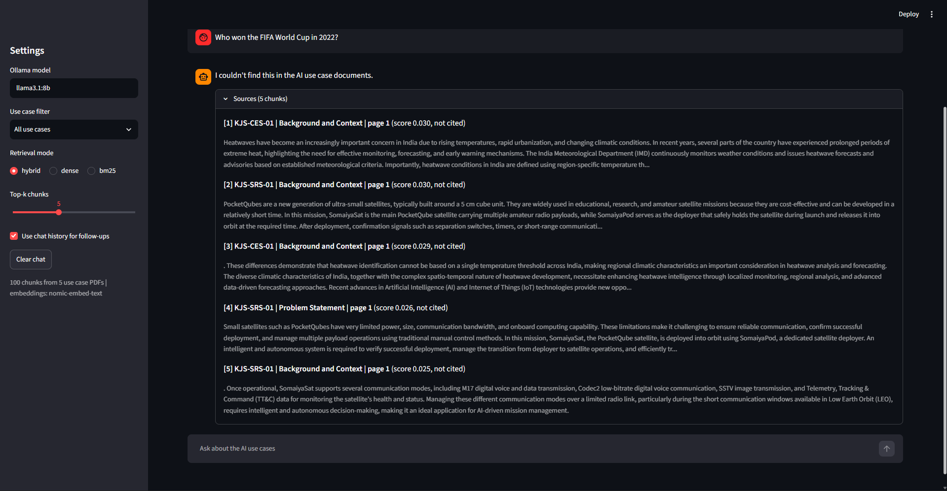
Fig. 8: General knowledge question is refused even though the model knows the answer
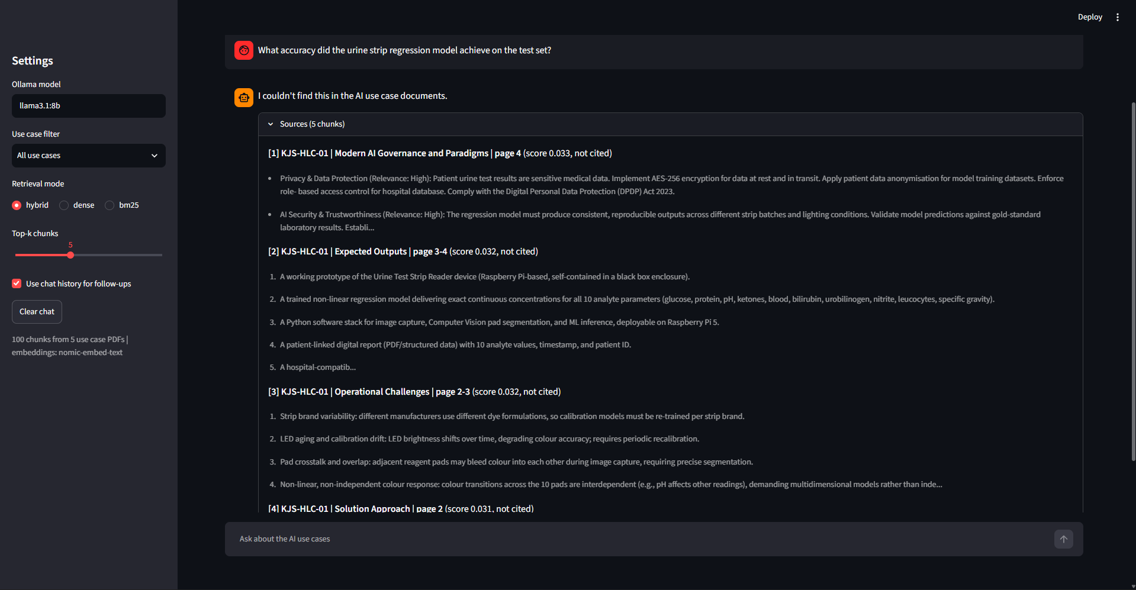
Fig. 9: A question that sounds related but is not answered in the PDF is also refused
Figure 9 is the more interesting case. The urine strip document talks about a regression model and about validation, so the retrieved chunks are all from KJS-HLC-01 and look relevant, but the document never gives an accuracy figure, and in this run the model did not produce one.

9. Testing and Evaluation

9.1 Test Set
The test set has 25 questions, written from the documents before the evaluation was run and not changed afterwards:
- 20 single-document questions, four per use case, each with a short evidence phrase that must appear in the correct chunk (for example "400-700" or "GMAT") and a list of keywords the answer should contain.
- 2 cross-document questions whose answers come from more than one use case (DPDP Act compliance, and which use cases rate Generative AI / LLMs as High).
- 3 out-of-scope questions that should be refused: one general knowledge question (FIFA World Cup) and two that sound related but whose answers are not in the PDFs (the heatwave project budget and the accuracy of the urine strip model).

9.2 Evaluation Protocol and Metrics
Table 6: Evaluation metrics
Metric | Meaning
Hit@k (k = 1, 3, 5) | Fraction of questions where a chunk from the correct use case containing the evidence phrase is within the top k results
MRR@5 | Mean of 1 / rank of the first correct chunk (0 if not in top 5). Rewards rank 1 more than rank 5
Use case coverage@5 | For cross-document questions, the fraction of expected use cases that appear in the top 5
Keyword recall | Fraction of the expected keywords that appear in the generated answer
Refusal accuracy | Out-of-scope questions answered with the refusal sentence, and answerable questions wrongly refused
Citation rate | Answerable questions whose answer cites at least one source

The evaluation follows these rules:
- Relevance: a retrieved chunk counts as correct only if it belongs to one of the expected use cases and contains the evidence phrase. Both texts are lowercased, whitespace is collapsed, and dash and subscript variants are unified before matching.
- Retrieval metrics are computed over the 22 answerable questions only; the 3 out-of-scope questions are excluded.
- Keywords are matched case-insensitively with spaces ignored, and a keyword written as "a|b" counts if either form appears.
- Refusals are detected by searching the answer for phrases such as "couldn't find" or "not mentioned".
- Fixed settings for the end-to-end run: hybrid retrieval, k = 5, nomic-embed-text, llama3.1:8b, temperature 0.2, num_ctx 8192. Chat history is not used, so each question is answered independently.
- Latency is the LLM generation time only and excludes retrieval. For the first question it also includes the time Ollama took to load the model.
- Each configuration was run once. With 22 questions, a single question changes Hit@k by about 0.045, so differences of that size should not be over-interpreted.

9.3 Retrieval Results
The 22 answerable questions were run through all three retrieval modes. The results are in Table 7 and Figure 10.
Table 7: Retrieval quality by mode (22 answerable questions)
Mode | Hit@1 | Hit@3 | Hit@5 | MRR@5 | Coverage@5
Dense | 0.773 | 0.909 | 0.909 | 0.833 | 0.977
BM25 | 0.773 | 0.818 | 0.909 | 0.814 | 1.000
Hybrid (RRF) | 0.727 | 0.818 | 0.955 | 0.802 | 1.000

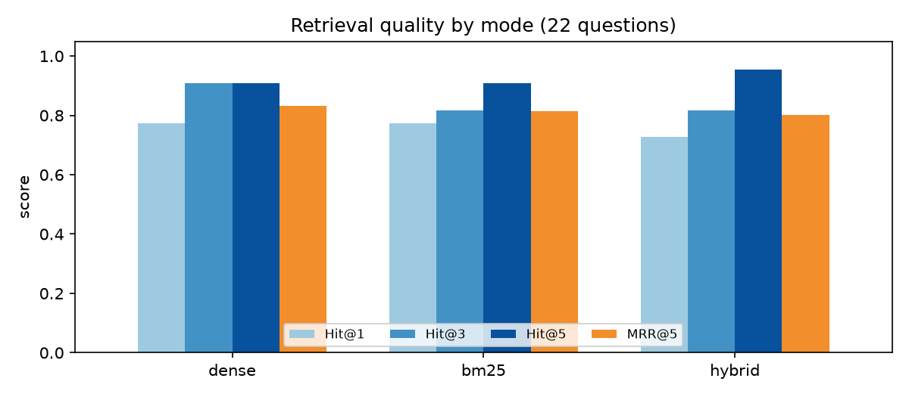
Fig. 10: Retrieval quality by mode, generated by eval.py
Table 8 shows only the questions where the three modes did not all put the correct chunk at rank 1. The other 15 questions were found at rank 1 by every mode.
Table 8: Rank of the first correct chunk where the modes disagree (- = not in top 5)
Question | Dense | BM25 | Hybrid
Which tools are used for mission analysis in the PocketQube mission? | - | 1 | 5
What hardware is used to build the urine test strip reader? | 1 | - | 5
Which analytes does the urine strip reader measure? | 1 | - | 2
What does STEPS stand for in the irrigation advisory use case? | - | 5 | -
Which nanofluid is used as the coolant in the BTMS? | 2 | 5 | 4
Which use cases rate Generative AI / LLMs as high relevance? | 3 | 1 | 2
Which functional safety standard should the BTMS comply with? | 2 | 1 | 1

9.4 Effect of Chunking
To measure the effect of the preprocessing, eval.py also builds a second, temporary vector store from the raw PyMuPDF text split into plain 900-character chunks (150 overlap), with no cleaning and no section headers, and runs the same questions on it with dense retrieval. This baseline differs from the main pipeline in three ways at once (no cleaning, fixed-size splitting and no header line), so the comparison shows their combined effect, not the effect of section-based splitting alone.
Table 9: Naive fixed-size chunking vs section-aware chunking (dense retrieval)
Chunking | Chunks | Hit@1 | Hit@3 | Hit@5 | MRR@5
Naive fixed-size | 92 | 0.545 | 0.818 | 0.864 | 0.686
Section-aware (this project) | 100 | 0.773 | 0.909 | 0.909 | 0.833

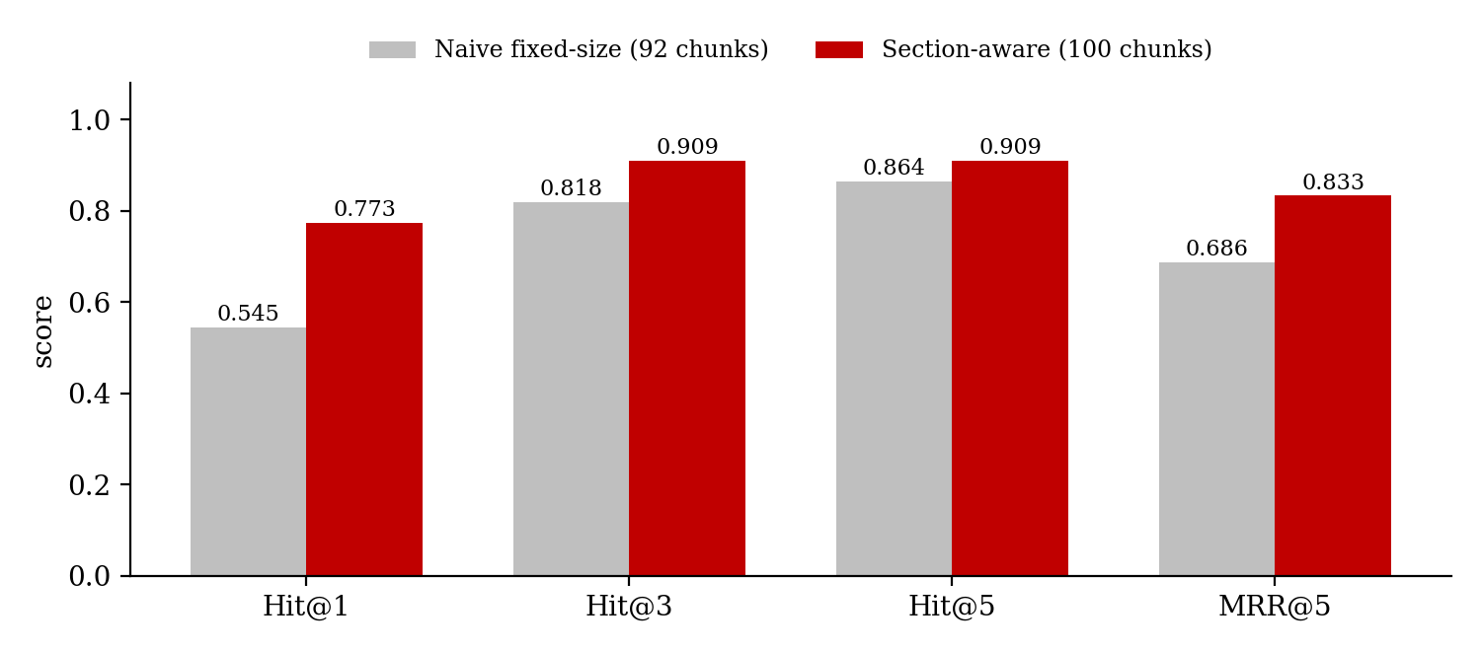
Fig. 11: Naive vs section-aware chunking

9.5 Answer Quality
All 25 questions were then answered end to end with the fixed settings listed in Section 9.2.
Table 10: End-to-end answer quality
Measure | Result
Keyword recall (22 answerable questions) | 0.932
Answers with all expected keywords | 20 of 22
Answerable questions wrongly refused | 1 of 22 (the STEPS question)
Out-of-scope questions correctly refused | 3 of 3
Answers with at least one citation | 21 of 22 (95%)
Mean LLM time per answer (all 25) | 12.4 s
Mean LLM time excluding the first question | 7.95 s (median 6.5 s)
Mean time for refusals | 3.7 s

9.6 Dense vs BM25 vs Hybrid on One Query
The query "What are 21700 cells used for?" illustrates the difference between the modes on a single question (Figures 12 to 14). It was a manual check, not part of the test set. "21700" is the size code of the lithium-ion cells in the EV battery pack.
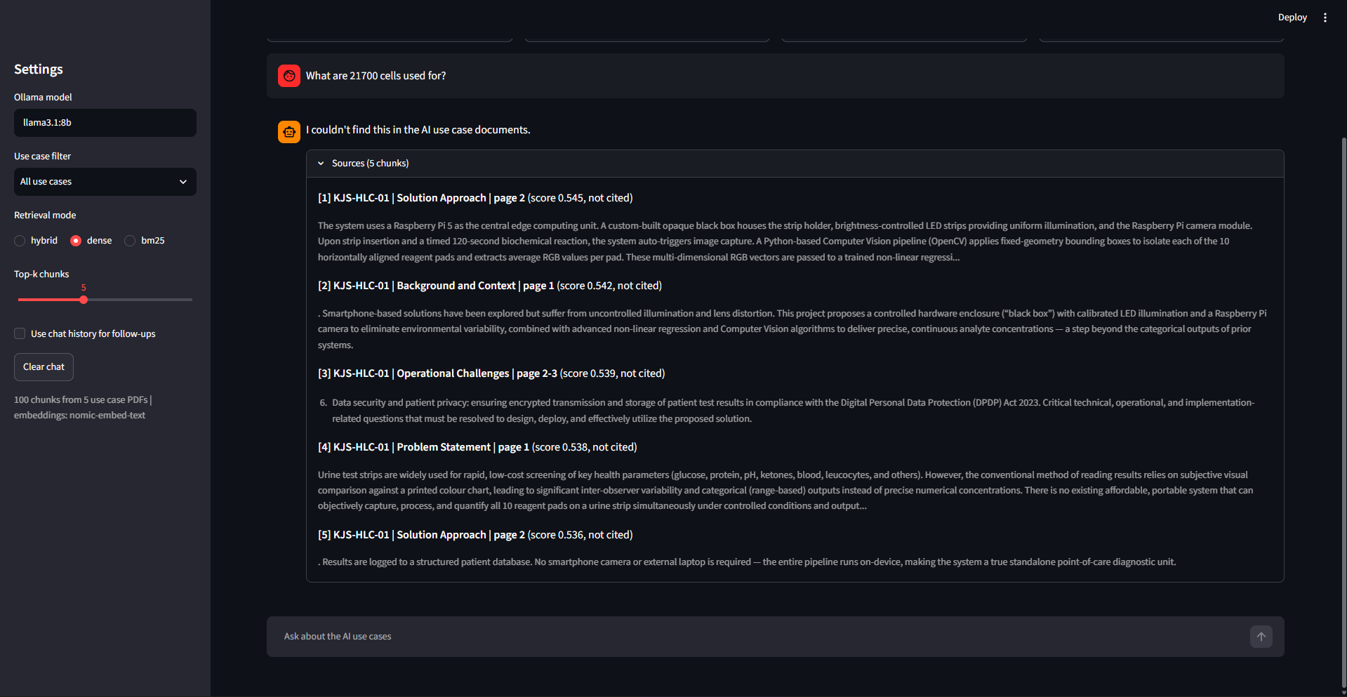
Fig. 12: Dense mode: all five chunks are from the urine strip document and the model refuses
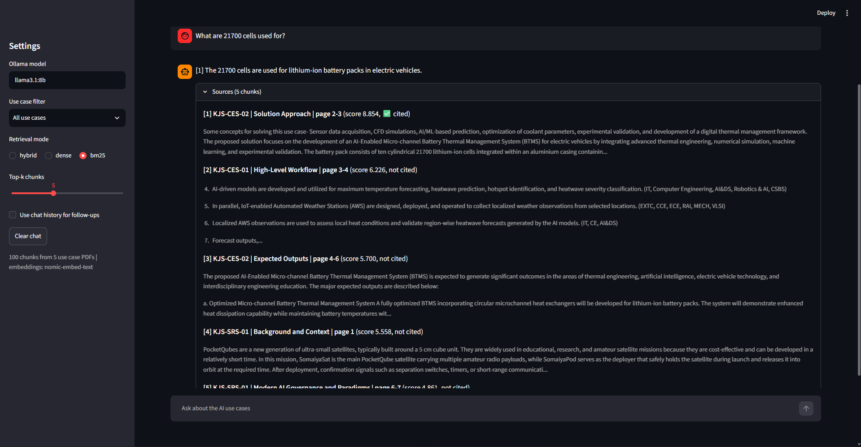
Fig. 13: BM25 mode: the exact term 21700 brings the KJS-CES-02 chunk to rank 1
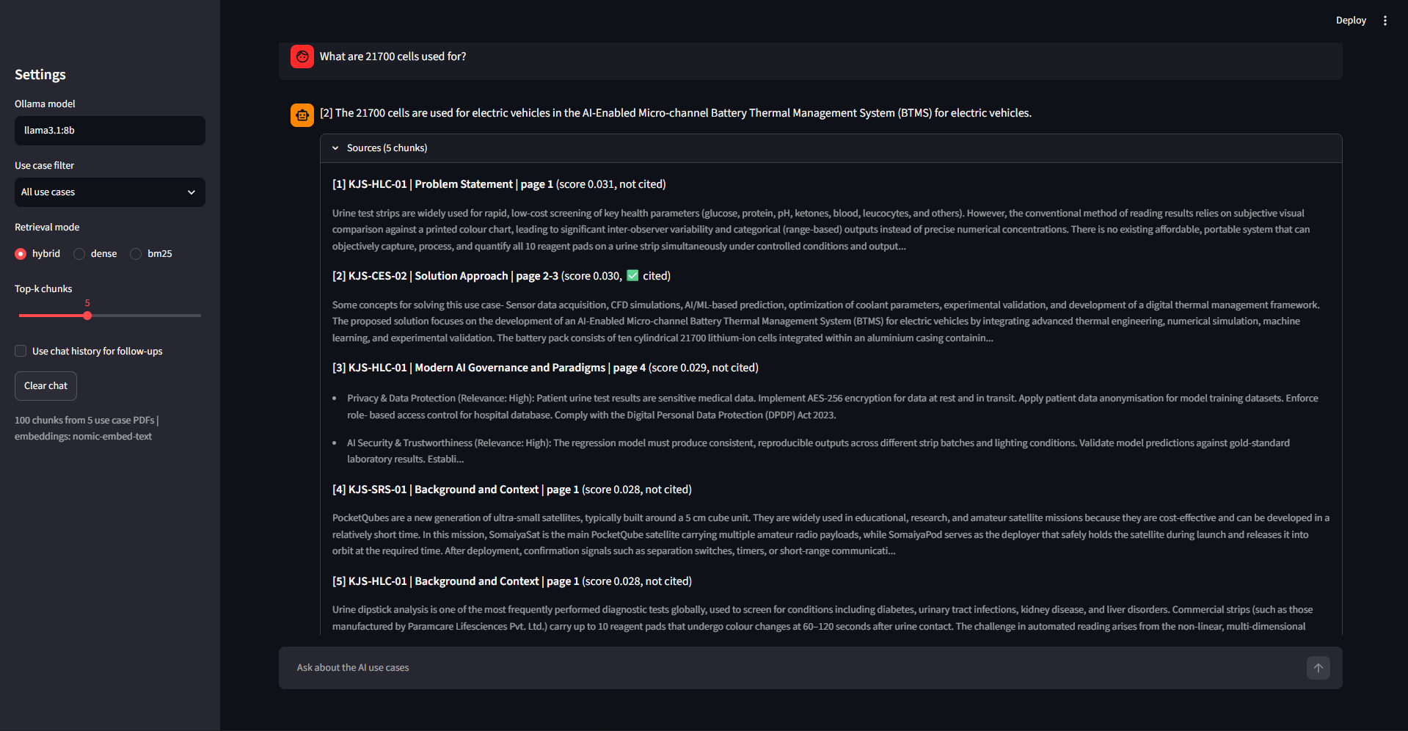
Fig. 14: Hybrid mode: the correct chunk is recovered at rank 2 and the answer is correct

10. Analysis and Discussion

10.1 Effect of Preprocessing and Chunking
Among the comparisons I ran, the preprocessing produced the largest difference. With dense retrieval, the cleaned, section-aware chunks raised Hit@1 from 0.545 to 0.773 and MRR from 0.686 to 0.833 (Table 9), meaning the correct chunk came first for 17 questions instead of 12. The gap at Hit@5 is smaller (0.864 against 0.909, a single question). Likely reasons are that naive chunks often mix the end of one section with the start of the next, governance rows lose the link between an area and its relevance level, and nothing in a naive chunk says which use case it belongs to. As noted in Section 9.4, the baseline changes all of these at once, so the contribution of each step was not measured separately. I also did not compare different LLMs or embedding models, so this result cannot be ranked against those choices.

10.2 Choice of Hybrid Retrieval
The three modes are close on this test set. Dense has the highest Hit@1 and MRR and hybrid the highest Hit@5, but most of these differences come down to a single question: Hit@1 of 0.773 against 0.727 is 17 against 16 questions, and Hit@5 of 0.909 against 0.955 is 20 against 21. The numbers alone therefore do not show that any one mode is better in general.
What Table 8 does show is that dense and BM25 failed on different questions. BM25 placed the GMAT chunk at rank 1 where dense missed it, while dense found the hardware and analyte chunks that BM25 missed, and hybrid kept all three in the top 5. Since the LLM reads all five chunks, being in the top 5 matters more for the final answer than being first, so hybrid was kept as the default. The cost shows in the same table: when one retriever is right and the other is not, fusion can push the correct chunk down (GMAT moves from rank 1 in BM25 to rank 5 in hybrid). The 21700 query in Section 9.6 is one case where hybrid recovered a chunk that dense search missed.

10.3 The One Wrong Refusal
The only answerable question the system refused was "What does STEPS stand for in the irrigation advisory use case?". The answer is in the document, inside the last bullet of the sugarcane Operational Challenges section, and Figure 5 shows the model reading it correctly when that chunk is retrieved. The problem was in retrieval. Dense search did not find the chunk, probably because a short acronym gives the embedding model little to work with, and BM25 ranked it only fifth, possibly because the word "steps" also appears in unrelated workflow sections. After fusion it dropped out of the top 5. The model then answered that it couldn't find the information rather than guessing, which is the intended behaviour when the context does not contain the answer.

10.4 Mistakes the Keyword Metric Did Not Catch
I also read all 25 answers manually. The keyword metric both over- and under-scored answers:
- For "Which use cases rate Generative AI / LLMs as high relevance?" the answer correctly listed KJS-AGR-01 and KJS-CES-01, but also added KJS-CES-02 with the note "(medium relevance, but high in the context of the specific use case)". The document clearly says Medium. This is a real error, but it got a keyword recall of 1.0 because the expected keywords were all present.
- For the coastal heatwave criteria, the answer gave the correct heatwave thresholds (departure of 4.5 to 6.4°C or above 35°C) but left out the severe heatwave threshold of 37°C, so it scored only 0.5 even though what it said was correct.
Keyword recall of 0.932 should therefore be treated as an approximate indicator, not a measure of correctness.

10.5 Questions That Need All Five Documents
"Compare the human-in-the-loop requirements across all five use cases" (Figure 15 in the appendix) shows a limit of top-k retrieval. All five governance tables have a human-in-the-loop row, but only two were among the top 5 chunks, so the model answered for the urine strip reader and the PocketQube mission and said it couldn't find the other three. It did not invent the missing entries, but the answer is incomplete. Questions about all use cases need at least one chunk from each, which similarity search does not guarantee.

10.6 Speed
The first question in the evaluation took 120 seconds because Ollama had to load the 4.9 GB model into memory. After that, answers took 7.95 seconds on average (median 6.5 s). Refusals were the fastest at about 3.7 s, likely because the output is a single short sentence. Ollama unloads the model after 5 minutes of inactivity by default, which is probably why a single question asked later from the command line (Appendix B) took 45.6 s. These timings come from one laptop and one run and will vary with hardware.

11. Limitations
- Figures are ignored. Some information exists only in diagrams, like the heatwave conceptual schema or the SomaiyaSat architecture, and cannot be answered.
- The section splitter depends on the "N. Heading:" template. A document in a different format would fall back to plain chunks.
- Acronyms and short codes are hard for dense retrieval (STEPS, 21700). BM25 helps, but not always enough after fusion.
- Questions that need information from all five documents get incomplete answers with top-5 retrieval.
- The test set has only 25 questions, all written by me, so the exact numbers would change with a different set of questions.
- Keyword recall is a rough metric and missed at least one wrong answer (Section 10.4).
- Answers take several seconds on a laptop, and the 8B model can still add something that is not in the context (Section 10.4).
- Every result comes from a single run. The LLM uses a non-zero temperature (0.2), so answers can vary slightly between runs, and no significance testing was done.
- The chunking baseline changes cleaning, splitting and the header line together, so their individual effects are not known.
- The retrieval parameters (RRF constant, candidate pool, k and chunk size) were not tuned.

12. Conclusion
On the test set used here, the system meets the objectives in Section 2. It answers questions about the five AI use case documents from their content, shows the section and page each answer came from, and refused all three out-of-scope questions, including two designed to tempt the model into inventing figures. With hybrid retrieval, the correct chunk was in the top 5 for 21 of 22 answerable questions, and the answers contained 93.2% of the expected keywords. Given the small, self-written test set, these results show that the approach works for these documents, not how it would perform on a larger or different collection.
The main thing I learned is how much the preprocessing matters. I expected the choice of LLM or embedding model to decide the quality, but in my comparisons the largest measured difference came from cleaning the PDFs and chunking them by section, which raised Hit@1 from 0.545 to 0.773. Reading the answers manually was also necessary, because it caught a wrong answer that the automatic metric had scored as perfect.
There are several ways to extend this. Questions about all use cases could be handled by retrieving the best chunk from each use case separately instead of the overall top 5. A re-ranking model after retrieval might help in cases like GMAT and STEPS, where the right chunk is retrieved but ranked low. Reading the figures with a vision model would cover information that is currently lost, and a larger test set, ideally written by someone other than me, would give more reliable numbers.

References
[1] P. Lewis, E. Perez, A. Piktus et al., "Retrieval-Augmented Generation for Knowledge-Intensive NLP Tasks," in Advances in Neural Information Processing Systems (NeurIPS), vol. 33, 2020.
[2] Y. Gao, Y. Xiong, X. Gao et al., "Retrieval-Augmented Generation for Large Language Models: A Survey," arXiv:2312.10997, 2023.
[3] S. Robertson and H. Zaragoza, "The Probabilistic Relevance Framework: BM25 and Beyond," Foundations and Trends in Information Retrieval, vol. 3, no. 4, pp. 333-389, 2009.
[4] V. Karpukhin, B. Oguz, S. Min et al., "Dense Passage Retrieval for Open-Domain Question Answering," in Proc. EMNLP, 2020, pp. 6769-6781.
[5] G. V. Cormack, C. L. A. Clarke and S. Buettcher, "Reciprocal Rank Fusion Outperforms Condorcet and Individual Rank Learning Methods," in Proc. ACM SIGIR, 2009, pp. 758-759.
[6] Z. Nussbaum, J. X. Morris, B. Duderstadt and A. Mulyar, "Nomic Embed: Training a Reproducible Long Context Text Embedder," arXiv:2402.01613, 2024.
[7] Z. Ji, N. Lee, R. Frieske et al., "Survey of Hallucination in Natural Language Generation," ACM Computing Surveys, vol. 55, no. 12, 2023.
[8] A. Grattafiori, A. Dubey, A. Jauhri et al., "The Llama 3 Herd of Models," arXiv:2407.21783, 2024.
[9] LangChain documentation, https://python.langchain.com
[10] Chroma documentation, https://docs.trychroma.com
[11] Ollama documentation, https://github.com/ollama/ollama
[12] K. J. Somaiya School of Engineering and K. J. Somaiya Institute of Technology, "AI Use Case Integration in Teaching-Learning, Part A: AI Use Case Profile," use cases KJS-AGR-01, KJS-CES-01, KJS-CES-02, KJS-HLC-01 and KJS-SRS-01, 2026.

Appendix A: How to Run
Requirements: Python 3.10 to 3.13 (3.12 used), Ollama installed and running. From the project folder in a terminal:
ollama pull nomic-embed-text
ollama pull llama3.1:8b
py -3.12 -m venv .venv
.venv\Scripts\Activate.ps1
pip install -r requirements.txt
python check_setup.py
python ingestion.py
python rag.py "What Reynolds number range is used in the CFD simulations?"
streamlit run app.py
python eval.py

Appendix B: Setup and Command Line Screenshots
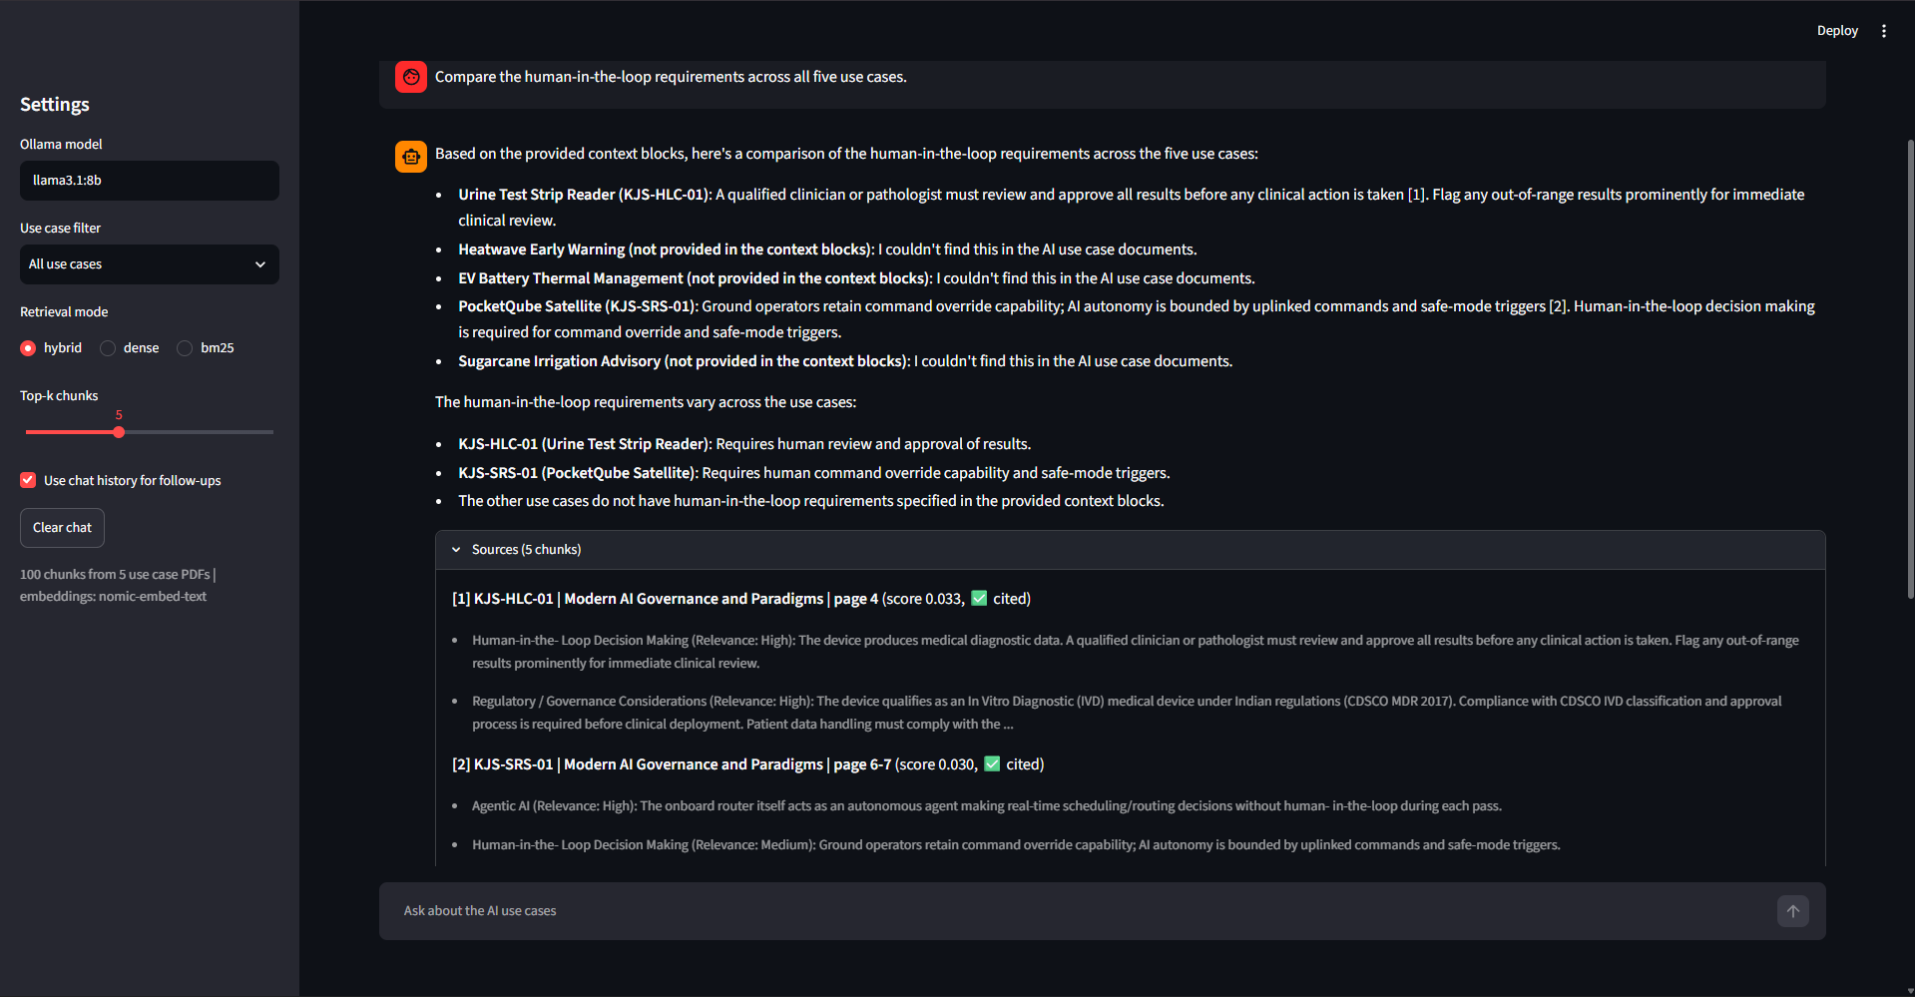
Fig. 15: Comparing human-in-the-loop requirements across all five use cases (discussed in 10.5)
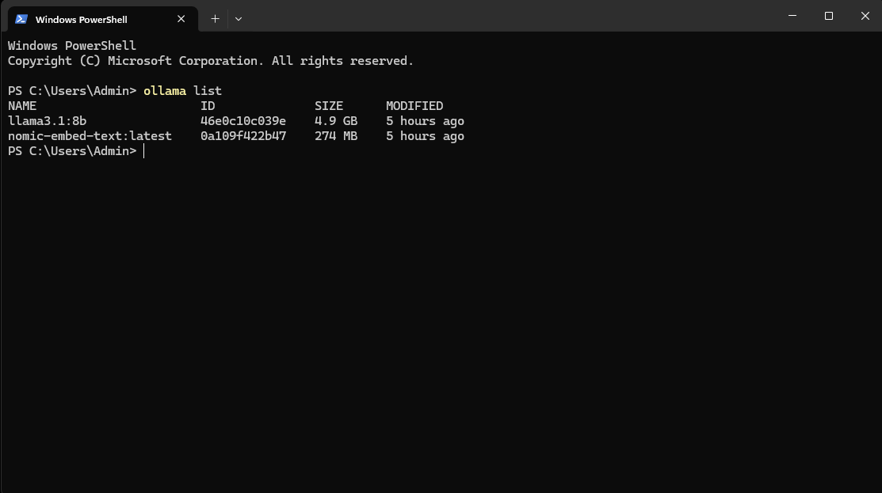
Fig. 16: Models pulled in Ollama
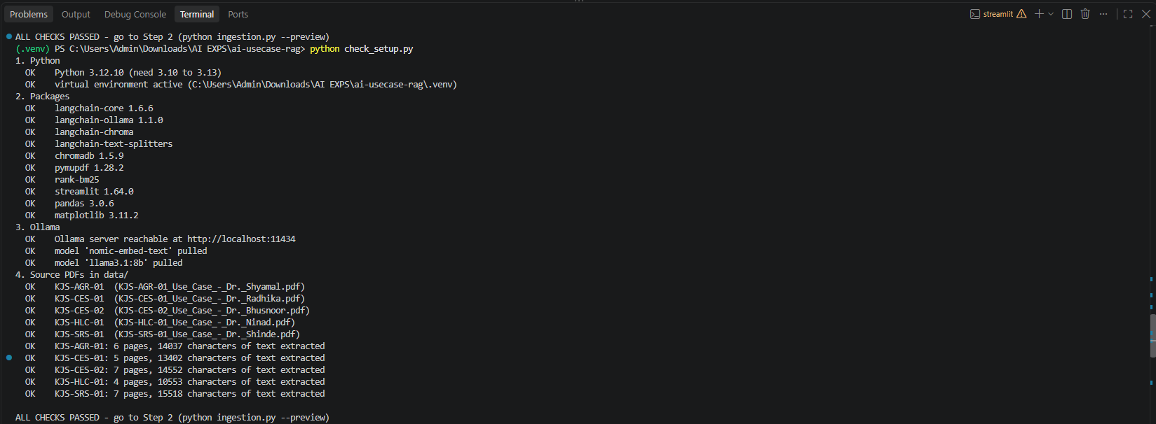
Fig. 17: Output of check_setup.py
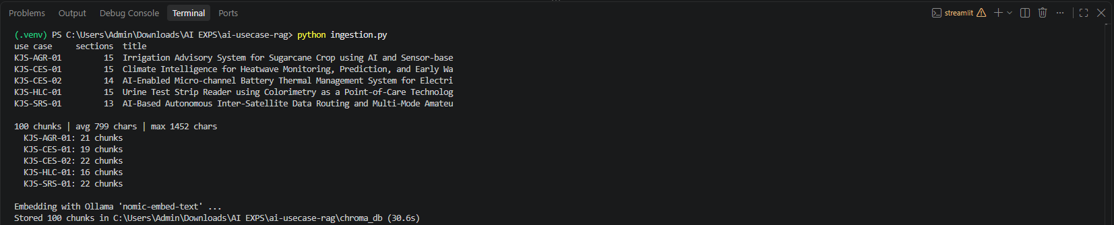
Fig. 18: Output of ingestion.py
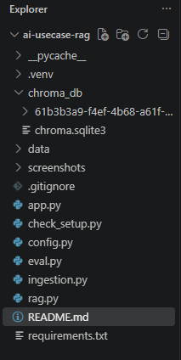
Fig. 19: Project structure in VS Code
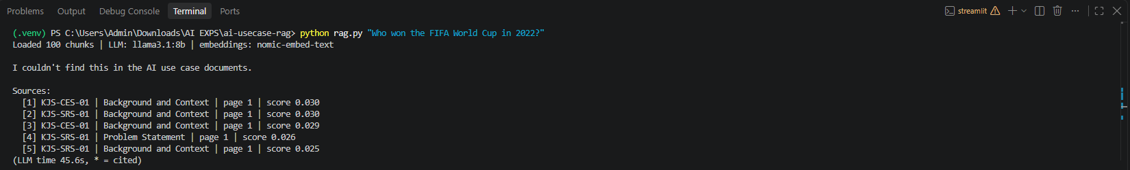
Fig. 20: rag.py used from the command line with an out-of-scope question

