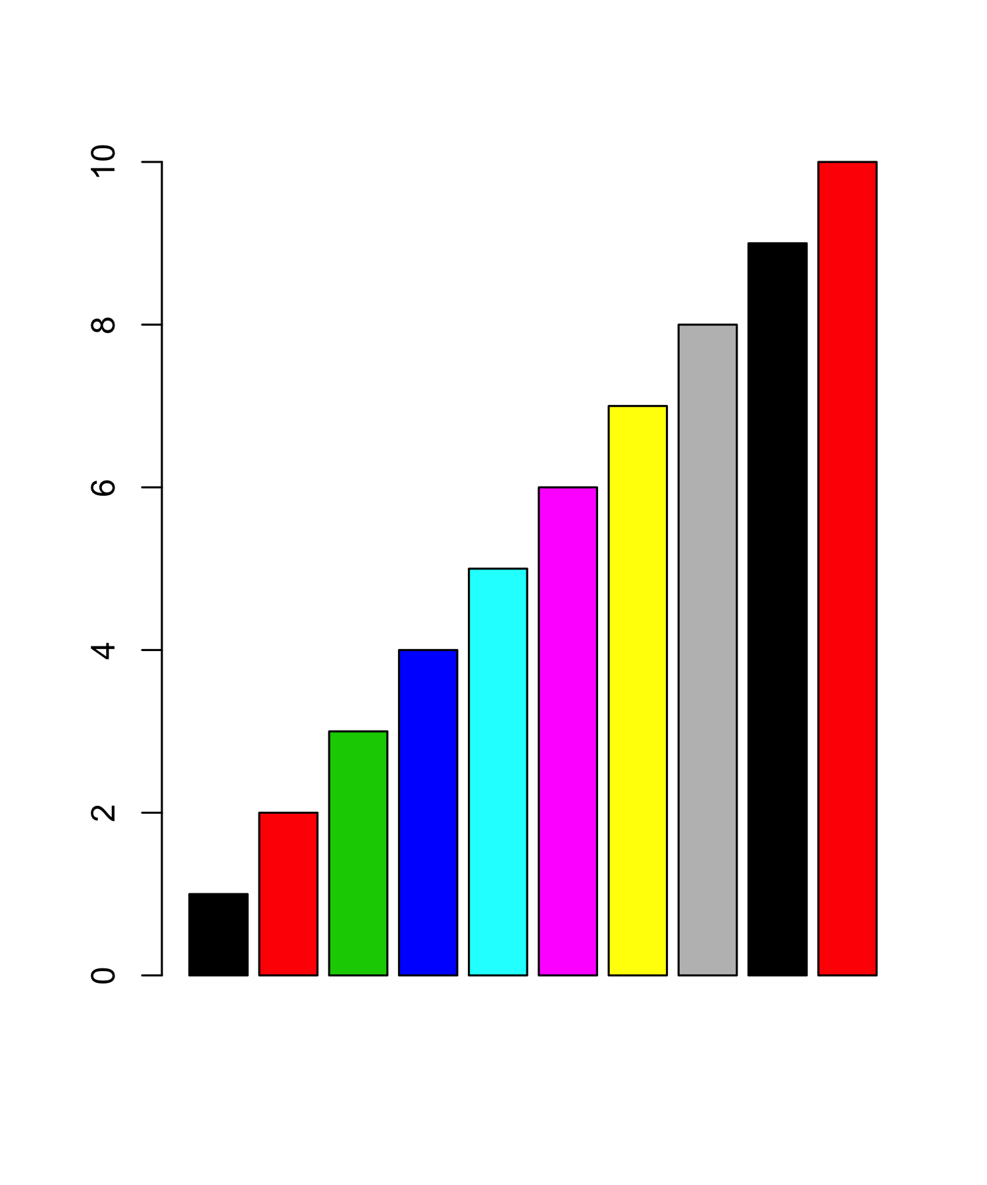

Hello world!

| Sepal.Length | Sepal.Width | Petal.Length | Petal.Width | Species |
| --- | --- | --- | --- | --- |
| 5.1 | 3.5 | 1.4 | 0.2 | setosa |
| 4.9 | 3.0 | 1.4 | 0.2 | setosa |
| 4.7 | 3.2 | 1.3 | 0.2 | setosa |
| 4.6 | 3.1 | 1.5 | 0.2 | setosa |
| 5.0 | 3.6 | 1.4 | 0.2 | setosa |
| 5.4 | 3.9 | 1.7 | 0.4 | setosa |
| 4.6 | 3.4 | 1.4 | 0.3 | setosa |
| 5.0 | 3.4 | 1.5 | 0.2 | setosa |
| 4.4 | 2.9 | 1.4 | 0.2 | setosa |
| 4.9 | 3.1 | 1.5 | 0.1 | setosa |
| 5.4 | 3.7 | 1.5 | 0.2 | setosa |
| 4.8 | 3.4 | 1.6 | 0.2 | setosa |
| 4.8 | 3.0 | 1.4 | 0.1 | setosa |
| 4.3 | 3.0 | 1.1 | 0.1 | setosa |
| 5.8 | 4.0 | 1.2 | 0.2 | setosa |
| 5.7 | 4.4 | 1.5 | 0.4 | setosa |
| 5.4 | 3.9 | 1.3 | 0.4 | setosa |
| 5.1 | 3.5 | 1.4 | 0.3 | setosa |
| 5.7 | 3.8 | 1.7 | 0.3 | setosa |
| 5.1 | 3.8 | 1.5 | 0.3 | setosa |
| 5.4 | 3.4 | 1.7 | 0.2 | setosa |
| 5.1 | 3.7 | 1.5 | 0.4 | setosa |
| 4.6 | 3.6 | 1.0 | 0.2 | setosa |
| 5.1 | 3.3 | 1.7 | 0.5 | setosa |
| 4.8 | 3.4 | 1.9 | 0.2 | setosa |
| 5.0 | 3.0 | 1.6 | 0.2 | setosa |
| 5.0 | 3.4 | 1.6 | 0.4 | setosa |
| 5.2 | 3.5 | 1.5 | 0.2 | setosa |
| 5.2 | 3.4 | 1.4 | 0.2 | setosa |
| 4.7 | 3.2 | 1.6 | 0.2 | setosa |
| 4.8 | 3.1 | 1.6 | 0.2 | setosa |
| 5.4 | 3.4 | 1.5 | 0.4 | setosa |
| 5.2 | 4.1 | 1.5 | 0.1 | setosa |
| 5.5 | 4.2 | 1.4 | 0.2 | setosa |
| 4.9 | 3.1 | 1.5 | 0.2 | setosa |
| 5.0 | 3.2 | 1.2 | 0.2 | setosa |
| 5.5 | 3.5 | 1.3 | 0.2 | setosa |
| 4.9 | 3.6 | 1.4 | 0.1 | setosa |
| 4.4 | 3.0 | 1.3 | 0.2 | setosa |
| 5.1 | 3.4 | 1.5 | 0.2 | setosa |
| 5.0 | 3.5 | 1.3 | 0.3 | setosa |
| 4.5 | 2.3 | 1.3 | 0.3 | setosa |
| 4.4 | 3.2 | 1.3 | 0.2 | setosa |
| 5.0 | 3.5 | 1.6 | 0.6 | setosa |
| 5.1 | 3.8 | 1.9 | 0.4 | setosa |
| 4.8 | 3.0 | 1.4 | 0.3 | setosa |
| 5.1 | 3.8 | 1.6 | 0.2 | setosa |
| 4.6 | 3.2 | 1.4 | 0.2 | setosa |
| 5.3 | 3.7 | 1.5 | 0.2 | setosa |
| 5.0 | 3.3 | 1.4 | 0.2 | setosa |
| 7.0 | 3.2 | 4.7 | 1.4 | versicolor |
| 6.4 | 3.2 | 4.5 | 1.5 | versicolor |
| 6.9 | 3.1 | 4.9 | 1.5 | versicolor |
| 5.5 | 2.3 | 4.0 | 1.3 | versicolor |
| 6.5 | 2.8 | 4.6 | 1.5 | versicolor |
| 5.7 | 2.8 | 4.5 | 1.3 | versicolor |
| 6.3 | 3.3 | 4.7 | 1.6 | versicolor |
| 4.9 | 2.4 | 3.3 | 1.0 | versicolor |
| 6.6 | 2.9 | 4.6 | 1.3 | versicolor |
| 5.2 | 2.7 | 3.9 | 1.4 | versicolor |
| 5.0 | 2.0 | 3.5 | 1.0 | versicolor |
| 5.9 | 3.0 | 4.2 | 1.5 | versicolor |
| 6.0 | 2.2 | 4.0 | 1.0 | versicolor |
| 6.1 | 2.9 | 4.7 | 1.4 | versicolor |
| 5.6 | 2.9 | 3.6 | 1.3 | versicolor |
| 6.7 | 3.1 | 4.4 | 1.4 | versicolor |
| 5.6 | 3.0 | 4.5 | 1.5 | versicolor |
| 5.8 | 2.7 | 4.1 | 1.0 | versicolor |
| 6.2 | 2.2 | 4.5 | 1.5 | versicolor |
| 5.6 | 2.5 | 3.9 | 1.1 | versicolor |
| 5.9 | 3.2 | 4.8 | 1.8 | versicolor |
| 6.1 | 2.8 | 4.0 | 1.3 | versicolor |
| 6.3 | 2.5 | 4.9 | 1.5 | versicolor |
| 6.1 | 2.8 | 4.7 | 1.2 | versicolor |
| 6.4 | 2.9 | 4.3 | 1.3 | versicolor |
| 6.6 | 3.0 | 4.4 | 1.4 | versicolor |
| 6.8 | 2.8 | 4.8 | 1.4 | versicolor |
| 6.7 | 3.0 | 5.0 | 1.7 | versicolor |
| 6.0 | 2.9 | 4.5 | 1.5 | versicolor |
| 5.7 | 2.6 | 3.5 | 1.0 | versicolor |
| 5.5 | 2.4 | 3.8 | 1.1 | versicolor |
| 5.5 | 2.4 | 3.7 | 1.0 | versicolor |
| 5.8 | 2.7 | 3.9 | 1.2 | versicolor |
| 6.0 | 2.7 | 5.1 | 1.6 | versicolor |
| 5.4 | 3.0 | 4.5 | 1.5 | versicolor |
| 6.0 | 3.4 | 4.5 | 1.6 | versicolor |
| 6.7 | 3.1 | 4.7 | 1.5 | versicolor |
| 6.3 | 2.3 | 4.4 | 1.3 | versicolor |
| 5.6 | 3.0 | 4.1 | 1.3 | versicolor |
| 5.5 | 2.5 | 4.0 | 1.3 | versicolor |
| 5.5 | 2.6 | 4.4 | 1.2 | versicolor |
| 6.1 | 3.0 | 4.6 | 1.4 | versicolor |
| 5.8 | 2.6 | 4.0 | 1.2 | versicolor |
| 5.0 | 2.3 | 3.3 | 1.0 | versicolor |
| 5.6 | 2.7 | 4.2 | 1.3 | versicolor |
| 5.7 | 3.0 | 4.2 | 1.2 | versicolor |
| 5.7 | 2.9 | 4.2 | 1.3 | versicolor |
| 6.2 | 2.9 | 4.3 | 1.3 | versicolor |
| 5.1 | 2.5 | 3.0 | 1.1 | versicolor |
| 5.7 | 2.8 | 4.1 | 1.3 | versicolor |
| 6.3 | 3.3 | 6.0 | 2.5 | virginica |
| 5.8 | 2.7 | 5.1 | 1.9 | virginica |
| 7.1 | 3.0 | 5.9 | 2.1 | virginica |
| 6.3 | 2.9 | 5.6 | 1.8 | virginica |
| 6.5 | 3.0 | 5.8 | 2.2 | virginica |
| 7.6 | 3.0 | 6.6 | 2.1 | virginica |
| 4.9 | 2.5 | 4.5 | 1.7 | virginica |
| 7.3 | 2.9 | 6.3 | 1.8 | virginica |
| 6.7 | 2.5 | 5.8 | 1.8 | virginica |
| 7.2 | 3.6 | 6.1 | 2.5 | virginica |
| 6.5 | 3.2 | 5.1 | 2.0 | virginica |
| 6.4 | 2.7 | 5.3 | 1.9 | virginica |
| 6.8 | 3.0 | 5.5 | 2.1 | virginica |
| 5.7 | 2.5 | 5.0 | 2.0 | virginica |
| 5.8 | 2.8 | 5.1 | 2.4 | virginica |
| 6.4 | 3.2 | 5.3 | 2.3 | virginica |
| 6.5 | 3.0 | 5.5 | 1.8 | virginica |
| 7.7 | 3.8 | 6.7 | 2.2 | virginica |
| 7.7 | 2.6 | 6.9 | 2.3 | virginica |
| 6.0 | 2.2 | 5.0 | 1.5 | virginica |
| 6.9 | 3.2 | 5.7 | 2.3 | virginica |
| 5.6 | 2.8 | 4.9 | 2.0 | virginica |
| 7.7 | 2.8 | 6.7 | 2.0 | virginica |
| 6.3 | 2.7 | 4.9 | 1.8 | virginica |
| 6.7 | 3.3 | 5.7 | 2.1 | virginica |
| 7.2 | 3.2 | 6.0 | 1.8 | virginica |
| 6.2 | 2.8 | 4.8 | 1.8 | virginica |
| 6.1 | 3.0 | 4.9 | 1.8 | virginica |
| 6.4 | 2.8 | 5.6 | 2.1 | virginica |
| 7.2 | 3.0 | 5.8 | 1.6 | virginica |
| 7.4 | 2.8 | 6.1 | 1.9 | virginica |
| 7.9 | 3.8 | 6.4 | 2.0 | virginica |
| 6.4 | 2.8 | 5.6 | 2.2 | virginica |
| 6.3 | 2.8 | 5.1 | 1.5 | virginica |
| 6.1 | 2.6 | 5.6 | 1.4 | virginica |
| 7.7 | 3.0 | 6.1 | 2.3 | virginica |
| 6.3 | 3.4 | 5.6 | 2.4 | virginica |
| 6.4 | 3.1 | 5.5 | 1.8 | virginica |
| 6.0 | 3.0 | 4.8 | 1.8 | virginica |
| 6.9 | 3.1 | 5.4 | 2.1 | virginica |
| 6.7 | 3.1 | 5.6 | 2.4 | virginica |
| 6.9 | 3.1 | 5.1 | 2.3 | virginica |
| 5.8 | 2.7 | 5.1 | 1.9 | virginica |
| 6.8 | 3.2 | 5.9 | 2.3 | virginica |
| 6.7 | 3.3 | 5.7 | 2.5 | virginica |
| 6.7 | 3.0 | 5.2 | 2.3 | virginica |
| 6.3 | 2.5 | 5.0 | 1.9 | virginica |
| 6.5 | 3.0 | 5.2 | 2.0 | virginica |
| 6.2 | 3.4 | 5.4 | 2.3 | virginica |
| 5.9 | 3.0 | 5.1 | 1.8 | virginica |