Міністерство освіти і науки України

Національний технічний університет України

«Київський політехнічний інститут ім. Ігоря Сікорського»

Факультет інформатики та обчислювальної техніки

ЛАБОРАТОРНА РОБОТА № 4

з дисципліни «Методи оптимізації та планування експерименту»

ВИКОНАВ:

студент ІІ курсу ФІОТ

групи ІВ-82

Іванов Д.Ю.

ПЕРЕВІРИВ:

ас. Регіда П.Г.

Київ – 2019

**Мета:**

Провести повний трьохфакторний експеримент. Знайти рівняння регресії адекватне об'єкту.

**Варіант 210**

x1_min: -20 x1_max: 15

x2_min: -30 x2_max: 45

x3_min: -30 x3_max: -15

**Текст програми:**

**import** math  
**import** numpy **as** np  
**from** numpy.linalg **import** solve  
**from** scipy.stats **import** f, t  
**from** functools **import** partial  
**from** random **import** randint  
**from** prettytable **import** PrettyTable  
  
  
**def** cohren(f1, f2, q=0.05):  
 q1 = q / f1  
 fisher_value = f.ppf(q=1 - q1, dfn=f2, dfd=(f1 - 1) * f2)  
 **return** fisher_value / (fisher_value + f1 - 1)  
  
  
fisher = partial(f.ppf, q=1-0.05)  
student = partial(t.ppf, q=1-0.025)  
  
  
X1max = 15

X1min = -20

X2max = -30

X2min = 15

X3max = -15

X3min = -30

Xmax_average = (X1max + X2max + X3max)/3  
Xmin_average = (X1min + X2min + X3min)/3  
  
y_max = round(200 + Xmax_average)  
y_min = round(200 + Xmin_average)  
  
x0_factor = [1, 1, 1, 1, 1, 1, 1, 1]  
x1_factor = [-1, -1, 1, 1, -1, -1, 1, 1]  
x2_factor = [-1, 1, -1, 1, -1, 1, -1, 1]  
x3_factor = [-1, 1, 1, -1, 1, -1, -1, 1]  
x1x2_factor = [a*b **for** a, b **in** zip(x1_factor, x2_factor)]  
x1x3_factor = [a*b **for** a, b **in** zip(x1_factor, x3_factor)]  
x2x3_factor = [a*b **for** a, b **in** zip(x2_factor, x3_factor)]  
x1x2x3_factor = [a*b*c **for** a, b, c **in** zip(x1_factor, x2_factor, x3_factor)]  
  
m = 3  
  
y1, y2, y3 = [], [], []  
**for** i **in** range(0, 8):  
 y1.append(randint(y_min, y_max))  
 y2.append(randint(y_min, y_max))  
 y3.append(randint(y_min, y_max))  
  
Y_row1 = [y1[0], y2[0], y3[0]]  
Y_row2 = [y1[1], y2[1], y3[1]]  
Y_row3 = [y1[2], y2[2], y3[2]]  
Y_row4 = [y1[3], y2[3], y3[3]]  
Y_row5 = [y1[4], y2[4], y3[4]]  
Y_row6 = [y1[5], y2[5], y3[5]]  
Y_row7 = [y1[6], y2[6], y3[6]]  
Y_row8 = [y1[7], y2[7], y3[7]]  
  
Y_average1 = np.average(Y_row1)  
Y_average2 = np.average(Y_row2)  
Y_average3 = np.average(Y_row3)  
Y_average4 = np.average(Y_row4)  
Y_average5 = np.average(Y_row5)  
Y_average6 = np.average(Y_row6)  
Y_average7 = np.average(Y_row7)  
Y_average8 = np.average(Y_row8)  
Y_average = [round(Y_average1, 3), round(Y_average2, 3), round(Y_average3, 3), round(Y_average4, 3),  
 round(Y_average5, 3), round(Y_average6, 3), round(Y_average7, 3), round(Y_average8, 3)]  
  
x0 = [1, 1, 1, 1, 1, 1, 1, 1]  
x1 = [-25, -25, -5, -5, -25, -25, -5, -5]  
x2 = [-70, -10, -70, -10, -70, -10, -70, -10]  
x3 = [-25, -5, -5, -25, -5, -25, -25, -5]  
x1x2 = [a*b **for** a, b **in** zip(x1, x2)]  
x1x3 = [a*b **for** a, b **in** zip(x1, x3)]  
x2x3 = [a*b **for** a, b **in** zip(x2, x3)]  
x1x2x3 = [a*b*c **for** a, b, c **in** zip(x1, x2, x3)]  
  
list_for_solve_b = [x0_factor, x1_factor, x2_factor, x3_factor, x1x2_factor, x1x3_factor, x2x3_factor, x1x2x3_factor]  
list_for_solve_a = list(zip(x0, x1, x2, x3, x1x2, x1x3, x2x3, x1x2x3))  
  
N = 8  
list_bi = []  
**for** k **in** range(N):  
 S = 0  
 **for** i **in** range(N):  
 S += (list_for_solve_b[k][i]*Y_average[i])/N  
 list_bi.append(round(S, 5))  
  
Disp1 = 0  
Disp2 = 0  
Disp3 = 0  
Disp4 = 0  
Disp5 = 0  
Disp6 = 0  
Disp7 = 0  
Disp8 = 0  
**for** i **in** range(m):  
 Disp1 += ((Y_row1[i] - np.average(Y_row1))**2)/m  
 Disp2 += ((Y_row2[i] - np.average(Y_row2))**2)/m  
 Disp3 += ((Y_row3[i] - np.average(Y_row3))**2)/m  
 Disp4 += ((Y_row4[i] - np.average(Y_row4))**2)/m  
 Disp5 += ((Y_row5[i] - np.average(Y_row5))**2)/m  
 Disp6 += ((Y_row6[i] - np.average(Y_row6))**2)/m  
 Disp7 += ((Y_row7[i] - np.average(Y_row7))**2)/m  
 Disp8 += ((Y_row8[i] - np.average(Y_row8))**2)/m  
sum_dispersion = Disp1 + Disp2 + Disp3 + Disp4 + Disp5 + Disp6 + Disp7 + Disp8  
disp_list = [round(Disp1, 3), round(Disp2, 3), round(Disp3, 3), round(Disp4, 3), round(Disp5, 3), round(Disp6, 3),  
 round(Disp7, 3), round(Disp8, 3)]  
  
pt1 = PrettyTable()  
column_names1 = [**"X0"**, **"X1"**, **"X2"**, **"X3"**, **"X1X2"**, **"X1X3"**, **"X2X3"**, **"X1X2X3"**, **"Y1"**, **"Y2"**, **"Y3"**, **"Y"**, **"S^2"**]  
pt1.add_column(column_names1[0], x0_factor)  
pt1.add_column(column_names1[1], x1_factor)  
pt1.add_column(column_names1[2], x2_factor)  
pt1.add_column(column_names1[3], x3_factor)  
pt1.add_column(column_names1[4], x1x2_factor)  
pt1.add_column(column_names1[5], x1x3_factor)  
pt1.add_column(column_names1[6], x2x3_factor)  
pt1.add_column(column_names1[7], x1x2x3_factor)  
pt1.add_column(column_names1[8], y1)  
pt1.add_column(column_names1[9], y2)  
pt1.add_column(column_names1[10], y3)  
pt1.add_column(column_names1[11], Y_average)  
pt1.add_column(column_names1[12], disp_list)  
print(pt1, **"\n"**)  
  
print(**"y = {} + {}*x1 + {}*x2 + {}*x3 + {}*x1x2 + {}*x1x3 + {}*x2x3 + {}*x1x2x3 \n"**.format(list_bi[0], list_bi[1],  
 list_bi[2], list_bi[3],  
 list_bi[4], list_bi[5],  
 list_bi[6], list_bi[7]))  
  
pt2 = PrettyTable()  
pt2.add_column(column_names1[0], x0)  
pt2.add_column(column_names1[1], x1)  
pt2.add_column(column_names1[2], x2)  
pt2.add_column(column_names1[3], x3)  
pt2.add_column(column_names1[4], x1x2)  
pt2.add_column(column_names1[5], x1x3)  
pt2.add_column(column_names1[6], x2x3)  
pt2.add_column(column_names1[7], x1x2x3)  
pt2.add_column(column_names1[8], y1)  
pt2.add_column(column_names1[9], y2)  
pt2.add_column(column_names1[10], y3)  
pt2.add_column(column_names1[11], Y_average)  
pt2.add_column(column_names1[12], disp_list)  
print(pt2, **'\n'**)  
  
list_ai = [round(i, 5) **for** i **in** solve(list_for_solve_a, Y_average)]  
print(**"y = {} + {}*x1 + {}*x2 + {}*x3 + {}*x1x2 + {}*x1x3 + {}*x2x3 + {}*x1x2x3"**.format(list_ai[0], list_ai[1],  
 list_ai[2], list_ai[3],  
 list_ai[4], list_ai[5],  
 list_ai[6], list_ai[7]))  
  
Gp = max(Disp1, Disp2, Disp3, Disp4, Disp5, Disp6, Disp7, Disp8) / sum_dispersion  
F1 = m-1  
N = len(y1)  
F2 = N  
Gt = cohren(F1, F2)  
print(**"\nGp = "**, Gp, **" Gt = "**, Gt)  
**if** Gp < Gt:  
 print(**"Дисперсія однорідна!\n"**)  
  
 Dispersion_B = sum_dispersion / N  
 Dispersion_beta = Dispersion_B / (m * N)  
 S_beta = math.sqrt(abs(Dispersion_beta))  
  
 beta0 = 0  
 beta1 = 0  
 beta2 = 0  
 beta3 = 0  
 beta4 = 0  
 beta5 = 0  
 beta6 = 0  
 beta7 = 0  
 **for** i **in** range(len(x0_factor)):  
 beta0 += (Y_average[i] * x0_factor[i]) / N  
 beta1 += (Y_average[i] * x1_factor[i]) / N  
 beta2 += (Y_average[i] * x2_factor[i]) / N  
 beta3 += (Y_average[i] * x3_factor[i]) / N  
 beta4 += (Y_average[i] * x1x2_factor[i]) / N  
 beta5 += (Y_average[i] * x1x3_factor[i]) / N  
 beta6 += (Y_average[i] * x2x3_factor[i]) / N  
 beta7 += (Y_average[i] * x1x2x3_factor[i]) / N  
 beta_list = [beta0, beta1, beta2, beta3, beta4, beta5, beta6, beta7]  
  
 t0 = abs(beta0) / S_beta  
 t1 = abs(beta1) / S_beta  
 t2 = abs(beta2) / S_beta  
 t3 = abs(beta3) / S_beta  
 t4 = abs(beta4) / S_beta  
 t5 = abs(beta5) / S_beta  
 t6 = abs(beta6) / S_beta  
 t7 = abs(beta7) / S_beta  
 t_list = [t0, t1, t2, t3, t4, t5, t6, t7]  
  
 F3 = F1 * F2  
 d = 0  
 T = student(df=F3)  
 print(**"t табличне = "**, T)  
 **for** i **in** range(len(t_list)):  
 **if** t_list[i] < T:  
 beta_list[i] = 0  
 print(**"Гіпотеза підтверджена, beta{} = 0"**.format(i))  
 **else**:  
 print(**"Гіпотеза не підтверджена.\nbeta{} = {}"**.format(i, beta_list[i]))  
 d += 1  
  
 y_1 = beta_list[0] + beta_list[1] * x1[0] + beta_list[2] * x2[0] + beta_list[3] * x3[0] + beta_list[4] * x1x2[0] \  
 + beta_list[5]*x1x3[0] + beta_list[6]*x2x3[0] + beta_list[7]*x1x2x3[0]  
 y_2 = beta_list[0] + beta_list[1] * x1[1] + beta_list[2] * x2[1] + beta_list[3] * x3[1] + beta_list[4] * x1x2[1] \  
 + beta_list[5] * x1x3[1] + beta_list[6] * x2x3[1] + beta_list[7] * x1x2x3[1]  
 y_3 = beta_list[0] + beta_list[1] * x1[2] + beta_list[2] * x2[2] + beta_list[3] * x3[2] + beta_list[4] * x1x2[2] \  
 + beta_list[5] * x1x3[2] + beta_list[6] * x2x3[2] + beta_list[7] * x1x2x3[2]  
 y_4 = beta_list[0] + beta_list[1] * x1[3] + beta_list[2] * x2[3] + beta_list[3] * x3[3] + beta_list[4] * x1x2[3] \  
 + beta_list[5] * x1x3[3] + beta_list[6] * x2x3[3] + beta_list[7] * x1x2x3[3]  
 y_5 = beta_list[0] + beta_list[1] * x1[4] + beta_list[2] * x2[4] + beta_list[3] * x3[4] + beta_list[4] * x1x2[4] \  
 + beta_list[5] * x1x3[4] + beta_list[6] * x2x3[4] + beta_list[7] * x1x2x3[4]  
 y_6 = beta_list[0] + beta_list[1] * x1[5] + beta_list[2] * x2[5] + beta_list[3] * x3[5] + beta_list[4] * x1x2[5] \  
 + beta_list[5] * x1x3[5] + beta_list[6] * x2x3[5] + beta_list[7] * x1x2x3[5]  
 y_7 = beta_list[0] + beta_list[1] * x1[6] + beta_list[2] * x2[6] + beta_list[3] * x3[6] + beta_list[4] * x1x2[6] \  
 + beta_list[5] * x1x3[6] + beta_list[6] * x2x3[6] + beta_list[7] * x1x2x3[6]  
 y_8 = beta_list[0] + beta_list[1] * x1[7] + beta_list[2] * x2[7] + beta_list[3] * x3[7] + beta_list[4] * x1x2[7] \  
 + beta_list[5] * x1x3[7] + beta_list[6] * x2x3[7] + beta_list[7] * x1x2x3[7]  
 Y_counted_for_Student = [y_1, y_2, y_3, y_4, y_5, y_6, y_7, y_8]  
  
 F4 = N - d  
 Dispersion_ad = 0  
 **for** i **in** range(len(Y_counted_for_Student)):  
 Dispersion_ad += ((Y_counted_for_Student[i] - Y_average[i]) ** 2) * m / (N - d)  
 Fp = Dispersion_ad / Dispersion_beta  
 Ft = fisher(dfn=F4, dfd=F3)  
 **if** Fp > Ft:  
 print(**"Рівняння регресії неадекватне."**)  
 **else**:  
 print(**"Рівняння регресії адекватне!"**)  
  
**else**:  
 print(**"Дисперсія неоднорідна. Спробуйте ще раз."**)

**Результат виконання роботи:**

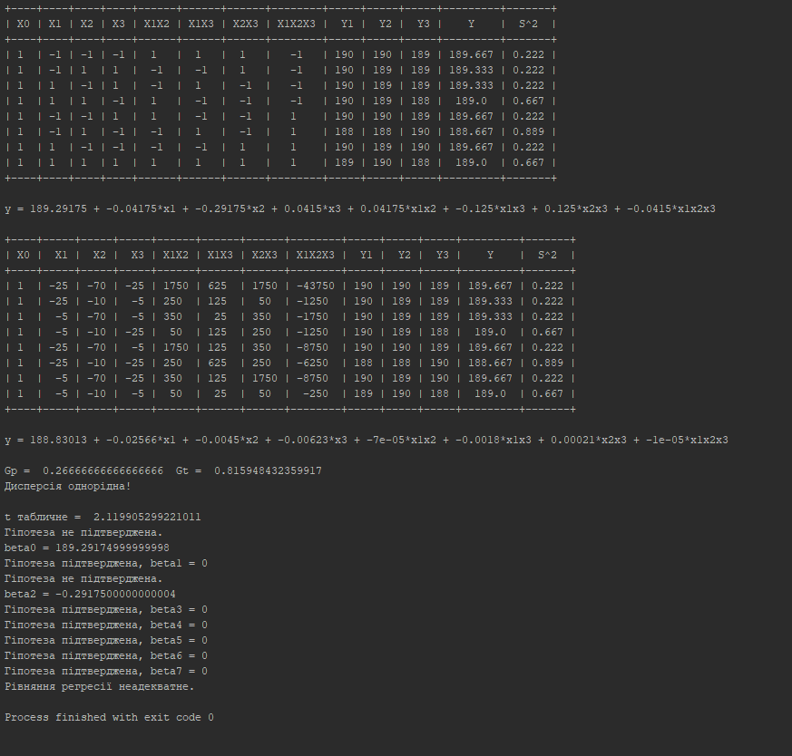

**Висновок:**

В даній лабораторній роботі я провела повний трьохфакторний експеримент з трьома статистичними