Limits of agreement with the mean (LOAM) for Woo et al.

Woo et al. have provided an open access dataset based on the diameters of 10 CT metastatic lesions measured by 13 observers (Woo et al. 2020). This dataset was supplemented by two additional datasets where increased and decreased measurement variability was simulated from the aforementioned dataset. For each of these three datasets, agreement plots as well as estimates and confidence intervals for the 95% reproducibility limits of agreement with the mean (LOAM) and the subject, observer, and residual standard deviation components from the underlying two-way random effects model (see Christensen et al. 2020) can be found in the following.

## The three datasets

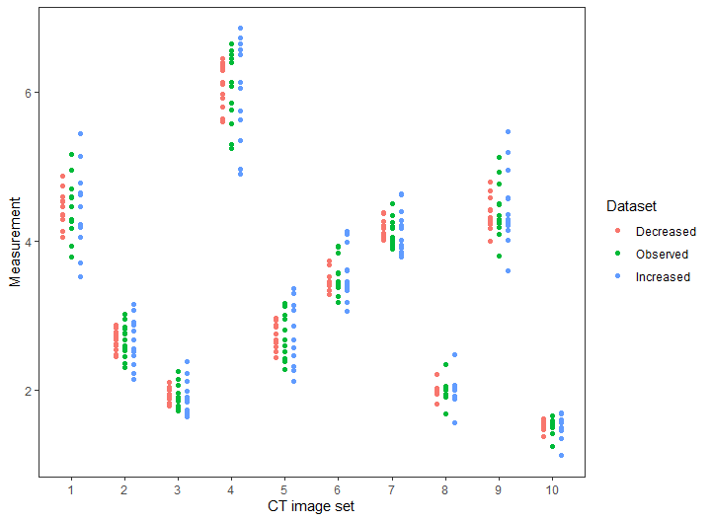

Plot of the ‘measurements’ from each of the three datasets.

## Agreement plots

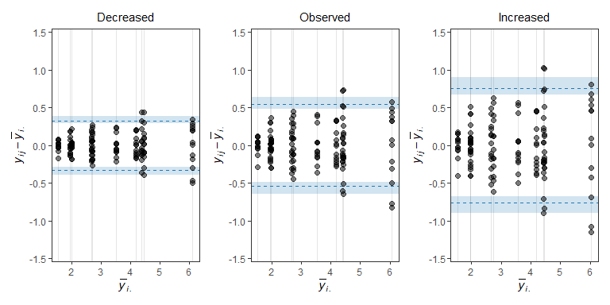

Agreement plots with estimates (dashed line) and 95% CIs (shaded regions) for the 95% reproducibility LOAM from Christensen et al. (2020).

## Estimates and CIs

Estimates and 95% CIs for the upper 95% reproducibility LOAM and the standard deviation components for subject, observer and residual variation (, , and , respectively) from the two-way random effects model in Christensen et al. (2020).

| Dataset | LOAM (CI) | (CI) | (CI) |  |
| --- | --- | --- | --- | --- |
| Decreased | 0.32 (0.29, 0.39) | 1.43 (0.77, 2.1) | 0.05 (0.01, 0.1) | 0.16 (0.14, 0.19) |
| Observed | 0.54 (0.48, 0.64) | 1.43 (0.77, 2.09) | 0.09 (0.02, 0.16) | 0.27 (0.24, 0.31) |
| Increased | 0.76 (0.67, 0.9) | 1.43 (0.76, 2.09) | 0.13 (0.03, 0.22) | 0.38 (0.34, 0.44) |

# References

Christensen, Heidi S, Jens Borgbjerg, Lars Børty, and Martin Bøgsted. 2020. “On Jones Et Al.’s Method for Extending Bland-Altman Plots to Limits of Agreement with the Mean for Multiple Observers.” *BMC Medical Research Methodology* 20 (1).

Woo, MinJae, Moonseong Heo, A Michael Devane, Steven C Lowe, and Ronald W Gimbel. 2020. “Retrospective Comparison of Approaches to Evaluating Inter-Observer Variability in CT Tumour Measurements in an Academic Health Centre.” *Nature Materials* 11 (4).