Christopher Jones

Development Environment Configuration

Filezilla Structure:

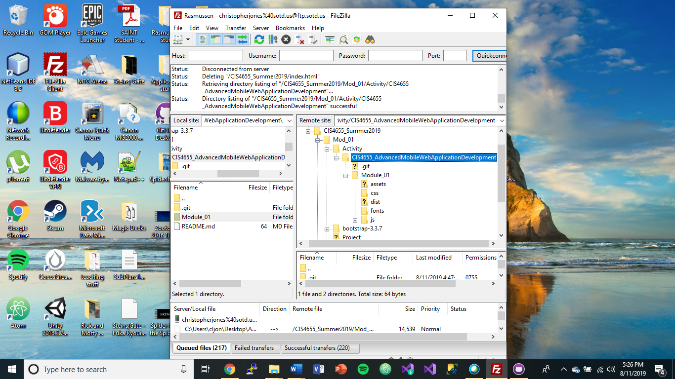

Local file structure in Atom

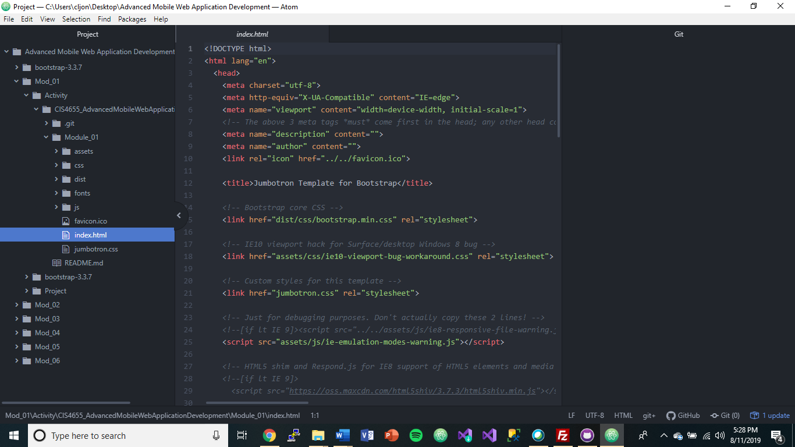

SOTD URL:

<http://sotd.us/christopherjones/CIS4655_Summer2019/Mod_01/Activity/CIS4655_AdvancedMobileWebApplicationDevelopment/Module_01/>

My URL Screenshot

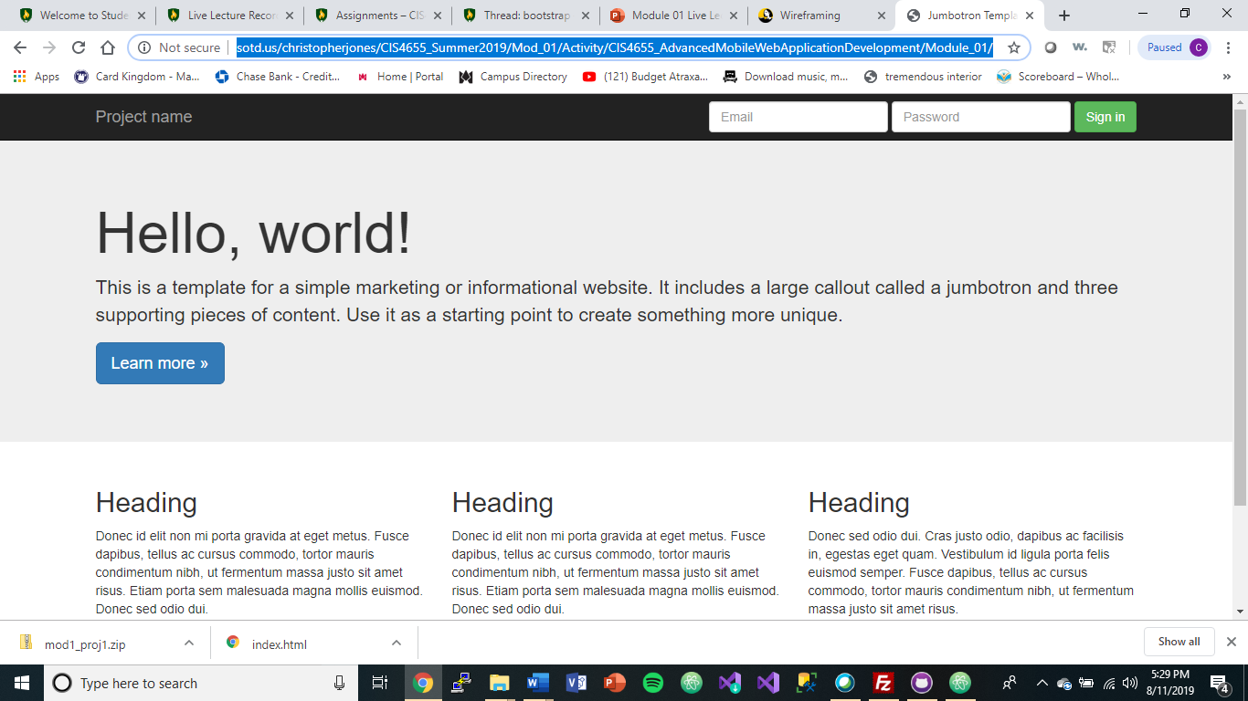

Github Repository URL

<https://github.com/CLJones051989/CIS4655_Summer2019/tree/master/Module_01>