Mod 3 Activity

Github:

<https://github.com/CLJones051989/AdvMobWebAppDev_Summer2019/tree/master/Mod_03/Activity/WebPage>

Webpage URL:

<http://sotd.us/christopherjones/CIS4655_AdvancedMobileWebApplicationDevelopment/Mod_03/Activity/WebPage/MockPage.html>

Screencaps:

Laptop

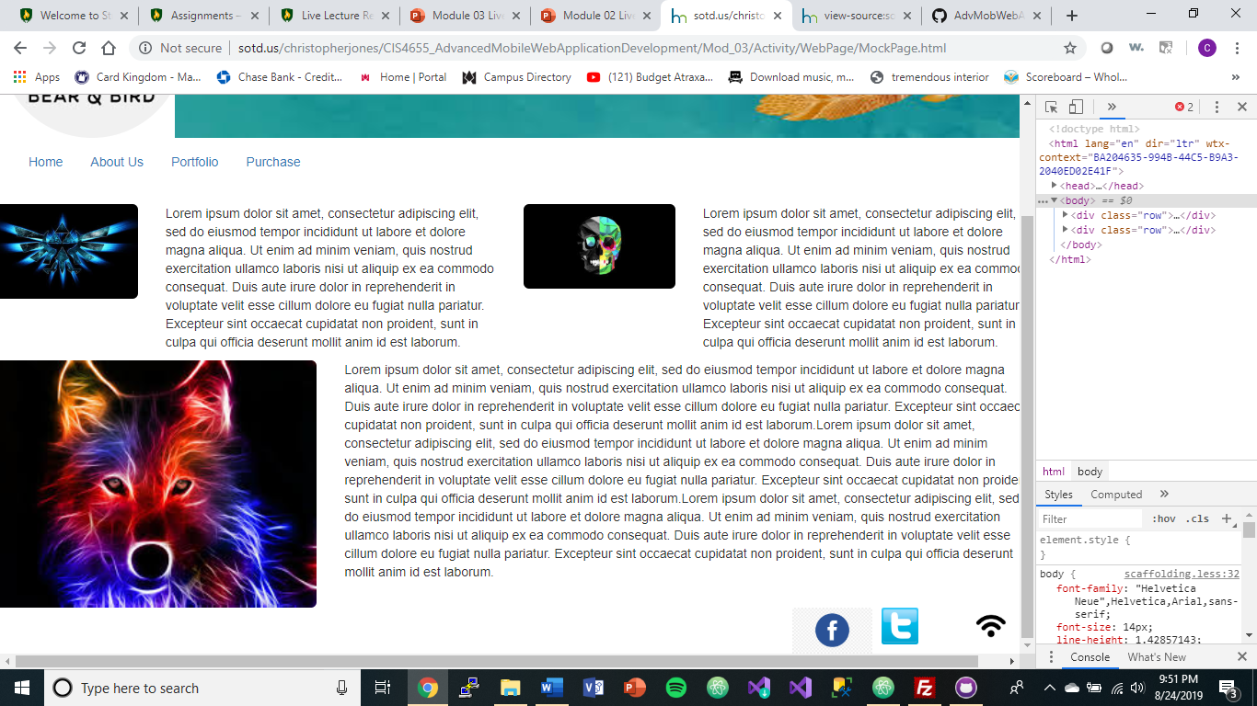

Pixel 2XL

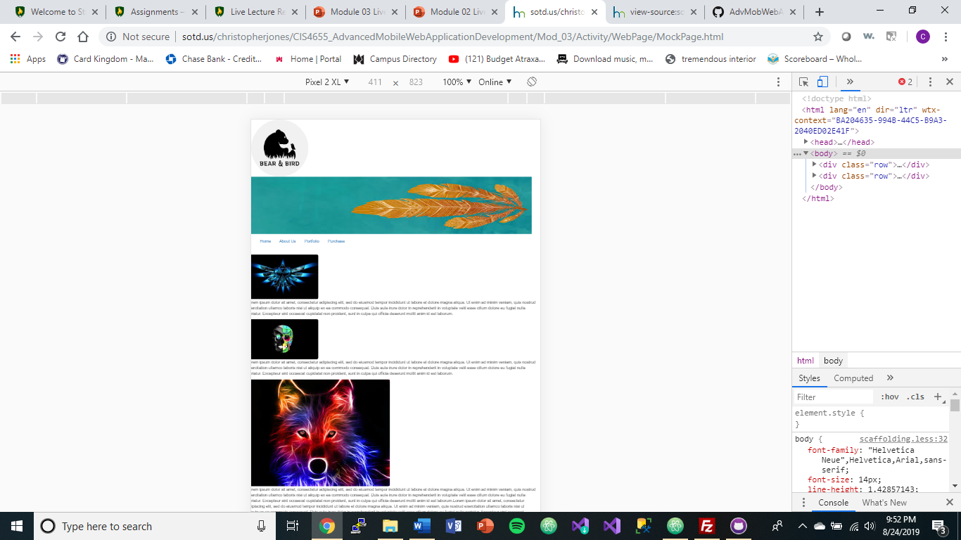

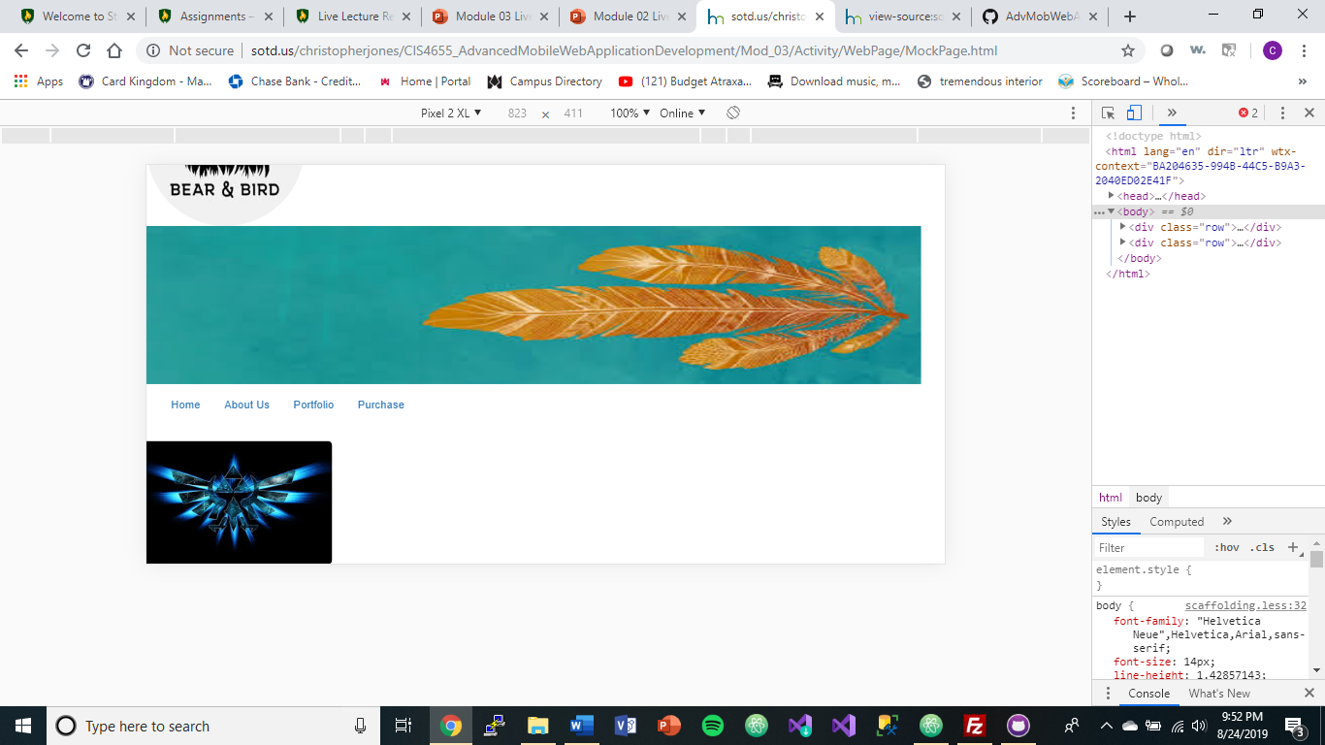

iPhone X

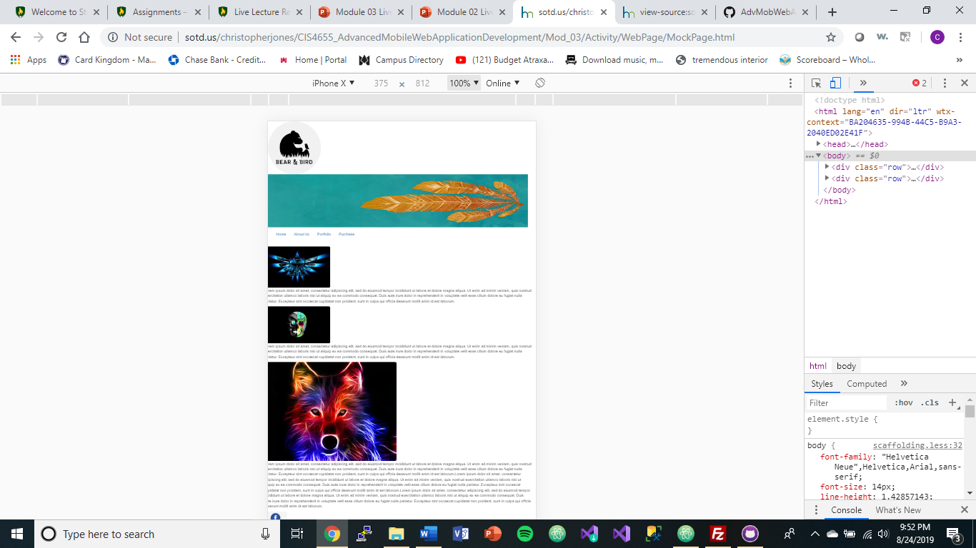

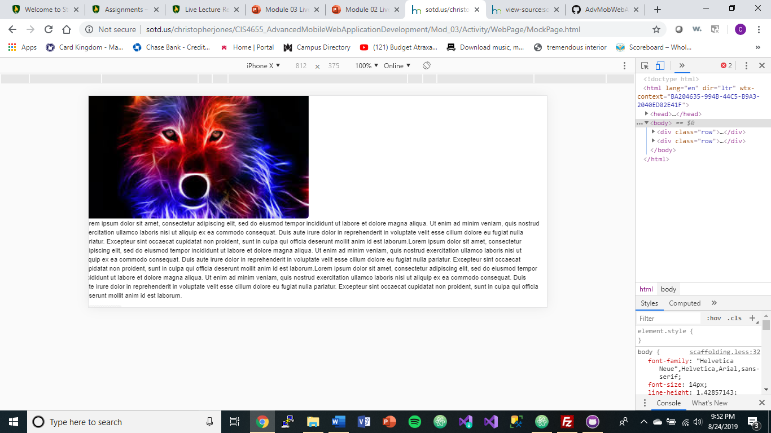

iPad

