Module 4 Project

08/31/2019

Christopher Jones

Github:

<https://github.com/CLJones051989/AdvMobWebAppDev_Summer2019>

Web URL:

<http://sotd.us/christopherjones/CIS4655_AdvancedMobileWebApplicationDevelopment/Mod_04/Project/MockPage.html>

Screenshots:

Pixel 2

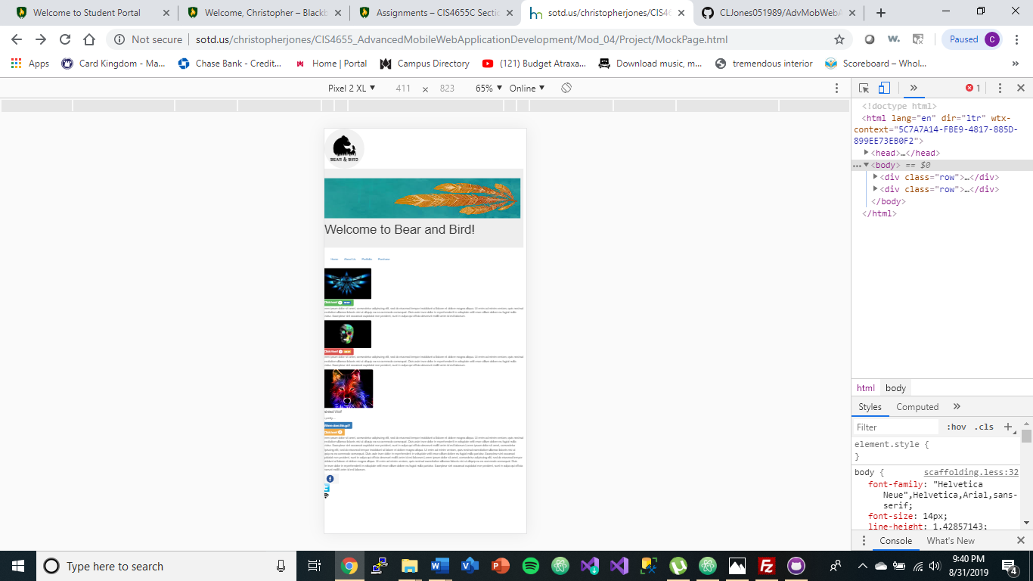

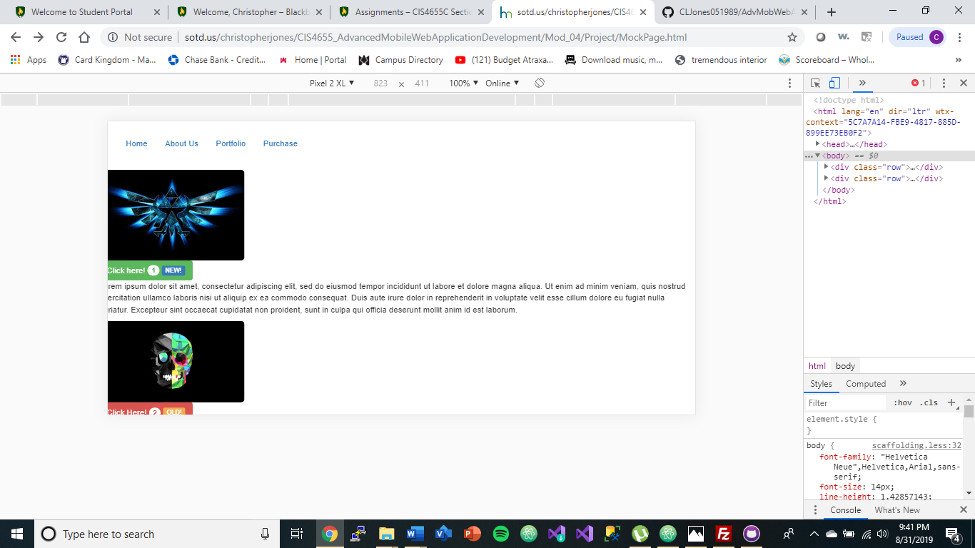

Galaxy S5

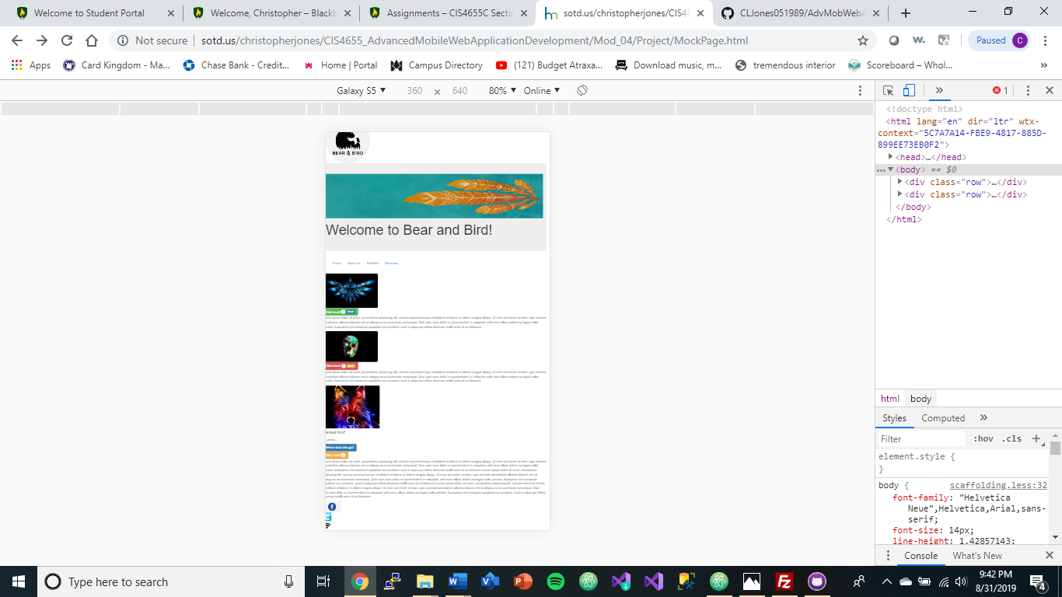

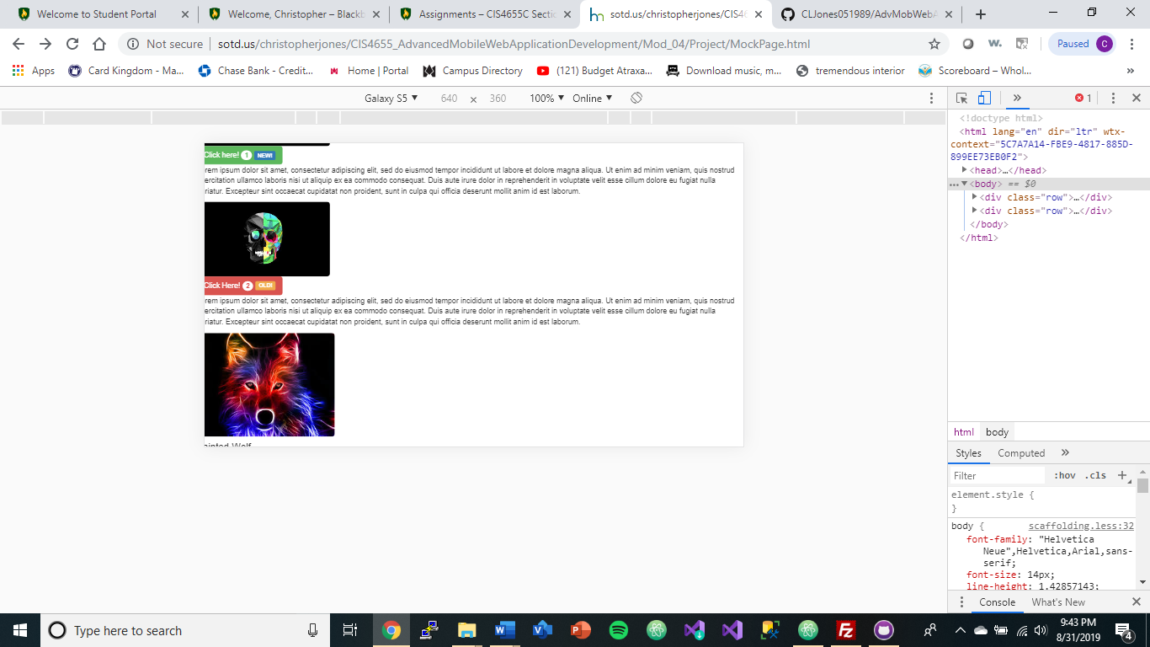

iPhoneX

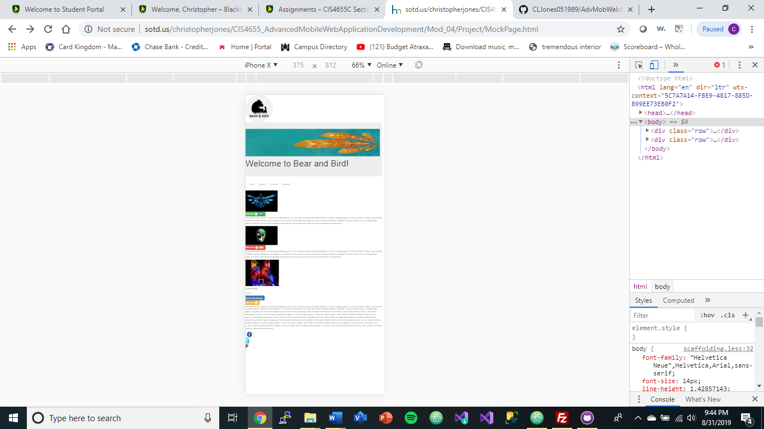

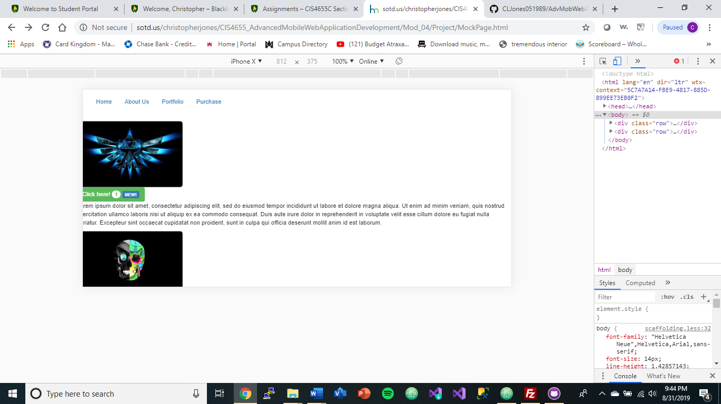

iPad

