Mod 3 Project

Christopher Jones

8/25/19

Website URL:

<http://sotd.us/christopherjones/CIS4655_AdvancedMobileWebApplicationDevelopment/Mod_03/Project/AwesomeTunesHome.html>

Github:

<https://github.com/CLJones051989/AdvMobWebAppDev_Summer2019/tree/master/Mod_03/Project>

ScreenCaps:

Computer

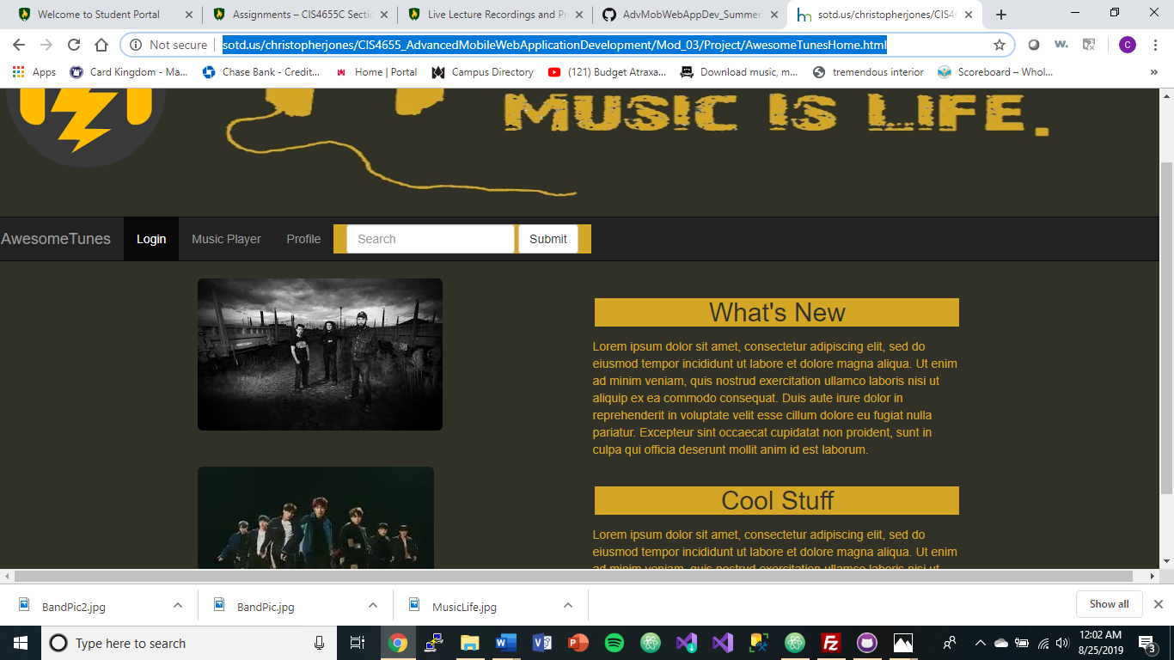

Pixel 2:

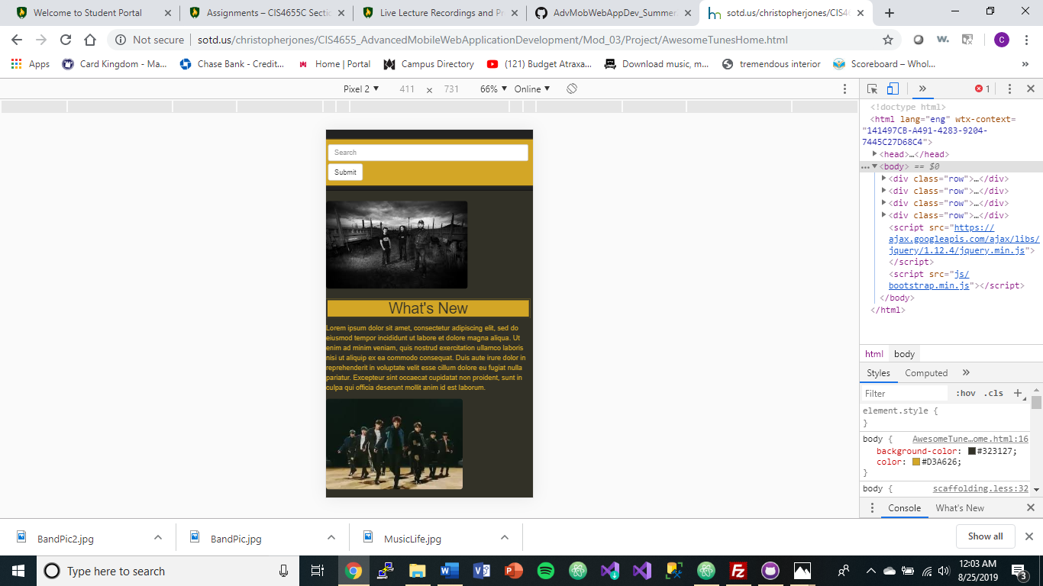

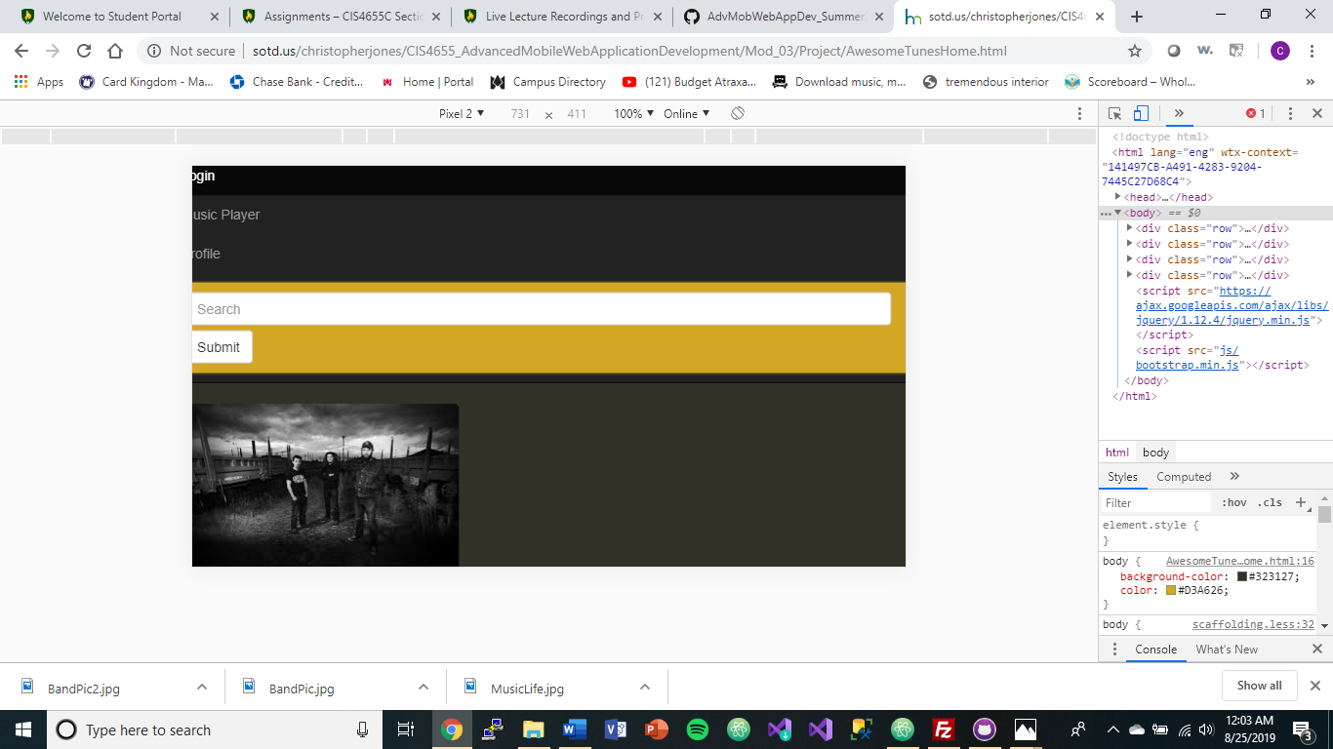

iPhoneX

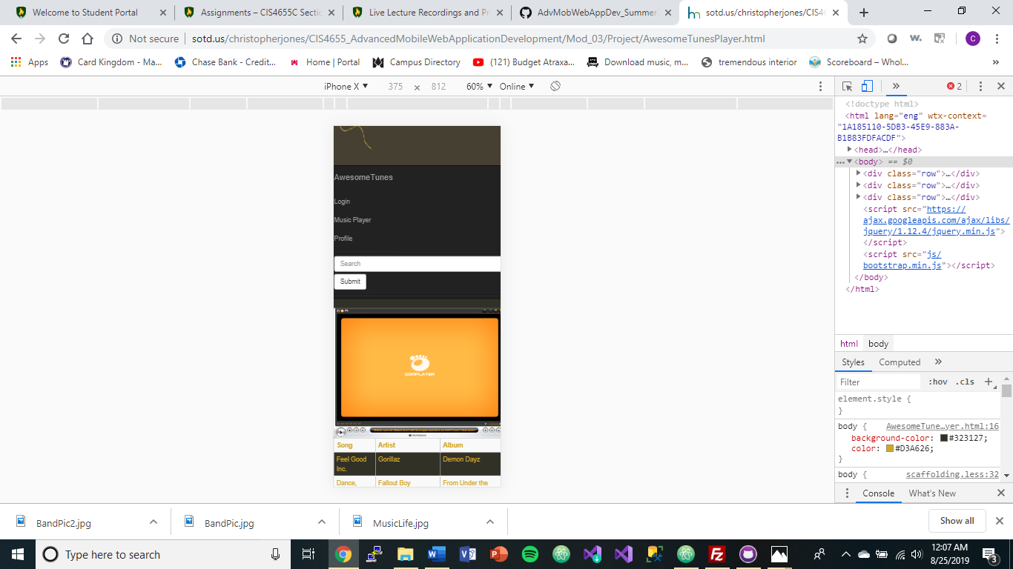

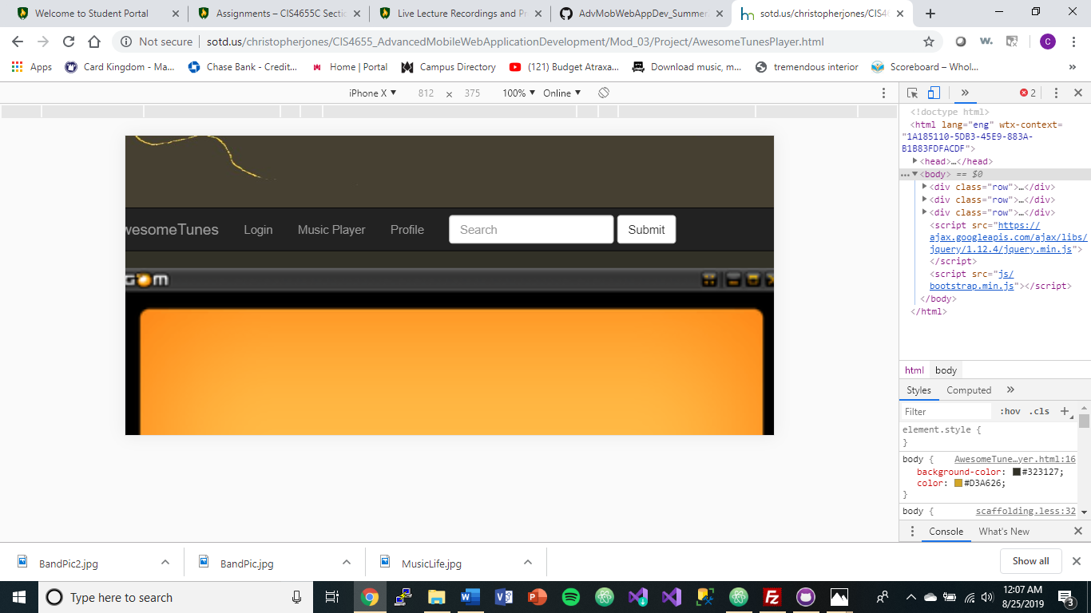

iPad

