Reality - ROOTCON 2020 Easter Egg Hunt

(by @katipuzer0)

Disclaimer: I am new to malware analysis so my approach for this problem is mostly by trial-and-error plus some ‘googling’. My target audience for this write-up are beginners so the text might be verbose. I started working on the problem on April 15 but I gave up because I cannot find the flag. I decided to document it today April 17 and luckily I was able to find the flag after repeating the steps! I used ABIWord for this write-up to save time.

In this problem, we are given a MS Excel file(topsecret.xls) that is possibly malicious. To the uninformed (like me), the initial thing to do is to open it in MS Excel. Better do this in a VM!

First my working folder for this problem. I used Windows 10 and Kali.

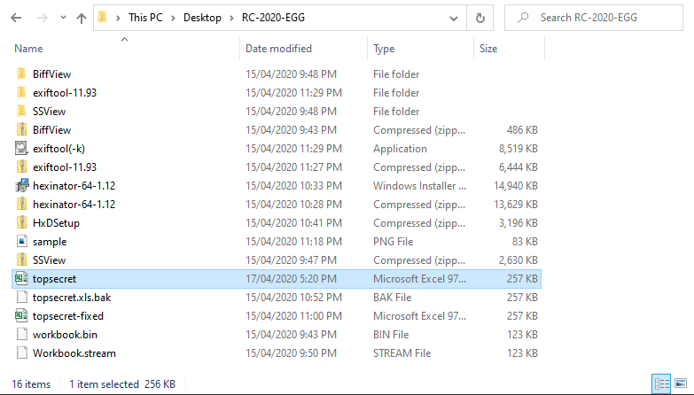

Figure 1.

This is how the spreadsheet looks like before I “enabled content”.

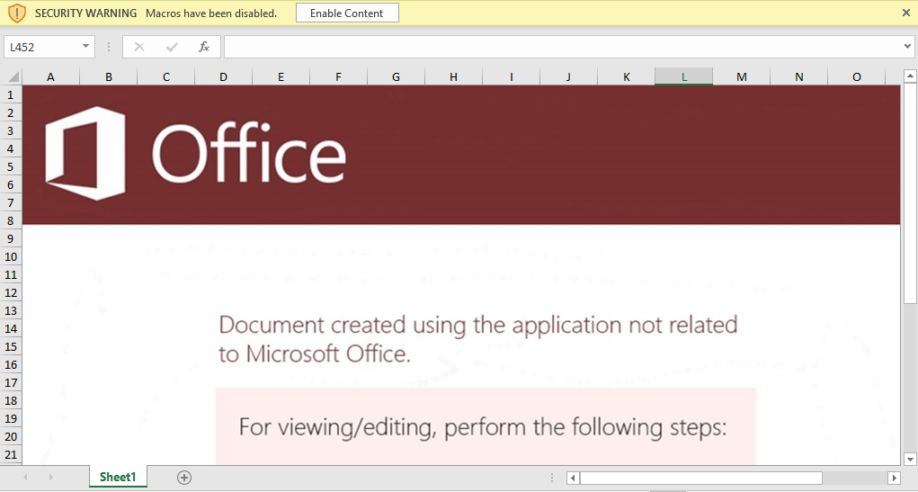

Figure 2.

After enabling the content, the calculator application appeared and a dialog box pops-up stating that the document cannot be opened. From this, we can infer that there is something fishy going on.

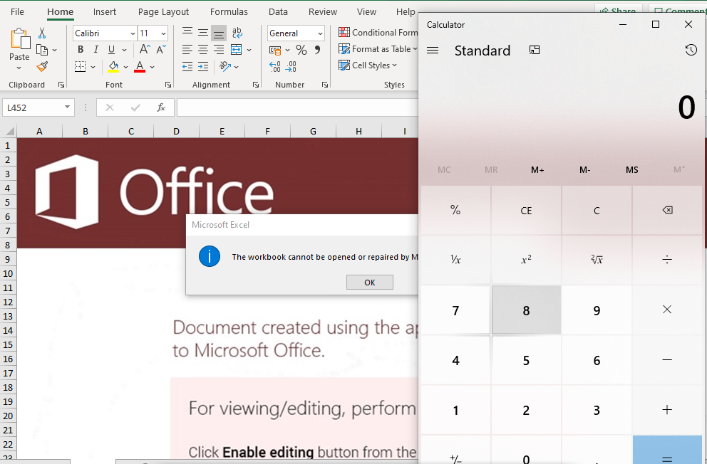

Figure 3.
Time to try some linux OLE tools [1][2]. I admit I have limited knowledge of OLE.

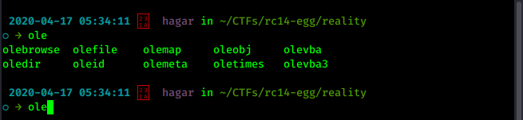

Figure 4.

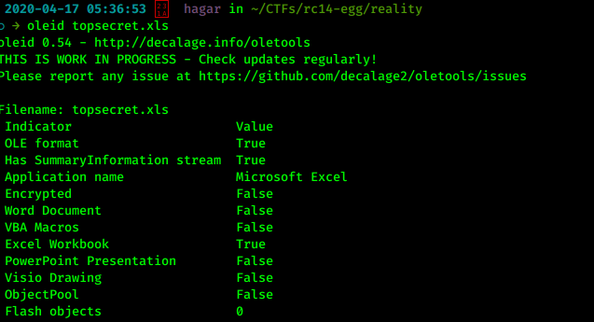

Figure 5. oleid

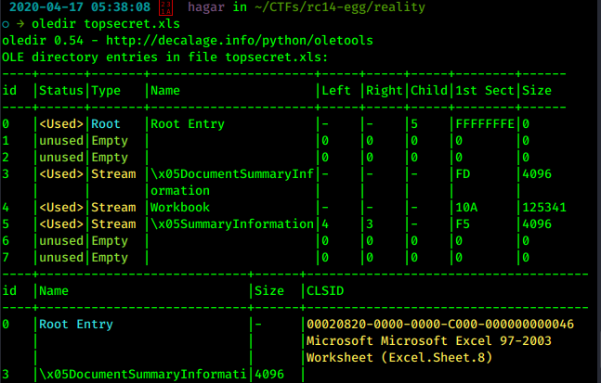

Figure 6. oledir

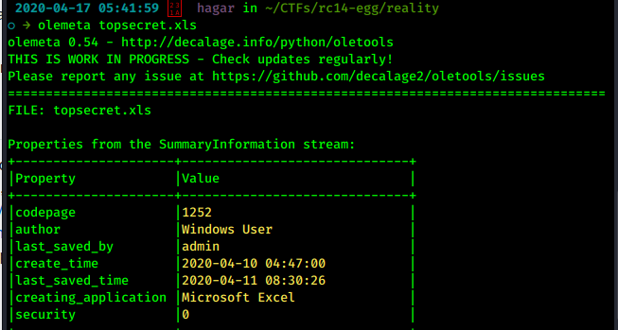

Figure 7. olemeta

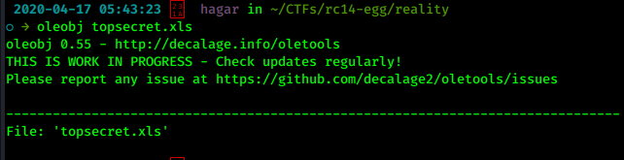

Figure 8. oleobj

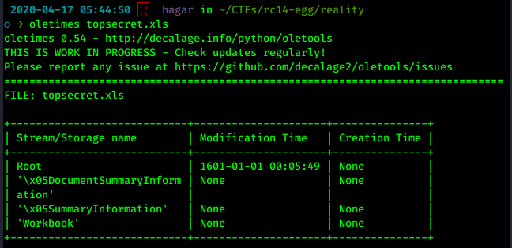

Figure 9. oletimes

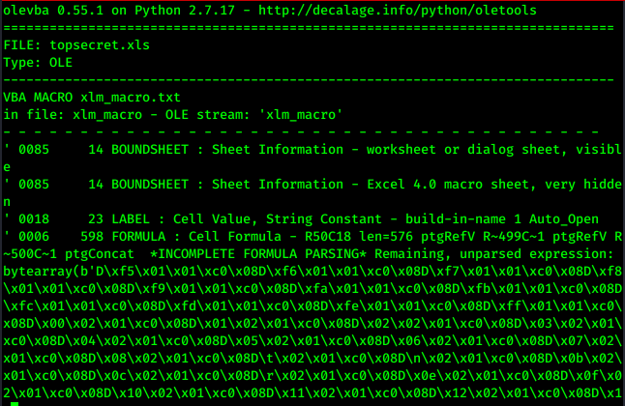

Figure 10. olevba (1)

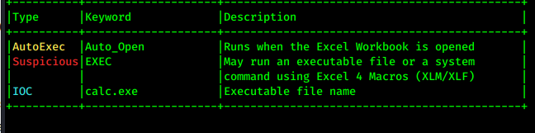

Figure 11. olevba (2)

So the document has some code in it that executed calc.exe. At this point I have no idea how to proceed so I searched for some online resources about malware in documents and I came across this blog post [3](Read this first!) The excel document given in this problem is very similar to the one discussed in this post.

I installed the necessary tools(Figure 1): BiffView, SSView, HxD. My key takeaway from [3] is that there is a hidden sheet in the workbook. We need to be able to access this sheet and see its contents. Observe that in Figure 2, there is only one sheet. However, in the olevba output there are two “BOUNDSHEET” entries with one marked as “very hidden”.

I opened the document in BiffView++.

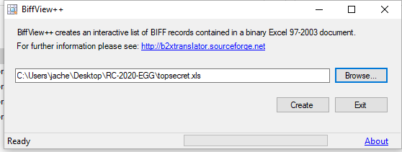

Figure 12.

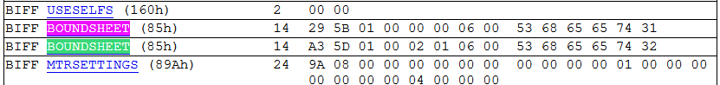

Figure 13.

The one in green is the hidden sheet because its hsState is 0x2, its offset is at 0x00015DA3 based on the discussions in [3]. We open the document in HxD and searched for the offset values.

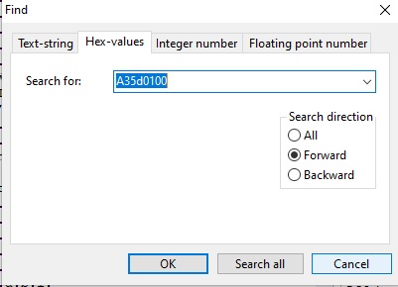

Figure 14.
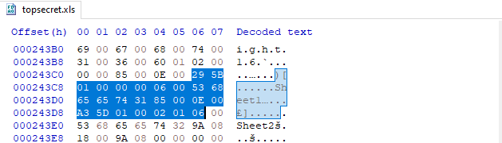

Figure 15.

We change the value from 0x2 (very hidden) to 0x0 (visible) then save the document.

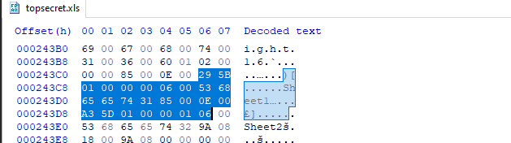

Figure 16.

Yay! We can now see Sheet2.
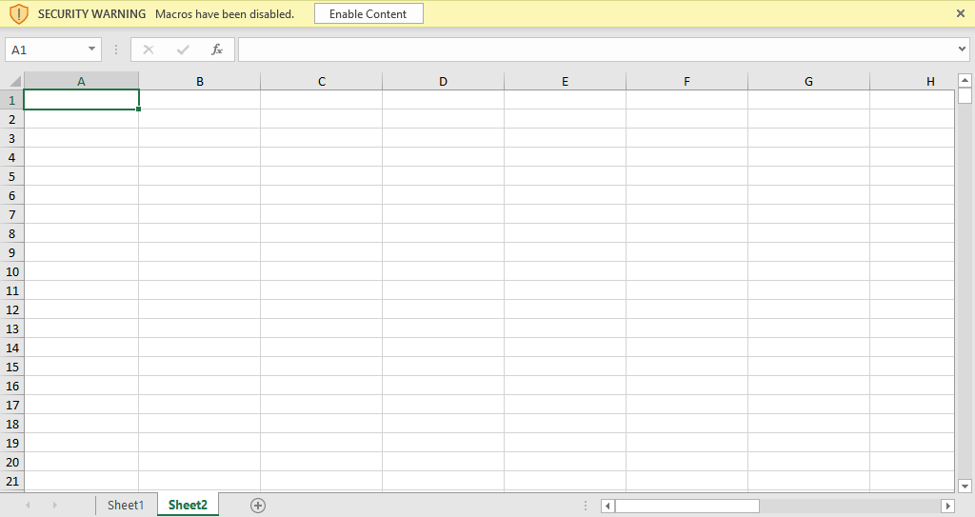
Figure 17.

Going back to the output of olevba (Figure 10), we go to cell R50C18 and here’s what we get.

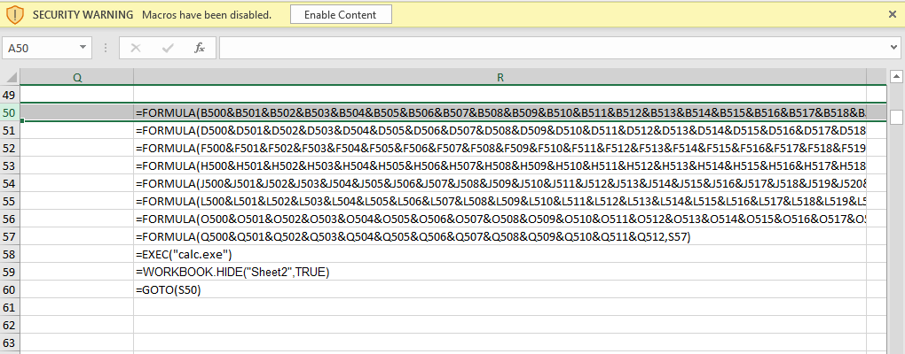

Figure 18.

If we go to B500 we get the following:

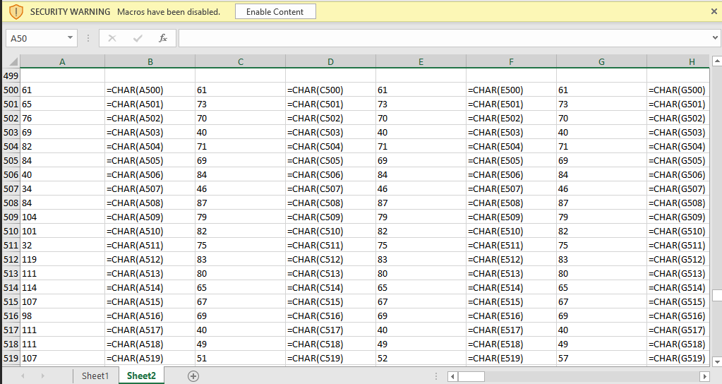

Figure 19.

In order to execute these code snippets, I created a new document and copy-pasted the cell values.
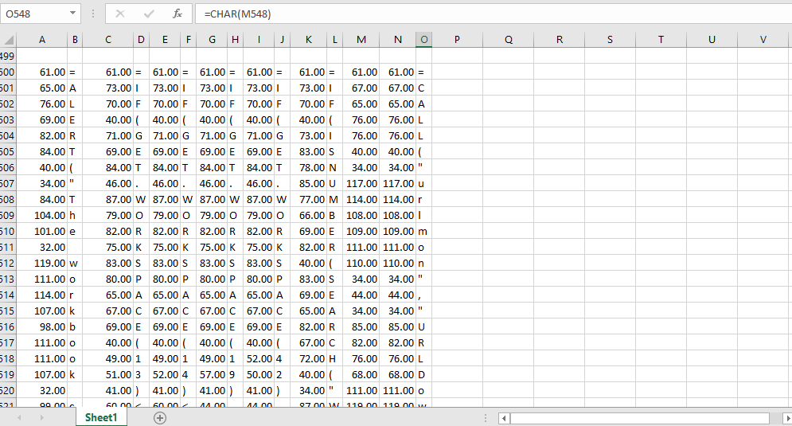

Figure 20.

Examining column O, it is a code fragment(vertically organized) that downloads something from rootcon.net so I extracted the URL parameter and pasted it in the browser. Originally I saved it as is (text file) but it was actually a binary file.

(Note: If this is a real malware doc, my machine could have been compromised already since I opened it in my main machine without an AV product! Anyways..)

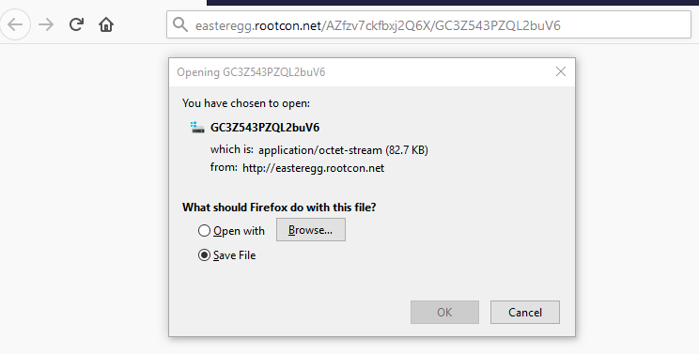
Figure 21.

I tried saving it as .png and here is what I got.

Figure 22.



Figure 23.

I noticed that the column M is used as input to the code in column O. What about column N? It seems unused. So I copied column N to column M and a different url is accessed.

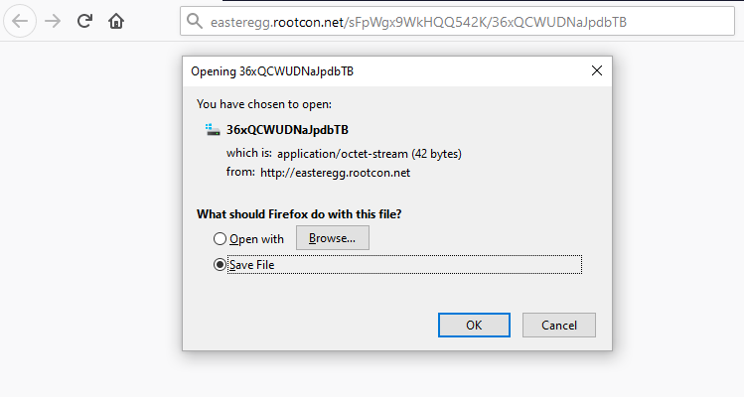
Figure 24.

And there goes the flag!

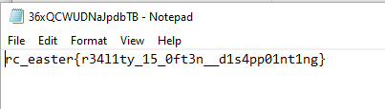

Figure 25.

References:
[1] https://github.com/decalage2/oletools
[2] https://blog.didierstevens.com/programs/oledump-py/
[3] https://inquest.net/blog/2019/01/29/Carving-Sneaky-XLM-Files

