**CREATE VIRTUAL ENVIRONMENT – 22/09/2020**

1. Make sure you have Anaconda installed. If you don’t, go to

<https://www.anaconda.com/products/individual>

1. Open the **Anaconda prompt**. You see this black screen:

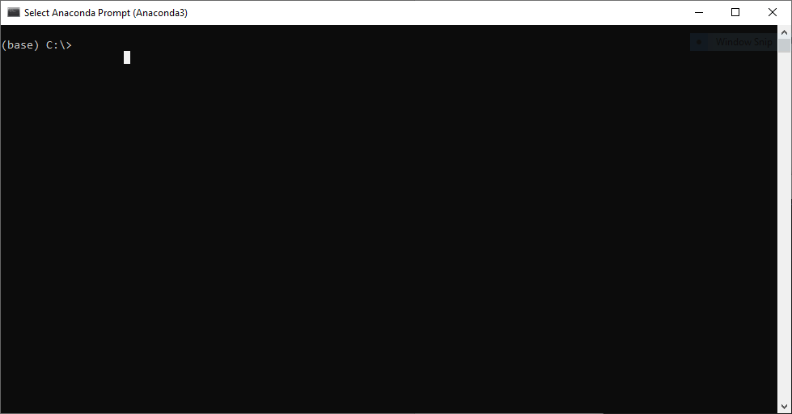

1. To go to the drive with code (the M- Staff Groups drive), type M: and press enter.
2. Move to your personal folder by typing

cd tnw/BN/dm/Shared/Lukas/Lukas vd Heuvel

and press “Enter”.

1. If you have a file with the requirements of your environment, run

conda env create -n tenv -f tenv_requirements.yml

Note: tenv stands for tensorflow-environment.  
Creating the environment will take a few minutes. When all the packages are installed, run conda activate tenv and continue to step 8.

1. If you don’t have the .yml file, create the environment by running

conda create –name myenv. After a short while, enter y to continue.

Then activate the environment:

conda activate myenv

1. Install the necessary libraries:

conda install numpy (for general scientific computing)

conda install –c conda-forge jupyterlab (for jupyter notebook)

conda install –c anaconda spyder (for spyder IDE, Integrated Development Env.)

conda install –c conda-forge scikit-image (for image processing)

conda install pyqt (for binding to C++)

conda install –c conda-forge llvm-openmp (for binding to C++)

conda install –c numba numba (for decoration, i.e. faster code performance)

conda install –c anaconda pandas (for reading xlsx files)

conda install xlrd (for reading xlsx files)

1. Type spyder and press enter. This will open the spyder console.
2. Open a code in spyder by dragging a .py file into the spyder console.
3. If you run a code, you may get the following error:

TypeError: handle_get_file_code() got an unexpected keyword argument 'save_all'

This is likely solved by closing spyder, and then de-installing spyder and installing it again:

conda deinstall spyder

conda install spyder

1. You are now ready to use the python image processing code. Make sure you activate the virtual environment every time you start using the code.