**STITCHING BASED ON MIST  
10/03/2021 | Lukas van den Heuvel**

This is a guide for stitching overlapping image tiles using MIST (Microscopy Image Stitching Tool).

**Contents**

1. Installation
2. Prepare tiles using the macro 1_prepareTilesMIST
3. MIST plugin
4. Stitch tiles using the macro 2_stitchMIST

**Installation**

1. Install / update Fiji.

Install: <https://imagej.net/Fiji/Downloads>

Update: Open Fiji and press Help > Update ImageJ.

**Important:** Make sure to do this update, the macros will only run on ImageJ **v1.53h** or higher!

1. Install the MIST plugin:  
   Go to Help > Update… > Manage update sites, check the MIST checkbox,

and press Close > Apply changes.

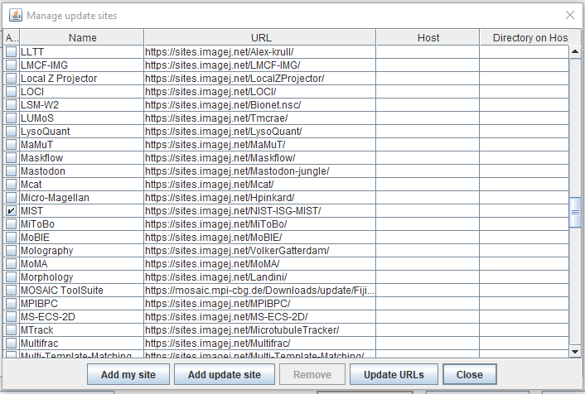

Once you restarted ImageJ, you are ready to use the MIST plugin.

**Prepare tiles using the macro 1_prepareTilesMIST**

**Macro:** 1_prepareTilesMIST.ijm  
**Input:** A directory with images created by the HCA (raw folder). Example of image filename: MFGTMP_201022140001_B03f00d0.tif

The number after “f” denotes the position of the tile in a **spiral grid**. The number after “d” denotes the channel number.

**Output:** Well folders (one for each well) inside the root folder. These well folders contain tiles and thresholded tiles. The template for tile names is:

tile_{ppp}_ch{t}.tif

where ppp is the position of the tile in a **column grid** and t is the channel number.

**Running:**

In the first screen you enter the basic parameters. You will get error messages if the wells are not found in the raw folder. Also, you will get error messages if the number of channels or the width/height of the fused image does not match the number of images found in the input well folders.

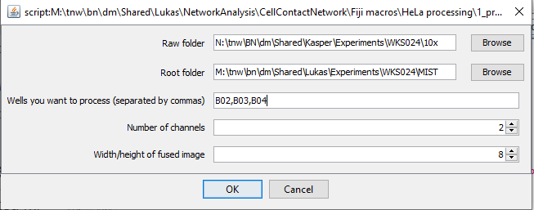

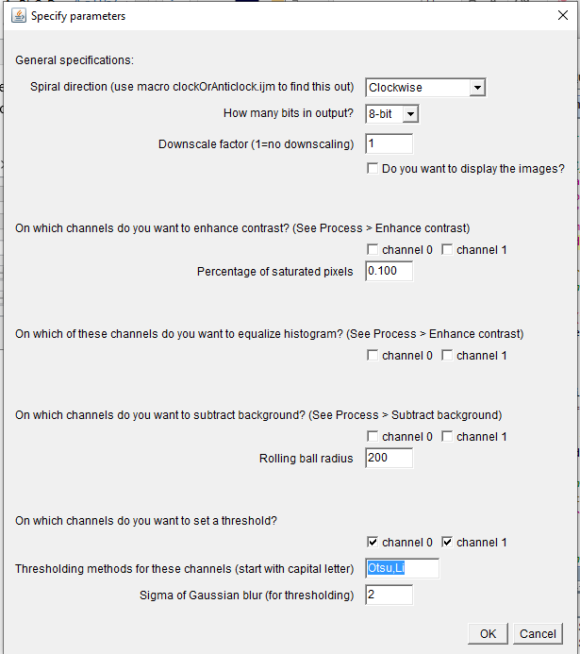

In the second channel screen you can enter additional parameters. Importantly, the HCA seems to be inconsistent about the direction of the spiral (either clockwise or anticlockwise). Use the macro 0_clockOrAnticlock.ijm to find out whether the spiral direction is clockwise or anticlockwise.

**The operations (downscaling, contrast enhancement, background subtraction and blurring+thresholding) are done in the order in which they appear on this dialog**. Test these operations on individual tiles before you run this macro.

Overview of spiral grid (clockwise) and column grid for 10x and 20x magnification:

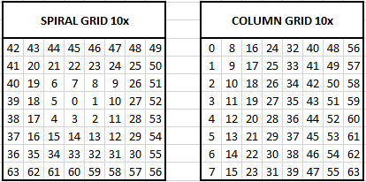

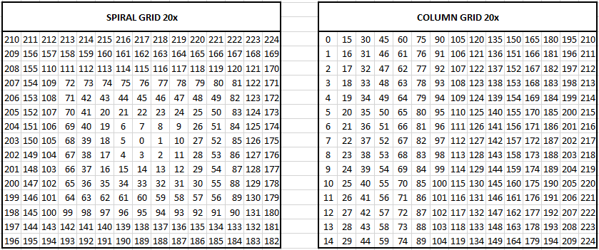

**MIST Plugin**

This is a stitching tool based on Fourier-based translation. For information and publications, see  
<https://pages.nist.gov/MIST/>

Also, see the MIST documentation on Github:  
<https://github.com/USNISTGOV/MIST/wiki/User-Guide>

I highly recommend trying out the plugin yourself, before using the macro (see below. You can find it here: Plugins > Stitching > MIST

The important parameters to change are under the tabs “Input” and “Advanced”. Below, I highlighted three of them.

**Timeslices:** the channel(s) you wish to stitch. Note that MIST can only calculate 2D overlaps, so when you run MIST for the first time on this image, you can only enter one number here. Once you have calculated the overlaps in one channel (say, channel 1), you can stitch the remaining channels based on the image coordinates of channel 1.

Example: you have 4 channels (ch 0-3), and you wish to calculate the overlaps based on channel 1. The other channels will then be stitched based on the coordinates of channel 1. You now need to run the MIST plugin twice:

First run:

* Timeslices = 1
* Leave the “Assemble from metadata” check button unchecked.

Copy the outputted file img-global-positions-1.txt once for each channel, to get   
img-global-positions-0.txt, img-global-positions-2.txt, and img-global-positions-3.txt

Second run:

* Timeslices = 0,2,3
* Check “Assemble from metadata”.
* Global Positions File: path/to/positions/files/img-global-positions-{t}.txt

The macro 2_stitchMIST.ijm will do these steps automatically for you.

**Horizontal / Vertical overlap** (under “Advanced”): Estimation of the overlap % between the tiles. I recommend 3%, but encourage you to vary this number and see what happens.

**Overlap uncertainty** (under “Advanced”): This number should be strictly smaller than the Horizontal/Vertical overlap, otherwise you’ll get “gaps” in the stitched image.

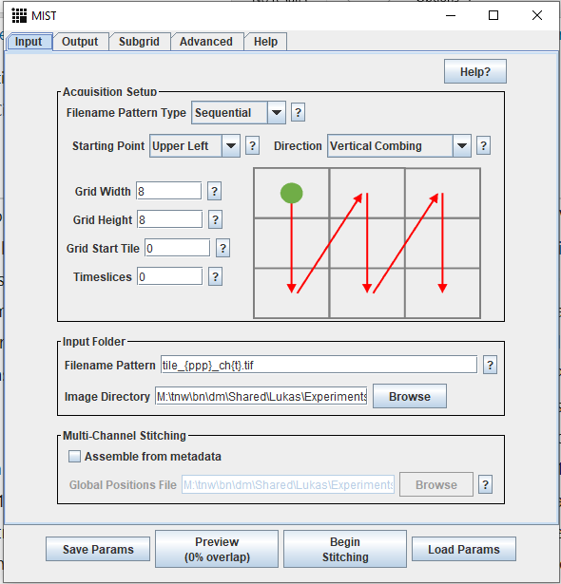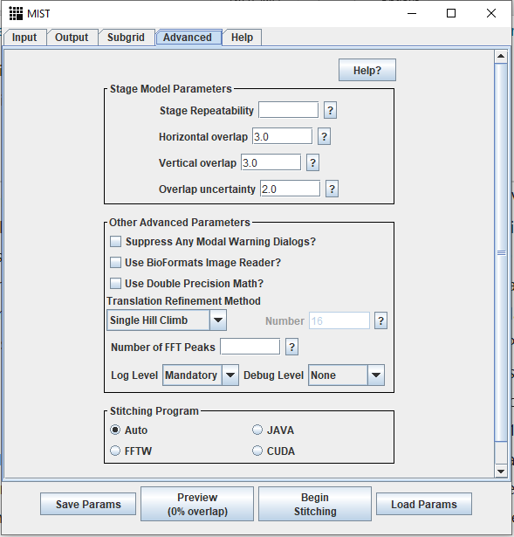

**Stitching using the macro stitchMIST**

**Macro:** 2_stitchMIST.ijm  
**Input:** Prepared tiles created with the macro 1_prepareTilesMIST.ijm.  
**Outputs:**

* Multi-channel image <well>_fused.tif stored inside the well folder.
* 8-bit RBG image <well>_fused_RGB.tif.
* Fused grayscale images, one for each thresholded channel.
* Text files containing the coordinates of tiles in the fused image.

**Running:**

In the first screen you enter the basic parameters. Note that you can only stitch one well at the time.

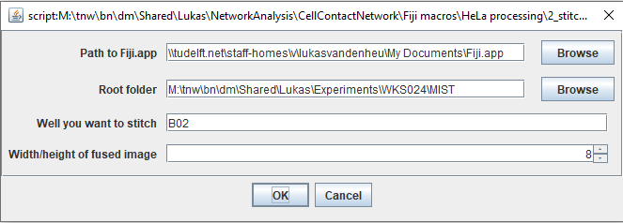

When you click OK, the macro will detect which channels and thresholded channels there are in the well folder you specified. You can choose which of these channels you want to stitch, and give names to the thresholded channels.

Note that you can only use one channel for calculating overlap (channel 1 in the example below). The remaining channels and the thresholded channels will be stitched based on the coordinates of this overlap channel. There is also the option to brute-force stitch.

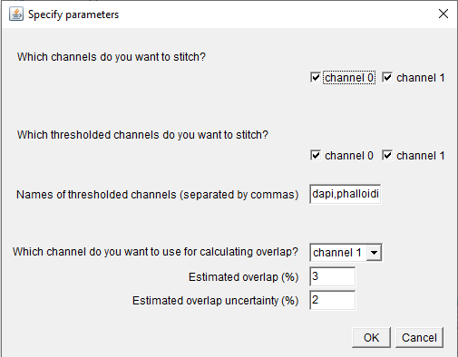

Once you click OK, the stitching will start. You can see the progress in the LOG window.