Mechanical Design

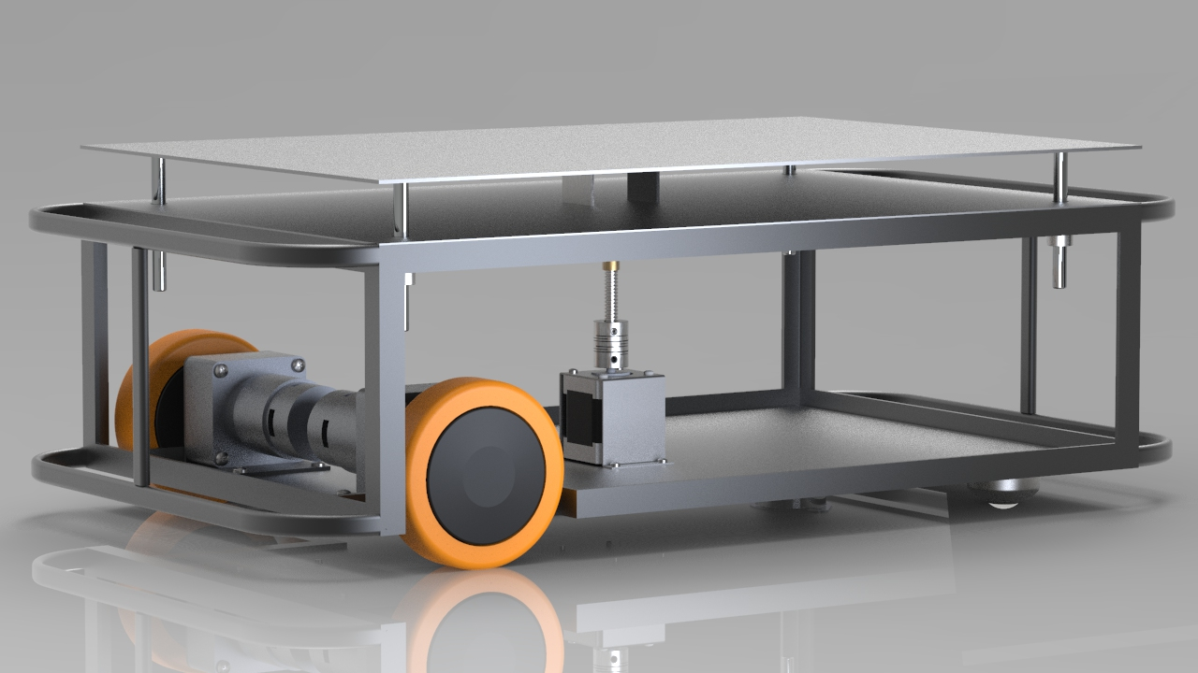

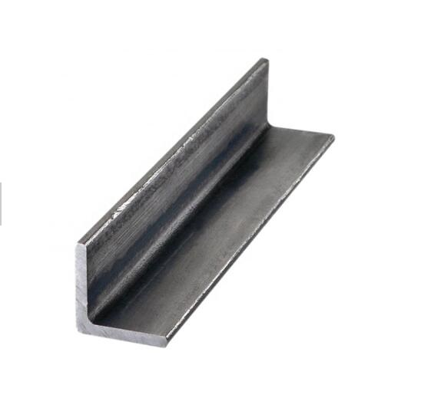**Chassis Design:**

Design the robot body chassis with steel structure to withstand heavy loads with regardless deformation. *L steel profile (Equal angle 15mm width, 3mm thickness)* is suitable for the robot because it is the smallest member in the market, which means lowest weight, and it gives the best results using Solidworks software simulation.

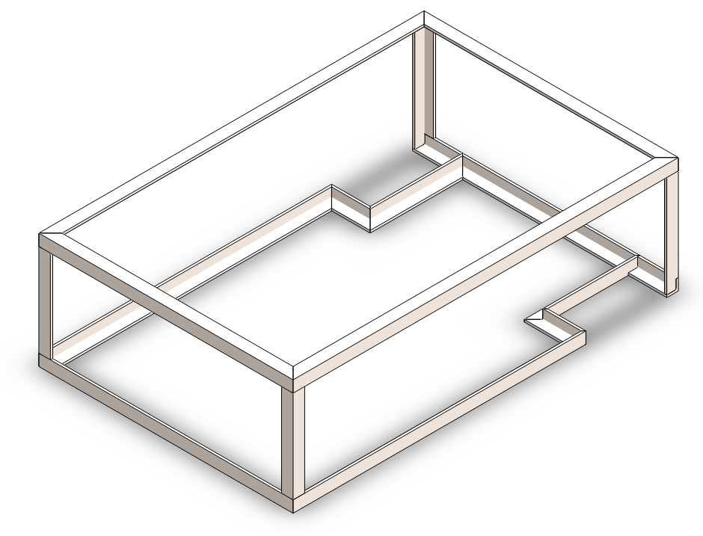

The drawings of the steel structure: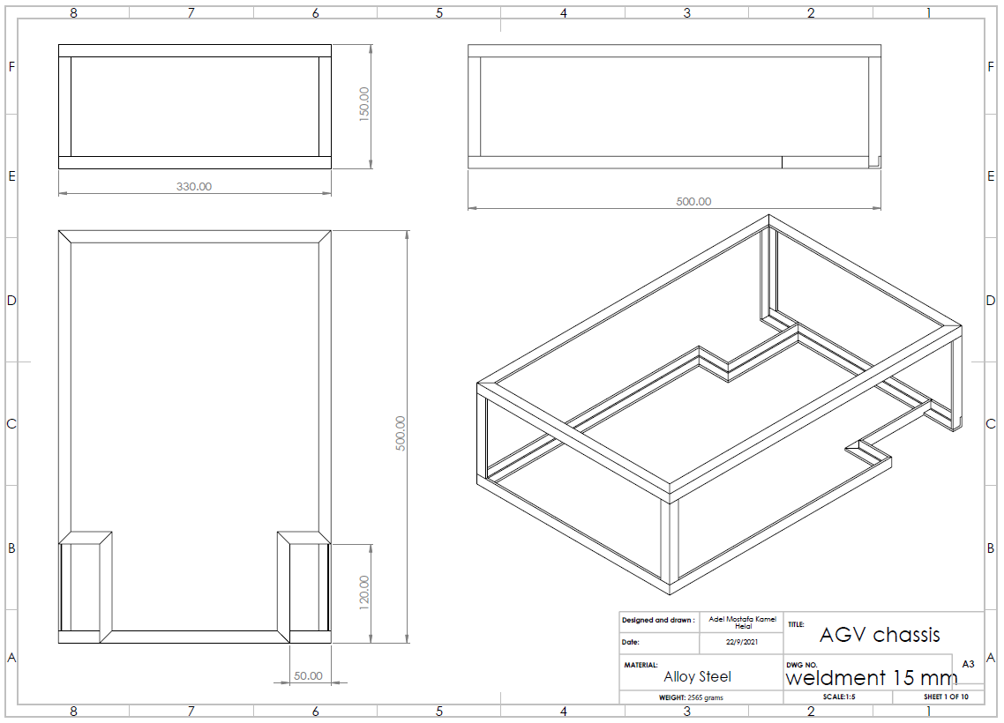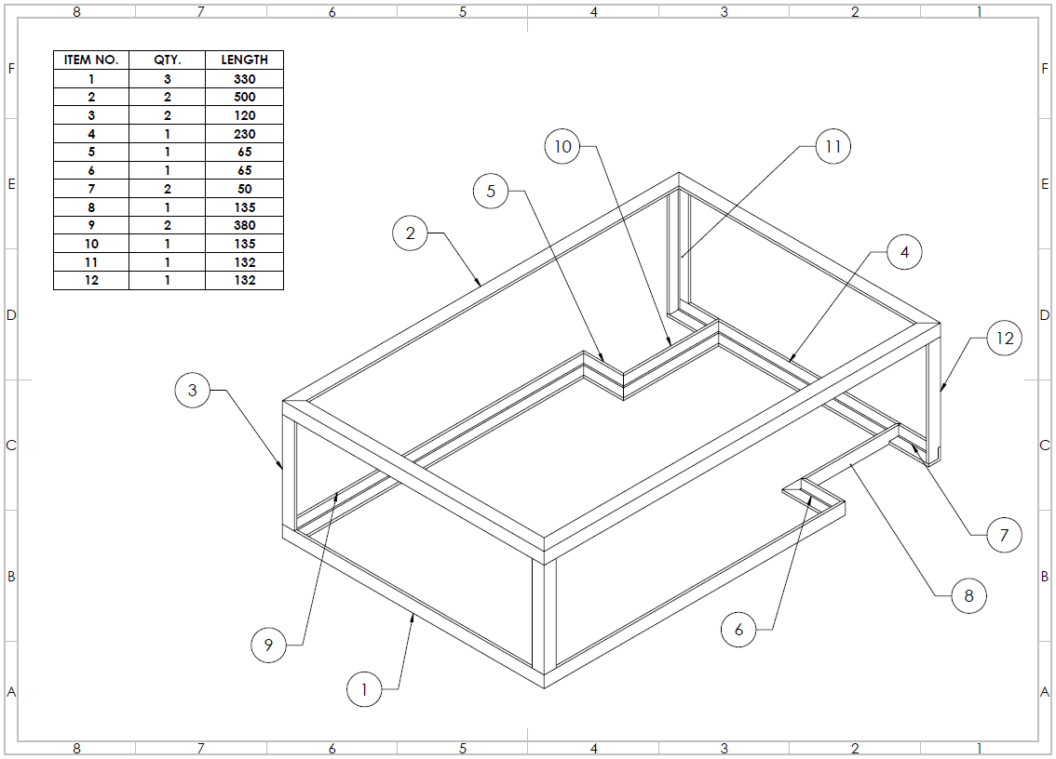

**The simulation results using Solidworks CAD software:**

With the full load the simulations results shows that the maximum resulted yield strenght equal 3.138 e+08 N/m^2, where the yeild strength of the steel is 6.204 e+08 N/m^2 which means that there is no temporary deformation of the stucture even it is a small deformation (0.11 e-1 mm).

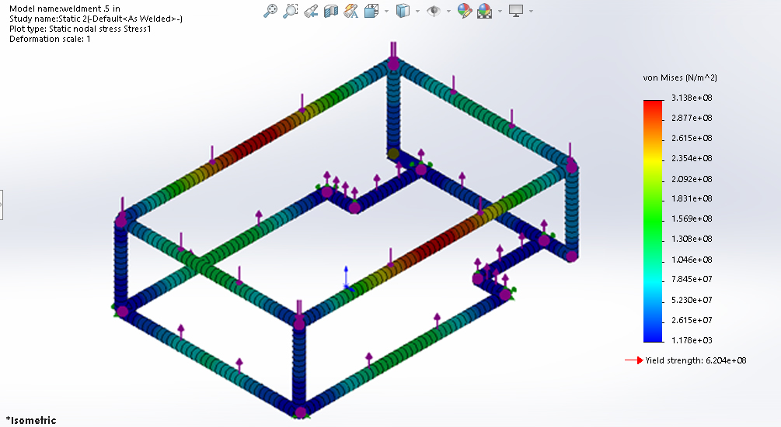

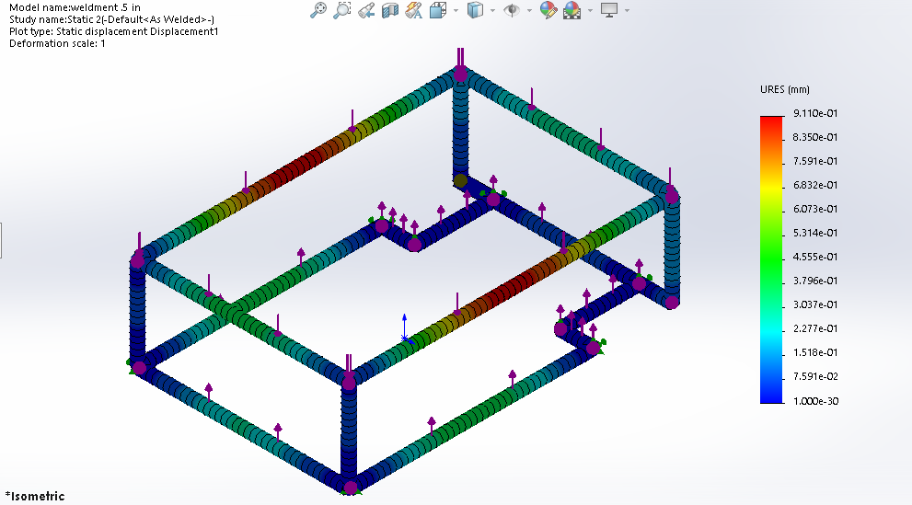

**The simulation of 1 mm sheet metal:**

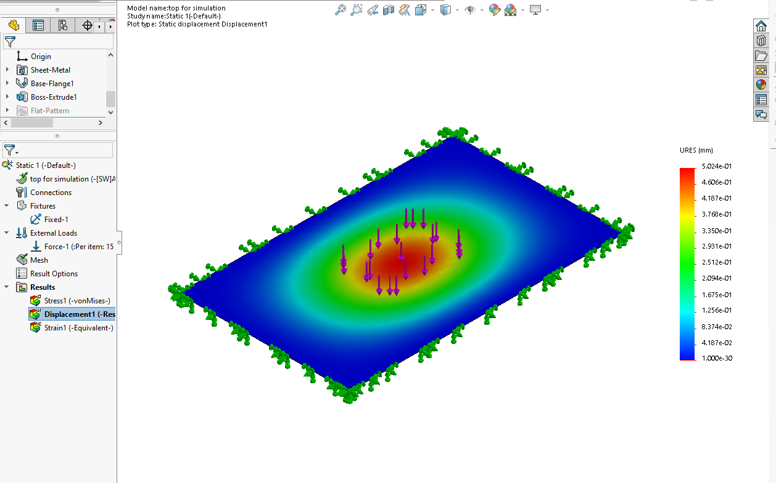

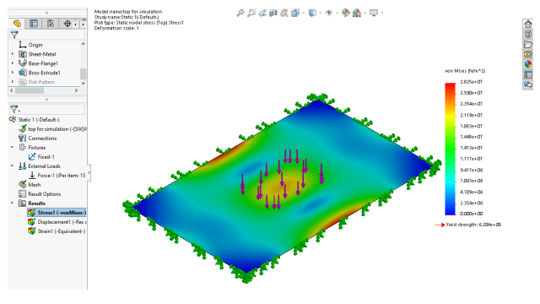

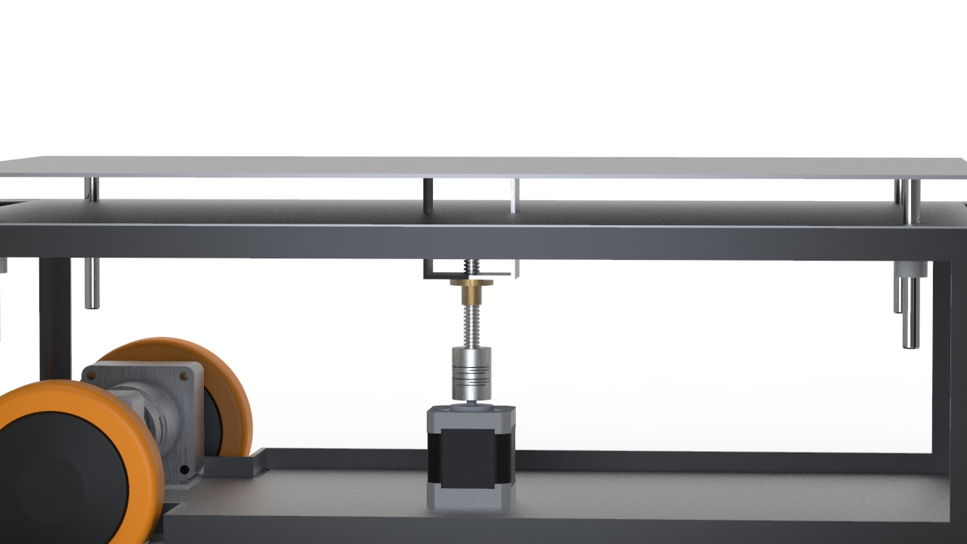**Lifter Mechanism**:

For the lifter mechanism we use ***Lead Screw*** mechanism to make linear actuator driven by a stepper motor.

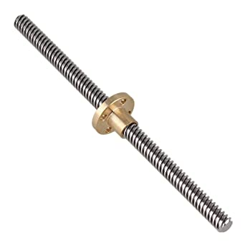- Lead screws are self-locking (they stay where they are with no need for braking mechanism). In addition to low cost, this make them the best solution.

**Lead screw**: Stainless Square threaded Lead Screw with single start thread and outer diameter of 8 mm.

**Stepper motor:** The calculations for the torque required to derive the Lead screw is given by the equation:

Where**:**

→ Weight force applied

→ Coefficient of friction

→ Mean diameter

→ Lead

→ Tread angle

For our project the force applied will be the weight of the load which is assumed to be

***F*** = 15 kg- force, and the other specifications are constant relative to the selected lead screw which are:

= 0.15, = 7 mm, = 2 mm, =

N.m

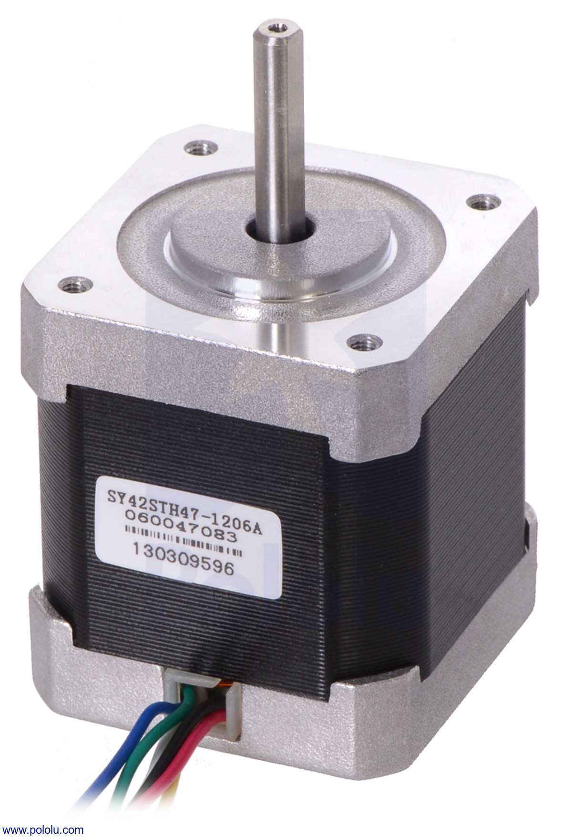

**NEMA 17** stepper motor is suitable for this mechanism because it gives maximum torque of 0.42 N.m which is greater than the required torque.

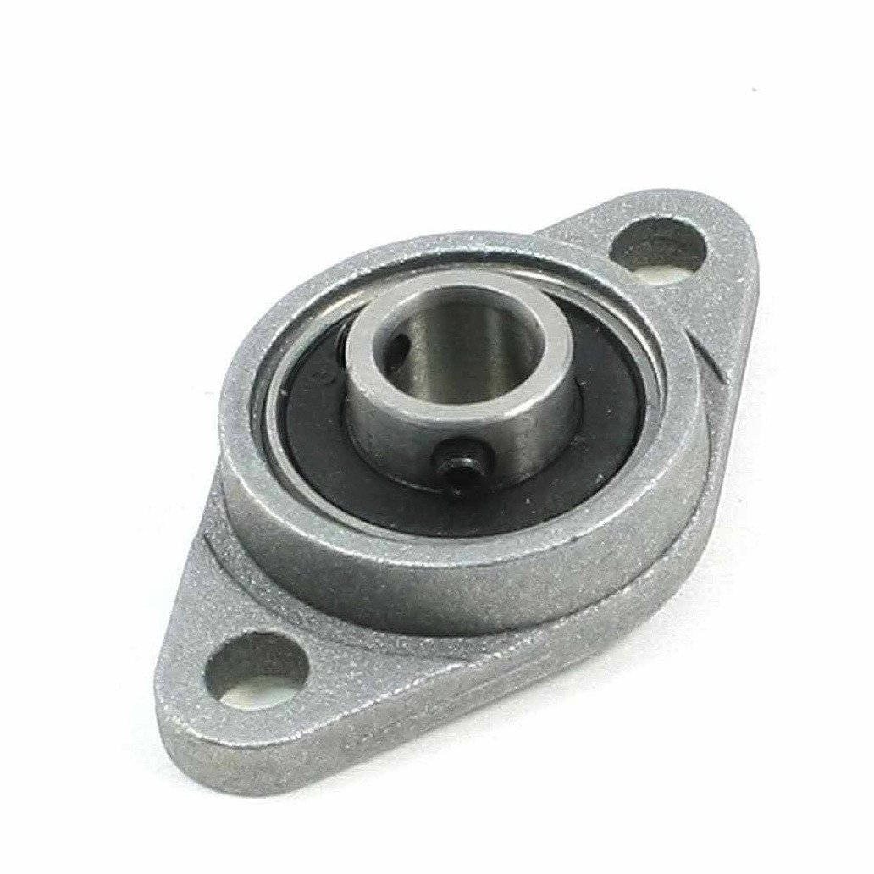

**Pillow bearing:** The KFL08 bearing is designed to provide shaft support where the mounting surface is perpendicular (vertical axis) to the shaft axis.

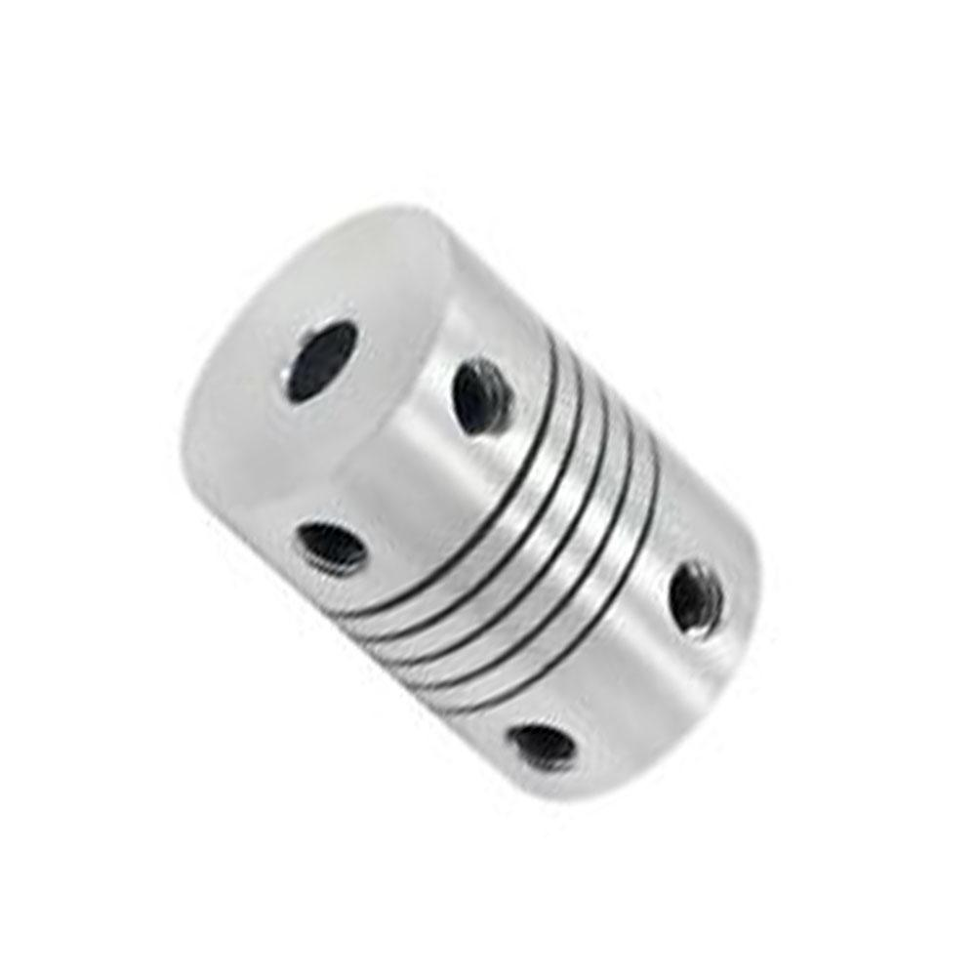

**Coupling:** Connect the stepper motor shaft (5 mm) to the screw (8 mm) with a set-screw coupler. These couplers are made of machined aluminum and have a spiral cut that makes them slightly flexible so they can be fit to two shafts even if they are not perfectly co-linear and will help reduce bending effects.

**Linear Bearing**.

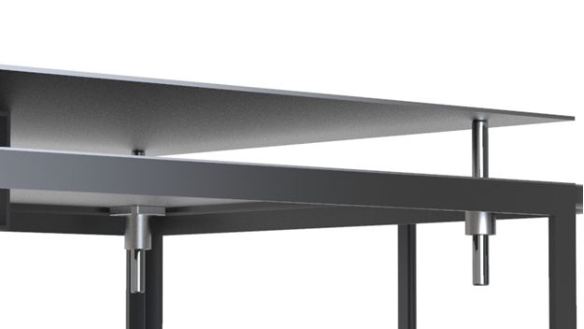For the lifting sheet, it must be

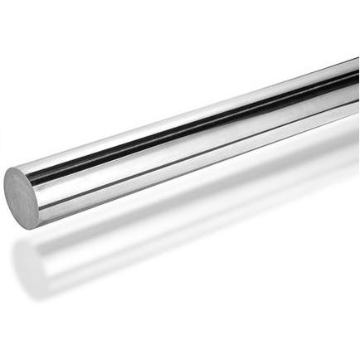

The chrome plated steel bar is used in conditions of high stress, friction and harsh conditions. Accordingly, the quality of the base metal and subsequent surface treatment are of paramount importance. Wear resistance, corrosion resistance, surface smoothness, high yield strength and uniform quality are essential properties of chrome plated bars.

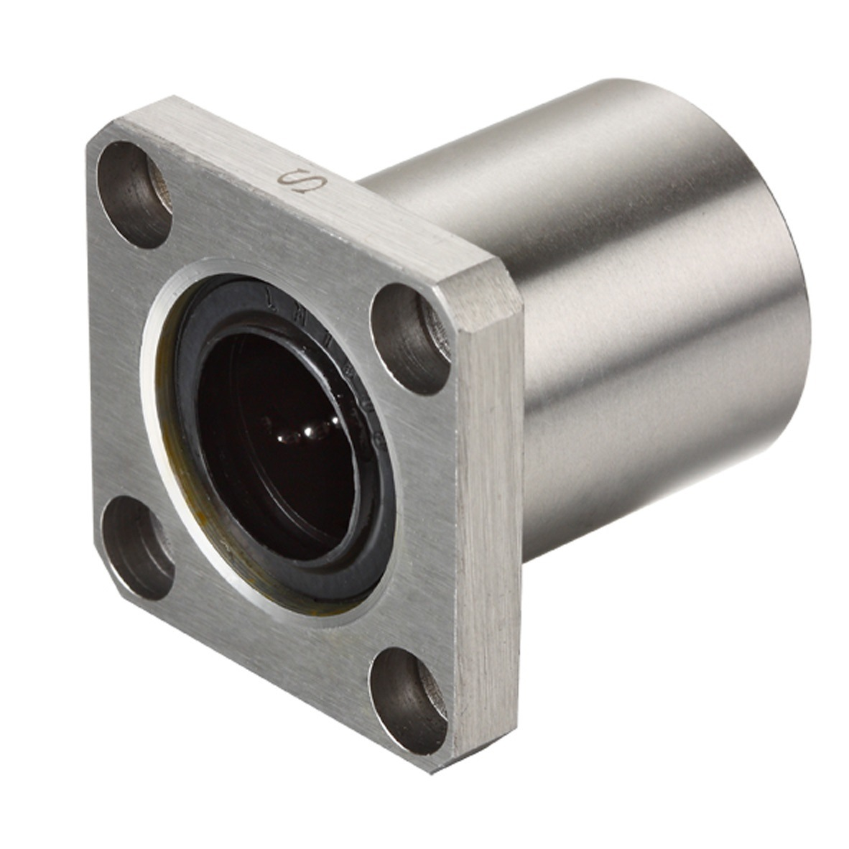

Flange Mounted Linear Bearing LMK8UU (8mm Diameter). Flange Mount Linear Recirculating Ball Bearings offer the same great advantages of the standard recirculating linear Ball Bearings and they also incorporate a perpendicular flange for easy mounting.

**DC Motor fixture**:

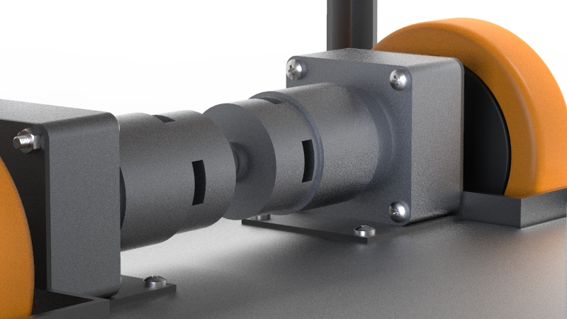

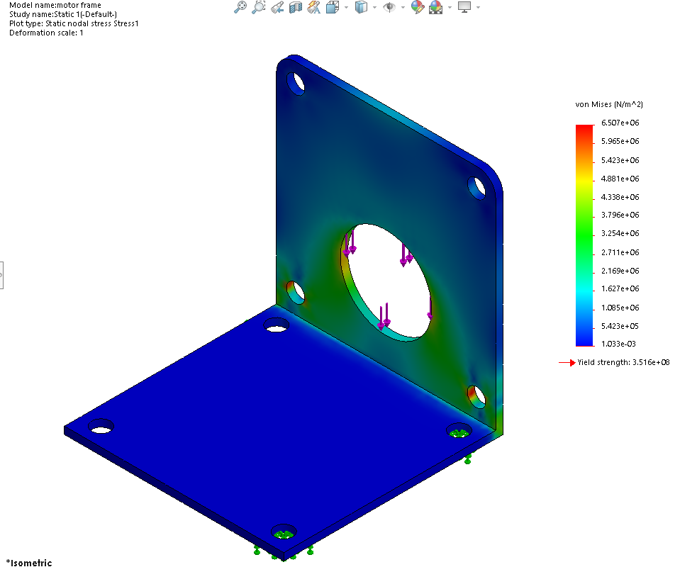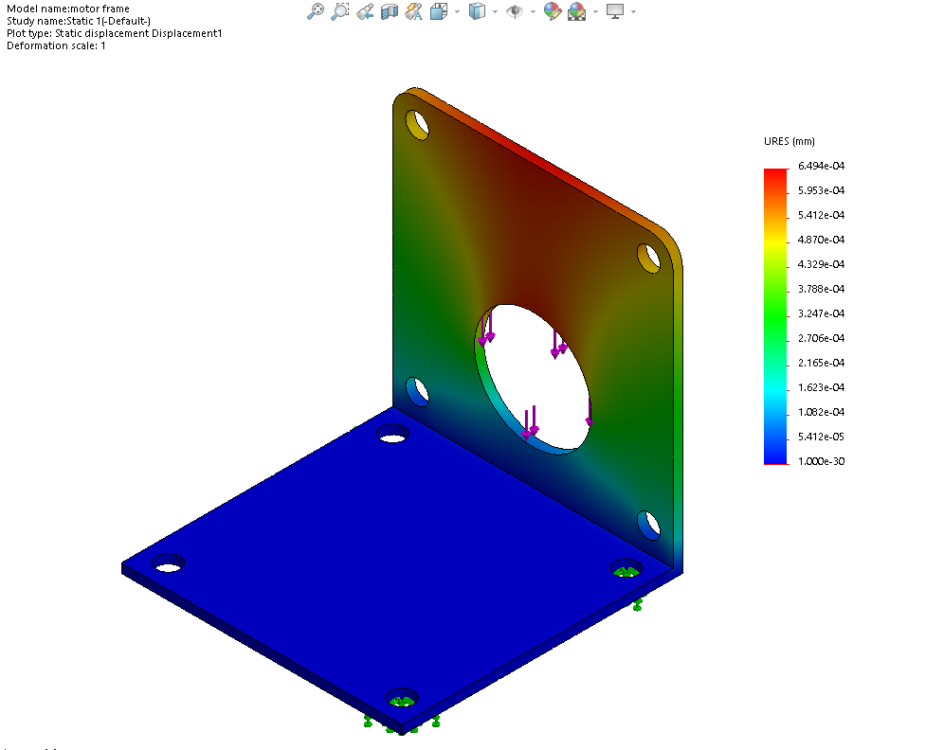

**Stepper motor fixture:**

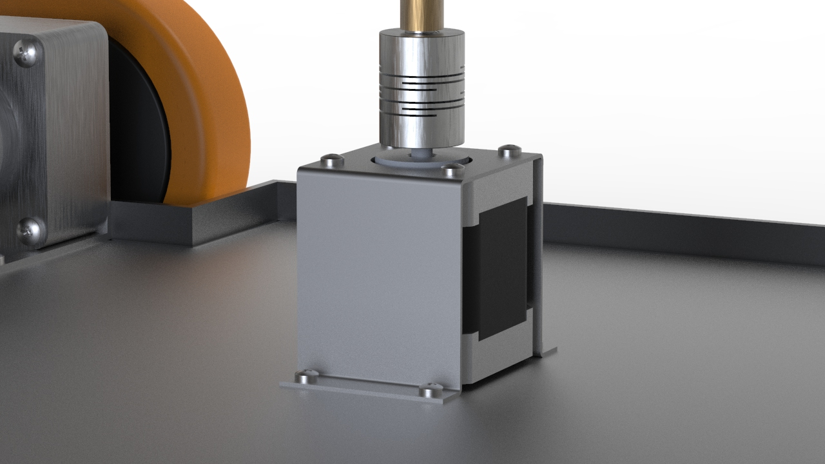

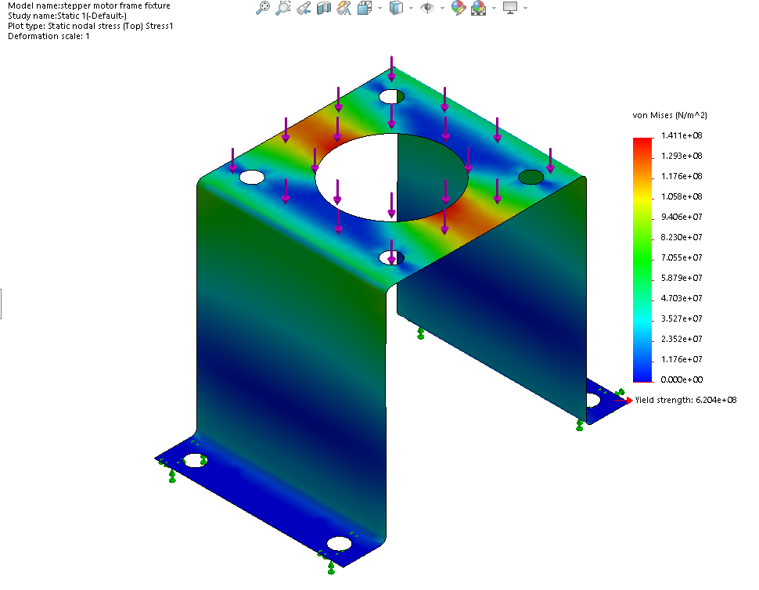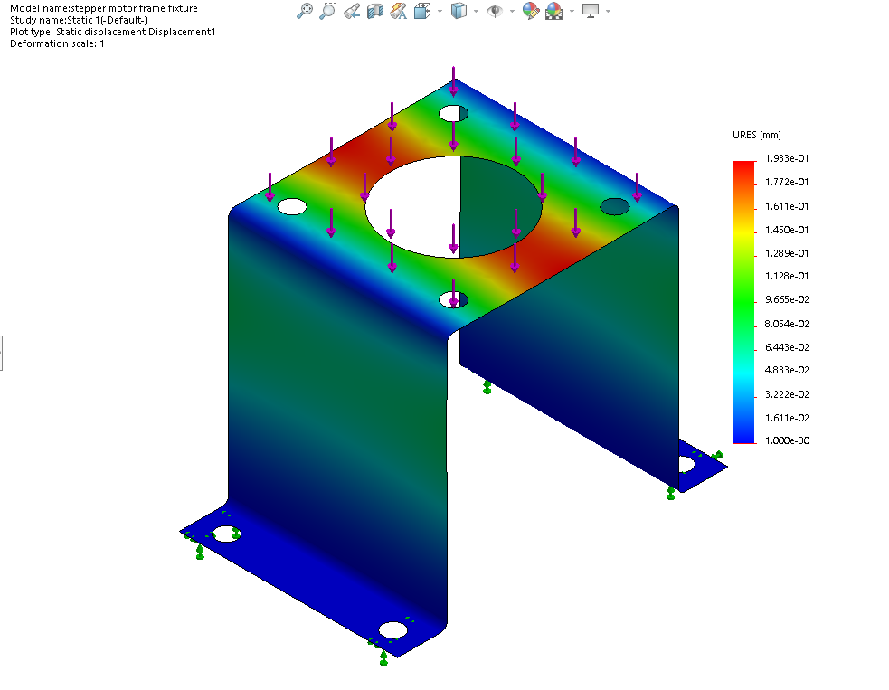

**Motor coupler lathe:**

The motor shaft is 8 mm diameter and the wheel bore is 20 mm diameter. To connect them together we have to fabricate a custom coupling.

