# Caret Left with solid fillRoboteQ

**Eng. Mahmoud Karam**





## Content

Chapter 1: Sorting 0

Content 1

1.1 Introduction 2

1.2 References 2

## Introduction

### Roboteq’s solutions

1. Motion Controllers.
2. Electric Motors.
3. Guidance Sensors.
4. Power Management.
5. Software.

### Auto Mobile Robot (AMR) Construction.

1. Chassis + Drive + Navigation foundation.
2. Fast charging 1000Wh battery.
3. Frame of high-grade aluminum, uniquely designed to bear heavy loads while still being as light weight as possible.

### Open Hardware Design

All drawings, documentation and models of the AMR are Open Hardware and are licensed under the CERN-OHL-P v2. You may redistribute and modify these files and make products using them under the terms of the CERN-OHL-P v2 (https:/cern.ch/cern-ohl).

#### Project Files

Mechanical drawing source files, 3d models, bill of material, wiring diagram, are available free of charge from and can be requested from RoboteQ.

## Design Objectives

1. Easy build: readily available standard components, requiring only cutting and drilling. Strictly minimal use of custom machined parts.
2. Scalable: Width, heigh, length can be changed as needed.
3. Efficient and maneuverable drivetrain for moving within confined spaces and tight routes.
4. Must be able to navigate floors with dips and cracks with the wheels always making full contact.
5. Withstand heavy vertical loads: mounting a robotic arm to carry shelves of inventory.
6. Bi-directional driving capabilities with identical maneuverability in both directions.

### Robot Specifications

* Dimensions : 935L x 555W x 200H (mm)
* Weight : 60kg including batteries
* Batteries : 15 cells in series, 54V max, 20Ah Lithium Ion
* Rocker Range of Motion : 10mm
* Weight Carrying Capacity : 900 kilograms
* Maximum Speed : 2.7 m/s
* Max continuous torque at each wheel : 60 Nm
* Max total pull force : 154 N (156kg)

### Mechanical Design

1. Chassis : standard and widely available 25 x 25 (mm) of X-Profile aluminum.
2. 6 wheels :
   1. Center left/right set of motor/gearbox/wheel.
   2. Casters at each corner.
3. Center of mass: Chassis is essentially composed of two simple rectangular frames connected via pivot to create a cantilever that ensures:
   1. The robot’s weight and its load are shared on all six wheels.
   2. All wheels permanently make contact on the floor even on uneven surfaces.

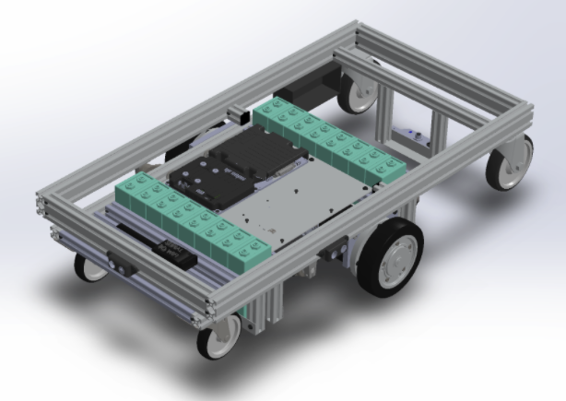

1. The top, larger frame carries almost no components. It serves as a large surface upon which loads can be mounted or carried. This frame has two casters and the pivots that attaches to the lower frame. The frame is made entirely of X profiles that are simply cut to size.

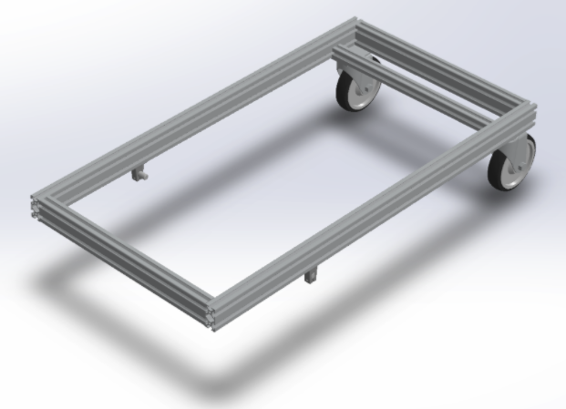

1. Chassis is designed with cantilevered wheels so as to best distribute the load weight over it six wheels. The cantilever also lets wheels pairs move up and down relative to the others, and therefore follow the shape of floor even if not perfectly flat.

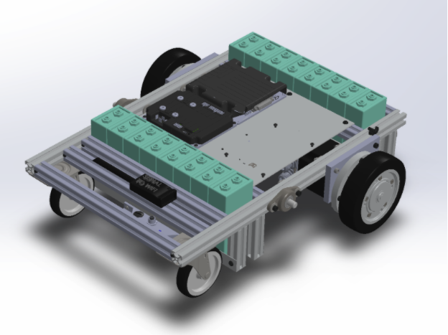

1. Weight Distribution and Carrying Capacity

The lower, smaller frame carries most of the Robot’s components. The pivots creates an articulated cantilever with the upper frame so that all six wheels always make contact with the floor. It is made of several lengths of X profile aluminum bars, a custom machined holder for the motors, custom cut and drilled L profiles for the battery holder, and a custom cut and drilled aluminum plate for mounting most of the electronic components.

The total carrying capacity – assuming it is evenly distributed - is the lowest carrying capacity of the weakest element divided by the weight ratio.

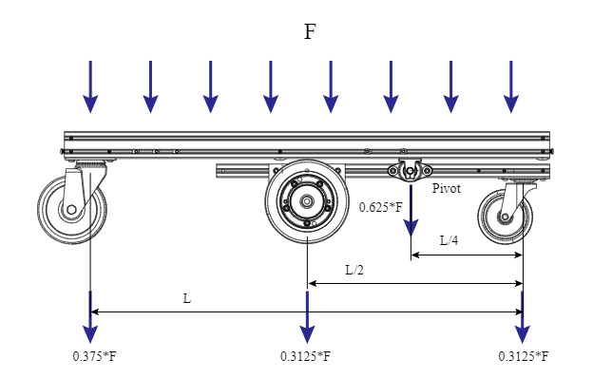

From table, maximum load is limited to 990kg by the smaller casters. This value can be raised by selecting higher capacity casters. Moving the pivot closer to the motor will shift the load away from the caster but will restrict the cantilever motion.

With a load of 900kg on top of the robot, each component will be subject to the load in the table below:

Analyze calculator for Stress and torsion of the aluminum X profiles: <https://8020.net/deflection-calculator>

### Motor, Gearbox, Wheel Sizing

The robot has a pair of Nidec CTD 089LDA30XROB Motors/Gearbox/Brake and wheel assemblies.

#### ImageMotor specs

1. **Dimensions**: 160mm long, 89 frame,
2. **Power**: 29Nm of continuous torque at the output of its precision, ultra-silent 9:1 Shimpo gearbox.
3. **Ratings**: 48V, 3000 RPM max, resulting in a maximum robot speed of 2.7m/s on the ground with its 156mm wheel.
4. Equipped with a mechanical brake.

#### Calculations

Exact dimensioning of the motor, gearbox and wheel is a complex calculation that depends on several factors:

1. Total weight of loaded robot
2. Maximum desired acceleration and deceleration
3. Floor inclination
4. Rolling resistance resulting from floor harness and tire stiffness
5. System friction

Roboteq has establish a mathematical model for estimating the motor requirements based on these factors. Contact Roboteq for an evaluation of specific requirements.

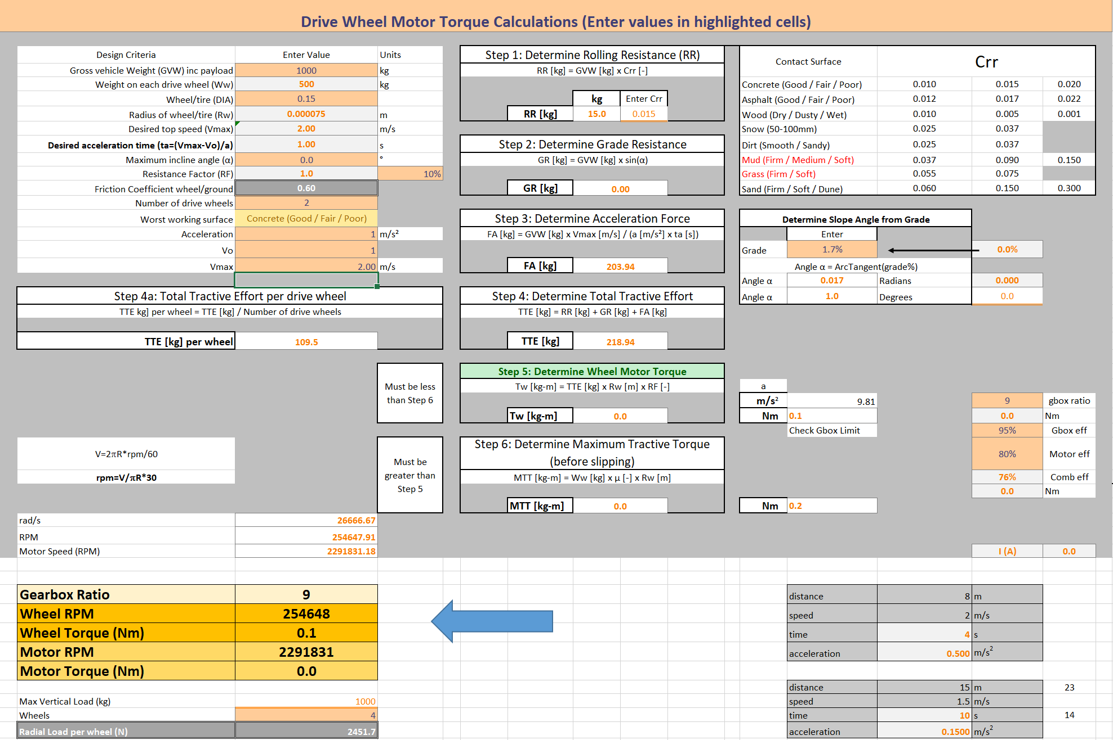

### Electronics, Power, and Sensor Components

|  |  |
| --- | --- |
| Motor Driver | FBL2360 dual channel. |
| Motors | Two Permanent Magnets Brushless motors. |
| Power Source | Lithium-Ion battery pack connected to the Battery Management System. |
| Autonomous Charge | Charge contacts to connect to the battery charger at docking stations. |
| Paths Follower | magnetic track sensors to follow paths made of magnetic tape affixed to the floor. |
| Navigation | Optical flow sensor includes an IMU to provides information about the robot’s motion for navigation and/or safety purposes. |
| Collision avoidance | ultrasound distance sensors |
| Communication | WiFi adapter for to a host computer |

Thanks to its built-in scripting language in the motor driver, it also acts as the Robot’s navigation and supervisory computer.

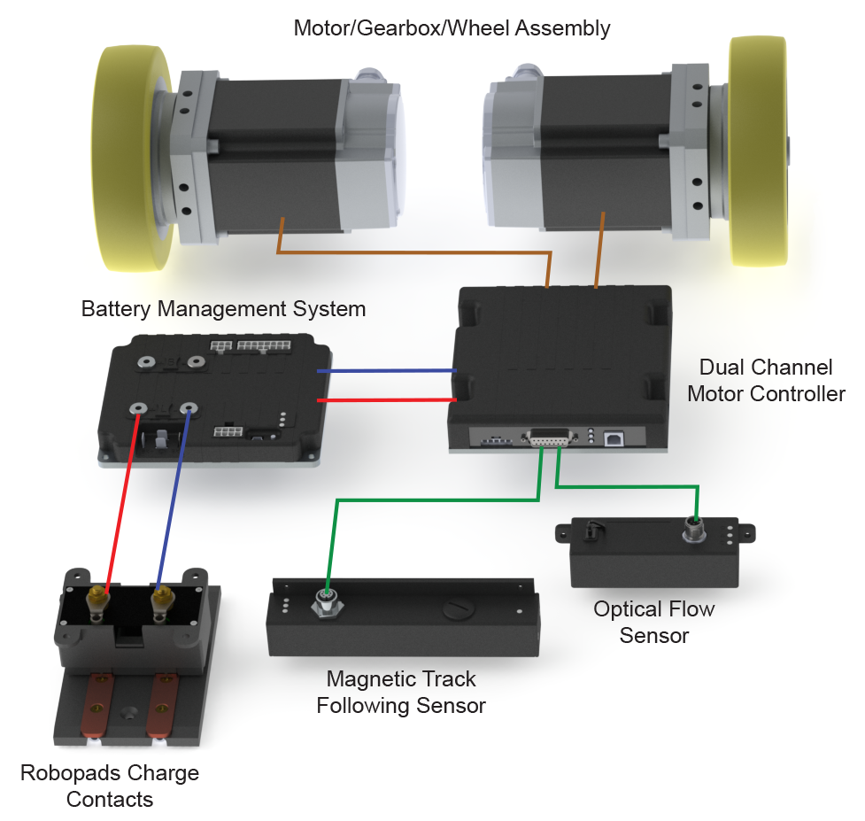

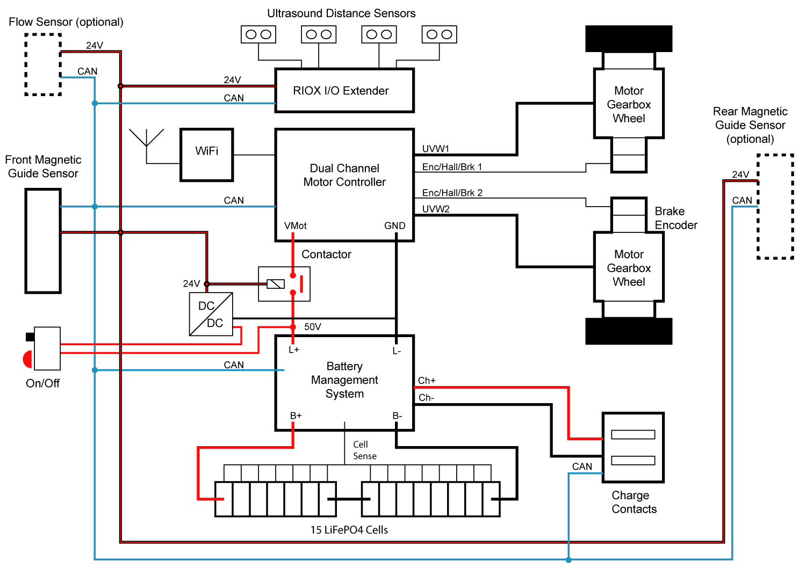

### Robot Mechanical Construction

A view of the complete, fully assembled robot

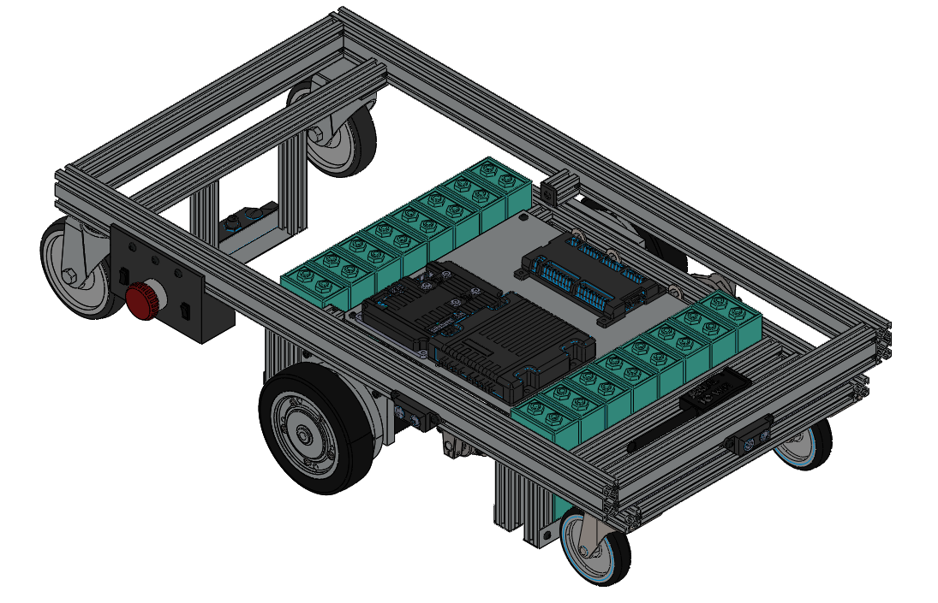

#### Subassembly 1 - Top Frame

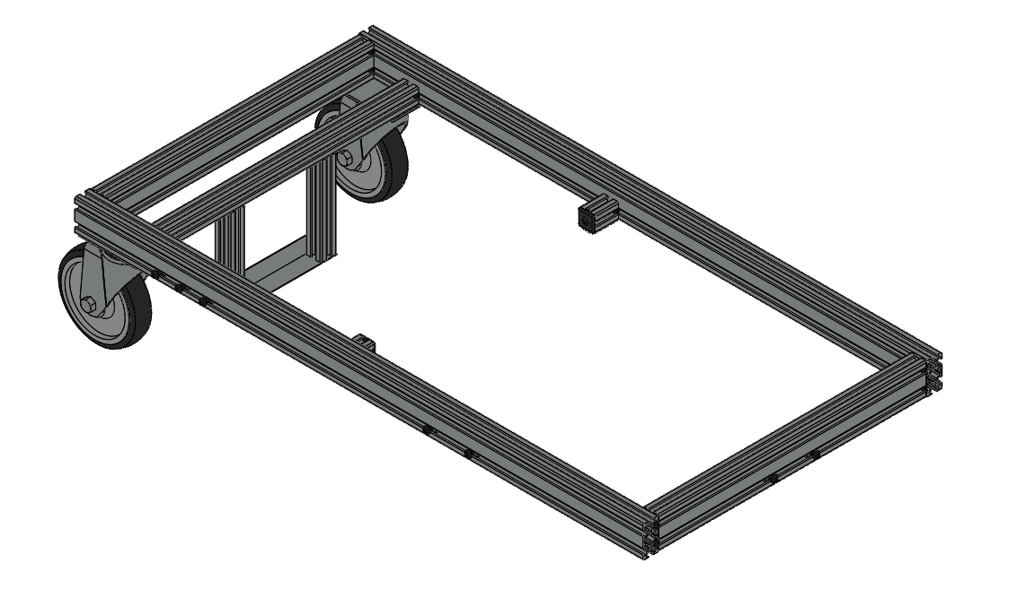

## Line Tracking

[1]

## References

|  |  |
| --- | --- |
| [1] | "Magnetic Track Following AGV demo 2018," RoboteQ, [Online]. Available: https://www.youtube.com/watch?v=6HFK8MZF2_M. [Accessed 2021]. |
| [2] | "Open Source Automatic Mobile Robot (AMR) Design," RoboteQ, [Online]. Available: https://www.roboteq.com/roboamr-2021. [Accessed 2021]. |