**Communication**

**Outline:**

1. Definition.
2. Wireless Communication.
3. Elements of Wireless Communication System:
4. Types of Wireless Communication.
5. Classifications of Wireless Communication.
6. References.
7. **Definition:**

Communication Systems can be:

1. Wired:

The medium is a physical path like Co-axial Cables, Twisted Pair Cables and Optical Fiber Links etc. which guides the signal to propagate from one point to other.

Such type of medium is called Guided Medium.

1. Wireless:

The medium is space which does not require any physical medium but propagates the signal through space. Since, space only allows for signal transmission without any guidance, it is called Unguided Medium. the transmission and reception of signals is accomplished with Antennas.

Antenna: and electrical device transforms the electrical signals to radio signals in the form of Electromagnetic (EM) Waves and vice versa. These Electromagnetic Waves propagates through space. Hence, both transmitter and receiver consist of an antenna.

Electromagnetic Waves carry the electromagnetic energy of electromagnetic field through space. They include Gamma Rays (γ – Rays), X – Rays, Ultraviolet Rays, Visible Light, Infrared Rays, Microwave Rays and Radio Waves.



Radio Waves

Electromagnetic Waves used in wireless communication to carry the signals are usually Radio Waves.

Electromagnetic Wave consists of (electric + magnetic fields) in the form of time varying sinusoidal waves. Both are oscillating perpendicular to each other and the direction of propagation is perpendicular to both these fields.

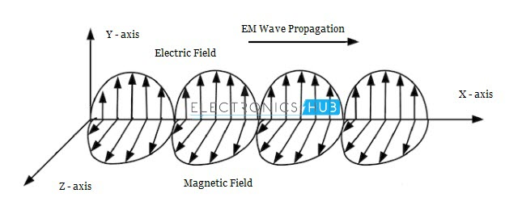

Mathematically, an Electromagnetic Wave can be described using Maxwell’s equations. Pictorial representation shows the Electric Field in the Y – axis, magnetic field in the Z – axis and the Electromagnetic Wave propagates in X – axis.

1. **Wireless Communication:**

Wireless Communication is a method of transmitting information from one point to another, without using any connection wires, cables, or any physical medium.

Generally, information is transmitted from a transmitter to a receiver placed over a limited distance.

Wireless Communication lets transmitter and receiver can be placed anywhere between:

1. few meters (like a T.V. Remote Control).
2. few thousand kilometers (Satellite Communication).

The commonly used Wireless Communication Systems:

* 1. Mobile Phones.
  2. GPS Receivers.
  3. Remote Controls.
  4. Bluetooth Audio.
  5. Wi-Fi.
  6. etc…

Wired communication can do most of the tasks that a wireless communication can.

So, why do we need Wireless Communication?

1. The primary and important benefit is mobility.
2. flexibility and ease of use; can be made anywhere and anytime with a considerably high throughput performance.
3. Infrastructure: the infrastructure setup and installation of wired communication systems is an expensive and time-consuming job. The infrastructure for wireless communication can be installed easily and low cost.
4. In emergency situations and remote locations, where the setup of wired communication is difficult.
5. **Elements of a Wireless Communication System:**

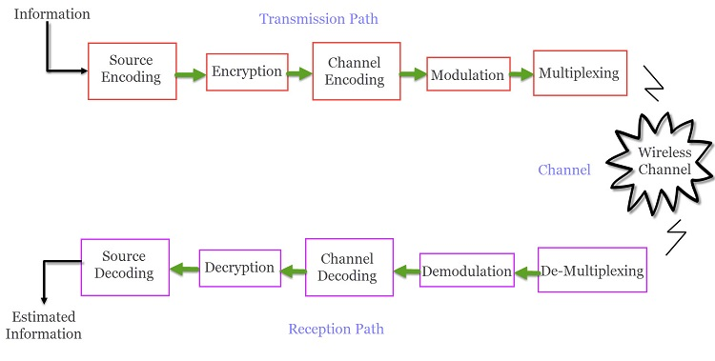

A typical Wireless Communication System can be divided into three elements:

1. Transmitter:

transmission path of a Wireless Communication System consists of:

1. Source Encoder: converts source signal to a suitable form to apply signal processing. Redundant information is removed to maximize resources utilization.
2. Encryption: The signal is then encrypted using an Encryption Standard so that the signal and the information is secured and doesn’t allow any unauthorized access.
3. Modulation: reduce the impairments like noise, interference, etc. During this process, a small amount of redundancy is introduced to the signal so that it becomes robust against noise. The signal is modulated using a suitable Modulation Technique (like PSK, FSK and QPSK etc.), to be easily transmitted using antenna.
4. Multiplexing: The modulated signal is multiplexed with other signals using different Techniques like Time Division Multiplexing (TDM) or Frequency Division Multiplexing (FDM) to share the valuable bandwidth.
5. Channel:

The medium of transmission of the signal i.e., open space. A wireless channel is unpredictable and also highly variable and random in nature. It may be subject to interference, distortion, noise, scattering etc. and the result is that the received signal may be filled with errors.

1. Receiver:

Collects the signal from the channel and reproduce it as the source signal.

The reception path of a Wireless Communication System consists of:

1. Demultiplexing: separates the signal from the channel from other signals.
2. Demodulation: Demodulated the individual signals using appropriate Techniques to recover the original message signal.
3. Channel Decoding: removes the redundant bits from the message.
4. Decryption: removes encryption security and turns it into simple sequence of bits.
5. Source Decoding: gets back the original transmitted message or signal.

From the components of the reception path it is clear that the task of the receiver is just the inverse to that of transmitter.

1. **Types of Wireless Communication:**

People need Mobile Phones for many things like talking, internet, multimedia etc. All these services must be made available to the user on the go i.e. while the user is mobile. With the help of these wireless communication services, we can transfer voice, data, videos, images etc.

Wireless Communication Systems also provide different services like video conferencing, cellular telephone, paging, TV, Radio etc. Due to the need for variety of communication services, different types of Wireless Communication Systems are developed. Some of the important Wireless Communication Systems available today are:

* 1. Television and Radio Broadcasting.
  2. Satellite Communication.
  3. Radar
  4. Mobile Telephone System (Cellular Communication)
  5. Global Positioning System (GPS)
  6. Infrared Communication
  7. WLAN (Wi-Fi)
  8. Bluetooth
  9. Zigbee
  10. Paging
  11. Cordless Phones
  12. Radio Frequency Identification (RFID)

1. **Classifications of Wireless Communication:**
   1. Simplex: one way communication. An example is Radio broadcast system.
   2. Half Duplex: two-way communication but not simultaneous one. i.e., walkie – talkie (civilian band radio).
   3. Full Duplex: two-way communication and simultaneous. i.e., mobile phones.

Examples:

1. 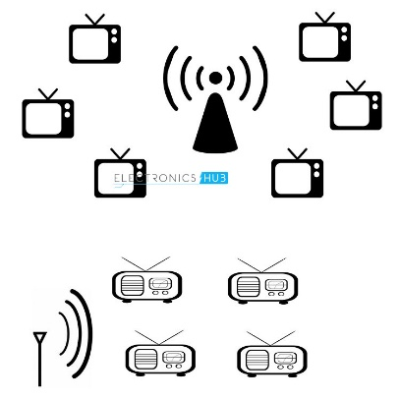Television and Radio Broadcasting:

Simplex Communication System where information is transmitted in one direction and all users receiving the same data.

1. Satellite Communication:

worldwide coverage independent to population density.

offer telecommunication (Satellite Phones), positioning and navigation (GPS), broadcasting, internet, etc. Other wireless services like mobile, television broadcasting and other radio systems are dependent of Satellite Communication.

1. Radar:
2. Mobile Telephone System (Cellular Communication): mobile phones are not limited to just making calls but are integrated with numerous other features like Bluetooth, Wi-Fi, GPS, and FM Radio.

The latest generation of Mobile Communication Technology is 5G. Apart from increased data transfer rates, 5G Networks are also aimed at Internet of Things (IoT) related applications and future automobiles.

1. Global Positioning System (GPS): a subcategory of satellite communication. It provides different wireless services like navigation, positioning, location, speed etc. with the help of dedicated GPS receivers and satellites.
2. Infrared Communication: uses the infrared waves of the Electromagnetic (EM) spectrum. It is used in remote controls of Televisions, cars, audio equipment etc.
3. Bluetooth: low range wireless communication system provides data, voice and audio transmission with a transmission range of 10 meters. Almost all mobile phones, tablets and laptops are equipped with Bluetooth devices. They can be connected to wireless Bluetooth receivers, audio equipment, cameras etc.
4. Paging:

An obsolete technology. It was a major success before the widespread use of mobile phones. It provides information in the form of messages in a simplex system i.e., the user can only receive the messages.

1. Wireless Local Area Network (WLAN):

An internet related wireless service. WLAN enables laptops and mobile phones connect to an access point (like a Wi-Fi Router) and access internet.

Wi-Fi is one of the widely used wireless network, usually for internet access (but sometimes for data transfer within the Local Area Network). It is very difficult to imagine the modern World without Wi-Fi.

1. **References:**
   1. **ElectronicsHub, Wireless Communication: Introduction, Types and Applications:** [**https://www.electronicshub.org/wireless-communication-introduction-types-applications/**](https://www.electronicshub.org/wireless-communication-introduction-types-applications/)