# Caret Left with solid fillIntroduction

## Content

Chapter 1: Sorting 0

Content 1

1.1 Introduction 2

1.2 References 2

## Introduction

Automated Guided Vehicles (AGVs) are also known by other names such as LGV (Laser-Guided Vehicle), Mobile Robots, SGV (Self-Guided Vehicle), Guided Carts, Autonomous Vehicles, and Driverless Vehicles.

Regardless the type of automated guided vehicle (forklift, tow tractor, , etc), the AGV requires an Automated Guidance System that drives the AGV and informs the AGV Management System about the AGV positioning.

Figure ‎1.1: Common types of AGVs

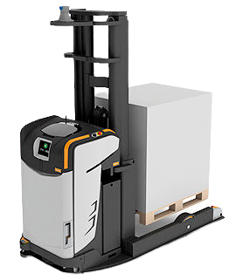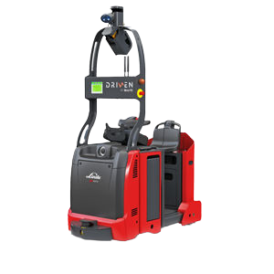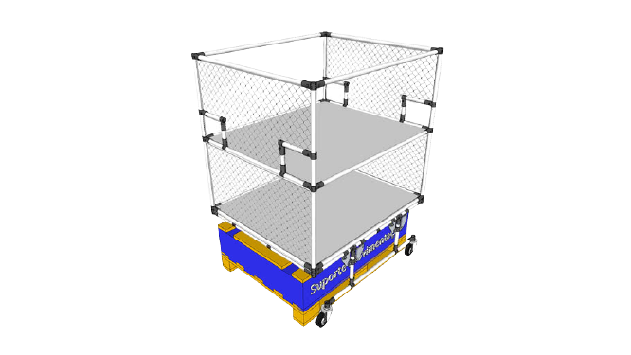

Vehicles and navigation are improving day after day. Mobile robots are reaching incredible performance levels that are redefining many industries, there are many AGV applications such ecommerce, warehouses, hospitals, etc, where AGVs are bringing new excellence levels.

This outstanding development is possible thanks to accurate, reliable, and cost-effective AGV navigation sensors. Depending on the application, AGVs and AMRs navigate thanks to 2D or 3D LiDAR, magnetic sensors, ultrasonic sensors, cameras, etc.

What are the main AGV Navigation Systems? AGV Navigation Technologies are Laser Guided Navigation, Magnetic Navigation, Natural Feature or Free navigation (including SLAM Navigation with LiDAR Sensors), Magnetic spot navigation, inductive wire navigation, optical navigation, vision navigation.

Choosing the right vehicle guidance technology is essential because it will influence the AGV Robot System performance. AGV performance is complex and depends on many key elements.

## What guides an AGV?

The most common AGV navigation systems are:

1. Laser-guided navigation (LGV)
2. Magnetic navigation
3. AGV with Natural navigation (SLAM or LiDAR NAVIGATION)
4. Magnetic spot navigation
5. Wire navigation
6. Optical Navigation
7. Vision Navigation

So, there are several Navigation Methods for Automated Guided Vehicles and Autonomous Mobile Robots.

### Natural Navigation AGV - Free Navigation

There are several technologies included in what’s called “Natural Navigation”.

AGV Manufacturers could buy from a Navigation Technology supplier or could develop its own Navigation Technology. The most important one is the SLAM Navigation, or Simultaneous Localization and Mapping (SLAM). It simply means that an AGV with SLAM Navigation is able to map its environment and localize where it is thanks to the information received from the surrounding environment.

The AGVs are able to map the environment with different AGV sensors such vision cameras, lidar sensors or even with the same lasers used for safety purposes.... all of this info is combined with internal inertial measurement unit (IMU) to define and recalculate the real AGV positioning. All of these calculations are made by a highly complex algorithm called SLAM.

#### How do AGVs with SLAM Navigation work?

You drive the AGV manually (for example with a joystick) or automatically along the AGV route. While running, the AGV will map the surrounding environment and creates a reference map that is used to navigate next time it will pass in the same place. You can also load an AutoCAD (or similar) map of your premises into the AGV Management System. Both sets of data, the AutoCAD map and the real mapped environment are matched to define the initial coordinates (0,0).

Based on the combined data sets, the AGV will automatically drive through the practiced route, and it will check if what it’s “seeing” is the same that was loaded on its “brain” enabling it to define its position.

All the data that the AGV acquires are combined with other data coming from odometrics, encoder, in order to improve accuracy.

#### Why to choose AGVs with natural navigation?

SLAM Navigation will substitute for other kinds of navigation such magnetic navigation, optical navigation ,etc. It’s a good solution for AGCs and Tow tractors. Many of the main AGV manufacturers are developing and including this technology on their AGVs.

#### Disadvantages of using SLAM

The main concern about Natural (SLAM, LIDAR, etc) technology is its reliability in variable environments such as production lines where there’s continuously moving of people, items, boxes, pallets, etc. In these conditions the AGV might not be able to find where it is.

For this reason, SLAM with LiDAR is a great solution for AGVs where you have well defined profiles and environments with fixed structures such as walls and columns. Natural Navigation can be used in warehouses and hospitals… in general, in any environment with a low level of “confusion”.

## References

General Resources: [1]

[1] “AGV Navigation: Methods, Comparison, Pros and Cons - Illustrated Guide.” https://www.agvnetwork.com/types-of-navigation-systems-automated-guided-vehicles (accessed Oct. 11, 2021).