# Caret Left with solid fillAnalysis of Line Sensor Configuration for the Advanced Line Follower Robot

**Eng. Mahmoud Karam**

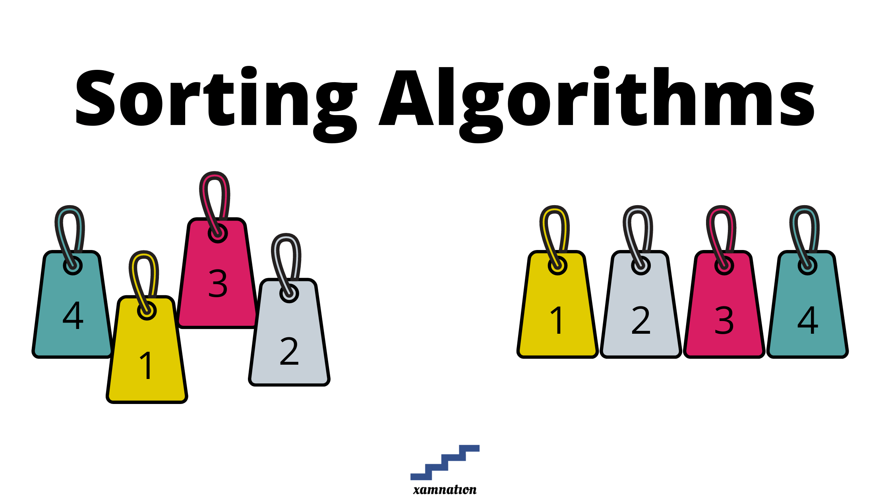



## Content

Chapter 1: Sorting 0

Content 1

1.1 Introduction 2

1.2 References 2

## Introduction

## References

**There are no sources in the current document.**