LC-HRMS Scan-to-sequence-list SOP
Prepared by: Maria Cardelino
Last edit: 11/5/2025
Overview
This application automates the process of converting Matrix ID data from sample tube racks into formatted sequence lists for LC-HRMS analysis. The app supports both C18 and HILIC analysis methods and handles up to 4 96-well plates that map to a single 384-well plate format.
This application significantly reduces manual work and potential errors in preparing LC-HRMS sequence lists while ensuring consistent formatting and sample tracking.
Folder structure – essential items
R:/diwalke/LC/Run_Lists/<Study_folder>/
- Samples.xlsx
- QAQCs.xlsx
- YYMMDD_Sequence_Generator_App/
  - App/
    - Mapping/ # contains instructions for generating 384wp positions.
    - server.R # server logic; instructions for actions performed in the app
    - ui.R # ui logic; instructions for how the app looks
    - write_list.R # instructions for writing the sequence file
  - RUN.R # open this in RStudio to run app.
Application Structure
The application is built using R Shiny and consists of four main tabs:
- Upload Plate Scans
- Check Layout
- Connect to Inventory
- Generate Sequence List
Requirements - Software Dependencies:
required_packages <- c( "openxlsx", "shinyjs", "tools", "shiny", "readr", "dplyr", "plotly", "readxl", "shinyFiles", "stringr", "this.path")
Detailed SOP
Prepping app for a new study:
Open “RUN.R” and edit the following lines to match the names of the excel inventory files in the study folder AND the name of the study folder in 1-Raw Files and E:/ drive (complete with date).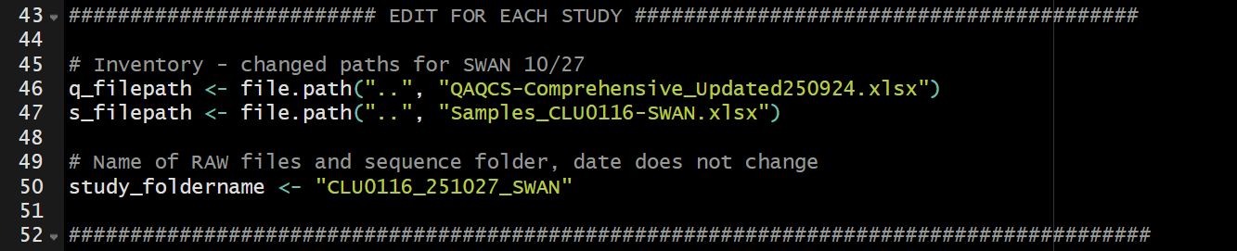
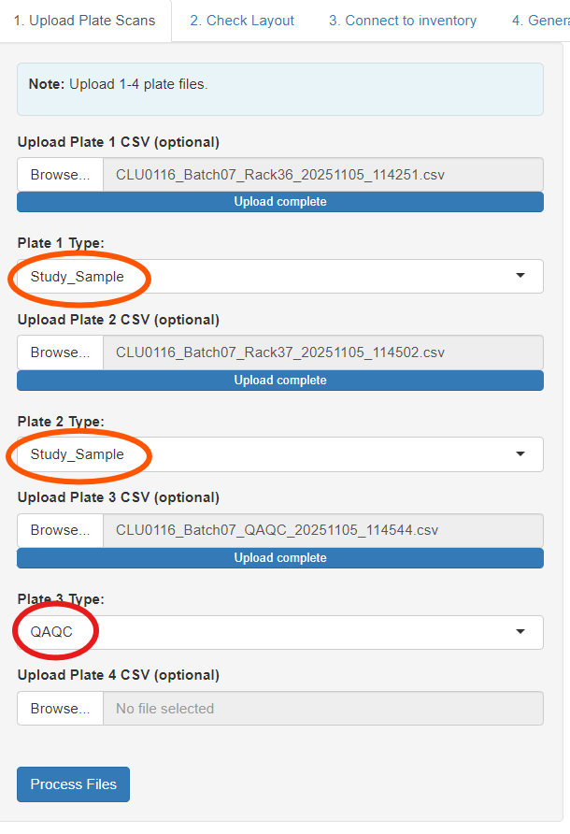
Tab 1: Upload Plate Scans
User Actions:
- Upload 1-4 CSV files containing Matrix IDs from plate scans
  - Ex for CLU0116: First two plates are study samples, 3rd plate is QAQC
- Specify plate type for each uploaded file (Study Sample or QAQC)
- Click "Process Files" to begin analysis

Backend Processing:
- Reads CSV files using dynamic header detection
- Maps 96-well positions to 384-well format
- Creates placeholders for missing plates
- Combines data from all plates into unified format
Tab 2: Check Layout
User Actions:
- Review combined data table, verify plate visualizations
Tab 3: Connect to Inventory
User Actions:
- Click "Step 1: Match IDs to inventory"
- Review the matched Sample_IDs in table AND QAQC plate layout on the right.
  - Hover mouse over colored dots to read sample_ID.
- IMPORTANT: Set injection order (by column: A1, C1, E1 or by row: A1, A3, A5…)
- Click “Step 2: Update inventory” (optional)
  - Checks to make sure samples have not been previously analyzed
  - Updates internal inventory (excel workbook included in parent folder) indicating samples as ‘Analyzed’
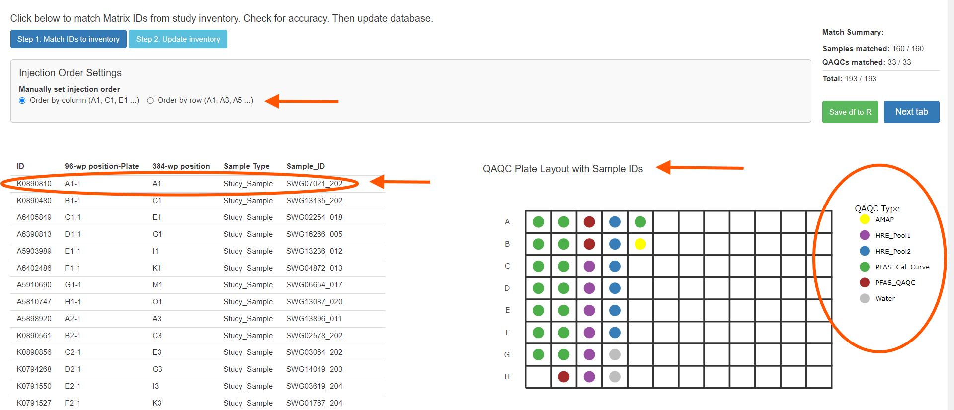
Backend processing:
- Matches Matrix IDs with sample inventory in .xslx files
- Displays number of samples matched using Matrix IDs
- Pulls sample IDs for each matched sample and adds to Sample_ID column
- QAQC plate visualization with dynamic color-coded sample types, grouped by name.
Tab 4: Generate Sequence List
User Actions:
- Enter run information (see below)
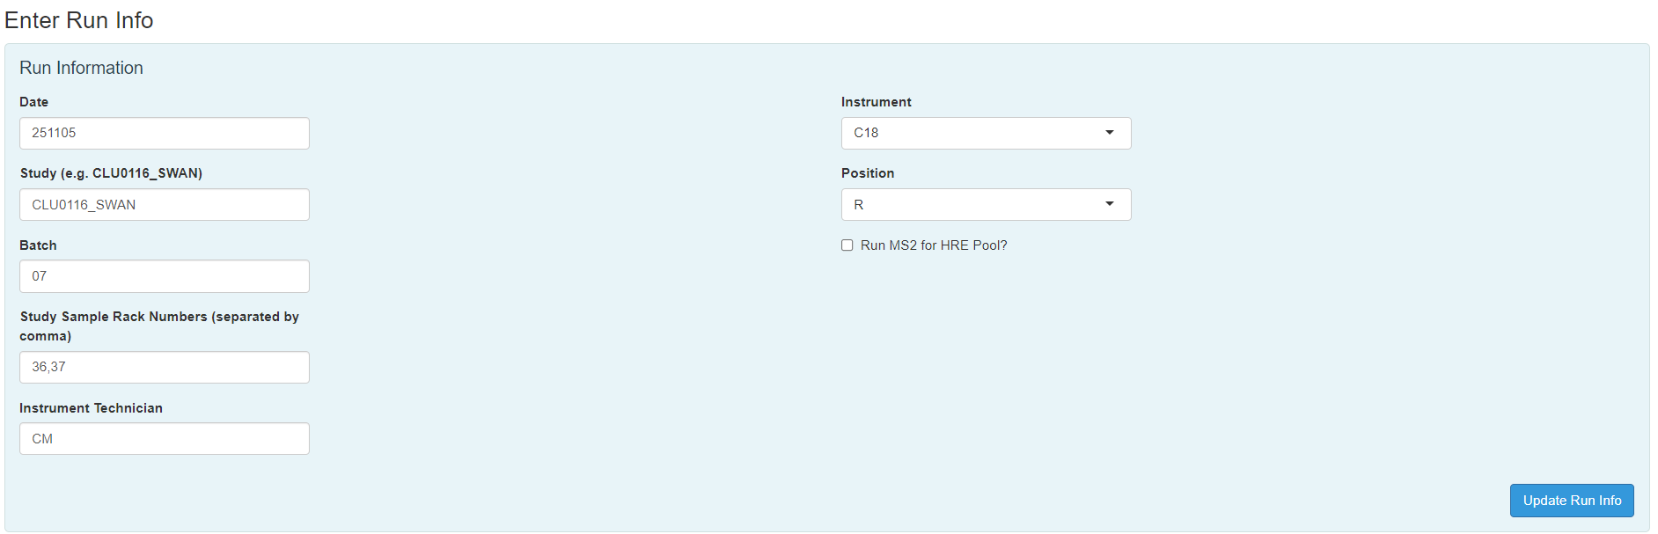
- Click "Update Run Info" ^^^
- Check filepaths and click Confirm Paths
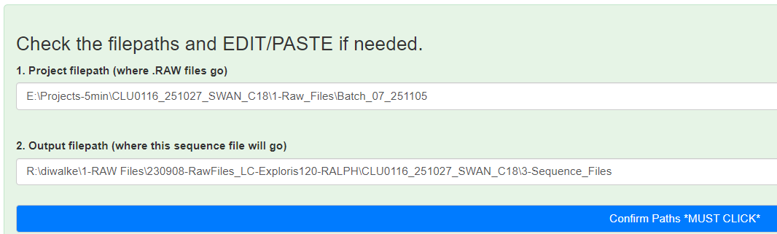
- Click "Generate Sequence List"
- If generating C18 and HILIC at the same time, return to the top and change instrument to “HILIC”, change position if needed, and click “Update Run Info” AGAIN, re-check filepaths, confirm, then “Generate Sequence List”
** Check errors in the Progress/Debug Console.
** Verify output with finish message:
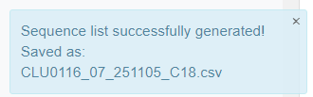
Output Generation:
- Creates CSV file with formatted sequence list including Sample types, File names, Sample IDs, Injection parameters, Method paths, Well positions, File Output Structure.

Run List Documentation
Current studies (post-Otober 2025)
Study affiliation: SWAN (CLU0116)
Major changes:
- Less QAQC samples
- Checks rack size and adjusts length of run list / which QAQC samples to include accordingly.
- New PFAS QAQCs and calibration curves.
*Bold: always runs
Conditions:
- 2 sample racks, each with >60 samples
  - FULL QAQC
- 2 sample racks, second rack < 60 samples
  - 1 less pool (5 instead of 6)
- 1 sample rack only:
  - 3 less pool (3 instead of 6)
  - 1 less PFAS baby cal curve (only need 2 of each calibration point instead of 3)
  - 1 less PFAS QAQC (only need 2 of 3)

CLU0116 RUN LIST:
1 real blank (front and back labeled 'Blank', middle labeled 'Cal\_Std')
1 water method blank (out of 2)
1 NIST (OPTIONAL, out of 1)
1 AMAP (optional, out of 1)
3 PFAS baby cal curve (0.1, 1, 10)
PFAS QAQC (1/3)
HRE Pool 1 and 2 (1)
Study samples
HRE Pool 1 and 2 (2)
only runs if first rack > 60 samples: {
| Study samples
| HRE Pool 1 and 2 (3)
}
PFAS QAQC (2/3) - only if there are two sample racks
1 'blank'
BIG CAL CURVE (1-8/8)
1 'blank'
only runs if there are two sample racks: {
| HRE Pool 1 and 2 (4)
| Study samples
| HRE Pool 1 and 2 (5)
| only runs if second rack > 60 samples: {
| | Study samples
| | HRE Pool 1 and 2 (6)
| } resume if only one chunk of samples in second half …
| 3 PFAS baby cal curve (0.1, 1, 1)
} resume if only one sample rack
PFAS QAQC (3/3 or 2/2)
1 water method blank (out of 2)
1 real blank
Old order of injections for CLU0120_MEC: (Before October 2025)
# 1 blank
# 1 water (1 of 2)
# 1 NIST (1 of 1)
# 1 AMAP (1 of 2)

# Pool 1
# Pool 2
# 20 study samples
# Pool 1
# Pool 2
# 20 study samples
# Pool 1
# Pool 2
# 20 study samples
# Pool 1
# Pool 2
# 20 study samples
# Pool 1
# Pool 2

# 1 'blank'
# CAL CURVE (1-8/8)
# 1 'blank'

# Pool 1 (6/10)
# Pool 2
# 20 study samples
# Pool 1
# Pool 2
# 20 study samples
# Pool 1
# Pool 2
# 20 study samples
# Pool 1
# Pool 2
# 20 study samples (160 total)
# Pool 1
# Pool 2

# 1 AMAP (2 of 2)
# MDL (Cal curve)
# Water (2 of 2)
# 1 blank

