Start menu

* Play game
* Options
* Exit

Play game dialogue or screen

* Select Players count 2 – 6

Game screen world map

Continents

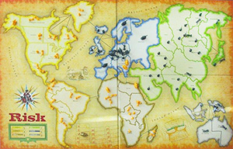

6 continents, 42 territories

(need to decide whether we want to implement all the rules or whatever, ie calvary and artillery, trading in etc…)

42 Cards are marked with a territory and a picture of Infantry, Cavalry, or Artillery.

Two "wild" cards marked with all three pictures, but no territory.

Start game with player

Players select colour

depending on how many players they get assingned different amount of infantry

each play rolls a die decides turn order going from highest to lowest

then go through and everyone places an infantry unit on a tile

after the entire board is filled with units each player takes on more turn one more unit

each turn has 3 phases

1. Getting and placing new armies
   1. Dependant on the amount of territories you own
   2. Also dependant on if you own a continent
2. Attacking
   1. Can only attack adjacent tiles
   2. You must have two armies
   3. Roll dice to see who wins (highest dice roll wins)
3. Fortifying your position

Placing new Armies